China + India Rice Harvest **Emissions Data**

The United Nations Food and Agriculture Organizations (FAO) statistics states that China and India together account for more than half of the global rice production. Together, these two countries produce an estimated 387 million metric tons, roughly 426.6 U.S. tons, of rice per year. Rice production goes a long way to feeding the majority of the globe and helps to alleviate world hunger problems. However, rice production comes at a cost for global greenhouse gas production.

Methane (CH4) is a potent greenhouse gas with a global warming potential that is around 30x that of Carbon dioxide (CO2). While methane does not spend nearly as much time in our atmosphere as CO2, it still is one of the main drivers of global warming. For this reason, methane has become a focus of scientific investigation into monitoring the emissions of this potent greenhouse gas (GHG).

Since 2015 an organization known as Climate Trace has been monitoring global methane emission sources. Out of the data that Climate Trace has made publicly available, it appears that the area of rice agricultural lands of a country can be directly correlated with the methane emissions of said country. If you look at the two map animations in Figure 1, you will notice something familiar. It does not take an expert in statistics to see that the rise and fall of methane emissions coincides with the rise and fall of the agricultural area of rice production.

Figure 1. Time Series of Annual Rice Harvest Area and CH4 Emissions





Animation created with ArcGIS Pro.

The charts in Figure 2 are created with the same data represented above in Figure 1, but without any spatial context showing the parts of the globe where rice and methane are produced. However, we do not need to use mapping software to show the correlation.

Figure 2. Area of Rice Production per Country (Above) and Methane Emissions per Country (Below).

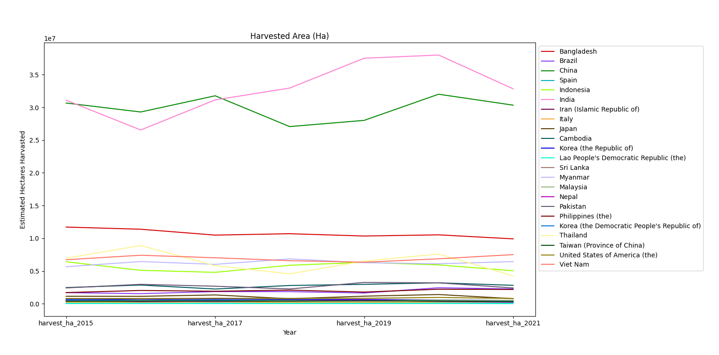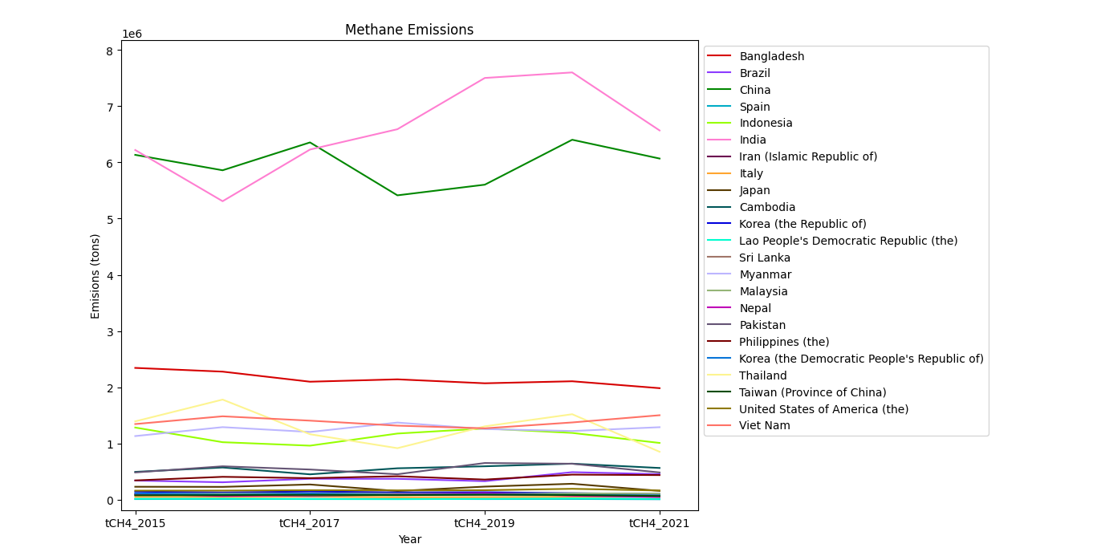

According to the data the two top rice and methane producing countries from 2015 - 2021 are India and China. Let’s take a close look at the production numbers of these two highly populated countries. In Figure 3, at India’s peak of production in 2020, there was an estimated 38 Million Hectares of agricultural land used in rice farming. In this same year they experienced peak methane emissions, estimated at 7.5 million tons of CH4 released into the atmosphere. In Figure 4, notice that China had a dip in agricultural rice land and methane produced in 2018. Both down 14.9% from the previous year.

Figure 3 Hectares of Rice Agriculture (Top) and Methane Emissions (Bottom) India

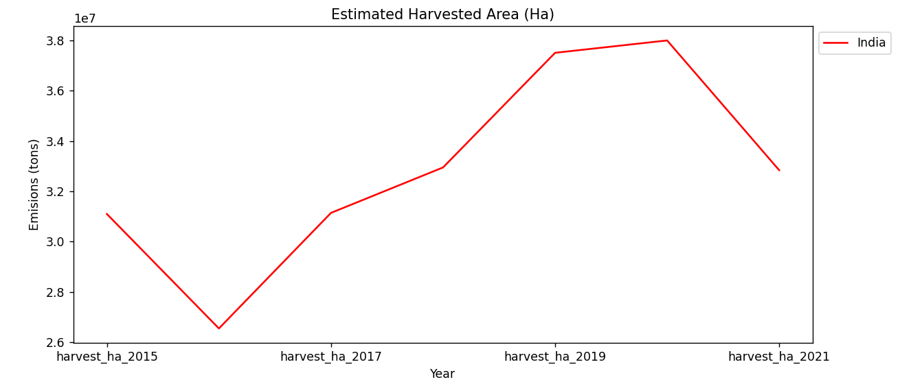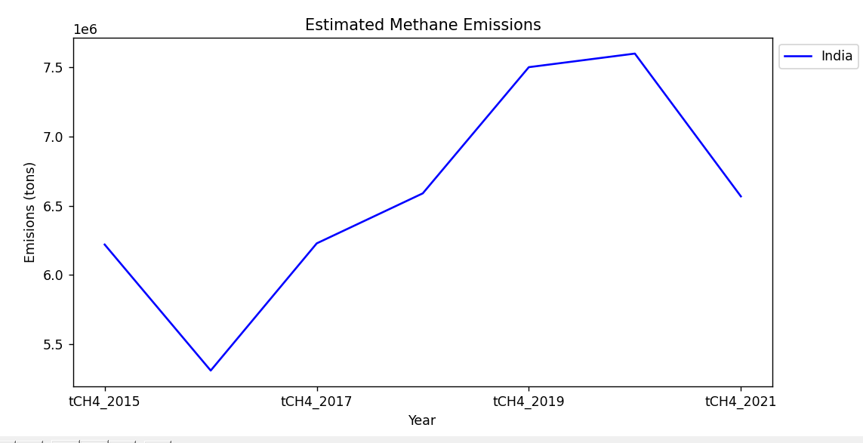

Figure 4 Hectares of Rice Agriculture (Top) and Methane Emissions (Bottom) India

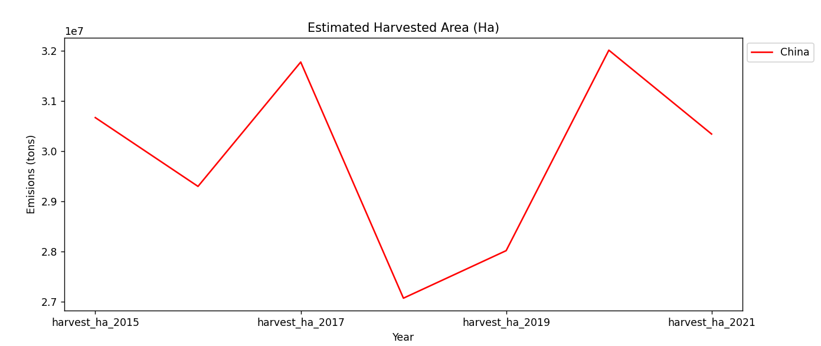 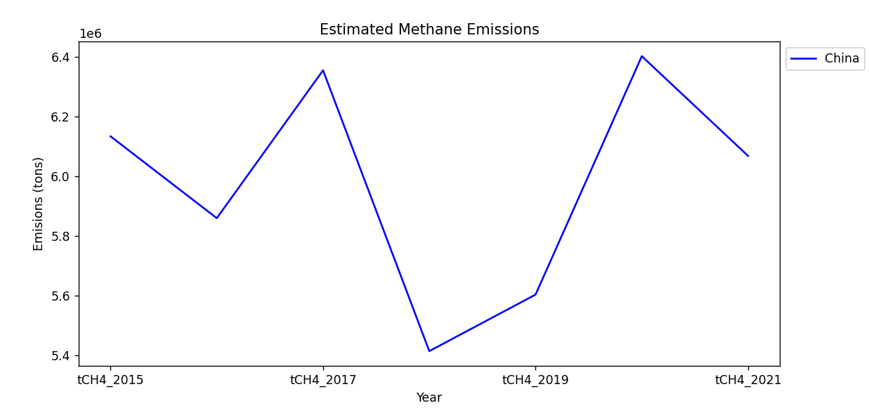

From the data collected from Climate Trace and other research organizations we can say that it is abundantly clear that global rice production is directly influencing the amount of methane released into the atmosphere. This will undoubtably become a target for climate action efforts going forward.