log4z
目录
log4z 1
intro 1
Structure chart 2
logger's configure 2
the log file's path and the log file's name 3
demo 4

intro
- Log4z is an open source C++ lightweight log library. It provides in a C++ application log and trace debug function. Using log4z can be very easy and convenient to debug log or track for conveying information to the screen, the log file
- log4z
- The advantages of log4z
- A very wide range of MIT open source license can unrestricted use in personal, educational and commercial cases
- log4z very lightweight. Using C++ and API system write only a header file and a CPP source files, very simple and easy to use
- suitable for cross platform (windows or Linux, 32 or 64bit) multithreading logging output occasions
- to provide a complete log priority control, and the procedure can be adjusted in any position.
- through a configuration file or call interface increased with the configuration of different log recorder.
- screen output according to priority to different log color display, file output information and neat enough, logging interface fast and convenient.
- excellent performance, a small memory footprint
- Interface clear and simple, a skilled programmer just visit the log4z.h interface can grasp the log system.

Structure chart
LOG4Z manager
logger 1
logger 1
logger 1
logger 1
logger 1 files
logger 1 files
logger 1 files
logger 1 files

logger's configure
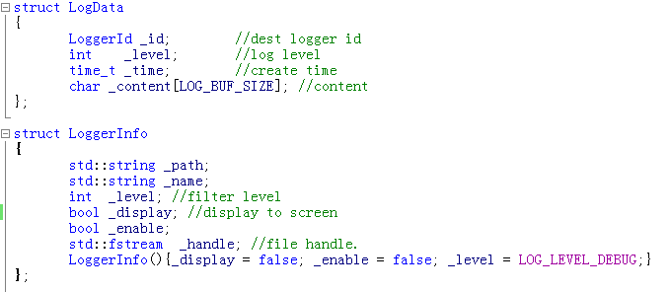

the log file's path and the log file's name
- output path
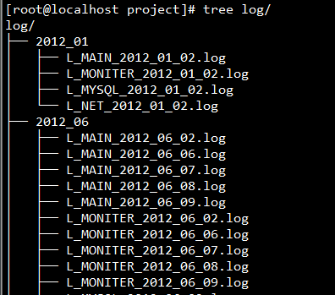

- log format
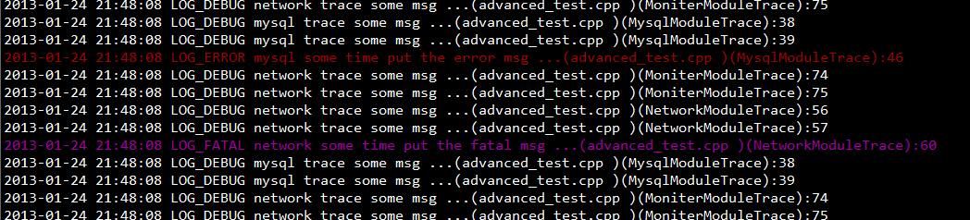

demo
- demo code
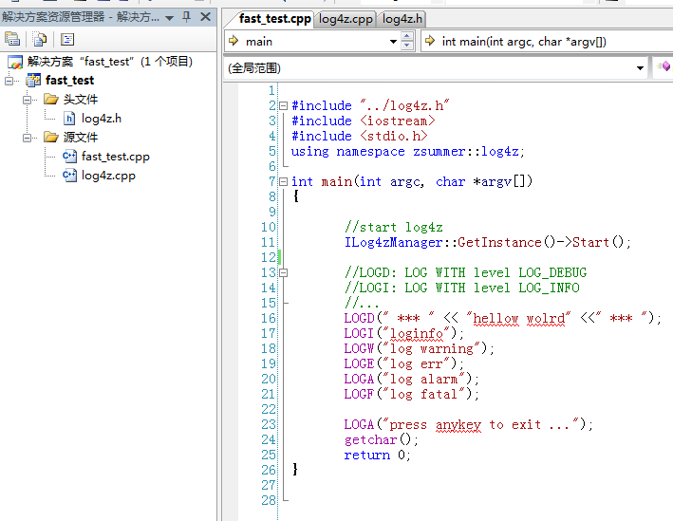
- compile
windows:
linux: makefile

- run
windows:
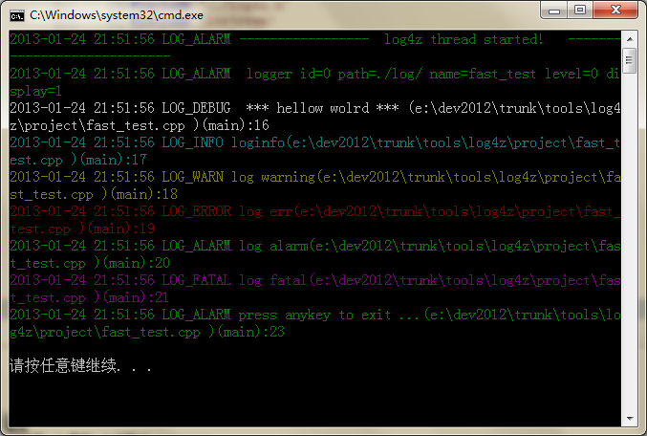
linux
