Chapter 2 Climate risk: An overview

2.1 Sources of climate risk

Climate risks refer to the risks posed by the exposure to physical and transition hazards associated with climate change (NGFS, 2020b). There is a broad consensus (SSF, 2019; UNEP, 2019; CFTC, 2020; BCBS, 2021a) that the source of climate risk can be categorised into two groups: (a) physical risk that arises from direct changes in weather and climate, and (b) transition risk that arises from indirect changes during the transition from a fossil fuel-based economy to a low carbon economy. Figure 2.1 depicts the classification of climate risk as well as the subcategories that we will examine next.

Figure 2.1 Classification of climate risk
Source: HKIMR staff compilation.

Physical risks affect the economy in two ways. Acute risks arise from extreme weather events that occur over relatively short periods of time, such as typhoons, droughts, floods, and storms. As Figure 2 indicates, such extreme events have resulted in an increase in economic loss in recent years, with an 81% growth in 2011-2020 compared to the decade before.

Chronic risks result from long-term climate and landscape evolution, such as global warming, ocean acidification, and ecosystem pollution. As one of the most representative manifestations of chronic risk, global average temperature has risen by more than 1°C above pre-industrial levels and by about 0.2°C over the previous decade. Scientific studies (IPCC, 2021) have established a strong link between this trend and greenhouse gas (GHG) emissions (Figure 3). As a result, global warming has already caused observable consequences such as rising sea levels and intensifying heatwaves, posing widespread and persistent threat to the ecosystem of the world (IPCC, 2021).

Figure 2 Estimated economic loss from natural disasters: 1981-2020 |  | Figure 3 Global CO2 concentration and anomaly temperature: 1875-2020
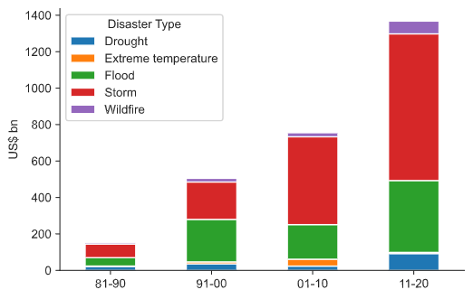 |  | 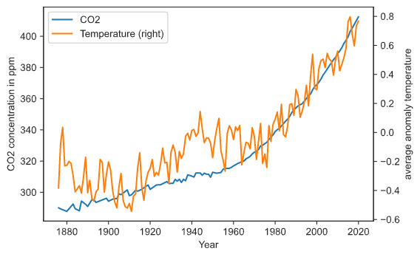
Source: The Emergency Events Database. (https://public.emdat.be) |  | Sources: National Oceanic and Atmospheric Administration (https://gml.noaa.gov/); Met Office Hadley Centre. (Morice et al., 2012)

Transition risk arises from the process of moving to a low-carbon economy. It works through three main channels, namely changes in regulation, technology, and preferences.

First, the implementation of mitigation policies and the exposure to litigation related to climate change create regulation risk. As a typical example, policymakers are levying carbon taxes and developing emissions trading systems to induce reductions in GHG emissions. The share of global GHG emissions covered by carbon pricing schemes has been steadily increasing since 2005, reaching a level of 21.5% in 2021 (World Bank, 2021). With increasing coverage of carbon pricing policies, carbon-intensive sectors may be exposed to greater risks of declining net profits and devaluation of their assets.

Second, technology risk arises from the adoption of new low-carbon and energy-saving technologies, the abolition of inferior technologies, as well as technological advancement that improve economic resilience to climate change (BCBS, 2021a). The electrification on road transport is a case in point. After a decade of rapid growth, the number of electric vehicles (EVs) on the world's roads has reached 10 million by the end of 2020. It is estimated that, by the end of 2030, the number of EVs will increase more than tenfold to 145 million (IEA, 2021). Despite the rapid expansion of the EV industry, technological barriers, bottlenecks in production capacity, and a lack of universal standards continue to pose major risks for the players involved.

Third, changes in consumer behaviour, investor sentiment, and social conventions contribute to preference risk. According to a recent survey by GWI (2020), 60% of respondents choose environmentally friendly products in their daily consumption, even if they are more expensive. Besides, more than half of customers want brands to become eco-friendlier by developing sustainable packaging, using more natural ingredients in their products, and being more transparent about their sustainability practices. These trends indicate a clear embrace of sustainability in consumer preferences. If companies do not respond quickly to adapt their manufacturing and marketing strategies accordingly, there is an increasing risk of being left behind.

Other forms of climate risk have been identified in the literature. Reputation risk might arise as a result of changes in consumer preferences and stakeholder expectations, while liability risk corresponds to the compensation that a company may have to pay should it be found responsible for the effects of climate change. We regard both reputation and liability concerns as subsets of transition risk.

Physical and transition risks have complex relationships, depending on the roles that human activities play in them. The NGFS (2019b) identifies four primary scenarios of physical and transition risk outcomes depending on how adequate and orderly human responses to climate change are (Figure 4). For example, if we act orderly and forcefully (southwest), it is possible to limit physical risk without incurring greater transition risk. If we do nothing to respond to climate change (southeast), we may suffer from severe physical risk but limited transition risk. And if we act too little too late (northeast), it is possible to face heightened transition risk without reducing physical risk.

Figure 4 High-level framework for the analysis of physical and transition risks
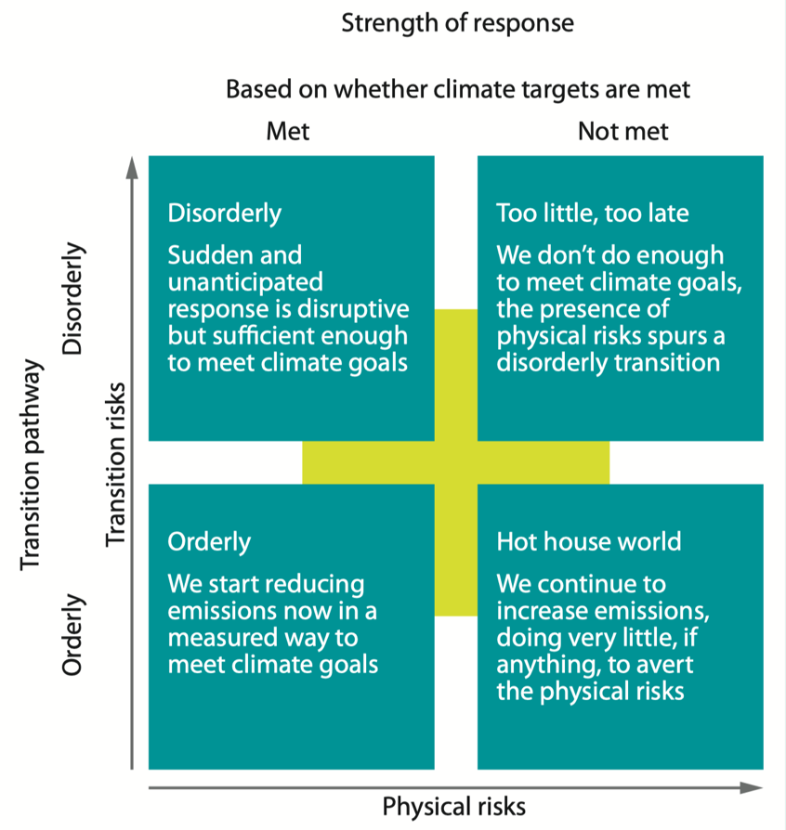
Source: NGFS (2019b).

There is also a trade-off in employing resources to mitigate these two types of risks (CFTC, 2020). Devoting more resources to accelerating the transition to net-zero energy could divert resources away from climate adaptation measures, thereby amplifying the vulnerability to physical risks. Conversely, adaptation investments that mitigate the exposure and sensitivity of assets without regard for carbon management may ultimately amplify transition risks. This underscore the importance of proper resource allocation in managing climate risks.

Despite being one of many factors influencing the financial system, climate risk has several distinguishing traits that necessitate separate consideration. These characteristics include:

- Heterogeneity: The effects of climate risk are diverse. Assets belonging to some locations and industries are more vulnerable to climate risks than others and therefore are expected to be more affected. For example, physical risks are more likely to affect the agriculture and infrastructure sectors, whereas transitions risks are more likely to influence the energy and transportation sectors (ECB, 2020; CTFC, 2020). While these non-systematic risks may only affect specific regions or sectors, systematic climate risks, such as changing climate patterns on a global scale, can impact multiple regions and sectors simultaneously, and will have broader impact on human activities.

- Nonlinearity: The degree of climate changes, the scope of policy implementation, and the magnitude of economic repercussions are not necessarily proportionally related. Instead, evidence suggests that there are ecological tipping points beyond which the affected system performs considerably worse or even ceases to function (BCBS, 2021a). Moreover, climate change may lead to abrupt and unpredictable social and economic transitions, with serious consequences to the economic and financial system. Another type of nonlinear relationship exists between the rise in the average temperature and the increase in the occurrence of extreme climate events. As shown in Figure 5, as the average temperature rises (shifting the bell curves to the right), the occurrence of extreme climate events (area in red) increases disproportionately.

Figure 5 Nonlinear relationship between temperature and the probability of extreme climate events
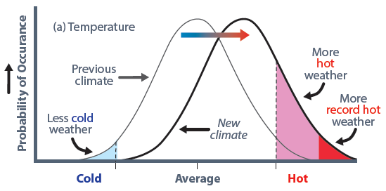
Source: HKIMR staff compilation.

- Uncertainty: Uncertainty is a crucial factor in the assessment of climate risk, as very little reliance can be placed upon historical experience to estimate magnitudes or identify patterns of the physical evolution. The difficulty of accounting for human activities makes the prediction even more challenging, especially when it comes to the pace of policy, technology, and preference shifts.

- Irreversibility: According to scientific evidence, human actions have already had irreversible effects on long-term climate change. Even if all human influences are eliminated, it may take centuries or even millions of years to reverse many changes in the climate system, such as the melting of glacier and the loss of tropical forest (IPCC, 2021).

- Retardation: As what Carney (2015) refers to as "the tragedy of the horizon", catastrophic climate damages occur with a significant time lag beyond traditional time horizons that economic players usually consider. This mismatch of the horizon implies that, owing to a lack to incentive to manage climate risks in the short term, mitigating the negative impact of climate change might become too late once it develops into a defining issue.

2.2 Transmission of climate risk in the financial system

Climate risk affects financial institutions (FIs) mainly through their lending activities (banks), underwriting activities (insurers), and investments in affected securities (asset managers). It can also directly cause disruptions to the operation of FIs. Through the financial network and macroeconomic linkages, climate risk may be magnified to have material impact to the FIs. The transmission channels are summarised in Figure 2.6 and explained in this section.

Figure 2.6 Transmission of climate risks in the financial system
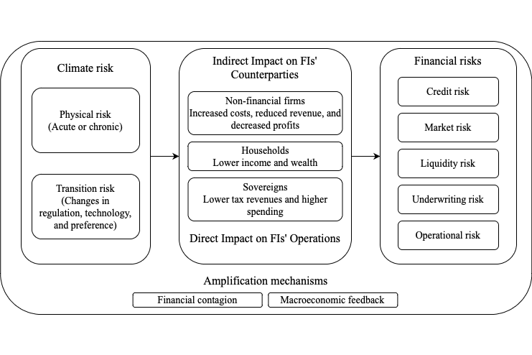
Sources: NGFS (2021), BCBS (2021a) and HKIMR staff compilation.

- Credit risk

Climate risk maps to credit risk in FIs because it affects their borrowers, including non-financial firms, households and sovereigns. Climate risk can weaken the borrower’s ability to service debt, resulting in higher default probabilities. It can also lower the value of the borrower’s collateralised assets. If the borrower defaults, the recovery value of the collateral becomes smaller.

For example, physical risk can affect non-financial firms by damaging their property, disturbing their operations, and disrupting their supply chains, thereby reducing their earnings and ability to repay debt. Extreme weather events, such as floods and wildfires, can cause the value of real properties to plummet, increasing credit risk for banks that hold mortgage loans on their balance sheets.

For sovereigns, physical risk arises through tax and spending. Lower tax revenues may result from companies and households affected by climate change, while higher government spending may be used to offset the negative effects of climate change. Both can affect a sovereign’s ability to repay its debt, as well as increasing the risk of default and the loss-given-default (BCBS, 2021).

Transition risk can develop into credit risk through its negative impact on lenders’ counterparties as well. For instance, the shift in consumer preferences towards environmentally friendly products may depress the profits of carbon-intensive firms, restricting their ability to repay loans. Besides, policy to limit the extraction of fossil fuels may create “stranded assets” that no longer yield economic returns (Carbon Tracker, 2017). Firms owning the right to exploit fossil fuel reserves may then be more likely to default. Implementing stringent air pollution regulations, for example, may necessitate governments’ fiscal assistance, which put more pressure on them to repay debt.

- Market risk

Market risk arises when climate risk depresses asset prices, or when it increases asset price volatility and the risk premia. FIs that own associated assets may incur losses caused by adverse price movements.

For example, an increase in the frequency and severity of droughts may substantially reduce revenues for firms in the agricultural sector. Investors may demand higher risk premia as a result of this unanticipated change, which depresses the equity and bond prices of the associated firms.

Municipal bonds, which consist of debt issued by local governments, offer another example. Physical risks may disturb publicly financed infrastructure projects and subsequently affect the value of municipal bonds tied to those projects. Transition risk could also affect the municipal bond market: If local governments in regions with a high concentration of carbon-intensive industries fail to rebalance their economies, a transition towards a low-carbon economy may result in lower royalties and taxes, bringing down the value of the associated municipal bonds (CFTC, 2020).

Certain investment strategies, such as portfolio diversification, divestment from carbon-intensive companies, and hedging through derivatives, can help FIs reduce non-systematic climate risks. By contrast, systematic climate risks have broad impacts for economic and financial activities, and they may increase co-movements between the prices of different assets. Such risk is not diversifiable and may threaten stability of the financial system.

- Liquidity risk

Climate risk may translate into funding liquidity risk if it hinders FIs from servicing their liabilities as they fall due, or into market liquidity risk if it impairs FIs’ ability to trade financial assets at a fair price in a timely manner (Nikolaou, 2009). While funding liquidity risk mainly affects lending institutions through their deposit-taking activities, market liquidity risk impacts all FIs through their investment decisions.

Physical risk can negatively affect both funding liquidity and market liquidity. Following a destructive weather event, affected households and businesses may withdraw their saving to support reconstruction. This might put banks’ short-term funding liquidity under pressure. At the same time, insurance companies may experience an elevated market liquidity risk: To settle an increasing number of claims after a natural disaster, they might be forced to liquidate assets under unfavourable conditions within a short period of time.

Transition risk can also manifest as liquidity risks. Increased carbon taxes, for example, could shift market preference away from stocks and bonds of carbon-intensive companies, making it more difficult for FIs holding these assets to liquidate them.

Funding and market liquidity risks are intensively connected with each other. Their close relationship would create a vicious spiral in turbulent times, jeopardising the stability of the financial system (Brunnemeier and Pederson, 2009). For example, if asset managers cannot fulfil increased liquidity demand caused by an extreme weather event, they may be obliged to sell illiquid assets at a discount, which aggravates the liquidity shortage in the market, further limiting funding and market liquidity (Diamond and Rajan, 2005).

- Underwriting risk

Climate risk may expose insurers to increased underwriting risk by incurring higher than expected insurance claim payouts. An insurer pools losses for a group of individuals and firms by diversifying risk across a wide base of exposure, but this is feasible only when risks are independent, thin-tailed, and quantifiable (Kousky, 2019). By contrast, climate risks are nonlinear, correlated, uncertain, and without historical precedents, making it difficult for insurers to predict the magnitude of losses when risks materialise.

Physical risk is a significant impediment to the pricing of insurance contracts. For property insurers, climate change may lead to an unforeseen increase in weather-related claims. For life insurers, the potential impact of climate risk on morbidity and mortality could increase the burden of insurers. Transition risk can also be a source of underwriting risk. For example, as an increasing number of insurers discontinue underwriting coal companies, property insurers that continue to service the market may face higher costs in their businesses.

As climatic hazards intensify over time, insurers may raise premiums to cover claims. This could increase the cost for policyholders, reducing their participation and leading to more severe consequences when the contingency occurs. Alternatively, insurers can transfer risk through reinsurance or insurance-linked securities such as catastrophe bonds. However, if actual losses significantly exceed expectations, especially as a result of systematic climate risk that cannot be transferred or diversified, insurers may declare insolvency or withdraw from the market, leaving the risk to the government and other unprotected market participants.

The scenario may be compounded by the problem of moral hazard, which arises when insurance provides the insured with the wrong incentive to engage in excessive risk-taking. Individuals may be oblivious to climate risk if they believe that insures will shield them from loss (Kousky, 2019). Insurance companies themselves may also be negligent about climate-related underwriting risks if they expect to be bailed out by the government in the event of a failure (CFTC, 2020). Therefore, if not managed appropriately, efforts for strengthening resistance to climate risks may actually increase these risks.

- Operational risk

Operational risk arises when climate events induce loss from inadequate or failed internal processes, people, and systems. For instance, extreme weather events can damage transportation and telecommunications infrastructure, reducing FIs’ operational capability. Chronic physical risks, such as global warming, can also threaten the operational efficiency of FIs by reducing labour supply and productivity.

The preference shift of FIs’ counterparties can produce operational risk as well. As noted in BCBS (2021a), retail and wholesale customers may compel banks to direct their savings or investments towards assets and projects with positive environmental impacts. This could prompt banks to adjust their business models, creating operational risk.

- Amplification mechanisms

The effect of climate-related financial risks can be amplified from FIs that are exposed to these risks to those not directly exposed through two main ways.

The first is the financial contagion. when FIs’ balance sheets are negatively affected by climate risk, they may be forced to fire sell assets at heavily discounted prices. With growing interconnectedness of the financial network, this in turn can erode the net worth of other market participants, triggering further rounds of fire sales (Shleifer and Vishny, 2011). Such pro-cyclical behaviour may induce large-scale simultaneous asset sales, depleting liquidity and introducing systemic risk into the financial market.

The second channel is the macroeconomic feedback. This arises from the interaction between the financial market and the real economy. For example, the realisation of acute climate risk may lead to elevated credit risk, which limits banks’ lending businesses and weakens their support for the economy. The resulting fall in economic activity may create higher credit risks, leading to even fewer lending businesses which amplifies the original shock.

2.3 Impact of climate risk on the financial market and financial institutions: Empirical findings

This section reviews the empirical evidence from the recent academic literature on (a) whether climate risks are priced into real estate, equity, and bond markets, and (b) the impact of climate risks on banks, insurers, and institutional investors.

So far, there is some evidence suggesting the pricing of climate risks in the real estate and bond markets, but the evidence in the stock market is more mixed. Moreover, studies show that FIs do react to climate risk or shocks. After natural disasters, banks are found to attract more funds, transfer increased risks, and increase lending to affected areas, while insurers raise premiums, adjust policies, and rebalance portfolios. For institutional investors, divestment is one of the most common strategies to address heightened regulation risks.

2.3.1 Effect of climate risk on financial asset prices

- Real estate market

Research on the real estate market shows that acute physical risks, such as hurricanes, and regulation transition risks, such as mitigating policies, have significant impacts on house prices. For example, Ortega and Taṣpınar (2018) find that, houses in areas affected by hurricane Sandy sell at an 8% discount, regardless of the degree of damage caused by the storm. Ferentinos et al. (2021) find that, after England and Wales began penalising property owners for low energy efficiency, the prices of affected homes fell by approximately £5,000 to £9,000.

Although there is no consensus on whether chronic risks, such as sea level rise, are fully priced in, some evidence suggests that in climate-concerned communities, houses affected by climate risks sell at a discount. Baldauf et al. (2020) show that a one standard deviation increase in the fraction of climate change believers in the United States reduces the prices of houses exposed to the risk of sea level rise by 7%.

- Equity market

There is mixed evidence on whether climate risks are factored in stock prices. Some studies find evidence that firms with higher emissions generate higher returns, which indicates that investors demand compensation for the higher regulation risks these stocks carry. For example, Bolton and Kacperczyk (2021) show that a one-standard-deviation increase in carbon emissions leads to a 1.8% to 4.0% increase in annualised stock returns, depending on different carbon measures.

However, there is also evidence pointing to the opposite conclusion. As Pastor et al. (2021) show, a green factor that captures the return difference between green and brown stocks accumulated a 35% return from 2012-2000. This demonstrates that, the growing climate concern in recent years has led to large-scale divestment in brown stocks.

In efficient markets, investors use all publicly available information to predict stock prices. Therefore, if some current information proves useful in forecasting future returns, then it means that this information is ignored by investors. Hong et al. (2019) and Kumar et al. (2019) test the above hypothesis and find that a firm’s current exposure to climate risks can predict its future stock returns, suggesting that climate risks are not fully reflected in stock prices.

- Bond market

Studies on the bond market may offer a clearer picture on the expected effects of climate risk because a bond’s yield to maturity is a direct measure of its expected return. Evidence suggests that climate risks, especially regulation risks, are beginning to be priced in corporate, municipal, and sovereign bonds. Seltzer et al. (2021) find that the yield spreads between corporate bonds issued by high-emitting firms and the risk-free bond increased by 0.37% after the Paris Agreement, suggesting that investors require a higher expected return in the face of higher transition risk. Painter (2020) shows that a 1% increase in climate risks for a county raises the cost of issuing municipal bonds by 1.7 million in US dollars.

Several studies look at the performance of green bonds, which differ from ordinary bonds in that they finance environmentally friendly projects. No conclusive evidence has been found so far. But HKIMR (2020) highlights that when a green bond is verified or certified, its yield at the issuance date is significantly lower than comparable conventional bonds. One interpretation is that investors are willing to accept a lower yield in exchange for a better hedge against climate risks.

2.3.2 Effect of climate risk on financial institutions

- Banking industry

The majority of discussions in the banking sector centre on the impact of acute physical risks. Extreme weather events impair the stability of banks by raising loan delinquency rate, increasing the share of non-performing loans, and drying up banks’ funding liquidity. For example, during the 1980s Farm Debt Crisis, a 1% reduction in crop yields due to extreme weather leads to a 3% increase in loan defaults and a 0.32% increase in the probability of bank failure (Bergman et al., 2020).

Following natural disasters, banks originate new mortgage and commercial loans in the affected areas, albeit charging higher lending rates and offering less borrower-friendly loan terms. Furthermore, they attract funds by setting higher deposit rates, as well as transfer risks through loan sales and securitisation.

While some studies suggest that banks increase lending in the short run to meet increased credit demand after natural disasters, there is also evidence that banks reduce lending to areas or firms with high exposure to climate risks in the long run.

Finally, some studies show that banks suffer from increased credit and market risks when their loans and investments are subject to higher regulation risks.

- Insurance industry

Studies of the insurance industry find that extreme weather events incur substantial losses to insurers. Insurers respond by raising insurance premiums. However, total premium earned in the affected areas declines, not only because of falling demand, but also because some insurers have exited the market. Insurers also adjust other insurance policies to cover the losses. Ge (2021) note that, after losses in an insurer’s property division caused by unusual weather, its life division adjusts policies to generate more immediate revenue and increases transfers to the property division.

Insurers also rebalance investment portfolios to mitigate increased underwriting and liquidity risks. This includes selling liquid assets, such as municipal and corporate bonds, as well as shifting towards safer and even more liquid securities. Massa and Zhang (2021) show that, after hurricane Katrina, severely affected insurers reduced their holdings of corporate bonds by 14%, moderately affected insurers decreased their holdings by 1%, while unaffected insurers increased their holdings of the same bonds.

- Institutional investors

Climate risks can influence the decision-making of institutional investors. Adverse weather events can affect investors’ performance by changing their mood and distract their attention. Alok et al. (2020) find that fund managers located near disaster regions underweight stocks from disaster areas, which causes a 1.5% price drop of each stock. Moreover, they find that this reflects managers’ behavioural bias rather than superior information they possess.

Most institutional investors are aware of the threat that climate risks pose to their portfolios, and divestment is one of the most widely adopted strategies to address heightened climate risks. Humphrey and Li (2021) show that mutual funds reduce their exposure to GHG emissions by 7.5% in one year after signing an initiative that commits to responsible investment.

References:

Alok, S., Kumar, N., & Wermers, R. (2020). “Do fund managers misestimate climate disaster risk.” The review of financial studies, 33(3), 1146-1183.

Baldauf, M., Garlappi, L., & Yannelis, C. (2020). “Does climate change affect real estate prices? Only if you believe in it.” The review of financial studies, 33(3), 1256-1295.

Basel Committee on Banking Supervision/BCBS. (2021a). “Climate-related risk drivers and their transmission channels.” April.

Basel Committee on Banking Supervision/BCBS. (2021b). “Climate-related financial risks – measurement methodologies.” April.

Bergman, N., Iyer, R., & Thakor, R. (2020). “The effect of cash injections: Evidence from the 1980 Farm Debt Crisis.” The Review of Financial Studies, 33(11), 5092-5130.

Bolton, P., & Kacperczyk, M. (2021). “Do investors care about carbon risk?” Journal of Financial Economics, forthcoming.

Brunnermeier, M., & Pederson, L. (2009). “Market liquidity and funding liquidity.” The Review of Financial Studies, 22(6), 2201-2238.

Carbon Tracker. (2017). “Stranded assets.” August.

Carney, M. (2015). “Breaking the tragedy of the horizon – climate change and financial stability.” September.

Commodity Futures Trading Commission/CFTC. (2020). “Managing climate risk in the U.S. financial system.” September.

Drehmann, M., & Nikolaou, K. (2013). “Funding liquidity risk: Definition and measurement.” Journal of Banking and Finance, 37(7), 2173-2182.

Diamond, D., & Rajan, R. (2005). “Liquidity shortages and banking crisis.” The Journal of Finance, 60(2), 615-647.

Nikolaou, K. (2009). “Liquidity (risk) concepts: Definitions and interactions.” European Central Bank Working Paper, No. 1008.

European Central Bank/ECB. (2020). “Guide on climate-related and environmental risks.” November.

Ferentinos, K, Gibberd, A., & Guin, B. (2021). “Climate policy and transition risk in the housing market.” Bank of England Staff Working Paper, No. 918.

Ge, S. (2021). “How do financial constraints affect product pricing? Evidence from weather and life insurance premiums.” Journal of Finance, forthcoming.

Global Web Index/GWI. (2020). “Connecting the dots 2021.” November.

Hong Kong Institute for Monetary and Financial Research/HKIMR. (2020). “The green bond market in Hong Kong: Developing a Robust Ecosystem for Sustainable Growth.” November.

Hong, H., Li, W., & Xu, J. (2019). “Climate risks and market efficiency.” Journal of Econometrics, 208, 265-281.

Humphrey, J., & Li, Y. (2021). “Who goes green: Reducing mutual fund emissions and its consequences.” Journal of Banking and Finance, 126, 106098.

Kumar, A., Xin, W., & Zhang, C. (2019). “Climate sensitivity and predictable returns.” SSRN Working Paper, No. 3331872.

Lau, P., Sze, A., Wan, W., & Wong, A. (2020). “The economics of the greenium: How much is the world willing to pay to save the Earth?” HKIMR Working Paper, No. 09/2020.

International Energy Agency/IEA. (2021). “Global EV outlook 2021.” April.

Intergovernmental Panel on Climate Change/IPCC. (2021). “Climate change 2021: The physical science basis.” August.

Kousky, C. (2019). “The role of natural disaster: Insurance in recovery and risk reduction.” Annual Review of Resource Economics, 11, 399-418.

Massa. M., & Zhang, L. (2021). “The spillover effects of Hurricane Katrina on corporate bonds and the choice between bank and bond financing.” Journal of Financial and Quantitative Analysis, 56(3), 885-913.

Morice, C., Kennedy, J., Rayner, N., & Jones, P. (2012). “Quantifying uncertainties in global and regional temperature change using an ensemble of observational estimates: The HadCRUT4 data set.” Journal of Geophysical Research: Atmospheres, 117, D08101.

Network for Greening the Financial System/NGFS. (2019a). “A call for action: Climate change as a source of financial risk.” April.

Network for Greening the Financial System/NGFS. (2019b). “Macroeconomic and financial stability: Implications of climate change.” July.

Network for Greening the Financial System/NGFS. (2020a). “Guide for supervisors integrating climate-related and environmental risks into prudential supervision.” May.

Network for Greening the Financial System/NGFS. (2020b). “Overview of environmental risk analysis by financial institutions.” September.

Ortega, S., & Taṣpınar, F. (2018). “Rising sea levels and sinking property values: Hurricane Sandy and New York’s housing market.” Journal of Urban Economics, 106, 81-100.

Painter, M. (2020). “An inconvenient cost: The effects of climate change on municipal bonds.” Journal of Financial Economics, 135(2), 468-482.

Pastor, L., Stambaugh, R., & Taylor, L. (2021). “Dissecting green returns.” NBER Working Paper, No. 28940.

Seltzer, L., Starks, L., & Zhu, Q. (2021). “Climate regulatory risks and corporate bonds.” SSRN Working Paper, No. 3563271.

Shleifer, A., & Vishny, R. (2011). “Fire sales in finance and macroeconomics.” Journal of Economic Perspectives, November.

Swiss Sustainable Finance/SSF. (2019). “Measuring climate related risks in investment portfolios.” March.

The World Bank. (2021). “State and trends of carbon pricing 2021.” May.

United Nations Environment Programme/UNEP. (2019). “Changing course: A comprehensive investor guide to scenario-based methods for climate risk assessment, in response to the TCFD.” May.

In our context, funding liquidity is defined from the perspective of lenders (Drehmann and Nikolaou, 2010). Some studies define funding liquidity from the perspective of borrowers as their ability to raise debt capital. These two definitions are consistent, because both can be interpreted in terms of a budget constraint. Further discussion can be found in Nikolaou (2009). As the report focuses on financial institutions, we follow the first definition to consider the funding liquidity of lenders.
See Lau et al. (2020) for a review of the literature on the green bond premium.

