**Two 8 bit addition program:**

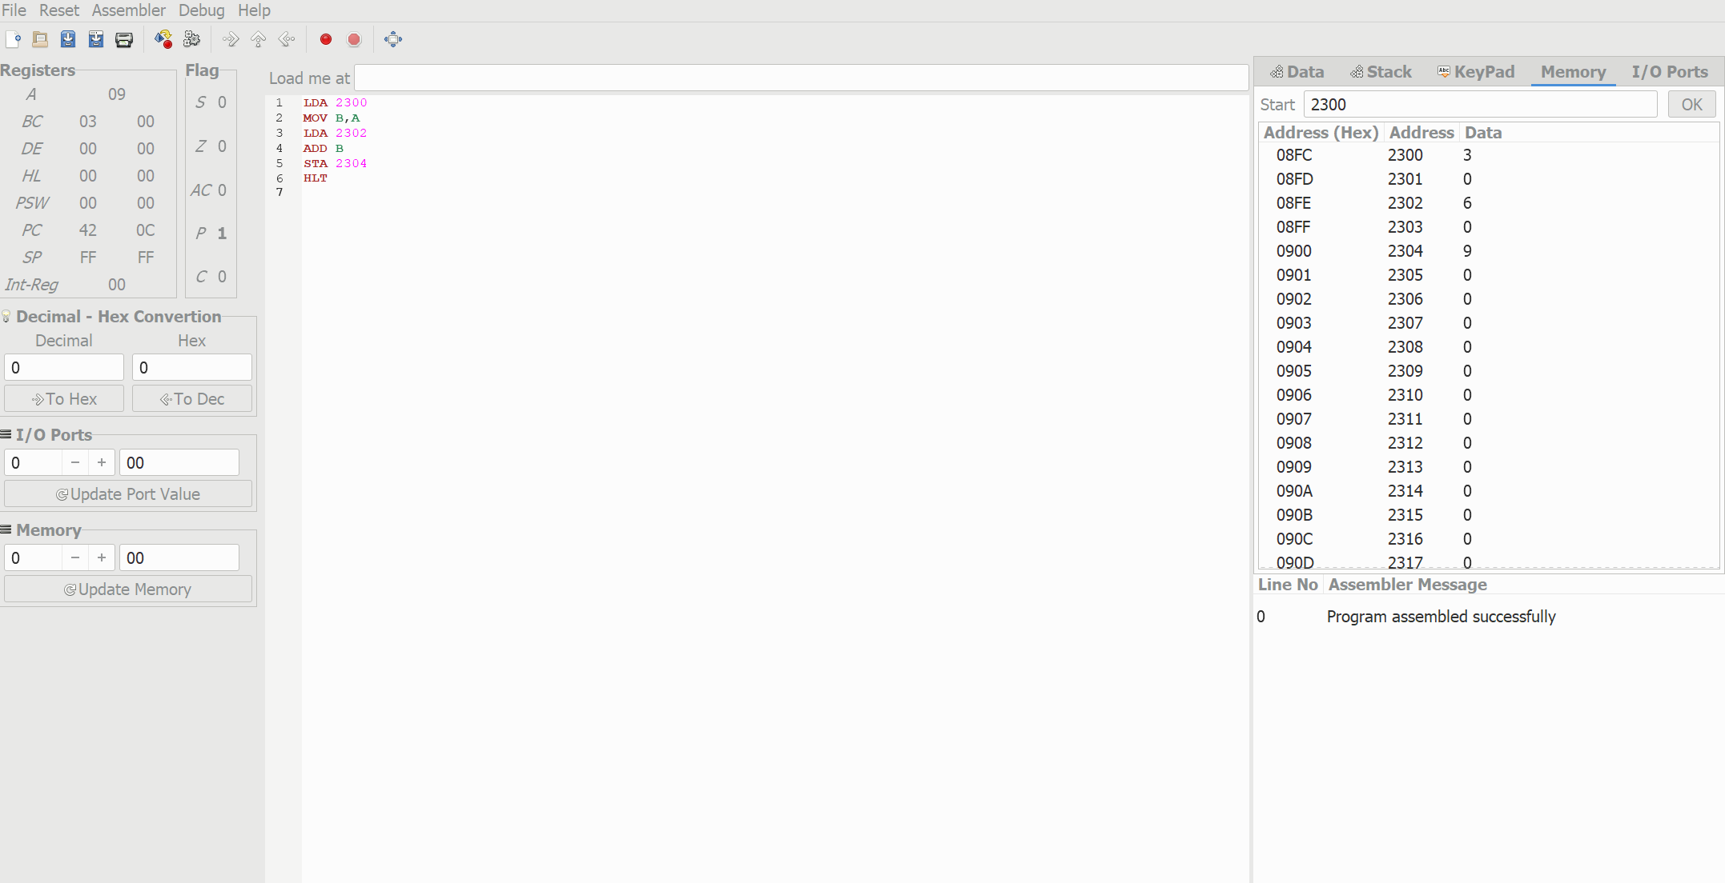

**Subtraction of two 8 bit numbers:**

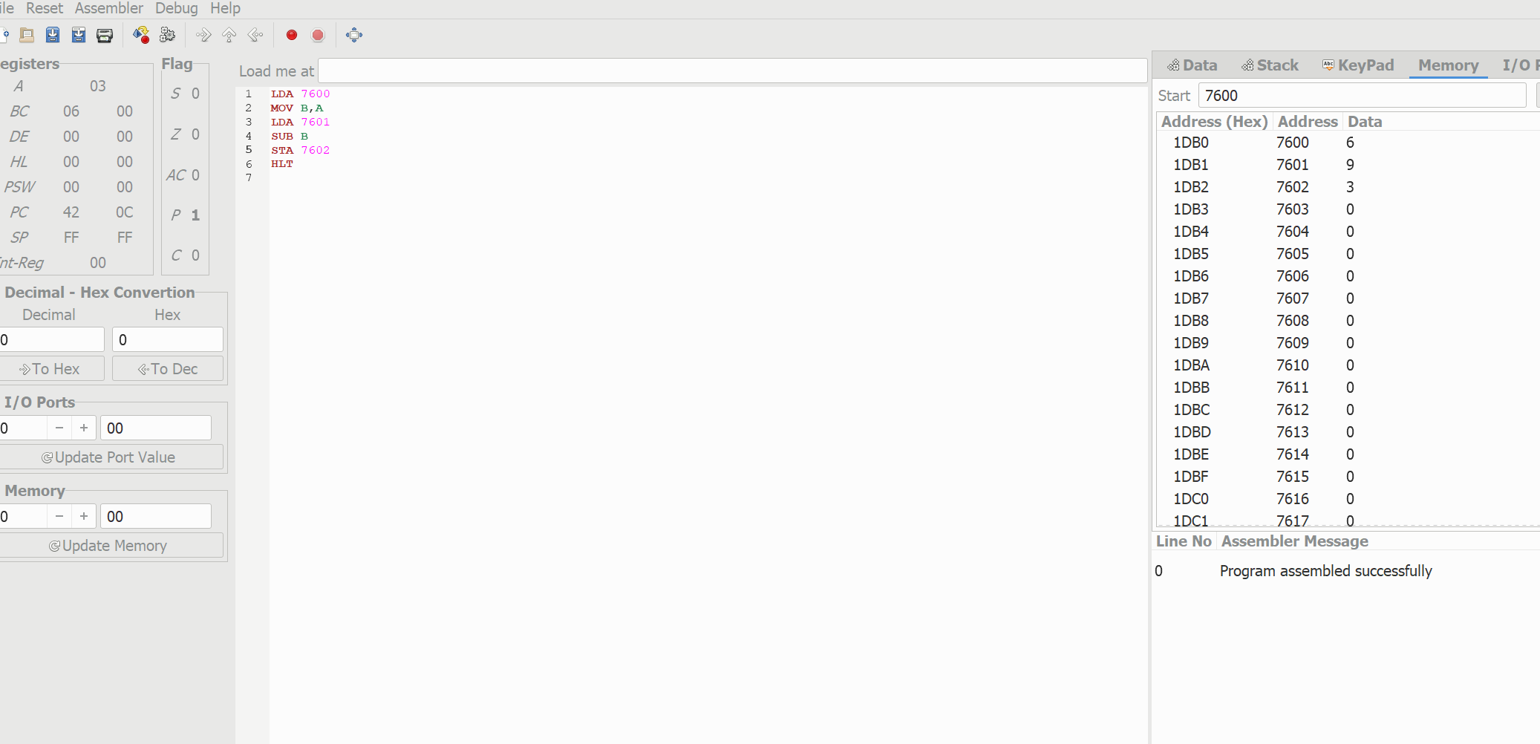

**Multiplication of two 8 bit numbers:**

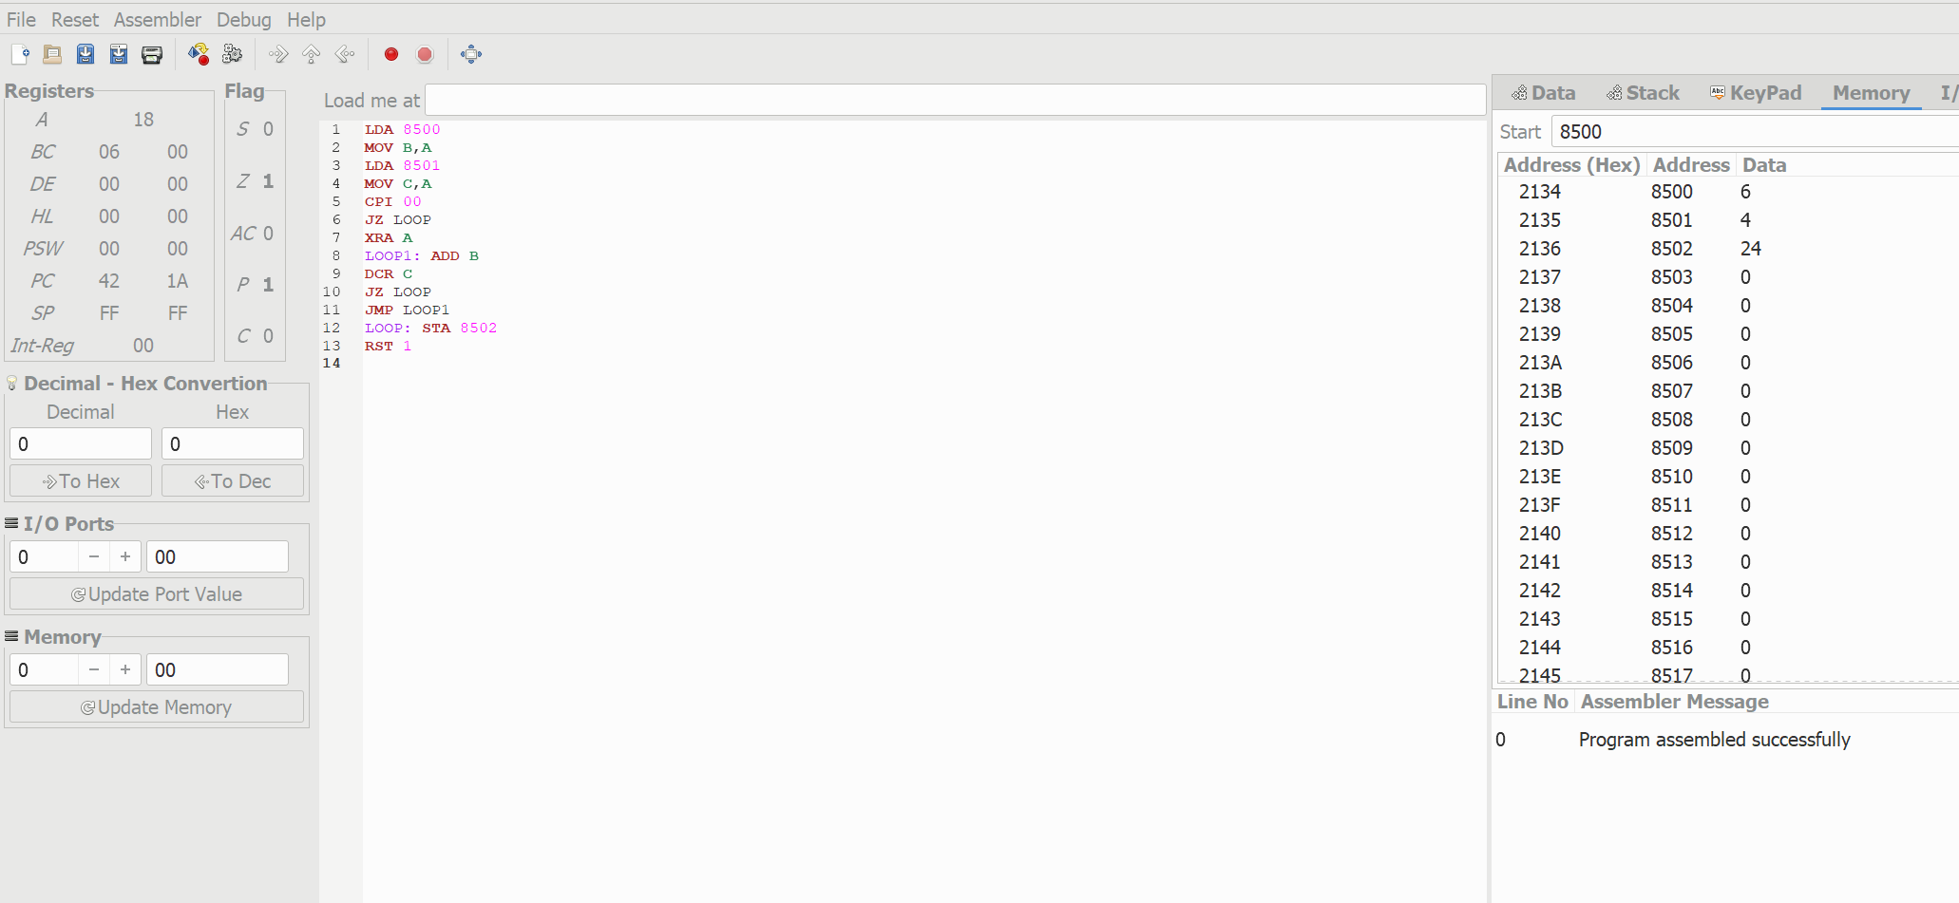

**Division of two 8 bit numbers:**

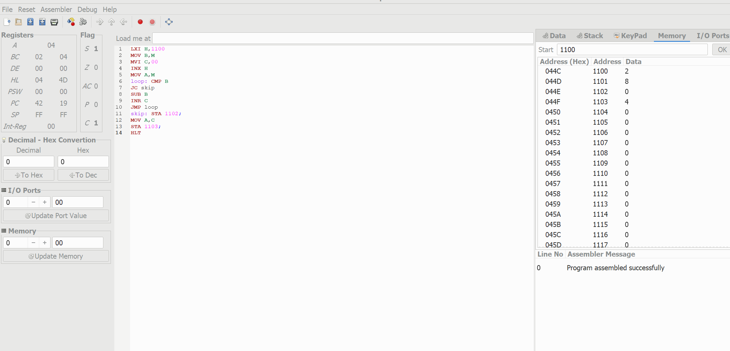

**Addition of two 16 bit numbers:**

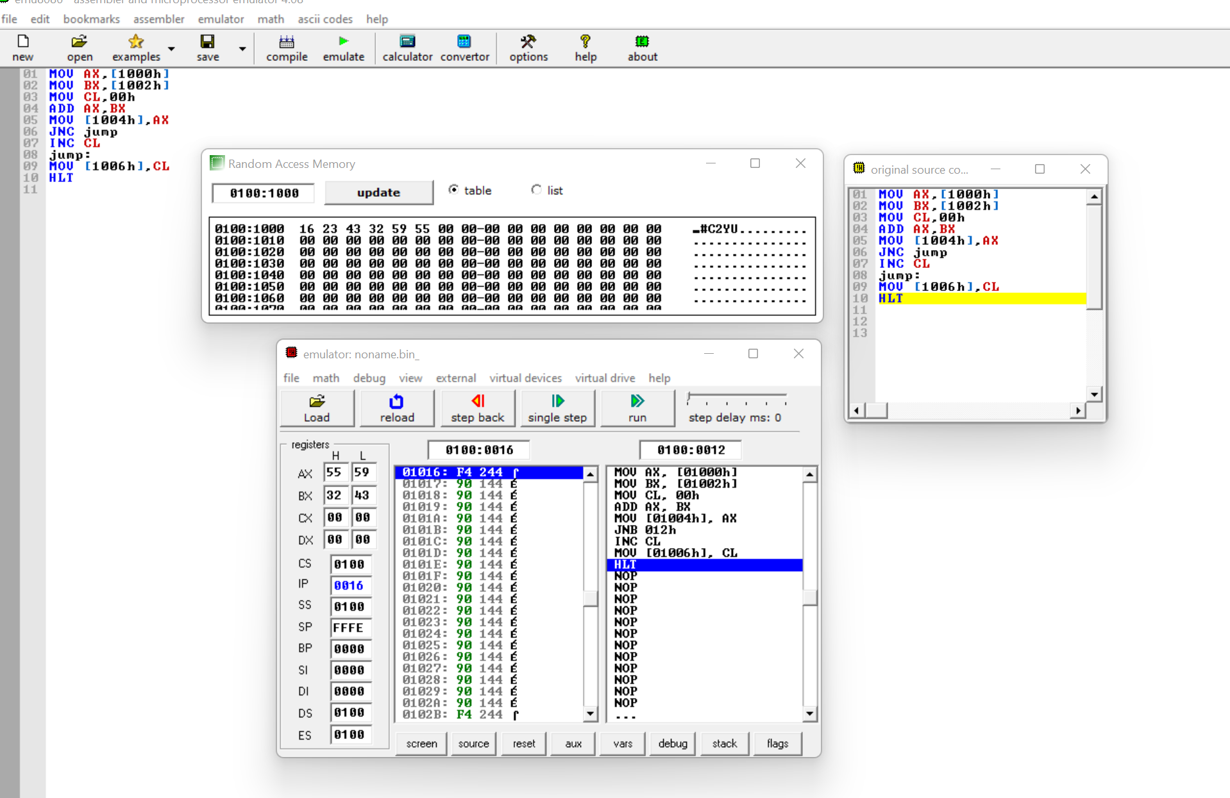

**Subtraction of two 16 bit numbers:**

