*Overview of aerodynamic influences in select thrown-ball athletics*

Zachary Swain[1]

Department of Mechanical Engineering, University of Delaware, Newark, Delaware 19716

and Department of Materials Science and Engineering, University of Delaware, Newark, Delaware 19716.

Received 7 December 2018

**Introduction**

From the Ancient Olympics Games to modern day Formula-1 racing, sport has been an ever-advancing aspect of human culture and activity, documented for over 2200 years [1]. Over this time, sport has seen major technological advancements likely unimaginable to the Ancient Greeks, with specifics including usage of composite materials and more generally the detail of equipment manufacture. There are, however, certain aspects of sport that have remained as permanent fixtures – a static medium through which sport is played. While certain aspects of game performance may be improved with better technological capabilities and knowledge, there are still physical bounds by which sport is governed. These frames could mainly be considered as its entertained and physical nature – the interaction with their cultural and material media. Simply put: sport has been, is, and will be entertainment of competitive class that is operated in the medium of its physical bounds. Cleats can allow for greater traction on the ground, but one is only as fast as their legs can move. With knowledge of the physical effects of their actions, players can implement particular techniques to optimize their play. Within this frame, aerodynamics of thrown-ball sport will be discussed here.

**The Thrown-ball Sport**

Thrown-ball sport will generally consist of throwing, passing, shooting, hitting, or otherwise aiming and ejecting a ball or projectile as a core component of the game. This is often incorporated in tandem with sprinting, jumping, accelerating, or decelerating. Common games to be considered under this label include baseball/softball, football, soccer, and golf. This ascribed motion of both the player and the ball are conducted through air, with partial exception only to include water polo. Motion through an air medium is a core component of the thrown-ball sport; and as such, it is important to consider aerodynamic influences on the game.

In a thrown-ball sport it is generally the goal to possess the ball in order to attempt to score – or to defend the opposing side from scoring. Players travel the playing field under their own power, and do not often encounter significant aerodynamic effects to their person. A player’s rate of motion under their own power is almost never fast enough to impose any considerable aerodynamic force relative to the momentum garnered by their bodily mass at that (relatively) low rate of translation. Consequently, only ball effects will be considered here.

**General Aerodynamics in the Thrown-ball Sport**

Relative to the player, the ball has a much lesser mass and generally travels at faster rates. In almost all thrown-ball sport, the ball will operate within a Reynolds number range of 40,000 - 400,000 [2]. The ball often encounters aerodynamic forces that impose quite significant effects. Not only is it significant in magnitude, one would be amiss to forgo aerodynamic consideration in thrown-ball sport. Indeed, it is often the situational goal of the player to impose specific aerodynamic forces onto the ball in its travel. In typical travel, a thrown ball may experience an opposing force comparable to its respective weight [3]. Namely, this is the air drag it encounters. A ball in flight can also generate large forces perpendicular to its travel, with magnitude around 50% of that of its weight. This factor is largely influenced by any spin applied to the ball, and by its surface geometry relative to its motion [4].

In throwing, passing, shooting, or hitting the ball, players will often apply specific initial conditions to its travel in order to achieve beneficial aerodynamic effects. These conditions are typically applied by contact forces normal and tangent to the ball surface [5]. Examples include a spiral, backspin, topspin, lateral rotation, or knuckling. These effects can be situationally advantageous to the player as to achieve greater travel distance on the thrown ball, to cause an opposing player to miss the ball in flight by unexpected pathing, or to bypass an opposing player or obstacle. It is also worth noting that ball compression is sometimes utilized on initial conditions – especially so on inflated balls, and in post-impact spin [5]. These effects are secondary, and are somewhat muted in comparison to the effects we will primarily consider here.

**Detailed Aerodynamics in the Thrown-ball Sport**

Two essential aerodynamic factors to be contextualized within thrown-ball sport are drag and lift. Aerodynamic drag and lift are given by the following expressions, respectively:

, [6].

A simple Second Law representation of the forces applied to a thrown ball in flight is then given by:

[7].

Drag is seen to depend on drag coefficient, the free stream fluid density, the travel speed, and the reference area. What isn’t shown in this equation is that drag in thrown-ball sport has a substantial dependence on both rotation and surface roughness. Achenbach saw that as surface roughness increases, drag crisis is induced at lower Reynolds number and becomes less severe. Rotation has also been found to influence of a ball by around 20% [8]. Surface interruptions such as stitching are also found to significantly influence the aerodynamic effects encountered by the ball, yielding higher drag and lift coefficients. [7].

It is also important to consider the impact spin has on the ball’s lift. Commonly known as the Magnus effect, spin has significant impact on the lifting and lateral aerodynamic forces encountered by all balls being considered [9]. These forces are perpendicular to the ball’s travel, and results in a lateral or lift coefficient around 0.3 [10]. The Magnus effect, although named after German chemist and physicist Gustav Magnus, was perhaps first described by Sir Isaac Newton:

*“For, a circular as well as a progressive motion…, its parts on that side, where the motions conspire, must press and beat the contiguous air more violently than on the other, and there excite a reluctancy*

*reaction of the air proportionably greater.”* (Newton, 1672) [11].

That is to say, as a ball travels through air with an applied spin, one side of the ball is rotating forward and the opposing side rotating backward relative to oncoming airflow. The side that is rotates against the airflow consequently experiences a faster airflow relative to its surface, and the side rotating with the airflow sees a slower velocity. This 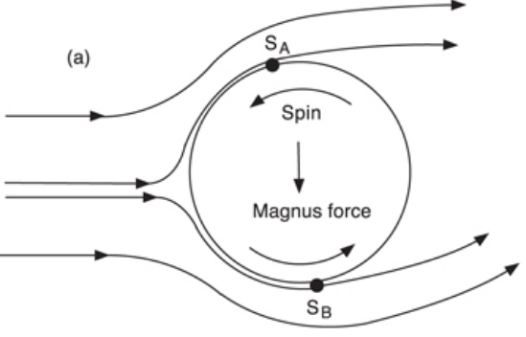results in unequal opposing pressures and asymmetric boundary layer effects, creating a lateral and/or lifting force [11]. This effect is akin to the well-documented fluid mechanics 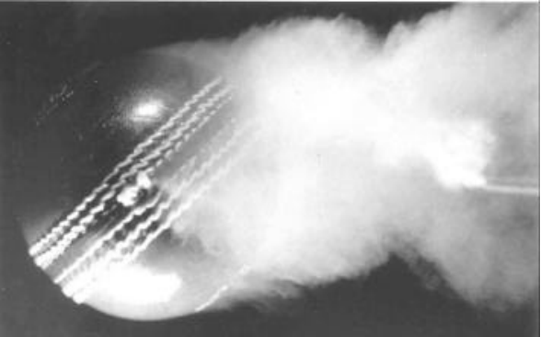scenario of lift generated by flow

**Fig. 1:** Visualization of the Magnus effect. (IOP Publishing)

over a cylindrical shaft in rotation – only now three-dimensional. Boundary layer effects are a very core component in the aerodynamic effects experienced in thrown-ball sport. Asymmetric boundary layer separation can also be induced without means of

**Fig. 2**: Pallis *et al.* flow visualization over a cricket ball.

rotation. Suitably angled stitching or seams on the surface of the ball can trip the boundary layer of one side into turbulence, whereas the opposing side may maintain a laminar state at separation [12]. This asymmetric and differing separation can be seen to deflect the wake trailing upward in Fig. 2, producing a downward force on the ball. Here the bottom boundary layer is being tripped while the top layer remains laminar at separation. This turbulent boundary layer applies a greater shear stress compared to its laminar counterpart [13].

There are other asymmetric wake effects that are likewise leveraged within thrown-ball sport, such as knuckling. Knuckling will be defined here as the time-varying motion of a thrown ball perpendicular to the direction of throw. Knuckling is most commonly achieved by imposing no (or precisely little) rotation to the thrown ball. These (sensory) unpredictable motions are associated with varying wake perturbations and influenced by vortex shedding and asymmetric shear destabilization [13] [14].

The spiral is yet another aerodynamic effect players apply to optimize their play in thrown-ball sport. Spiraling the ball upon release reduces drag and imparts gyroscopic stabilization to the ball during flight [15]. The spiral reduces wake size and aids in resisting ball reorientation as a result of conservation of momentum [16].

There are ­­­3 main categories encompassing most other common aerodynamic effects that are applied in thrown-ball sport. These will be termed spiral, rotation, and knuckling.

***References***

[1] *The Real Story of the Ancient Olympics Games*. Penn Museum,

<[www.penn.museum/sites/olympics/olympicorigins.shtml](http://www.penn.museum/sites/olympics/olympicorigins.shtml)>.

[2] Pallis *et al.* (2011 ). “Aerodynamics and Hydrodynamics in Sports.” *International*

*Sports Engineering Association.* (p 1).

[3] Goff (2013). “A Review of Recent Research into Aerodynamics of Sport Projectiles.”

*Sports Engineering, 16:3.* (p 151).

[4] Mehta (1985). “Aerodynamics of Sports Balls.” *Annual Review of Fluid Mechanics*,

*17:1.* (p 188).

[5] Hubbard (2005). “Spinning Sports Balls.” *American Society of Biometrics*, *ASB 29th*

*Annual Meeting*. (p 990).

[6] Goff (2013). “A Review of Recent Research into Aerodynamics of Sport Projectiles.”

*Sports Engineering, 16:3*. (p 138).

[7] Jalilian *et al*. (2014). “Computational Aerodynamics of Baseball, Soccer Ball and

Volleyball.” *American Journal of Sports Science, 2:5*. (p 121).

[8] Kensrud *et al*. (2010). “In Situ Drag Measurements of Sports Balls.” *Procedia*

*Engineering, 2:2.* (p 2438–42).

[9] Goff (2013). “A Review of Recent Research into Aerodynamics of Sport Projectiles.”

*Sports Engineering, 16:3*. (p 151).

[10] Mehta (1985). “Aerodynamics of Sports Balls.” *Annual Review of Fluid Mechanics,*

*17:1*. (p 188).

[11] Mehta (2008 ). “Sports Ball Aerodynamics.” *Sport Aerodynamics, International*

*Centre for Mechanical Sciences.*

[12] Pallis *et al.* (2011 ). “Aerodynamics and Hydrodynamics in Sports.” *International*

*Sports Engineering Association.* (p 5).

[13] Borg, *et al*. (2014). “Aerodynamics of the Knuckleball Pitch: Experimental

Measurements on Slowly Rotating Baseballs.” *American Journal of Physics*,

*82:10* (p 926).

[14] Dunlop (2003). “Free Flight Aerodynamics of Sports Balls.” *Penn State, Information*

*Sciences and Technology.*

[15] “What Do a Submarine, a Rocket and a Football Have in Common?” *Scientific American*, 8 Nov. 2010.<[www.scientificamerican.com/article/football-science-shapes/](http://www.scientificamerican.com/article/football-science-shapes/)>.

[16] “The Surprising Science behind Tom Brady's Perfect Spiral.” *Resolved Analytics*, 5 Feb. 2016, <[www.resolvedanalytics.com/theflux/cfd-football-aerodynamics](http://www.resolvedanalytics.com/theflux/cfd-football-aerodynamics)>.

1. Electronic mail: zswain@udel.edu