Zach Swain 11/5/19

MSEG608-HW8

**1.**

$$M=100 g , M_{0}=54 \frac{g}{mol}$$

$$\frac{\left(100 g\right)}{\left(54 \frac{g}{mol}\right)}= 1.85 mol$$

$$\left(1.85 mol\right)*\left(6.022E23 \frac{monomers}{mol}\right)=1.11E24 monomers$$

A crosslinked system will have all monomers covalently bonded together (networked) via their crosslinks

$$1.11E24 monomers covalently bonded$$

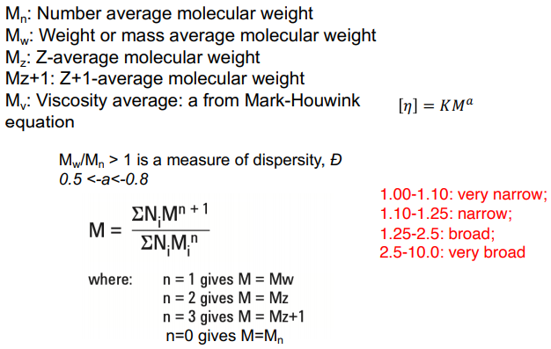**2.**



**[1]**

|  |  |  |  |  |  |  |  |
| --- | --- | --- | --- | --- | --- | --- | --- |
| **MW** | **#** |  | **n*M** | **n*M2** | **n*M3** | **n*M4** | **n*M1+a** |
| 5.50E+03 | 1.09E+19 |  | 6.02E+22 | 3.31E+26 | 1.82E+30 | 1.00E+34 | 2.50E+25 |
| 2.00E+04 | 3.01E+18 |  | 6.02E+22 | 1.20E+27 | 2.41E+31 | 4.82E+35 | 6.17E+25 |
| 5.00E+04 | 1.20E+18 |  | 6.02E+22 | 3.01E+27 | 1.51E+32 | 7.53E+36 | 1.17E+26 |
| 1.00E+05 | 6.02E+17 |  | 6.02E+22 | 6.02E+27 | 6.02E+32 | 6.02E+37 | 1.90E+26 |
| 2.00E+05 | 3.01E+17 |  | 6.02E+22 | 1.20E+28 | 2.41E+33 | 4.82E+38 | 3.09E+26 |
| 4.00E+05 | 1.51E+17 |  | 6.02E+22 | 2.41E+28 | 9.64E+33 | 3.85E+39 | 5.03E+26 |
| 4.13E+05 | 1.46E+17 |  | 6.02E+22 | 2.49E+28 | 1.03E+34 | 4.24E+39 | 5.14E+26 |
| 5.00E+05 | 1.20E+17 |  | 6.02E+22 | 3.01E+28 | 1.51E+34 | 7.53E+39 | 5.88E+26 |
| 6.50E+05 | 9.26E+16 |  | 6.02E+22 | 3.91E+28 | 2.54E+34 | 1.65E+40 | 7.06E+26 |
| 7.00E+05 | 8.60E+16 |  | 6.02E+22 | 4.22E+28 | 2.95E+34 | 2.07E+40 | 7.44E+26 |
| 8.00E+05 | 7.53E+16 |  | 6.02E+22 | 4.82E+28 | 3.85E+34 | 3.08E+40 | 8.16E+26 |
|  |  |  |  |  |  |  |  |
| **Sum** | 1.67E+19 |  | 6.62E+23 | 2.31E+29 | 1.32E+35 | 8.42E+40 | 4.57E+27 |
|  |  |  |  |  |  |  |  |
| **Mn** | **3.96E+04** |  |  |  |  |  |  |
| **Mw** | **3.49E+05** |  |  |  |  |  |  |
| **Mz** | **5.69E+05** |  |  |  |  |  |  |
| **Mz+1** | **6.40E+05** |  |  |  |  |  |  |
| **Mv** | **3.05E+05** |  |  |  |  |  |  |
| **Đ** | **8.82** |  |  |  |  |  |  |

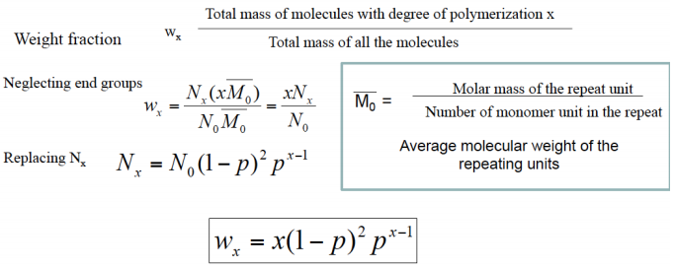**3.**

**[2]**

**FIG. 1.** Statistically derived mole fraction for a step-growth polymerization is plotted as a function of x, and varied by extent of reaction.

**FIG. 2.** Statistically derived weight fraction for a step-growth polymerization is plotted as a function of x, varied by extent of reaction.

References

**[1]** Korley, Wang. (2019). *MSEG608 – Structures and Properties of Materials*. University of Delaware. Lecture 16, Slide 17.

**[2]** Korley, Wang. (2019). *MSEG608 – Structures and Properties of Materials*. University of Delaware. Lecture 17, Slide 23.

Supplementary

**2.** If there is question about the calculations used, the full excel file can be found here:

<https://github.com/zswain/MSEG608> as “ZachSwain_MSEG608-HW8.xlsx”

**3.** These calculations were done in the same excel worksheet as detailed above.

|  |  |  |  |  |  |  |  |  |  |  |  |  |
| --- | --- | --- | --- | --- | --- | --- | --- | --- | --- | --- | --- | --- |
| **Mol frac** |  |  |  |  |  |  |  |  |  |  |  |  |
|  |  |  |  |  |  |  |  |  |  |  |  |  |
| **P\X** | **0** | **5** | **10** | **25** | **50** | **75** | **100** | **150** | **200** | **300** | **400** | **500** |
| **0.9** | 1.11E-02 | 6.56E-03 | 3.87E-03 | 7.98E-04 | 5.73E-05 | 4.11E-06 | 2.95E-07 | 1.52E-09 | 7.84E-12 | 2.08E-16 | 5.53E-21 | 1.47E-25 |
| **0.925** | 6.08E-03 | 4.12E-03 | 2.79E-03 | 8.66E-04 | 1.23E-04 | 1.76E-05 | 2.50E-06 | 5.07E-08 | 1.03E-09 | 4.23E-13 | 1.74E-16 | 7.16E-20 |
| **0.95** | 2.63E-03 | 2.04E-03 | 1.58E-03 | 7.30E-04 | 2.02E-04 | 5.62E-05 | 1.56E-05 | 1.20E-06 | 9.22E-08 | 5.46E-10 | 3.23E-12 | 1.91E-14 |
| **0.98** | 4.08E-04 | 3.69E-04 | 3.33E-04 | 2.46E-04 | 1.49E-04 | 8.97E-05 | 5.41E-05 | 1.97E-05 | 7.18E-06 | 9.52E-07 | 1.26E-07 | 1.67E-08 |
| **0.99** | 1.01E-04 | 9.61E-05 | 9.14E-05 | 7.86E-05 | 6.11E-05 | 4.75E-05 | 3.70E-05 | 2.24E-05 | 1.35E-05 | 4.95E-06 | 1.81E-06 | 6.64E-07 |
|  |  |  |  |  |  |  |  |  |  |  |  |  |
|  |  |  |  |  |  |  |  |  |  |  |  |  |
| **Weight frac** | |  |  |  |  |  |  |  |  |  |  |  |
|  |  |  |  |  |  |  |  |  |  |  |  |  |
| **P\X** | **0** | **5** | **10** | **25** | **50** | **75** | **100** | **150** | **200** | **300** | **400** | **500** |
| **0.9** | 0 | 3.28E-02 | 3.87E-02 | 1.99E-02 | 2.86E-03 | 3.08E-04 | 2.95E-05 | 2.28E-07 | 1.57E-09 | 6.25E-14 | 2.21E-18 | 7.34E-23 |
| **0.925** | 0 | 2.06E-02 | 2.79E-02 | 2.17E-02 | 6.17E-03 | 1.32E-03 | 2.50E-04 | 7.61E-06 | 2.06E-07 | 1.27E-10 | 6.96E-14 | 3.58E-17 |
| **0.95** | 0 | 1.02E-02 | 1.58E-02 | 1.82E-02 | 1.01E-02 | 4.21E-03 | 1.56E-03 | 1.80E-04 | 1.84E-05 | 1.64E-07 | 1.29E-09 | 9.57E-12 |
| **0.98** | 0 | 1.84E-03 | 3.33E-03 | 6.16E-03 | 7.43E-03 | 6.73E-03 | 5.41E-03 | 2.96E-03 | 1.44E-03 | 2.86E-04 | 5.05E-05 | 8.37E-06 |
| **0.99** | 0 | 4.80E-04 | 9.14E-04 | 1.96E-03 | 3.06E-03 | 3.57E-03 | 3.70E-03 | 3.36E-03 | 2.71E-03 | 1.49E-03 | 7.25E-04 | 3.32E-04 |

**Mole Fraction**

**FIG. 3.** Statistically derived mole fraction for a step-growth polymerization is plotted as a function of x, for P=0.9

**FIG. 4.** Statistically derived mole fraction for a step-growth polymerization is plotted as a function of x, for P=0.925

**FIG. 5.** Statistically derived mole fraction for a step-growth polymerization is plotted as a function of x, for P=0.95

**FIG. 6.** Statistically derived mole fraction for a step-growth polymerization is plotted as a function of x, for P=0.98

**FIG. 7.** Statistically derived mole fraction for a step-growth polymerization is plotted as a function of x, for P=0.99

**Weight Fraction**

**FIG. 8.** Statistically derived weight fraction for a step-growth polymerization is plotted as a function of x, for P=0.9

**FIG. 9.** Statistically derived weight fraction for a step-growth polymerization is plotted as a function of x, for P=0.925

**FIG. 10.** Statistically derived weight fraction for a step-growth polymerization is plotted as a function of x, for P=0.95

**FIG. 11.** Statistically derived weight fraction for a step-growth polymerization is plotted as a function of x, for P=0.98

**FIG. 12.** Statistically derived weight fraction for a step-growth polymerization is plotted as a function of x, for P=0.99