**MSEG 410/610**

**Experimental Mechanics of Composite Materials**

**Lab 2: 0 and 90 Degree Tension Lab**

Zachary Swain

*Group Members*

Chunyan Zhang

Evan Minnigh

Jerome Premkumar

Casey Busch

Performed on: March 6, 2019 Submitted on: March 15, 2019

**Abstract**

***Objective*:**

The purpose of this lab was to predict and determine mechanical properties of a unidirectional carbon fiber laminate. This was done by utilizing Rule of Mixtures (ROM), a Self-consistent Field Model (CFM), and by experimental tensile loading of various specimens. This promoted a better understanding of effective experimental tensile loading, the mechanical properties that can be obtained from such experiments, and how to use and analyze different property prediction models.

***Summary of Results*:**

Experimental tensile testing of 0° and 90° oriented specimens from the fabricated unidirectional laminate resulted in moduli of E1 = 14.02±0.16 Msi, E2 = 1.024±0.013 Msi, and a ν12 of 0.3324±0.008. The experimental results of E2 and ν12 line up quite well with those of Self-consistent Field Model and Rule of Mixture models, but experimental results for E1 fall a bit short of CFM and ROM results. This is attributed to the void content verified to be present within the laminate.

**Procedure**

***ASTM Standard*:**

The panel was fabricated with a lay-up that will be described by nomenclature and notation as defined in ASTM D 6507. Tensile testing set up and operation was executed in accordance with ASTM D 3039.

***Specimen Lay-up and Geometries*:**

The unidirectional laminate was fabricated with a [0]8 lay-up[1] composed of G-83C resin and T700 carbon fiber prepreg.[2] Post-process machining was done to form two types of specimens with geometries suitable for tensile testing.[3] A series of five 0° test specimens and five 90° test specimens were machined for tensile testing, to examine the mechanical properties of the panel both longitudinal and transverse to the fiber orientation. End tabs were machined to dimensions consistent with the pertaining ASTM, but three 0° specimens resulted in end tab failure due to large loading magnitude. This is a failure mode not acceptable for analysis, and three replacement specimens were made and tested. Averaged specimen geometries for 0° and 90° testing can be found in Tables 1 and 2, respectively.

***Instrumentation*:**

An Instron 5985 was used for tensile loading of each specimen. A Micro-Measurements strain gage of type CEA-06-125UT-350 was placed on each sample to record axial and lateral strain data. Grid 1 had a gage factor of 2.135±0.5% and transverse sensitivity of (+1.1±0.2)%, while Grid 2 had a gage factor of 2.160±0.5% and transverse sensitivity of (+0.8±0.2)%. Bluehill and StrainSmart software suites were used to control and record data measurement.

***Instron Settings*:**

Tensile testing was operated with a 250kN (56000lb) load cell, at a 0.05 in/min crosshead rate.

***Testing Environment*:**

Testing was done in University of Delaware’s Center for Composite Materials, inside a controlled test lab. Appropriate safety equipment was worn and utilized, including safety glasses and polymer (PMMA/PC) shielding for explosive 0° tensile failures.

**Results**

***Data Reduction Scheme*:**

Load and strain data obtained from their respective recording softwares were saved for each sample tested, and exported to excel. This data, along with necessary geometry specifications, were used to generate stress-strain curves and to calculate Poisson ratios for each sample. The results were averaged over the 0° and sample sets, and standard deviations were calculated and reported. These resulting properties were compared to those resulting from ROM and CFM model results and analyzed.

***Tables*:**

|  |  |  |  |  |  |
| --- | --- | --- | --- | --- | --- |
| **Specimen** | **0° #1** | **0° #2** | **0° #5** | **0° #7** | **0° #8** |
| **Width (in)** | 0.5 | 0.4993 | 0.4983 | 0.4982 | 0.501 |
| **Thickness (in)** | 0.0713 | 0.0734 | 0.0763 | 0.0757 | 0.0758 |

***Table 1:*** 0° specimen geometries

|  |  |  |  |  |  |
| --- | --- | --- | --- | --- | --- |
| **Specimen** | **90° #1** | **90° #2** | **90° #3** | **90° #4** | **90° #5** |
| **Width (in)** | 0.9967 | 0.9957 | 0.9897 | 1 | 0.999 |
| **Thickness (in)** | 0.1464 | 0.1521 | 0.1498 | 0.1482 | 0.1488 |

***Table 2:*** 90° specimen geometries

|  |  |  |  |  |  |  |  |
| --- | --- | --- | --- | --- | --- | --- | --- |
| **Sample** | **0° #1** | **0° #2** | **0° #5** | **0° #7** | **0° #8** | **Average** | **s.d.** |
| **Max Load (lbs)** | 9752 | 9029 | 8512 | 9901 | 9882 | 9415.2 | 618.92 |
| **UTS (ksi)** | 272.633 | 245.4 | 222.807 | 261.308 | 259.57 | 252.3436 | 19.1368 |
| **US** | 0.017373 | 0.015917 | 0.014596 | 0.017296 | 0.017108 | 0.016458 | 0.001196 |

***Table 3:*** 0° specimen Maximum Load, Ultimate Tensile Stress, Ultimate Strain

|  |  |  |  |  |  |  |  |
| --- | --- | --- | --- | --- | --- | --- | --- |
| **Sample** | **90° #1** | **90° #2** | **90° #3** | **90° #4** | **90° #5** | **Average** | **s.d.** |
| **Max Load (lbs)** | 736 | 858 | 903 | 725 | 714 | 787.2 | 86.993 |
| **UTS (ksi)** | 4.982 | 5.593 | 6.084 | 4.899 | 4.775 | 5.2666 | 0.555085 |
| **US** | 0.004937 | 0.005559 | 0.006128 | 0.004839 | 0.004688 | 0.00523 | 0.000601 |

***Table 4:*** 90° specimen Maximum Load, Ultimate Tensile Stress, Ultimate Strain

***Graphs of Stress-Strain Data*:**

***Fig. 1:*** 0° #1 stress-strain data

***Fig. 2:*** 0° #2 stress-strain data

***Fig. 3:*** 0° #5 stress-strain data

***Fig. 4:*** 0° #7 stress-strain data

***Fig. 5:*** 0° #8 stress-strain data

***Fig. 6:*** 90° #1 stress-strain data

***Fig. 7:*** 90° #2 stress-strain data

***Fig. 8:*** 90° #3 stress-strain data

***Fig. 9:*** 90° #4 stress-strain data

***Fig. 10:*** 90° #5 stress-strain data

***Summary of Test Results*:**

The specimens’ cross-sectional area was first calculated by multiplying the averaged, sampled width and thickness of each. Each step of the recorded loading data imported into excel was then divided by this cross-sectional area to obtain the stress at each step. The given μStrain from the recorded strain data was then converted to Strain at each step. A plot was generated relating the Stress (psi) to the Strain of each recorded step for both testing orientations (Figs. 1-10). For the 0° specimens, an average ultimate tensile load of 9415.2±618.92 lbs. was found to generate an average ultimate tensile stress of 252.34±19.14 ksi. in the samples, at an average ultimate strain of 0.0165±0.0012 (Table 3). For the 90° specimens, an average ultimate tensile load of 787.2.2±86.99 lbs. generated an average ultimate tensile stress of 5.267±0.555 ksi. in the samples, at an average ultimate strain of 0.0052±0.0006 (Table 4).

Next, a relevantly defined strain region as specified in ASTM D 3039[3] was isolated from the full stress-strain curve of each tested specimen, and Young’s modulus (Stress/Strain) was determined over this strain range. It is important to note that for the 0° specimens, the strain range all failed over the applicable 0.006 strain, while most of the 90° specimens did not. As such, most of the 90° specimens had to be evaluated at a strain range of 25-50% of their respective ultimate strains – as per ASTM D 3039[3]. The resulting 0° and 90° moduli are displayed below in Tables 5 and 6, respectively. The resulting value of E1 is found to be 14.02±0.16 Msi. while E2 is calculated at 1.024±0.013 Msi.

|  |  |  |  |  |  |
| --- | --- | --- | --- | --- | --- |
| **sample** | E_1 (Msi) |  |  | **sample** | E_2 (Msi) |
| **1** | 14.248 |  |  | **1** | 1.0206 |
| **2** | 14.078 |  |  | **2** | 1.021 |
| **5** | 14.001 |  |  | **3** | 1.0066 |
| **7** | 13.948 |  |  | **4** | 1.0298 |
| **8** | 13.808 |  |  | **5** | 1.0405 |
|  |  |  |  |  |  |
| **Ave:** | **14.0166** |  |  | **Ave:** | **1.0237** |
| **s.d.:** | **0.162619** |  |  | **s.d.:** | **0.012538** |

***Table 5 Table 6***

Values of major Poisson’s ratio (ν12) were then sought. ν12 was found by taking the difference in lateral strain at the extrema of the strain range (as defined in ASTM D 3039[3]), and dividing it by the difference in axial strain of the strain range extrema. The values calculated for ν12 for each relevant sample are shown in Table 7. The resulting value of ν12 is found to be .3324±0.008.

|  |  |
| --- | --- |
| **sample** | n_12 |
| **1** | 0.322674 |
| **2** | 0.338046 |
| **5** | 0.340275 |
| **7** | 0.324919 |
| **8** | 3.36E-01 |
|  |  |
| **Ave:** | **0.332418** |
| **s.d.:** | **0.008022** |

***Table 7***

***Description of Failure Modes:***

Reconstructions of the post-failure 0° tensile specimens are shown below in Fig. 11.

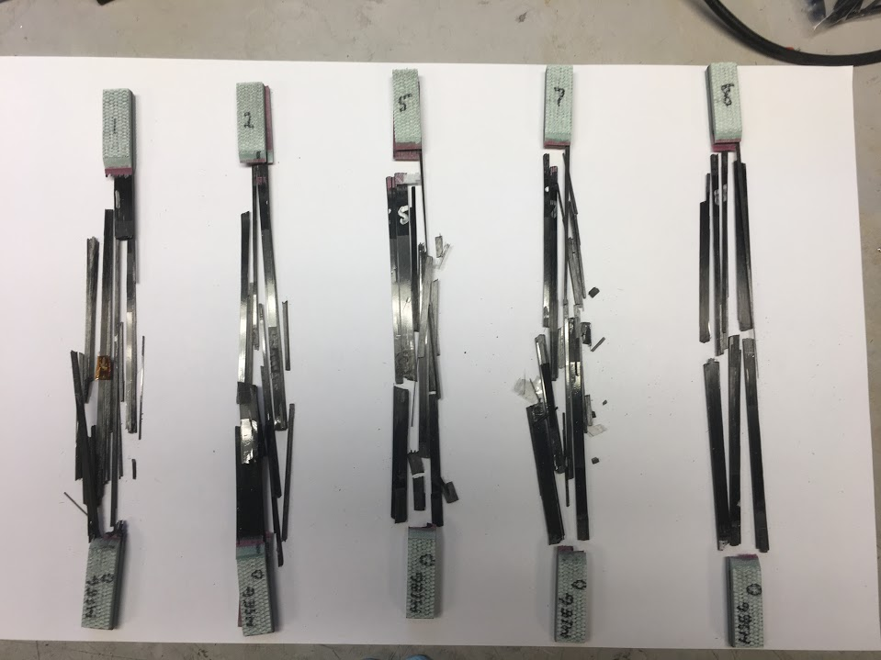

***Fig. 11***

Specimens 1, 7, and 8 are seen to have failed explosively within the gage length (~XGU[3]). Specimens 2 and 5 are found to have experienced an explosive endtab/gage length failure (~XAU/XMU[3]). These are taken as failure modes acceptable for our lab purposes, as per ASTM D 3039.

Fig. 12 displays reconstructed post-failure 90° tensile specimens.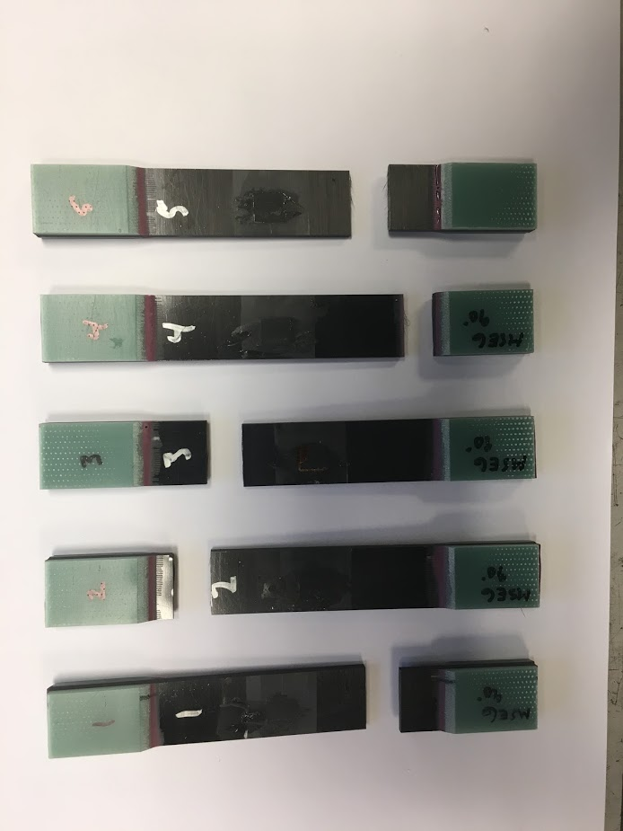

***Fig. 12***

These are likewise seen to have failed acceptably within the ASTM specifications. Specimens 1, 4, and 5 are determined to have experienced LGB[3] failures, while specimens 2 and 3 failed by LGT.[3]

**Error Analysis**

The relevant values for error analysis are given in Table 8, below.

|  |  |  |
| --- | --- | --- |
| **Value** | **Ave.** | **s.d.** |
| **E_1 (Msi)** | 14.017 | 0.1626 |
| **E_2 (Msi)** | 1.0237 | 0.0125 |
| **n_12** | 0.3324 | 0.008 |
| **FVF** | 0.5392 | 0.05898 |

***Table 8***

All values are found to have a percent relative standard deviation (%RSD) within 2.5%, with the exception of fiber volume fraction (FVF) at 10.94%. This will be accepted, as the average FVF is obtained from all results of Lab Report 1, and there is no other way to obtain better sampled results at present.

**Theoretical Predictions**

***Rule of Mixtures (ROM):***

**[1]**

**[2]**

**[3]**

**[4]**

A Rule of Mixtures analysis (Equations 1-3) is conducted with consideration to relevant standard deviations. A range of E1 values will be determined by using Equation 1 ranging by one standard deviation above and below each constituent value to maximize/minimize the resultant E1 within a standard deviation. Em is taken as 487ksi, as per the resin data sheet.[4] Maximum and minimum E1 values within a standard deviation are calculated below, respectively. E1 is found to range from 16.26 - 20.21 Msi.

**, *EL* = 33.4 Msi , *Em* = 0.487Msi ,**

Next, E2 is calculated in a similar manner, by varying the values of FVF and ET over their relevant ranges to maximize and minimize the resulting E2. Maximum and minimum E2 values within a standard deviation are shown calculated below, respectively. E2 is found to range from 0.6575 – 0.9983 Msi.

**, *Em* = 0.487Msi , ET = 1-3Msi ,**

**🡪 *E2* = 1.214 Msi.**

**🡪 *E2* = 0.9347 Msi.**

Next, is found by Equation 2, and similarly maximized and minimized. and are taken to be 0.320 and 0.351[4], respectively. A manufacturer-provided value of could not be located, and as such, the value being used here is taken from the CFM spreadsheet as-received as being a typical value. It is important to note that this approximation could introduce more error into the calculation, in a significant manner.

**, , ,**

Finally, is found by Equation 4, and again maximized and minimized – giving pertinence to the relevant constituent value ranges to obtain a reasonable range.

**, ,**

***Self-Consistent Field Model (CFM):***

The given Self-Consistent Field Model spreadsheet was also utilized to predict mechanical properties of the tested tensile specimens. Known and manufacturer-provided values were input to the CFM excel spreadsheet, and few outlier unknown variables were left at their as-received value to approximate a typical laminate. The extrema of ET (E2f in CFM) range and of FVF and standard deviations were then trialed to see their impact on the CFM-predicted properties. The results of these trials are presented below.

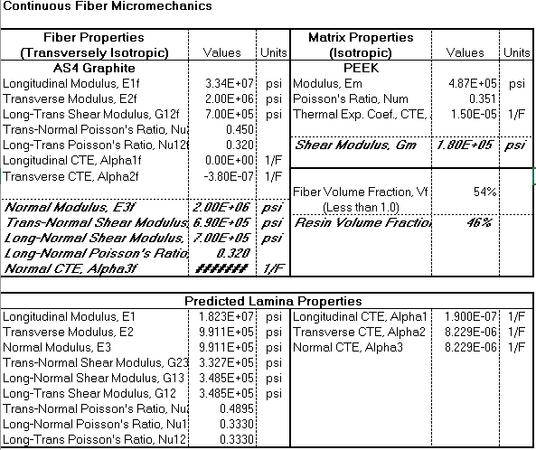

**Table 9:** Nominal values of E2f and FVF

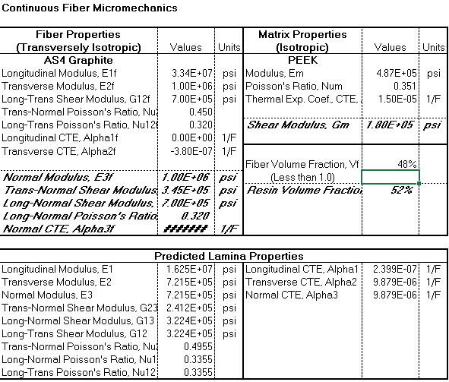

**Table 10:** Low E2f and low FVF

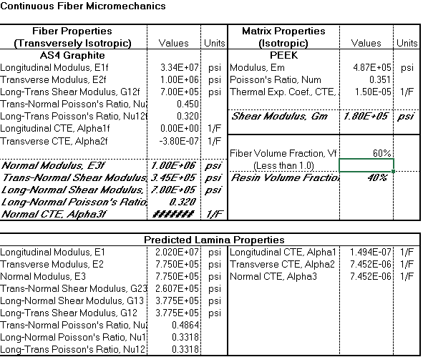

**Table 11:** Low E2f and high FVF

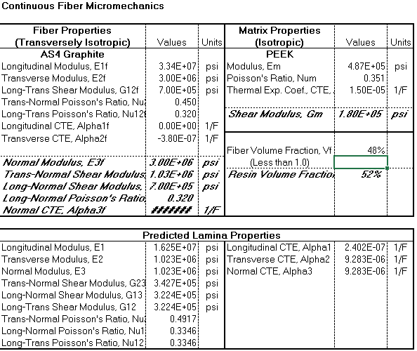

**Table 12:** High E2f and low FVF

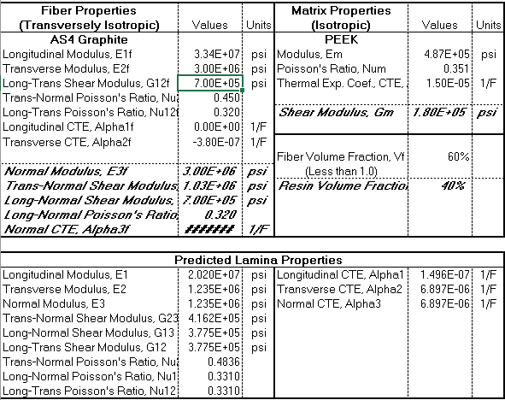

**Table 13:** High E2f and high FVF

**Correlation of Theory and Experiments**

|  |  |  |  |  |
| --- | --- | --- | --- | --- |
| **Method** | **value** | **range low** | **range high** | **units** |
|  | E1 | 13.854 | 14.179 | Msi |
| **experiment** | E2 | 1.011 | 1.036 | Msi |
|  | n_12 | 0.3244 | 0.3404 |  |
|  |  |  |  |  |
|  | E1 | 16.25 | 20.2 | Msi |
| **ROM** | E2 | 0.9347 | 1.214 | Msi |
|  | n_12 | 0.332 | 0.336 |  |
|  |  |  |  |  |
|  | E1 | 16.25 | 20.2 | Msi |
| **CFM** | E2 | 0.721 | 1.235 | Msi |
|  | n_12 | 0.331 | 0.3355 |  |

**Table 14:** Summary of all methods’ results

The result of ROM and CFM E1 match each other quite well due to the degree of accuracy of the ROM for E1. Their values don’t, however, align with those measured experimentally for E1. The lower experimental result is attributed to laminate defects known to be in the panel, as reported in Lab 1; see Fig. 13. The void content is above 1% and cannot be used in certain application due to its lesser mechanical properties.

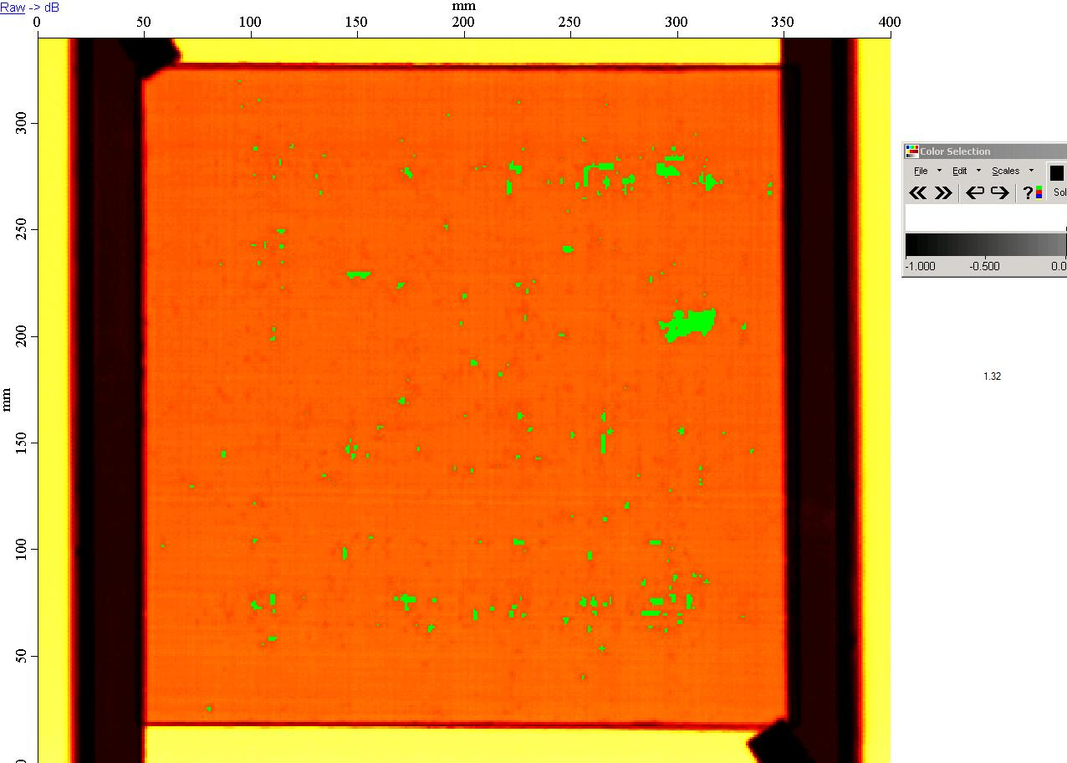

**Fig. 13:** C-scan results of panel.

The experimental results for E2, however solidly fall within the range of ROM and CFM predicted values. This is a promising result for the experimentally calculated E2. Experimental has a larger range of values than either ROM or CFM results, but nominally falls within them. This is, again, promising for the experimentally determined .

**Conclusions**

The experimental methodology resulted in an E1 of 14.02±0.16 Msi, an E2 of 1.024±0.013 Msi, and a ν12 of 0.3324±0.008. ROM modelling presented E1 as being within , E2 within , and ν12 within . Lastly, CFM gave a range of E1 as 16.25 - 20.20 Msi, E2 as 0.721 – 1.235 Msi, and ν12 as 0.331 – 0.3355. The lower experimental E1 is presented as being attributed to the void content in the panel, as evidenced in C-scan results reported on in Lab 1. Other useful properties are predicted in the more expansive CFM model, but do not have a counterpart to compare to in both the experimental and ROM results.

**References**

[1] ] ASTM Standard D6507, 2016, “Standard Practice for Fiber Reinforcement Orientation Codes for Composite Materials,” ASTM International, West Conshohocken, PA, 2003, DOI: 10.1520/D6507-16, [www.astm.org/Standards/D6507.htm](http://www.astm.org/Standards/D6507.htm).

[2] T700S Data Sheet [PDF]. Santa Ana, CA: Toray Carbon Fibers America Inc. <https://www.toraycma.com/file_viewer.php?id=4459>.

[3] ASTM Standard D3039, 2006, “Standard Test Method for Tensile Properties of Polymer Matrix Composite Materials,” ASTM International, West Conshohocken, PA, 2006, [www.astm.org/Standards/D3039.htm](http://www.astm.org/Standards/D3039.htm).

[4] G-83C Data Sheet [PDF]. Santa Ana, CA: Toray Carbon Fibers America Inc. (Digital).

**Supplemental**

**Fig. 14:** Example strain range of E1 for 0° #1.

**Fig. 14:** Example strain range of E2 for 90° #1.

|  |  |  |  |  |  |  |  |
| --- | --- | --- | --- | --- | --- | --- | --- |
| **Sample** | **0° #1** | **0° #2** | **0° #5** | **0° #7** | **0° #8** | **Average** | **s.d.** |
| **Max Load (lbs)** | 9752 | 9029 | 8512 | 9901 | 9882 | 9415.2 | 618.92 |
| **UTS (ksi)** | 272.633 | 245.4 | 222.807 | 261.308 | 259.57 | 252.3436 | 19.1368 |
| **US** | 0.017373 | 0.015917 | 0.014596 | 0.017296 | 0.017108 | 0.016458 | 0.001196 |
|  |  |  |  |  |  |  |  |
| **Sample** | **90° #1** | **90° #2** | **90° #3** | **90° #4** | **90° #5** | **Average** | **s.d.** |
| **Max Load (lbs)** | 736 | 858 | 903 | 725 | 714 | 787.2 | 86.993 |
| **UTS (ksi)** | 4.982 | 5.593 | 6.084 | 4.899 | 4.775 | 5.2666 | 0.555085 |
| **US** | 0.004937 | 0.005559 | 0.006128 | 0.004839 | 0.004688 | 0.00523 | 0.000601 |

**Fig. 14:** Non-strain data collected from experimental tensile testing