**MSEG 410/610**

**Experimental Mechanics of Composite Materials**

**Lab 3: 0 and 90 Degree Compression Lab**

Zachary Swain

*Group Members*

Chunyan Zhang

Evan Minnigh

Jerome Premkumar

Casey Busch

Performed on: March 13, 2019 Submitted on: March 22, 2019

**Abstract**

***Objective*:**

The purpose of this lab was to predict and experimentally determine specific mechanical properties of a unidirectional carbon fiber laminate. This was done by executing experimental compressive loading of various specimens, as well as utilizing Rule of Mixtures (ROM) and a Self-consistent Field Model (CFM). This provided a better understanding of effective experimental compression testing, the mechanical properties that can be obtained from such experiments, and how to use and analyze different property prediction models.

***Summary of Results*:**

Experimental compression testing of 0° and 90° oriented specimens from the fabricated unidirectional laminate resulted in moduli of E1 = 11.66±0.22 Msi. and E2 = 1.04±0.04 Msi, and fiber direction strength of X1C=91.68±5.53 ksi. The experimental results of E2 line up very well with those of the CFM and ROM models, but experimental results for E1 fall short of CFM and ROM results. This is attributed to the large relative standard deviation present for Fiber Volume Fraction (FVF), as well as the void content that was verified to be present in the laminate – both introducing inherent uncertainty in correlation between experimental and model-predicted results.

**Procedure**

***ASTM Standard*:**

The panel was fabricated with a lay-up that will be described by nomenclature and notation as defined in ASTM D 6507. Tensile testing set up and operation was executed in accordance with ASTM D 3410.

***Specimen Lay-up and Geometries*:**

The unidirectional laminate was fabricated with a [0]8 lay-up[1] composed of G-83C resin and T700 carbon fiber prepreg.[2] Post-process machining was done to form two groups of perpendicular fiber orientation to produce specimens with geometries suitable for tensile testing.[3] A series of five 0° oriented test specimens and five 90° oriented test specimens were machined for compressive testing to examine the mechanical properties of the panel, compare the axial and transverse results, and to compare to multiple property prediction models. End tabs were machined to dimensions consistent with the pertaining ASTM, but two 0° specimens and one 90° specimen resulted in failure modes that are not acceptable for analysis. Three respective replacement specimens were made and tested in place of these failed specimens. Sampled and averaged specimen geometries for 0° and 90° testing can be found in Tables 1 and 2, respectively.

***Instrumentation*:**

An Instron 5985 was used for tensile loading of each specimen. A Micro-Measurements strain gage of type CEA-06-125UE-350 was placed on each sample to record axial and lateral strain data. The singular grid had a gage factor of 2.160±0.5% and transverse sensitivity of (+0.6±0.2)%; a resistance of 350.0±0.3% Ω with gage factor TC (+1.2±0.2) %/100°C. Bluehill and StrainSmart software suites were used to control and record data measurement.

***Instron Settings*:**

Compression testing was operated with a 250kN (56000lb) load cell secured on the Instron 5985, and specimens were compressed at a 0.05 in/min crosshead rate. Instron input was modulated by the Bluehill software suite.

***Testing Environment*:**

Testing was done in University of Delaware’s Center for Composite Materials, inside a controlled test lab. Appropriate safety equipment was worn.

**Results**

***Data Reduction Scheme*:**

Load and strain data obtained for each specimen tested were recorded and exported to excel. This data, in parallel with geometry specifications, were used to generate stress-strain curves to characterize the mechanical properties of the specimen. The results were averaged over the 0° and 90° sample sets, and standard deviations were then calculated and reported. The resulting properties were compared to those resulting from ROM and CFM models and then analyzed.

***Tables*:**

|  |  |  |  |  |  |
| --- | --- | --- | --- | --- | --- |
| **Specimen** | **0° #1** | **0° #2** | **0° #3** | **0° #4** | **0° #7** |
| **Width (in)** | 0.4965 | 0.4985 | 0.501 | 0.508 | 0.5 |
| **Thickness (in)** | 0.14255 | 0.14465 | 0.14915 | 0.1519 | 0.15535 |

***Table 1:*** 0° specimen geometries

|  |  |  |  |  |  |
| --- | --- | --- | --- | --- | --- |
| **Specimen** | **90° #2** | **90° #3** | **90° #4** | **90° #5** | **90° #6** |
| **Width (in)** | 0.498 | 0.492 | 0.4915 | 0.497 | 0.4955 |
| **Thickness (in)** | 0.14595 | 0.1487 | 0.1508 | 0.1539 | 0.15265 |

***Table 2:*** 90° specimen geometries

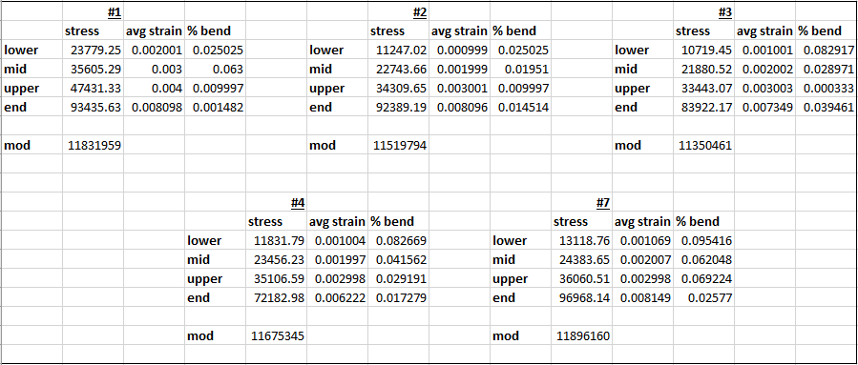

***Table 3:*** 0° specimen results

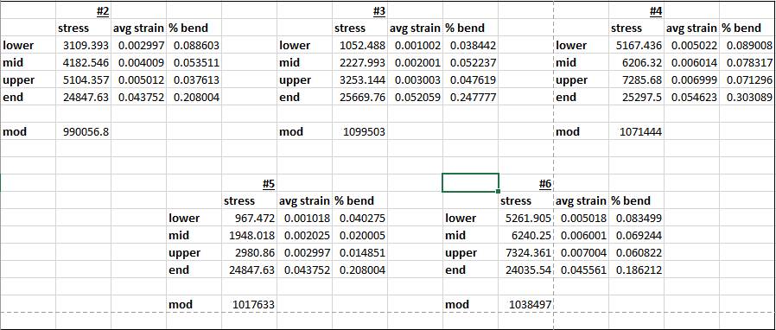

***Table 4:*** 90° specimen results

***Graphs of Stress-Strain Data*:**

***Fig. 1:*** 0° #1 stress-strain data

***Fig. 2:*** 0° #2 stress-strain data

***Fig. 3:*** 0° #3 stress-strain data

***Fig. 4:*** 0° #4 stress-strain data

***Fig. 5:*** 0° #7 stress-strain data

***Fig. 6:*** 90° #2 stress-strain data

***Fig. 7:*** 90° #3 stress-strain data

***Fig. 8:*** 90° #4 stress-strain data

***Fig. 9:*** 90° #5 stress-strain data

***Fig. 10:*** 90° #6 stress-strain data

***Summary of Test Results*:**

The specimens’ cross-sectional area was first calculated by multiplying the averaged, sampled widths and thicknesses of each test bar. Each step of the recorded loading and stress data were imported into excel to be suitably manipulated. Each loading step was then divided by the specimen-specific cross-sectional area to obtain the stress generated at each step. The given μStrains from the recorded strain data were then converted to Strain for each step. Plots were generated relating the Stress (load/area) to the Strain of each recorded step for both specimen fiber orientations (Figs. 1-10). The 0° specimens averaged an ultimate tensile strength of 87779.62± 9947.39 psi. at an average ultimate strain of 0.00758± 0.00083. The 90° specimens experienced an average ultimate tensile strength of 24939.61± 611.45 psi. that caused an average ultimate strain of 0.0479±0.00506 ksi. in the samples.

Next, a strain region was defined as specified in ASTM D 3410[3] for each tested specimen, and Young’s modulus of elasticity was determined over this strain range. It is important to note that for the 0° specimens, the specimens all failed over the applicable 0.006 strain threshold, while all of the 90° specimens fell short. The 90° specimens therefore had to be evaluated at an alternative appropriate strain range. When a specimen fails at an ultimate strain below 0.006, the ASTM standard generally recommends placing your strain region at 25% and 50% of the ultimate strain experienced. However, all 90° specimens experience significant plastic deformation prior to reaching 50% of their ultimate strain. This would certainly impact the calculated modulus of elasticity, and can be visualized in the yield stresses found by 0.002 strain offset shown in Figs. 11-15. So an applicable strain range is found above the low-load buckling region (Degree of Bending <0.1), but before reaching significant yield (0.002 strain offset). These strain regions are reported above in Table 4, labeled as “lower” and “upper” bounds of the strain region. Other designations “mid” and “end” respectively refer to the middle strain point between the two bounds and to the ultimate strain seen before failure. It is likewise important to assess the degree of bending found at the midpoint of the chosen strain region, to ensure buckling effects remain insignificant over the entire region; all specimens are found to pass this stipulation. The data represented in Tables 3 and 4 are largely represented in summarized Tables 5 and 6, respectively. Degree of bending is calculated as

(ε1 – ε2)/( ε1 + ε2)

and is represented as “% bend” in tables 3 and 4. This degree of bending is inspected to ensure the specimen is not experiencing any excessive buckling. If bending exceeds 0.1 in the strain region in question, buckling effects are no longer considered to be negligible, and it can no longer be considered to provide valid or meaningful results as per the ASTM.[3] If this value does exceed 0.1, it cannot be said to truly isolate the compressive properties of the material. As such, properties must be evaluated over a strain region where Degree of Bending < 0.1. Degree of bending for each sample is shown in Figs. 24-33 in Appendix A. Experimentally, buckling is seen in a divergence in strain, as measured by the back-to-back strain gages. Opposing compressive and tensile strains in back-to-back strain gages are characteristic of significant buckling. Strain, by strain gage, is plotted for all specimens tested in Figs. 34-43 available in Appendix A.

|  |  |  |  |
| --- | --- | --- | --- |
|  | **Averaged Value** | **s.d** | **%RSD** |
| **Ult. Strength (psi)** | 87779.62 | 9947.39 | 11.33 |
| **Modulus (Msi)** | 11.655 | 0.224 | 1.923 |
| **Ult. Strain** | 0.007583 | 0.00083 | 10.95 |

***Table 5:*** 0° specimen averaged stress-strain results

|  |  |  |  |
| --- | --- | --- | --- |
|  | **Averaged Value** | **s.d** | **%RSD** |
| **Ult. Strength (psi)** | 24939.61 | 611.449 | 2.451718 |
| **Modulus (Msi)** | 1.043 | 0.0432 | 4.140904 |
| **Ult. Strain** | 0.047949 | 0.005059 | 10.55048 |

***Table 6:*** 90° specimen averaged stress-strain results

Since the 90° specimens did undergo significant plastic deformation, the yield stress can be calculated by simply utilizing a 0.002 strain offset. This offset-intercept yield stress is averaged over the 5 specimens and found to be 18204±1004.2 psi. The 0° orientation specimens are not seen to experience significant plastic deformation before failure, due to the stiffness imparted by the axial orientation of the fibers.

**Fig. 11:** 90° #2 stress-strain, 0.002 strain offset intercept

**Fig. 12:** 90° #3 stress-strain, 0.002 strain offset intercept

**Fig. 13:** 90° #4 stress-strain, 0.002 strain offset intercept

**Fig. 14:** 90° #5 stress-strain, 0.002 strain offset intercept

**Fig. 15:** 90° #6 stress-strain, 0.002 strain offset intercept

|  |  |  |  |  |  |
| --- | --- | --- | --- | --- | --- |
| **Sample #** | **2** | **3** | **4** | **5** | **6** |
| **Yield stress (psi)** | 19850 | 17700 | 17300 | 18420 | 17750 |
|  |  |  |  | **Average** | 18204 |
|  |  |  |  | **s.d.** | 1004.2 |

***Table 6:*** 90° specimen yield stress results

***Description of Failure Modes:***

Images were recorded of each sample after it had undergone compressive testing and ultimate failure. Figs. 16 and 17 show the 0° specimens from two separate angles, while Figs. 18 and 19 display that of the 90° samples.

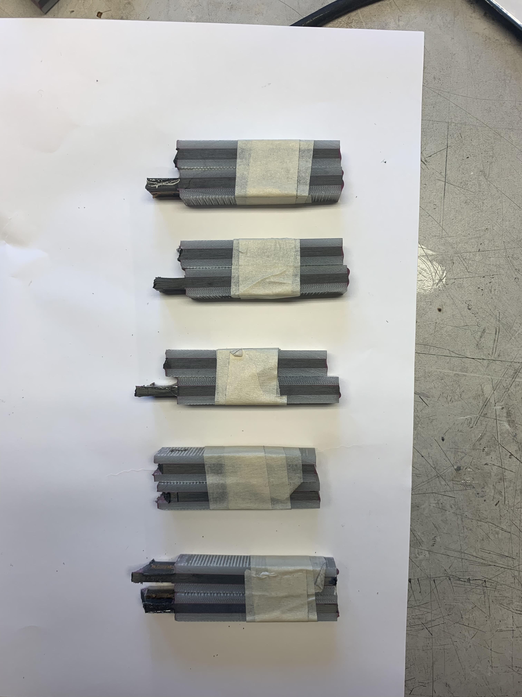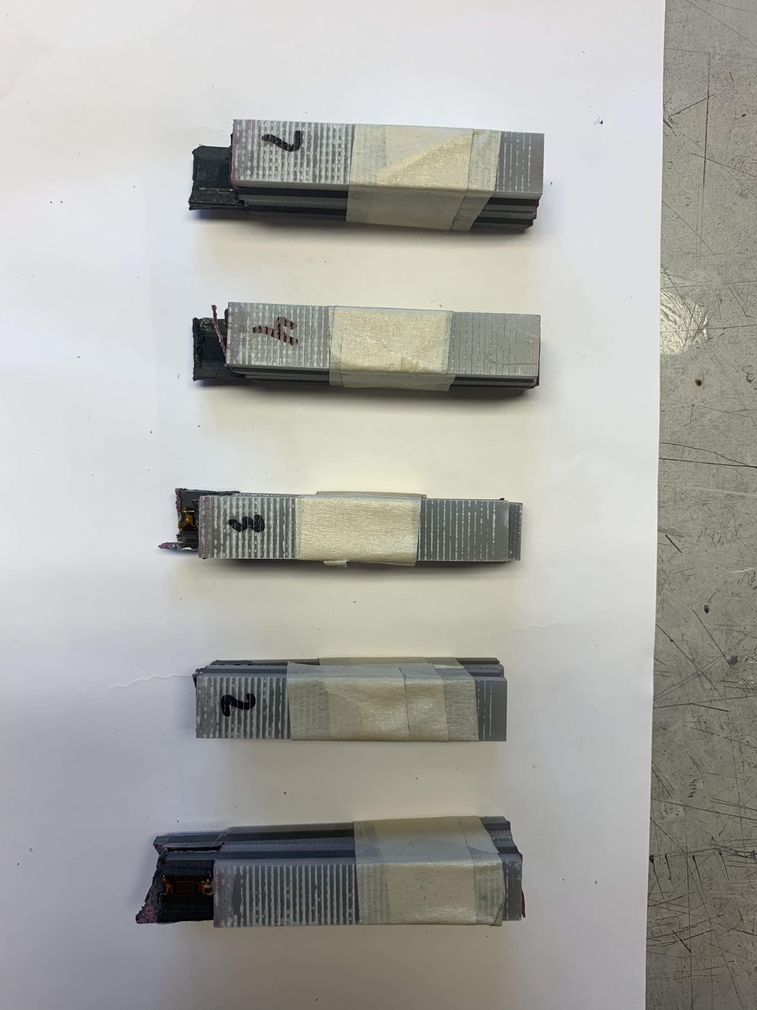

**Fig. 16:** 0° failed samples **Fig. 17:** 0° failed samples (side)

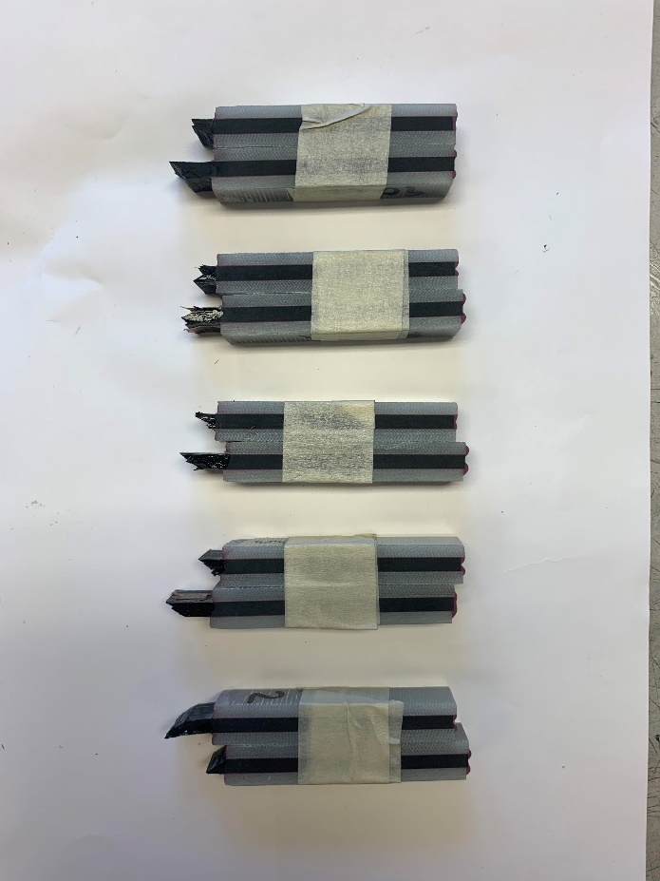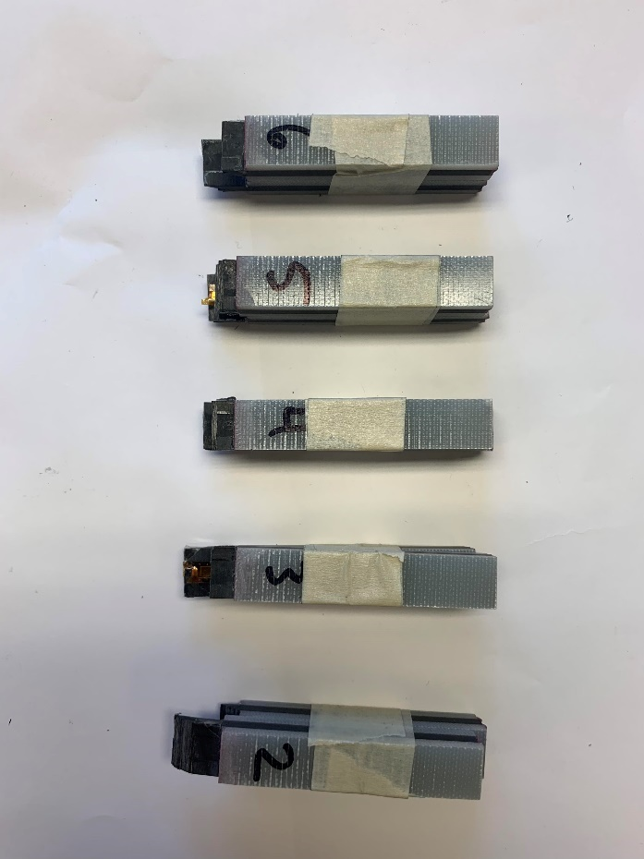

**Fig. 18:** 90° failed samples **Fig. 19:** 90° failed samples (side)

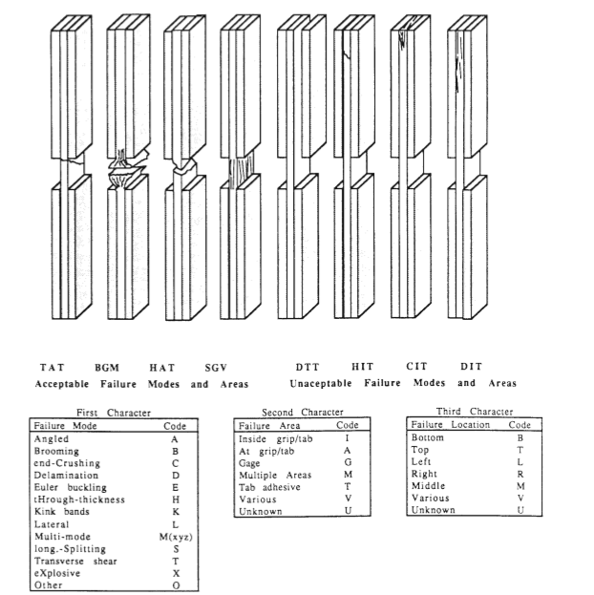

**Fig. 20:** ASTM compressive failure mode specifications

From the 0° fiber-oriented sample set, specimens 1 and 2 are seen to have experienced TAT failure, as defined in Fig. 19. It is determined that the 1 and 2 samples were grouped incorrectly for the pictures, both tops being paired as “2” and bottoms as unlabeled “1.” Specimens 3, 4, and 7 were determined to have experienced LAB failures. For the 90° specimen set, 2 is seen to have HAB failure, while 3, 4, and 6 all experienced HAT failure modes. 4 seems to have a somewhat-reserved BGM failure mode. All analyzed failure modes are determined to be acceptable as per the ASTM standard’s specifications.

**Error Analysis**

The relevant values for error analysis are given in Table 7, below.

|  |  |  |
| --- | --- | --- |
| **Value** | **Ave.** | **s.d.** |
| **E_1 (Msi)** | 11.655 | 0.224 |
| **E_2 (Msi)** | 1.043 | 0.0432 |
| **0° Ult. Strength (Msi)** | 0.0878 | 0.009947 |
| **90° Ult. Strength (Msi)** | 0.02494 | 0.006115 |
| **Yield stress (Msi)** | 0.0182 | 0.001004 |
| **FVF** | 0.5392 | 0.05898 |

***Table 7***

All values are found to have a percent relative standard deviation (%RSD) within ~4%, with the exception of Ultimate Strains for both specimen sets, 0° Ultimate Strength, and Fiber Volume Fraction; these properties were found to have %RSD ~10%. The deviating FVF will be accepted, as the averaging of FVF is obtained from all results of Lab Report 1, and there is no other way to obtain better sampled results at present. Significant variation in Ultimate Strain has ben seen across the board in all experimental testing conducted as a part of this course, without necessarily directly impacting the variability in tensile or compressive moduli. As such, this variation will be hesitantly accepted. The large variability in 0° Ultimate Strength does give pause, however. The driving force in making this averaged value have such a relatively large standard deviation is specimen #4, which can be seen to have a much lower Ultimate Strength than any other samples, despite having a undeviating modulus. Specimen #4 will be considered an outlier in this analysis, and 0° Ultimate Strength will be calculated to be 0.09168±0.00553 Msi, halving the standard deviation.

**Theoretical Predictions**

***Rule of Mixtures (ROM):***

Theoretical predictions using the Rule of Mixtures and Self-consistent Field Model are provided in Appendix B.

**Correlation of Theory and Experiments**

|  |  |  |  |  |
| --- | --- | --- | --- | --- |
| **Method** | **value** | **range low** | **range high** | **units** |
|  | E1 | 11.44 | 11.88 | Msi |
| **experiment** | E2 | 1.00 | 1.08 | Msi |
|  | X_1c | 86.15 | 97.21 | ksi |
|  |  |  |  |  |
|  | E1 | 16.25 | 20.2 | Msi |
| **ROM** | E2 | 0.9347 | 1.214 | Msi |
|  | X_1c | 345.94 | 449.47 | ksi |
|  |  |  |  |  |
|  | E1 | 16.25 | 20.2 | Msi |
| **CFM** | E2 | 0.721 | 1.235 | Msi |

**Table 8:** Summary of all methods’ results

The result of ROM and CFM E1 predictions match each other quite well due to the high degree of accuracy of the ROM for E1. Their values don’t, however, align with those measured experimentally for E1. The lower experimental compressive modulus result is attributed to laminate defects known to be in the panel, as reported in Lab 1, as well as compressive moduli being known to manifest in artificially low results in experimental testing. The void content in the panel is above 1% and cannot be used in certain application due to its lesser – and widely variable – mechanical properties.

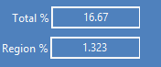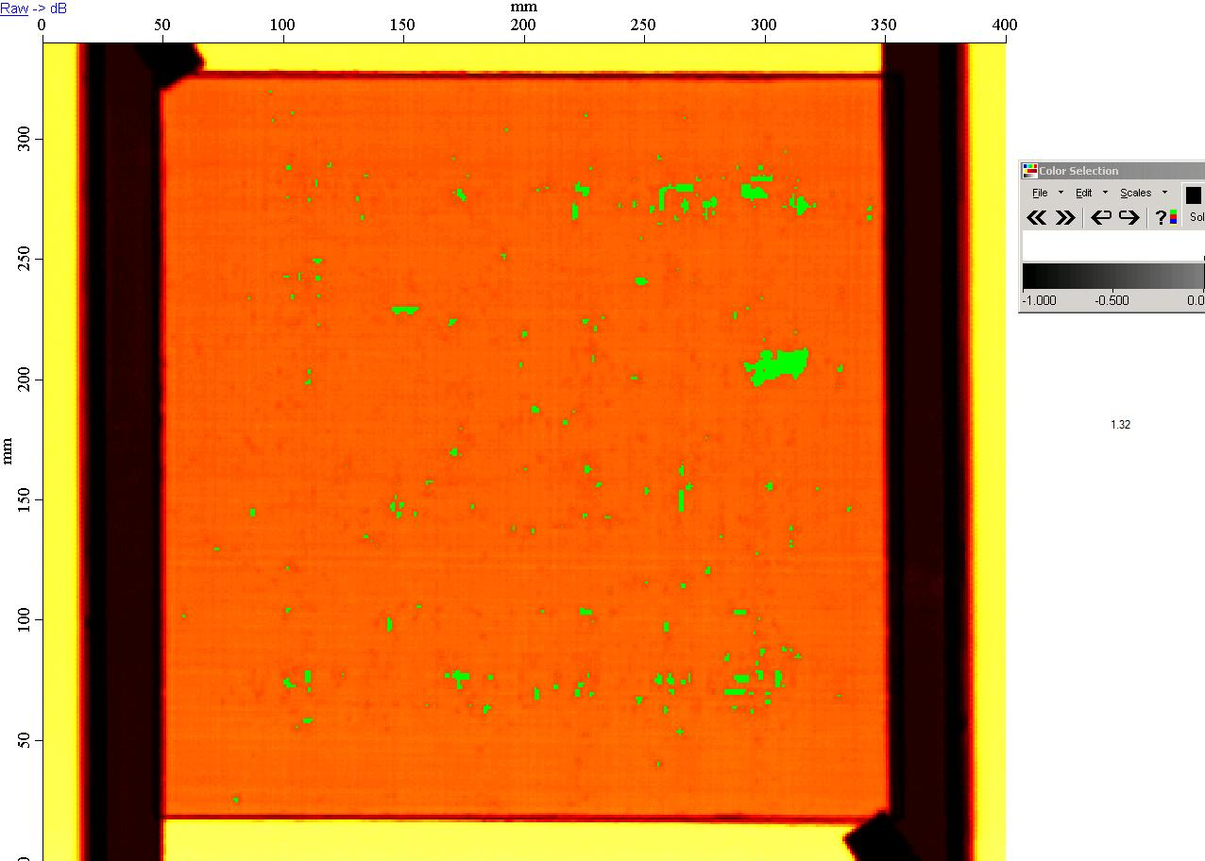

**Fig. 21:** C-scan results of panel.

The experimental results for E2, 90° compressive stiffness, fall well within the range of ROM and CFM predicted values. This is a promising result for the experimentally calculated lateral compressive modulus.

**Conclusions**

Experimental compression testing of 0° and 90° oriented unidirectional carbon fiber epoxy composite specimens from the fabricated laminate resulted in moduli of E1 = 11.66±0.22 Msi. and E2 = 1.04±0.04 Msi, as well as axial strength of X1C=91.68±5.53 ksi. The experimental results of E2 line up very well with those of the CFM and ROM models, but experimental results for E1 fall somewhat short of CFM and ROM results. This is attributed to the large relative standard deviation present for Fiber Volume Fraction (FVF), as well as the void content that was verified to be present in the laminate – both introducing inherent uncertainty in correlation between experimental and model-predicted results. Experimental strength results, however, fall significantly below the predicted value range, and further investigation is required to correlate the two, and more appropriately ascertain the disparity in experimental and predicted values.

**References**

[1] ] ASTM Standard D6507, 2016, “Standard Practice for Fiber Reinforcement Orientation Codes for Composite Materials,” ASTM International, West Conshohocken, PA, 2003, DOI: 10.1520/D6507-16, [www.astm.org/Standards/D6507.htm](http://www.astm.org/Standards/D6507.htm).

[2] T700S Data Sheet [PDF]. Santa Ana, CA: Toray Carbon Fibers America Inc. <https://www.toraycma.com/file_viewer.php?id=4459>.

[3] ASTM Standard D3410, 2006, “Standard Test Method for Compressive Properties of Polymer Matrix Composite Materials with Unsupported Gage Section by Shear Loading,” ASTM International, West Conshohocken, PA, 2006, [www.astm.org/Standards/D3039.htm](http://www.astm.org/Standards/D3039.htm).

[4] G-83C Data Sheet [PDF]. Santa Ana, CA: Toray Carbon Fibers America Inc. (Digital).

**Appendix A**

**Fig. 22:** Example strain range of E1 for 0° #2.

**Fig. 23:** Example strain range of E2 for 90° #3.

**Fig. 24:** % Bending as a function of Average Strain for 0° #1.

**Fig. 25:** % Bending as a function of Average Strain for 0° #2.

**Fig. 26:** % Bending as a function of Average Strain for 0° #3.

**Fig. 27:** % Bending as a function of Average Strain for 0° #4.

**Fig. 28:** % Bending as a function of Average Strain for 0° #7.

**Fig. 29:** % Bending as a function of Average Strain for 90° #2.

**Fig. 30:** % Bending as a function of Average Strain for 90° #3.

**Fig. 31:** % Bending as a function of Average Strain for 90° #4.

**Fig. 32:** % Bending as a function of Average Strain for 90° #5.

**Fig. 33:** % Bending as a function of Average Strain for 90° #6.

**Fig. 34:** Strain vs time interval sampling, by strain gage for 0° #1.

**Fig. 35:** Strain vs time interval sampling, by strain gage for 0° #2.

**Fig. 36:** Strain vs time interval sampling, by strain gage for 0° #3.

**Fig. 37:** Strain vs time interval sampling, by strain gage for 0° #4.

**Fig. 38:** Strain vs time interval sampling, by strain gage for 0° #7.

**Fig. 39:** Strain vs time interval sampling, by strain gage for 90° #2.

**Fig. 40:** Strain vs time interval sampling, by strain gage for 90° #3.

**Fig. 41:** Strain vs time interval sampling, by strain gage for 90° #4.

**Fig. 42:** Strain vs time interval sampling, by strain gage for 90° #5.

**Fig. 43:** Strain vs time interval sampling, by strain gage for 90° #6.

**Appendix B**

**Theoretical Predictions**

***Rule of Mixtures (ROM):***

**[1]**

**[2]**

**[3]**

A Rule of Mixtures analysis (Equations 1-3) is conducted with consideration to relevant standard deviations. A range of E1 values will be determined by using Equation 1 ranging by one standard deviation above and below each constituent value to maximize/minimize the resultant E1 within a standard deviation. Em is taken as 487ksi, as per the G-83C resin data sheet.[4] Maximum and minimum E1 values within a standard deviation are calculated below, respectively. E1 is found to range from 16.26 - 20.21 Msi.

**, *EL* = 33.4 Msi , *Em* = 0.487Msi ,**

Next, E2 is calculated in a similar manner, by varying the values of FVF and ET over their relevant ranges to maximize and minimize the resulting E2. Maximum and minimum E2 values within a standard deviation are shown calculated below, respectively. E2 is found to range from 0.6575 – 0.9983 Msi.

**, *Em* = 0.487Msi , ET = 1-3Msi ,**

**🡪 *E2* = 1.214 Msi.**

**🡪 *E2* = 0.9347 Msi.**

Next, is found by Equation 2, and similarly maximized and minimized. and are taken to be 0.487 ksi and 0.351[4], respectively. is found to bind the range of 345.94 – 449.47 ksi.

***, , , ,***

***Self-Consistent Field Model (CFM):***

The given Self-Consistent Field Model spreadsheet was also utilized to predict mechanical properties of the tested tensile specimens. Known and manufacturer-provided values were input to the CFM excel spreadsheet, and few outlier unknown variables were left at their as-received value to approximate a typical laminate. The extrema of ET (E2f in CFM) range and of FVF and standard deviations were then trialed to see their impact on the CFM-predicted properties. The results of these trials are presented below.

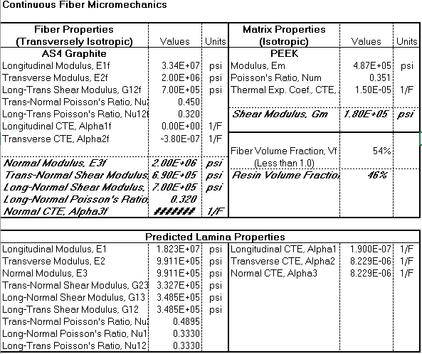

**Table 9:** Nominal values of E2f and FVF

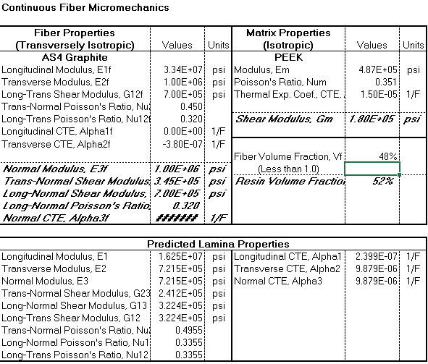

**Table 10:** Low E2f and low FVF

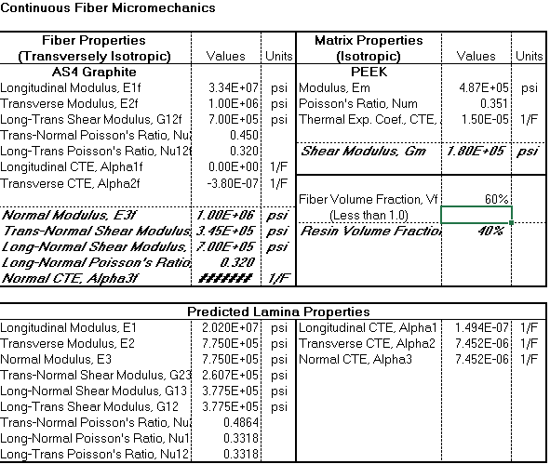

**Table 11:** Low E2f and high FVF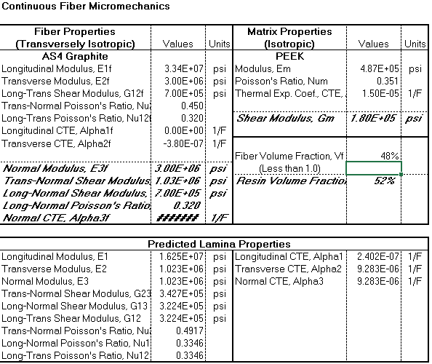

**Table 12:** High E2f and low FVF

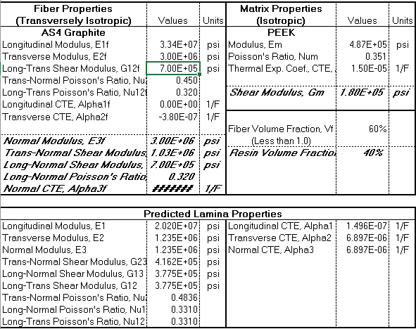

**Table 13:** High E2f and high FVF