**1)**

x

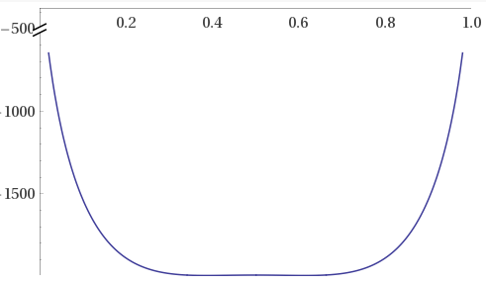

G (J/mol)

**FIG. 1.** G is plotted against x over full axes **[1].**

x

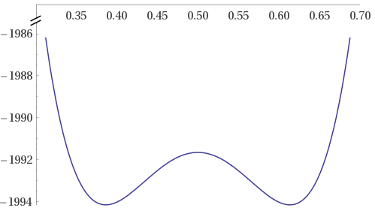

Binodal equilibrium points

Spinodal inflection points

G (J/mol)

**FIG. 2.** G is plotted against x on truncated axes to display the local minima and maximum, as well as inflection points **[1].**

**1) cont.**

d2G/dx2

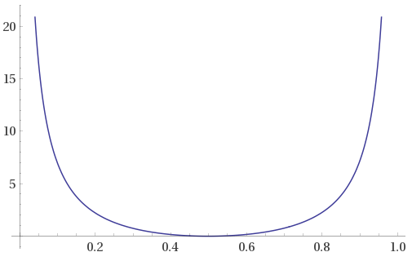

x

**FIG. 3.** d2G/dx2 is plotted against x over full axes **[1].**

d2G/dx2

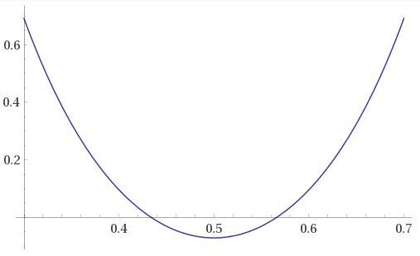

0.566

0.434

x

**FIG. 4.** d2G/dx2 is plotted on truncated axes to display its roots on x **[1].**

**1) cont.**

 -Aβ2-Bβ4

= 3.3E6

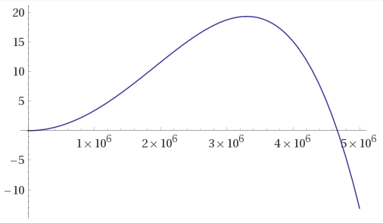



= 4.67E6

β (1/cm)

**FIG. 5.** Exponent term -Aβ2-Bβ4 is plotted against β to evaluate its values at βmax and βcrit. **[1].**

C(y,t)

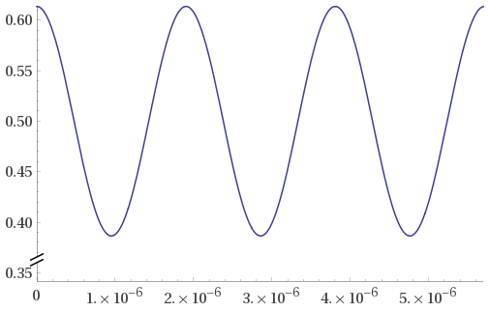

y (cm)

**FIG. 6.** C(y,t) is plotted against y at its βmax condition for maximum fluctuation at t = 0.6381s before reaching an equilibrium concentration **[1].**

**1) cont.**

0.6136

C(y,t)

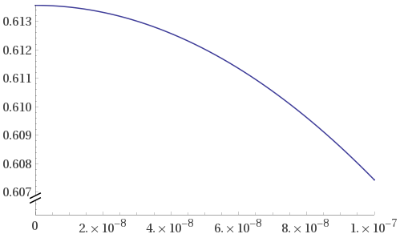

y (cm)

**FIG. 7.** C(y,t) for βmax is evaluated at its initial value to verify its maximum fluctuation at t = 0.6381s is equal to the corresponding binodal equilibrium point **[1].**

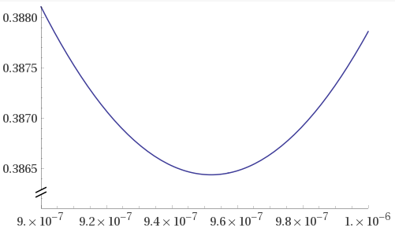

0.3864

**FIG. 8.** C(y,t) for βmax is evaluated at its minimum value to verify its fluctuation at t = 0.6381s is equal to the corresponding binodal equilibrium point **[1].**

**1) cont.**

**FIG. 9.** C(y,t) is plotted against y over varied values of t. Amplitude of the cosinusoidal fluctuation increases with time until it reaches the equilibrium concentraion defined earlier (too many data points to fit on this document **[2]**).

**2)**

|  |  |  |  |  |  |  |  |  |  |  |  |
| --- | --- | --- | --- | --- | --- | --- | --- | --- | --- | --- | --- |
| ***T_c =*** | ***110°C*** |  |  | ***T_c =*** | ***236°C*** |  |  | ***T_c =*** | ***240°C*** |  |  |
| **X_t** | **t (min)** | **log(-ln(1-X_t))** | **log(t)** | **X_t** | **t (min)** | **log(-ln(1-X_t))** | **log(t)** | **X_t** | **t (min)** | **log(-ln(1-X_t))** | **log(t)** |
| 0.096 | 15.8 | -0.9960 | 1.1987 | 0.005 | 12.6 | -2.2999 | 1.1004 | 0.004 | 20.2 | -2.3971 | 1.3054 |
| 0.176 | 20 | -0.7131 | 1.3010 | 0.014 | 14.4 | -1.8508 | 1.1584 | 0.018 | 27.8 | -1.7408 | 1.4440 |
| 0.275 | 25.7 | -0.4927 | 1.4099 | 0.018 | 15.9 | -1.7408 | 1.2014 | 0.029 | 35.5 | -1.5312 | 1.5502 |
| 0.407 | 30.8 | -0.2819 | 1.4886 | 0.026 | 17.7 | -1.5793 | 1.2480 | 0.051 | 40.1 | -1.2811 | 1.6031 |
| 0.469 | 36.2 | -0.1986 | 1.5587 | 0.038 | 19.1 | -1.4118 | 1.2810 | 0.099 | 45.3 | -0.9819 | 1.6561 |
| 0.709 | 54.3 | 0.0915 | 1.7348 | 0.085 | 24.6 | -1.0514 | 1.3909 | 0.16 | 52.7 | -0.7586 | 1.7218 |
| 0.811 | 63.1 | 0.2217 | 1.8000 | 0.134 | 27.7 | -0.8420 | 1.4425 | 0.238 | 59.5 | -0.5657 | 1.7745 |
| 0.879 | 71.7 | 0.3247 | 1.8555 | 0.244 | 31.6 | -0.5533 | 1.4997 | 0.395 | 67.1 | -0.2988 | 1.8267 |
| 0.952 | 84.3 | 0.4824 | 1.9258 | 0.353 | 36.8 | -0.3611 | 1.5658 | 0.592 | 79.9 | -0.0475 | 1.9025 |
|  |  |  |  | 0.608 | 44.3 | -0.0285 | 1.6464 | 0.739 | 91.9 | 0.1282 | 1.9633 |
|  |  |  |  | 0.736 | 47.4 | 0.1244 | 1.6758 | 0.855 | 99.3 | 0.2858 | 1.9969 |
|  |  |  |  | 0.826 | 49 | 0.2427 | 1.6902 | 0.911 | 114.1 | 0.3837 | 2.0573 |
|  |  |  |  | 0.907 | 58.8 | 0.3757 | 1.7694 | 0.976 | 128.6 | 0.5717 | 2.1092 |
|  |  |  |  | 0.965 | 63.5 | 0.5254 | 1.8028 |  |  |  |  |

**Table 1.** The given data is listed along with their respective calculations for Avrami analysis. A TA Instruments reference was utilized as extra reading and to determine ln(-ln()) vs. log(-ln()) convention **[3].** Excel equations are available for inspection **[4].**

**FIG. 10.** The given degree of crystallization vs. time data is overlaid by isotherm **[4].**

**2) cont.**

**FIG. 11.** Avrami analysis is presented, overlaid by linear-fit isotherms **[4].**

|  |  |  |  |
| --- | --- | --- | --- |
| ***Temp(°C)*** | ***n*** | ***log(k)*** | ***k*** |
| 110 | 1.932 | -3.237 | 5.79E-04 |
| 236 | 3.905 | -6.457 | 3.49E-07 |
| 240 | 3.729 | -7.205 | 6.24E-08 |
|  |  |  |  |
|  |  |  |  |
| ***Temp(°C)*** | ***xtal*** | ***nucleation*** | ***rate det.*** |
| 110 | rod | sporadic | diffusion |
| 236 | sphere | sporadic | contact |
| 240 | sphere | simultaneous | contact |

**Table 2.** Avrami exponent and rate constant, as well as predicted crystal morphology, method of growth, and rate determining aspect are displayed above. **[3].**

References / Supplemental

**[1]** Figure was plotted utilizing WolframAlpha computing suite.

**[2]** If there are any uncertainties of the calculations used, the full excel worksheet can be accessed here: <https://github.com/zswain/MSEG804> as “ZachSwain_MSEG804-Exam2_#1.xlsx”

**[3] “**TA393,” TA Instruments, New Castle, DE. <http://www.tainstruments.com/pdf/literature/TA393.pdf>

**[4]** If there are any uncertainties of the calculations used, the full excel worksheet can be accessed here: <https://github.com/zswain/MSEG804> as “ZachSwain_MSEG804-Exam2_#2.xlsx”