[Quality of Experience in Distributed Interactive Multimedia Environments: Toward a Theoretical Framework]

The past decades have witnessed a rapid growth of Distributed Interactive Multimedia Environments (DIMEs).

We introduce a mapping methodology to quantify the correlations between QoS and QoE, and describe our controlled and uncontrolled studies as illustrating examples.

We present a methodology to compute the mapping from QoS to QoE, which can offer useful insights for DIME designers and practitioners.

Interactivity is the key characteristics in DIMEs.

Graphical backgrounds and virtual objects can also be integrated into the virtual environment, which is not possible with 2D video-based systems.

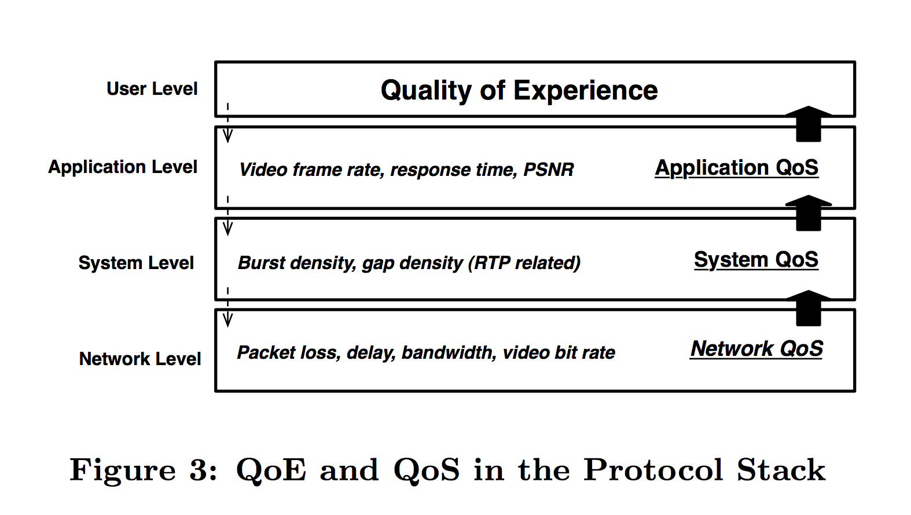

Notice that QoE is not only influenced by the technological environment, but also by the human factors that strongly embed user’s experiences and cultural background.

Flow can measure “the holistic sensation that people feel when they act with total involvement”.

Subjective results can be obtained by having the users rank the noticeability or disruptiveness of delay as they perceive on a Likert scale.

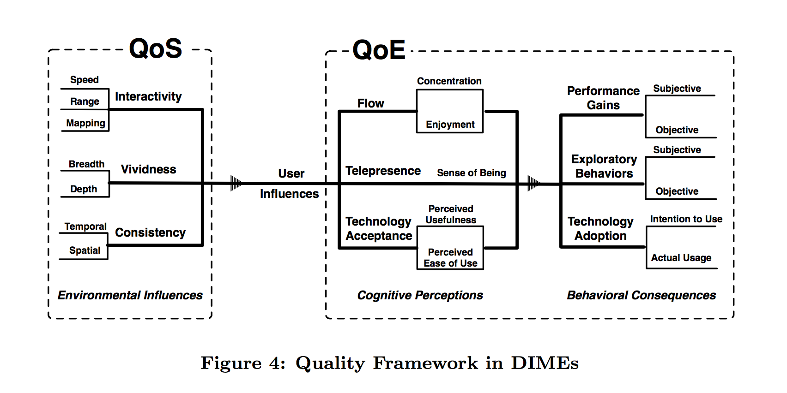

[A Framework for Collaborative Real-Time 3D Teleimmersion in a Geographically Distributed Environment]

A critical aspect of the teleimmersive experience is the realistic representation of users inside the virtual space.

[Human-Centered Computing: A Multimedia Perspective]