OSAC Storage: LVMS as a CSI Backend — Options Analysis
Working document for the Storage WG · prepared for discussion · reflects merged code + in-flight PRs + the OSAC-2872 design as of review.
TL;DR. The OSAC Storage Control Plane (OSAC-2872) was designed exclusively for network-attached arrays (VAST/NetApp/Pure). Its entire model — provision a Volume via the API independently of any pod, vendor controllers on the hub, credential isolation — assumes the storage is reachable from anywhere. LVMS is node-local and sticky: a volume physically lives in a volume group on one node and can only be created once the consuming pod's node is known. LVMS therefore cannot fit the design cleanly. The three options below are three different levels of compromise, not three equivalent implementations. None makes LVMS behave like a network tier. Crucially, LVMS was introduced for a dev-only purpose — giving developers usable storage without a real backend array. That premise (not a "who is the user?" question) should drive the decision: it removes any hard requirement for tenant-facing inventory, quota, or a uniform provisioner, and points away from the heaviest option.

1. Background: how the OSAC Storage Control Plane works (network-attached)
Four repos plus the installer make up the storage control plane. The key design principles, quoted from the OSAC-2872 design:
- Asynchronous, declarative Volume API. The CSI driver calls CreateVolume, which persists a record and returns immediately. A reconciler then creates a Volume CR on the hub; the operator drives the vendor call; a feedback controller syncs status back.
- "The tenant cluster has no vendor controllers and no vendor credentials." All controller operations route through the fulfillment-service. Vendor controllers run on the hub; only vendor node plugins run on the tenant cluster.
- "The CSI driver never connects directly to vendor controllers." The CSI node plugin is a proxy (it routes mount calls to a vendor node socket by volume_context["osac.backend"]). The CSI controller is not a proxy — it talks only to the fulfillment-service.

Deployment topology (VAST)
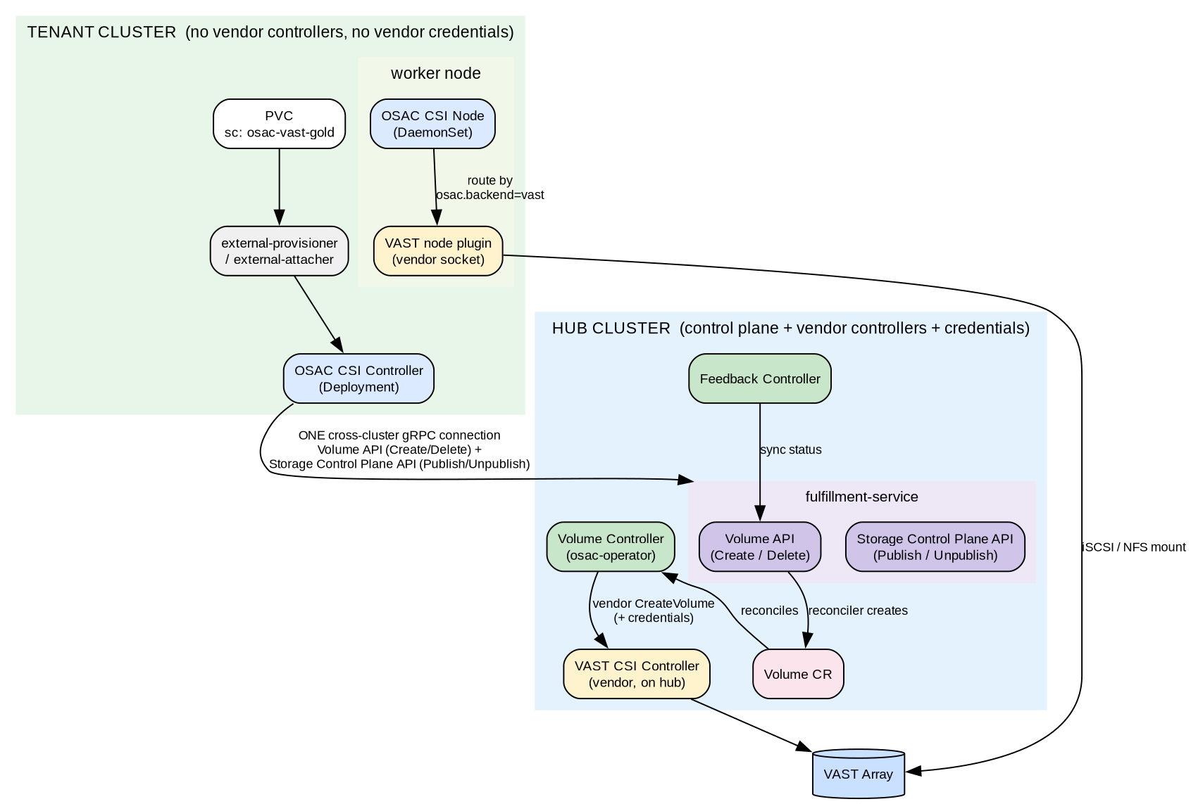
Note where things live: vendor controller + credentials + operator on the hub; vendor node plugin on the tenant worker. The OSAC CSI driver has exactly one cross-cluster connection — to the fulfillment-service — and never to a vendor controller.

2. Reference flow: VAST (network-attached) provisioning
This is the CSI / PVC-driven path (dynamic provisioning). The other entry is API-first: the Volume is created via the API with no consumer, then a pre-provisioned PV (csi.volumeHandle = <osac volume id>) is bound statically and CreateVolume is never called. API-first is out of scope here — it is impossible for LVMS (see §3.1) — so only the CSI-driven path is elaborated.
Numbered, matching the OSAC-2872 sequence:
1. Tenant creates PVC (storageClassName: osac-<vendor>-gold)
2. external-provisioner → OSAC CSI Controller.CreateVolume(tier=gold, tenant, size, accessMode, clusterID)
3. Volume API: resolve tier→backend+protocol, OPA policy check, persist record (state=CREATING), return now
4. fulfillment reconciler (on pg_notify) creates a Volume CR on the HUB
5. operator Volume controller: reads tenant creds from hub Secret, calls vendor CSI CreateVolume
6. VAST CSI controller creates the volume on the array, returns vendor volume ID
7. feedback controller → Volume API: Update(state=AVAILABLE, vendor_volume_id) + Signal(id)
8. OSAC CSI polls GetVolume until AVAILABLE → returns volume_context{osac.backend, osac.volume-id, osac.protocol}
9. Kubernetes creates the PV (volume_context stored as spec.csi.volumeAttributes), binds the PVC
Mount is a separate timeline, triggered not by provisioning but by a consumer being scheduled onto a node — a pod, or for VMaaS the KubeVirt VM's virt-launcher pod. It repeats every time a consumer starts on a node; provisioning happens only once. Sequence: pod/VM scheduled → VolumeAttachment created → external-attacher → ControllerPublishVolume → Storage Control Plane API → operator → vendor ControllerPublishVolume (attach); then kubelet → OSAC CSI node → NodeStageVolume / NodePublishVolume, routed by osac.backend=vast → VAST node plugin → iSCSI/NFS mount. No control-plane call is made from the node; all routing is baked into volume_context at create time.

3. Why LVMS does not fit: the node-local constraint
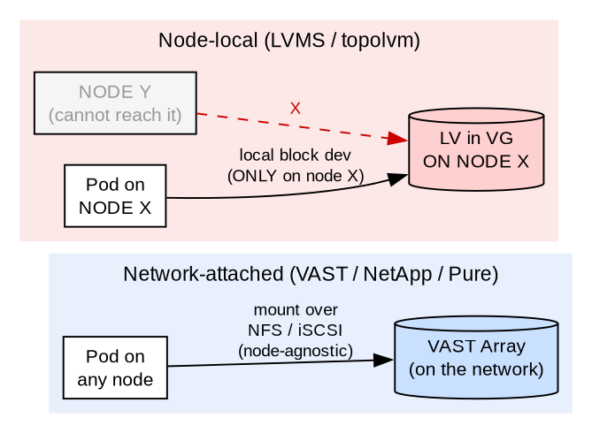
VAST is node-agnostic: the array is on the network, any node mounts it. LVMS is the opposite — the volume is an LV carved from a volume group on one specific node, and it is only reachable from that node. Consequences that ripple through the whole architecture:
- WaitForFirstConsumer is mandatory. You cannot pick where to put the volume until the scheduler picks the pod's node.
- Topology must flow end-to-end. Scheduler picks node X → CSI CreateVolume receives accessibility_requirements.preferred=[{topology.topolvm.io/node: X}] → provisioning must target X → the response's accessible_topology pins the PV to X.
- Node affinity must be propagated to the PV. The LV (the LVM block device) is physically on node X — that's a given. The challenge is making Kubernetes aware of it: the PV must carry spec.nodeAffinity=node X so the scheduler only places consumers there. A VAST PV has no node affinity (mountable anywhere); an LVMS PV must be pinned to node X for its lifetime, and that pin has to be threaded through the provisioning path.

3.2 Deployment asymmetry: why the vendor-controller-on-hub model breaks for LVMS
A CSI driver is two halves — a controller (Deployment) and a node plugin (DaemonSet). OSAC splits them deliberately:
Piece | Where it runs | Why
Vendor controller (VAST/NetApp/Pure) | Hub | Credential isolation — vendor creds stay on the hub, never reach the tenant cluster. The controller just makes a network API call to the array, so it doesn't matter where nodes are.
Vendor node plugin | Tenant / CaaS | Must run where the mounts happen; reached by the OSAC node plugin via socket routing.
OSAC CSI driver (controller + node) | Tenant / CaaS (and the hub too, per the passthrough proposal) | That's where tenant PVCs are. Its only cross-cluster reach is one gRPC connection to the fulfillment-service.
topolvm-controller cannot follow the vendor-controller-on-hub pattern. Unlike VAST's controller (which makes a network call to a remote array), topolvm-controller on CreateVolume creates a LogicalVolume CR in its own cluster's API, which the topolvm-node DaemonSet in that same cluster watches and acts on, and its scheduling reads that cluster's node VG capacity. It operates entirely within one cluster and can only manage that cluster's own nodes. Run it on the hub and it would target hub nodes, not tenant nodes. So it must live on the tenant cluster — exactly where OSAC-3011/3234 already install LVMS. This is the concrete reason Option A's "operator on the hub calls the vendor controller" model does not translate to LVMS.

3.3 How a CSI controller is normally reached (context for Option B)
A CSI controller pod contains the vendor plugin container plus the CSI sidecars (external-provisioner, external-attacher, external-resizer). The plugin serves its CSI gRPC over a unix-domain socket on an in-pod emptyDir, and the only clients are those co-located sidecars. external-provisioner watches PVCs → calls CreateVolume on the socket; external-attacher watches VolumeAttachments → calls ControllerPublish. Nothing outside the pod ever talks to topolvm-controller; it is never on the network. That is why any option where a different pod (the OSAC CSI controller) drives topolvm-controller needs a new access path — see Option B.

3.1 The deepest mismatch: API-first provisioning
With pvc_ref now removed from the Volume API (PR #341, merged) and a future VolumeAttachment object (OSAC-3278) taking over the Volume↔PVC linkage, the OSAC Volume lifecycle is decoupled from pods. The canonical path becomes API-first: create a Volume with no consumer, attach it later. This is natural for a network array — and structurally impossible for LVMS.
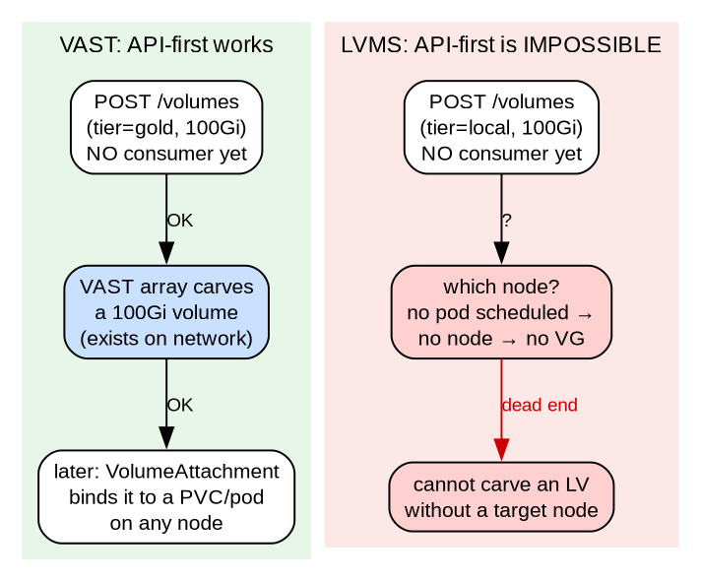
This is the single strongest architectural argument: the direction the Volume API is evolving (provision-in-advance, pod-independent) is exactly the direction LVMS cannot follow. For LVMS the only viable entry point is the CSI + WaitForFirstConsumer path, where a node exists at provision time. The pure-API path must be forbidden for local tiers.

4. The three options

Option A Full chain — CSI → fulfillment → Volume CR → operator → topolvm
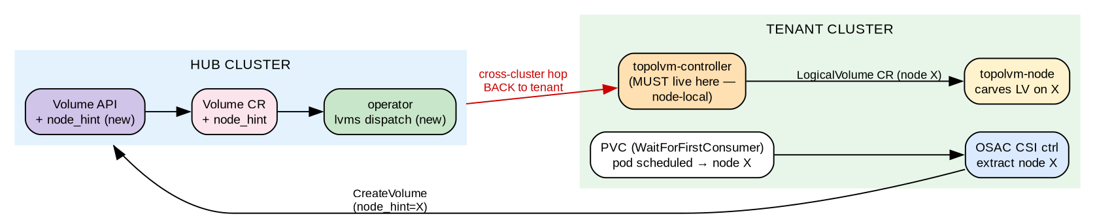

Components
OSAC CSI controller (+ topology extraction), Volume API (+ a new node_hint/topology field), Volume CR (+ node_hint), operator Volume controller (+ an lvms VendorProvisioner), topolvm on the tenant cluster, OSAC CSI node (+ topology labels).

Data flow
1. Pod scheduled → node X (WaitForFirstConsumer)
2. OSAC CSI ctrl extracts node X from accessibility_requirements
3. → fulfillment.CreateVolume(tier=local, size, accessMode, node_hint=X) [Volume API needs new field]
4. tier resolution → backend=lvms; DB record; Volume CR on HUB (spec: ..., node_hint=X)
5. operator lvms dispatch → creates a LogicalVolume CR targeting node X ON THE TENANT CLUSTER
6. operator polls LV ready → Volume CR status (AVAILABLE); feedback → DB
7. OSAC CSI polls GetVolume → volume_context + accessible_topology=[node X]
8. node plugin routes osac.backend=lvms → topolvm-node socket → mount
Two structural problems. (1) Control-flow round-trip: the request climbs from the tenant cluster to the hub (fulfillment + CR + operator), then the operator must reach back down into the tenant cluster to create the LogicalVolume on node X — for a purely local operation the hub has no part in. (2) topolvm-controller cannot live on the hub where VAST's controller lives; it must run on the tenant cluster with the nodes and VGs. So step 5 is either the operator reimplementing topolvm-controller's job (fragile, duplicative) or the operator delegating to topolvm-controller — in which case Option A = Option B plus fulfillment/CR/ operator bookkeeping and a cross-cluster hop.

Pros
- ✓ Full volume inventory in the OSAC DB
- ✓ Quota enforcement possible
- ✓ One provisioner name (osac-csi) — looks uniform to the tenant

Cons
- ✗ Needs a new topology field in the Volume API (Volume API owner / OSAC-3273/3280) — not there today
- ✗ Needs an operator lvms provisioner — not there today
- ✗ Cross-cluster reach hub→tenant to create the LV
- ✗ Still cannot support API-first / provision-in-advance (§3.1) — no VAST parity despite the most work
- ✗ Most engineering of the three

Option B Passthrough — CSI controller forwards local provisioning to topolvm
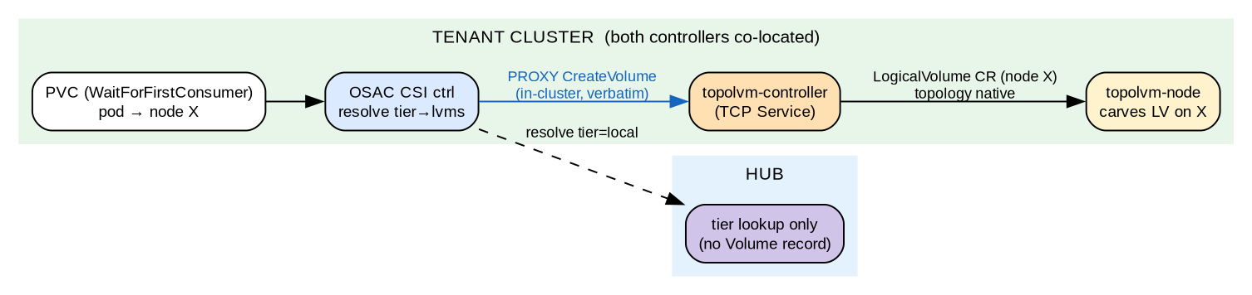

Two realizations (confirm which with the proposer — they differ in what must be exposed)
 | B1 · gRPC proxy | B2 · CRD create
OSAC CSI ctrl does | Proxies the CSI CreateVolume RPC to topolvm-controller | Directly creates a topolvm LogicalVolume CR
Requires | topolvm-controller exposed via a TCP Service (non-standard) | A k8s client + RBAC in the CSI driver (none today)
Security surface | Network-exposes a normally in-pod socket | RBAC to create one CRD type
Note | Bypasses topolvm's own provisioner sidecar | Reimplements the thin part of topolvm-controller (CR creation)
Sidecar nuance: with StorageClass provisioner: osac-csi, OSAC's external-provisioner sidecar handles the PVC and topolvm's own provisioner sidecar sits idle (it only watches provisioner: topolvm.io). So Option B effectively replaces topolvm's provisioner sidecar with a cross-pod hop (B1) or with direct CR creation (B2).

Components
OSAC CSI controller (+ an lvms proxy branch), fulfillment (tier-resolution lookup only, no Volume record), topolvm-controller exposed via a TCP Service, OSAC CSI node (existing socket routing).

Data flow
1. Pod scheduled → node X
2. OSAC CSI ctrl: resolve tier=local → backend=lvms + topolvm-controller endpoint
3. OSAC CSI ctrl PROXIES CreateVolume verbatim → topolvm-controller (in-cluster)
4. topolvm-controller creates the LogicalVolume on node X, returns AccessibleTopology natively
5. OSAC CSI returns topolvm's response, adding volume_context{osac.backend=lvms}
6. node plugin routes osac.backend=lvms → topolvm-node socket → mount
This is the design's rejected Alternative 3 ("CSI driver proxies vendor calls / client-side orchestration"). It was rejected for credential isolation — vendor credentials would transit the tenant cluster. But LVMS has no vendor credentials (local disk, no array API, no Secret), so the specific reason for the rejection does not apply to LVMS. That makes B a defensible exception rather than a violation.
Co-location detail: on both shapes the OSAC CSI controller and topolvm-controller are on the same cluster (CaaS: both on the guest cluster per OSAC-3234; VMaaS/hub: both on the hub per OSAC-3011), so the path is an in-cluster hop — strictly simpler than A's cross-cluster reach. The one new mechanic applies to B1 only: topolvm-controller isn't network-exposed by default (its csi-provisioner sidecar uses an in-pod unix socket), so a TCP Service must be added — pre-condition to confirm with the CSI driver owner / topolvm. B2 sidesteps this entirely (create the LogicalVolume CR directly; needs only RBAC).

Pros
- ✓ No dependency on the operator lvms path or a new Volume-API field
- ✓ Topology "just works" — topolvm owns it natively
- ✓ Low latency (direct, in-cluster); provisioner name stays osac-csi
- ✓ The credential-isolation objection is moot for LVMS

Cons
- ✗ No Volume record → no inventory, no quota for LVMS
- ✗ The controller behaves differently per backend (proxy for lvms, full-chain for network) — a split path to maintain
- ✗ New exposure: TCP Service for topolvm-controller (B1) or a CR-creation RBAC client in the CSI driver (B2)

Option C Native — keep the topolvm/AAP path, OSAC not in the LVMS path
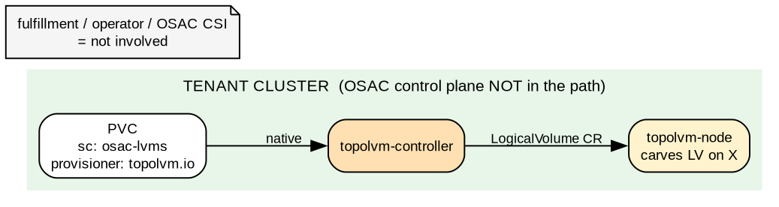

Components
A topolvm StorageClass created by AAP (already shipped via OSAC-3011/3234), provisioner: topolvm.io. The OSAC CSI driver, fulfillment, and operator are not involved in the LVMS path at all.

Data flow
PVC (sc=osac-lvms, WaitForFirstConsumer) → topolvm-controller → LogicalVolume → topolvm-node → LV
(zero OSAC control-plane involvement)

Pros
- ✓ Zero new work — already functional and merged
- ✓ Correct by construction (topolvm as designed); no new security surface, no cross-cluster hops
- ✓ Honest about LVMS being a different category

Cons
- ✗ StorageClass provisioner is topolvm.io, not osac-csi — an abstraction leak (tenant sees LVMS internals)
- ✗ No OSAC inventory or quota for LVMS
- ✗ Two visibly different tenant UXes (local tier vs network tiers)

5. Side-by-side comparison
Every row where a "network parity" property is ✗ is a compromise that no option removes — because they stem from LVMS being node-local, not from implementation choices.
Dimension | VAST (reference) | A · Full chain | B · Passthrough | C · Native
OSAC volume inventory | ✓ | ✓ | ✗ | ✗
Quota enforcement | ✓ | ✓ | ✗ | ✗
Provisioner = osac-csi | ✓ | ✓ | ✓ | ✗ (topolvm.io)
API-first / provision-in-advance | ✓ | ✗ | ✗ | ✗
Topology handled by | n/a | OSAC (4 layers) | topolvm | topolvm
Cross-cluster reach needed | ✓ (by design) | ✗ hub→tenant | in-cluster only | none
New security surface | — | operator→tenant | topolvm TCP Service | none
Follows OSAC-2872 design | ✓ | partly | rejected Alt. 3* | rejected Alt. 4
New engineering | — | Highest | Medium | ~None
* Alternative 3 was rejected for credential isolation, which does not apply to LVMS.

6. Open questions for the WG
Settled premise: LVMS is dev-only (usable storage without a real backend array). So there is no tenant-facing requirement for inventory, quota, or a uniform provisioner — which removes the only justification for Option A. The remaining questions are about B vs C.
- Does the tenant-visible provisioner name matter even for dev use? (osac-csi vs topolvm.io) — if no, C is sufficient; if we want dev flows to exercise the real osac-csi path, B.
- Do we want dev flows to exercise the OSAC CSI path at all (so dev testing mirrors the network-backend path), or is native topolvm fine for dev?
- [B pre-condition] Which realization — B1 (expose topolvm-controller via a TCP Service) or B2 (CSI driver creates the LogicalVolume CR directly, RBAC only)? Confirm with the CSI driver owner / topolvm.
- Are we OK maintaining a split controller path (B) long term — passthrough for lvms, full-chain for network backends?
Option A is retained below for completeness only; the dev-only premise rules it out.

7. Recommendation
Given the dev-only premise, it's B vs C. Option C is already done and correct — if native topolvm (provisioner topolvm.io) is acceptable for dev use, stop there. Option B is worth it only if we want dev flows to exercise the real osac-csi path (so dev testing mirrors the network-backend experience) — topology is correct for free and the credential objection is moot for LVMS; the split path is the only real cost. Prefer the B2 realization (direct LogicalVolume CR creation, RBAC only) over B1 (TCP-exposing topolvm-controller). Option A is ruled out by the dev-only premise: it buys tenant-facing inventory/quota nobody needs here, and still cannot achieve VAST parity (API-first is impossible for LVMS regardless) — A-delegate is just B plus bookkeeping and a cross-cluster hop, A-reimplement duplicates topolvm-controller.

Appendix A — Verified current code state
Area | State (verified)
VolumeSpec proto | storage_tier, size_gib, access_mode only. pvc_ref removed (PR #341 merged). No topology/node_hint field.
Tier resolution | Merged (PR #342): Volume Create resolves tier→backend+protocol, writes status.backend/status.protocol.
OSAC CSI controller | Delegates to fulfillment VolumeClient (PR #141 merged). No topology extraction, no AccessibleTopology in response, no VOLUME_ACCESSIBILITY_CONSTRAINTS capability.
OSAC CSI node | Routes mount to a vendor socket by osac.backend (proxy.Manager). NodeGetInfo returns only node_id — no topology labels.
operator Volume controller | PR #340 (open): VendorProvisioner interface, currently nil. No lvms/topolvm/LogicalVolume awareness anywhere in the codebase.
Volume reconciler (fulfillment) | PR #339 (open).
Vendor CSI controllers deploy | PR #188 (open): csi-backends Helm chart (VAST/Trident/Pure) — network backends only.

Appendix B — What OSAC-3702 must add on the CSI side (any of A/B)
- ControllerGetCapabilities += VOLUME_ACCESSIBILITY_CONSTRAINTS (required for WaitForFirstConsumer)
- CreateVolume: extract accessibility_requirements.preferred[0], return AccessibleTopology
- NodeGetInfo: return topology.topolvm.io/node=<nodeID>
- Helm: mount the topolvm-node socket into the OSAC CSI node container; register lvms=<socket> in --vendor-sockets
Sources: OSAC-2872 storage-control-plane design.md (authoritative), verified against merged code (PR #141/#341/#342) and open PRs (#339/#340/#188), OSAC-1110 StorageTier design (single-backend-per-tier), OSAC-3011/3234 (LVMS install). Diagrams rendered locally with graphviz.

