Copy cloud disk project

Group：11

Group Mumbers：Jing Wang，Zenghui Xu

Mingming Cui，Ting Zhang

Contents

**Copy cloud disk project plan 4**

1 Introduction 4

1.1 Purpose of writing 4

1.2 Background 4

1.3 Definition 4

1.4 Reference material 5

2 Project Overview 5

2.1 Project target 5

2.2 Work content 5

2.3 Project development environment 6

2.4 Assumptions and constraints 6

2.5 Deliverables 7

3 Implementation Plan 7

3.1 Division of labor 7

3.2 Collaboration and communication 7

4 WBS+Gantt chart 7

5 Milestone plan 8

**Copy cloud disk project** **requirement analysis and design report 9**

1 Introduction 9

1.1 Writing purpose 9

1.2 Project background 10

1.3 Reference materials 10

2 Description of project 10

2.1 Project objectives 10

2.2 Assumptions and constraints 11

2.3 Functional requirements 12

3 Operating environment regulation 13

3.1 Equipments 13

3.2 Required software 13

4 Product overview design 13

4.1 Interface design 13

4.2 Database design 14

4.3 Error handling design 14

4.4 Security and confidentiality design 15

4.5 System maintenance design 15

5 Detailed product design 15

5.1 Overall performance requirements 15

5.2 User information module 16

5.3 File management module 17

6 Product operation manual 17

6.1 Product overview 17

6.2 Products running 18

6.3 Product description 18

7 Test analysis report 20

7.1 Scopes and main contents of the test 20

7.2 Test methods 20

7.3 Test report 20

7.4 Test results 20

**Copy cloud disk project 21**

1、 Introduction 21

1.1 Writing purpose 21

1.2 Project background 21

1.3 Test resources 21

2、 Test Plan Implementation 22

2.1 Test object and content 22

2.2 Testing progress 23

3、 Deliverables 23

3.1 Test documentation 23

3.2 Systematic risk 23

3.3 The test strategy 24

4、 Test results and findings 27

4.1 Software evaluation scale 27

4.2 Test results and findings 27

5、 Evaluation 28

5.1 Software capabilities 28

5.2 Defects and limitations 29

5.3 Advice 29

5.4 Evaluation 29

**Conclusion 30**

Copy cloud disk project plan

# Introduction

## Purpose of writing

Let project members and project stakeholders understand the role of the project development plan and the desired results. The purpose of the development plan is “the consensus and agreement between the project members and the stakeholders, the operational basis of all activities in the project life cycle, so that the project team can carry out and check the project work according to this plan.”

In order to ensure that the project team completes the project objectives on time and in good quality, it is convenient for the project team members to better understand the project situation and make the various processes of the project work reasonable and orderly. Therefore, in the form of document, the work tasks in the project life cycle are The scope, the task decomposition of each work, the project team structure, the communication and collaboration mode inside and outside the team, the development schedule, the budget, the internal and external environmental conditions of the project, the risk countermeasures, etc. are arranged in writing, as project team members and projects. Consensus and agreement between stakeholders, the basis of action for all project activities within the project life cycle, and the basis for project teams to conduct and review project work.

## Background

Project Name: Imitation Cloud Project Project

Team: Group 11

Project team members: Jing Wang, Zenghui Xu, Mingming Cui, Ting Zhang

Project users: network disk individual users

## Definition

Cloud storage: A new concept that has been extended and developed in the concept of cloud computing. It is an emerging network storage technology. When the core of computing and processing of cloud computing systems is the storage and management of large amounts of data, cloud computing systems need to be configured with a large number of storage devices, then the cloud computing system is transformed into a cloud storage system, so cloud storage is a data storage system. And management as the core of the cloud computing system.

Network disk: It is a professional Internet storage tool. It is the product of Internet cloud technology. It provides enterprises, individuals, and other information storage, reading, downloading and other services through the Internet. It has the characteristics of safety, stability and mass storage.

## Reference material

《Software Project Management·lvqing Yang》

# Project Overview



## Project target

In order to achieve the overall goal and reduce risk, the system is divided into multiple phases:

1. Gradually improve performance as the number of users increases;
2. Gradually develop functions based on the interdependencies of functions.

## Work content

* First period
  + Confirm the project plan and build the foundation;
  + Design project models, analyze software requirements and detailed design.
* Second period
  + Write code to develop software;
  + The basic functions of the network disk: user registration and login user identity; home file view display function; network disk file management and other functions;
* Third period
* Testing the software developed in the second phase;
* Improve the system, increase functionality, or improve performance based on the conditions of the test, and try the product.

The following is a horizontal decomposition and vertical decomposition of the project work content.

|  |  |
| --- | --- |
| Stage | Function and target |
| First period（13days）  2019.3.7~2019.3.19 | 1.Correctly master the needs of the software  2.Determine the detailed design of the project |
| Second period（20days）  2019.3.20~2019.4.8 | 1.Web-based user identity management  a) Login b) Registration  2.Web-based cloud disk file management  c) File upload and download  d) deletion and search of files |
| Third period（7days）  2019.4.9~2019.4.15 | Make a perfect product to meet demand |

## Project development environment

|  |  |  |
| --- | --- | --- |
| Hardware | CPU | i5 |
| RAM | 8GB |
| Software | Operating system | Window10 |
| Programming language | JAVA |

## Assumptions and constraints

1. The demand and prototype must be confirmed before March 19, otherwise the overall delay will be caused;

2. The code must be written before March 20, otherwise it will affect the progress of project function development;

3. Project development must be completed by April 8th;

4. The test must be completed before April 12, otherwise it will affect the quality of the project;

5. Product trials must be completed by April 15th.

## Deliverables

|  |  |  |
| --- | --- | --- |
| **Name** | **Delivery date** | **Discription** |
| Demand analysis specification | 2019.3.14 | Word document |
| System design detailed plan | 2019.3.19 | Word document |
| System software and coding documentation | 2019.4.8 | Word document |
| Testing report | 2019.4.12 | System testing report |

# Implementation Plan



## Division of labor

|  |  |
| --- | --- |
| Principal | Duties |
| Zenghui Xu | Demand analysis,design |
| Jing Wang | Write code |
| Ting Zhang | Project testing, document editing |
| Mingming Cui | Project maintenance, document editing |

## Collaboration and communication

Mainly use QQ and WeChat.

# WBS+Gantt chart

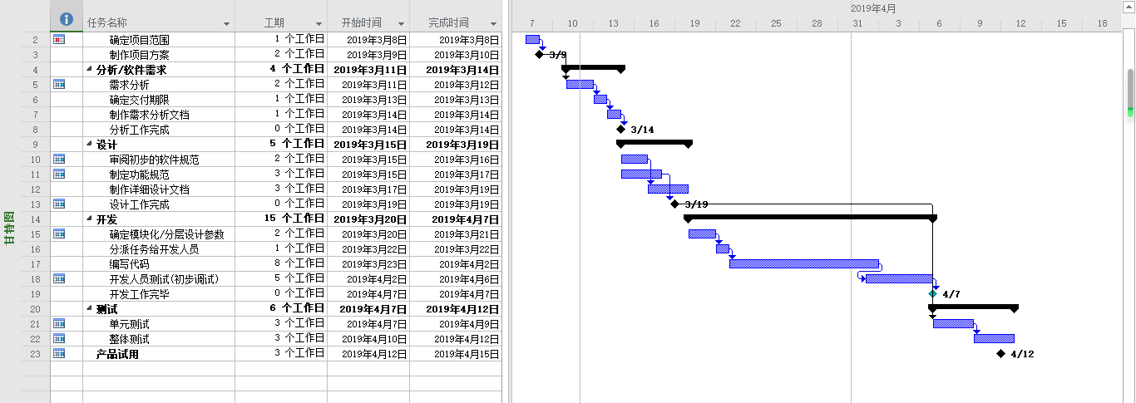

# Milestone plan

|  |  |  |  |  |
| --- | --- | --- | --- | --- |
| Milestone event | 3/1—3/15 | 3/15—3/31 | 4/1—4/15 | 4/15 |
| Demand analysis | ▲ |  |  |  |
| System design |  | ▲ |  |  |
| Program code |  |  | ▲ |  |
| Program test |  |  |  | ▲ |

|  |  |  |  |
| --- | --- | --- | --- |
| **Number** | **Milestone event** | **Deliverables** | **Complete time** |
| 1 | Demand analysis completed | Demand analysis Instruction manual | 2019.3.14 |
| 2 | System design completed | System design detailed plan | 2019.3.19 |
| 3 | Program code completed | System software and coding documentation | 2019.4.8 |
| 4 | Program test completed | Testing report | 2019.4.12 |

Copy cloud disk project

requirement analysis and design report

# Introduction

With the rapid development of information and Internet technology, we have entered a new era of E. Cloud disk software on the Internet has brought people great benefits, anytime and anywhere can access documents or large files on the Internet, and cloud disk software development is mature, the operation is also very simple, extremely suitable for development.

Requirement analysis is an important activity in software planning stage and also an important link in software life cycle. The preparation of demand analysis and design report can provide a complete description of the main functions and performance of the developed software system, provide a basis for software developers to carry out detailed design and programming, and provide a basis for testing and acceptance of the software.

Through reading books and searching the Internet, the team carefully and comprehensively investigated users' demands for cloud disk imitation software, and thus determined the software functional requirements, system operation support and data items. All of the above also laid a good foundation for the overall design.

This requirements analysis and design report describes the functions of the software in a comprehensive and detailed way, so that the software developers, testers and maintainers can reach a consensus on their business processes and functions, thus completing all the work.

## Writing purpose

The requirements analysis report describes the requirements of the pseudo-cloud disk project. The main purpose of writing the requirements analysis report is to provide users and software developers with a common understanding of the initial requirements of the software and make it the basis of the whole development work.

As the basis of software products, this specification document will make detailed provisions from the functional requirements, performance requirements, operating hardware environment requirements, operating software environment requirements and security of the system. To ensure that the system software system to achieve the ultimate goal.

This specification is also the basis for final product integration testing (also known as comprehensive testing or requirements testing).

Intended audience: systems analysts, programmers, and testers.

## Project background

Cloud disk is the product of Internet cloud technology. It provides enterprises and individuals with information storage, reading, downloading and other services through the Internet. With the characteristics of security and stability, mass storage. Compared with traditional physical disks, it is more convenient and users do not need to carry the physical disk with them to store important data.

Because cloud disk has so many advantages, the project team decided to develop the imitation cloud disk product. Specifically, the client program is an application program built on the Windows system with Java as the development software, the server also uses the Windows as the operating system workstation, and MySQL as the database service program for the development software.

## Reference materials

《Software project management》 Lvqing Yang Electronic industry press

《Java2 utility tutorial (third edition)》Xiangyi Geng and Yueping Zhang Tsinghua university press

# Description of project

## Project objectives

This project aims to develop a pseudo-cloud disk software applied in the browser, providing users with file storage, access, backup, sharing and other file management functions. The development mode is C/S mode, and it can realize all functions expected by the pseudo-cloud disk software, and it has enough flexibility for users of all ages.

Some functions of the software are still to be developed, such as adding friends, sharing files, becoming a member and so on.

## Assumptions and constraints

The project is assumed as follows:

（1）The requirements and prototypes must be confirmed before March 19, otherwise the overall delay will be caused;

（2）The code must be written before March 20, otherwise it will affect the progress of functional development of the project;

（3）Project development must be completed by April 8;

（4）The test must be completed before April 12, otherwise the quality of the project will be affected;

（5）Product trials must be completed by April 15.

The project's constraints are as follows:

The developers of this software have already possessed the necessary qualities for compiling the software, such as teamwork spirit, proficiency in JAVA language, certain programming experience, and certain ability problems in the realization of some relatively advanced functions, which cannot be realized in detail, but can only be realized by subsequent learning.

The time schedule for project development and management is as follows:

|  |  |
| --- | --- |
| **Phases** | **Functional goals** |
| **The first phase (13 days)**  **2019.3.7~2019.3.19** | 1. Master the software requirements correctly 2. Determine the detailed design of the project |
| **The second phase (20 days)**  **2019.3.20~2019.4.8** | 1. Web-based user identity management 2. Login 3. Registration 4. Cloud disk file management based on web 5. Upload and download files 6. file deletion and search |
| **The third phase (7 days)**  **2019.4.9~2019.4.15** | Make perfect products to meet requirements |

## Functional requirements

The software has the following main functions:

（1）Login module: It is mainly used to record the user name and password of the login and compare them with the corresponding data in the database to achieve successful login. It can also create new users instantly.

（2）Registration module: A complete new user information is formed by recording the user name entered by the user, saving the file path and password to the database.

（3）Upload module: Mainly by clicking the upload button to open the selection box of the uploaded file, the file can be uploaded and saved in the user's pseudo-cloud disk space.

（4）Folder module: Click the create button and enter the name of the new folder to create a new folder in the user's imitation cloud disk space. You can also open the folder or upload files in the folder and create the built-in folder.

（5）File module: Users can view the name, directory, modification date, size of existing files, or perform download and delete operations in the pseudo-cloud disk space.

The overall flow chart of the system is shown below:



# Operating environment regulation

## Equipments

CPU i5 3.20G

Memory 8G

HD Graphics-530 128M Graphics memory

Hard disk 1T

Display ordinary 18.5 inch flat CRT

## Required software

Encoding software: IDEA

Database software: MySQL Workbench

# Product overview design

## Interface design

User registration interface design: After filling in the user name, password and confirm password, the backend queries the database to see if the same user name exists and if the password and confirmation password are the same. If the user name exists and If the user name exists and the password is consistent with the confirmation password, the system saves the user name and password to the database, and creates a folder named after the user name in the HDFS cloud storage system.

User login interface design: After filling in the user name and password, the backend matches the user name and password, if it exists in the database, user enters the main interface.

User login interface design: After filling in the user name and password, the backend matches the user name and password, if it exists in the database, user enters the main interface.

User login interface design: After filling in the user name and password, the backend matches the user name and password, if it exists in the database, user enters the main interface.

Search file interface design: Users input text, then the system performs fuzzy matching and return multiple results containing the text.

File deletion interface design: The system queries the path of files saved in HDFS, sends to the back end and deletes the information of files in the database.

## Database design

1. File information（file_inf）

|  |  |  |
| --- | --- | --- |
| Name | Type | Note |
| file_name | varchar(100) | primary key |
| file/folder | varchar(6) |  |
| file_size | varchar(10) |  |
| file_time | varchar(20) |  |
| user | varchar(50) |  |

1. User information（user）

|  |  |  |
| --- | --- | --- |
| Name | Type | Note |
| username | varchar(50) | primary key |
| password | varchar(50) |  |

## Error handling design

This software takes full account of the respective system errors to avoid inconsistency or damage to the database system. The main methods are as follows:

（1）Use the error window to alert the user to an error and handle the error amicably. For example, when a user fails to log in, it will be prompted based on the cause of the error, and when the user input is incorrect, it will be prompted appropriately.

（2）Make regular database backups, and if the server database is compromised, restore it using the latest copy of the database.

## Security and confidentiality design

The database system requires strict user identification, and users can only log in to the application software with an account and password, and access the database through the application software, but there is no other way to operate the database. The software encrypts the password for a user's account to ensure that it is never in clear text anywhere.

It sets access control to determine the operation permissions of each role on the database table, such as create, retrieve, update, delete, etc., each role has the right to complete the task, and the user is assigned the role when the application, then the permissions of each role is equal to the sum of the permissions of the role he holds concurrently.

## System maintenance design

1. Basic data maintenance: The system will irregularly arrange the administrator for maintenance.
2. Database backup and recovery: Realizing the backup and recovery functions provided by the database itself.
3. Database backup and recovery: Realizing the backup and recovery functions provided by the database itself.

# Detailed product design

## Overall performance requirements

1. Data accuracy: Data must meet the requirements of various accuracy in the process of input, output and transmission.
2. Time characteristics: The response time of the software should be within the range of human perception and vision (less than 1 second), and the slowest should not exceed 5 seconds.
3. Time characteristics: The response time of the software should be within the range of human perception and vision (less than 1 second), and the slowest should not exceed 5 seconds.
4. Usability: The operation interface is simple, clear and easy to operate. It validates data with format and data type restrictions, including client validation and server validation, and an error alert mechanism is used to prompt the user to input correct data.
5. Usability: The operation interface is simple, clear and easy to operate. It validates data with format and data type restrictions, including client validation and server validation, and an error alert mechanism is used to prompt the user to input correct data.
6. Maintainability: The software uses logs to record the user's operation and fault information, and adopts B/S mode, which has a clear structure and is convenient for maintenance.

## User information module

This part includes user's registration, login and user's management of personal data.

1. Registration: A user accesses the user registration page through the client. He need to fill in a relevant personal information to get the network disk access rights and personal network disk space.
2. Login: It displays a login window of account and password. Entering relevant personal information through the login dialog box to log in personal space and then access personal network disk resources.
3. User validation: Matching the user's input with the group of background database. If it is inconsistent, an error is prompted.
4. Log out: After logging out of the account, interface will return to the user login window.
5. Personal information management: Users can update their personal information, including user name, password, mobile phone number, Email and other information.

The following is the user's use case diagram:



## File management module

1. Upload file module: When a user enters a path to upload the file, the system saves the path in the file information.
2. Download file module: It downloads the file according to the specified file path by searching.
3. Download file module: It downloads the file according to the specified file path by searching.
4. Search file module: After a user enters the name of the file, it will perform fuzzy matching, and return multiple results containing the text.

The following is a tree diagram of file management:



# Product operation manual

## Product overview

This software is a simple, convenient, small memory occupation cloud disk software for the public, only need to register to log in, and has a large storage space, simplify the use of steps, simple way of processing, with the user as the first consideration object, the realization of the new concept of the network era storage mode.

## Products running

The software server runs on a specific host, and the user runs a browser and logs in to the specified url.

## Product description

* 1. Log on to the software

The user runs the browser, enters the specified url, and the login interface appears, as shown in the figure below:

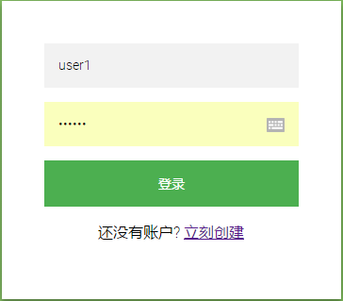

* 1. User registration

If the user name has been registered, enter the user name and password to enter the main interface; If not, click the "create now" button and the registration interface appears, as shown in the figure below:



* 1. The main interface

After successful login, the user can enter the main interface to perform operations such as uploading files, creating new folders, searching, downloading and deleting, as shown in the figure below:

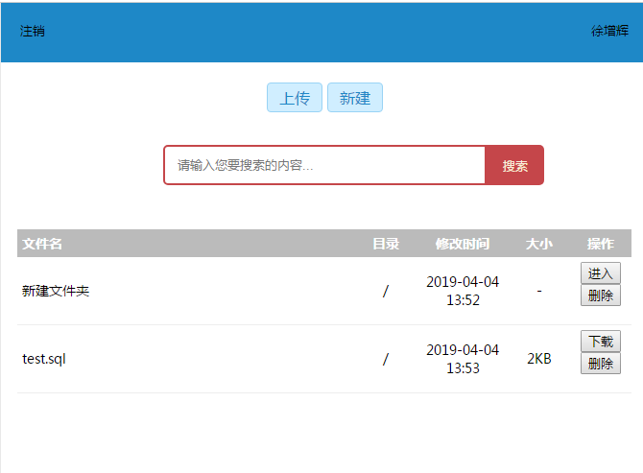

* 1. Folder interface

Click "new" button to display the folder interface, and enter the name of the newly created folder, as shown in the figure below:

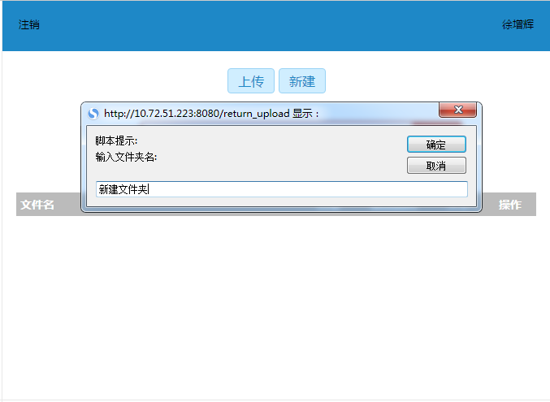

* 1. Download interface

Click the "download" button to display the download interface, and the download box that comes with the browser pops up, as shown in the figure below:

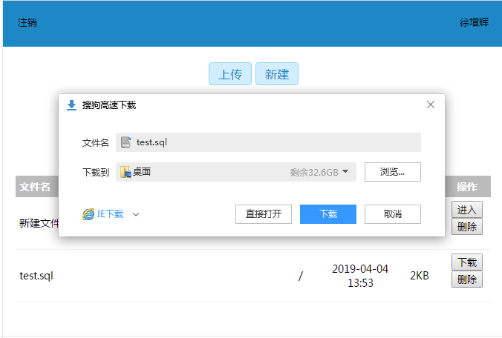

# Test analysis report

## Scopes and main contents of the test

|  |  |  |
| --- | --- | --- |
| Test scope | Main contents | Brief description |
| Client login authentication | Verify the login information and restrict the login with the same name | Functional testing |
| Server run test | Test whether the server can run normally for a long time | Functional testing |
| Upload and download test | Test whether the function of upload and download can be realized normally | Functional testing |
| Data integrity test | Test the integrity of upload and download files | Functional testing |
| Database connection testing | Test whether the database is properly connected to the software | Functional testing |
| Core code review | Verify the quality of the core code | Logical error detection tests |

## Test methods

Functional testing: continuous single tests, paired comparison tests.

## Test report

|  |  |  |
| --- | --- | --- |
| Test project | Test results | Improvements |
| Client login | Achieve normal login | Long response time |
| Server test | It can run steadily for hours on end | No |
| Upload and download tests | A certain number of uploads and downloads without error | No |
| File integrity | Multiple downloaded files can be opened normally | No |
| Database connection | The response is normal and basic operations can be implemented | No |
| Core code review | Good coding style with well-documented internal comments | No |

## Test results

This product has realized all the design tasks, the function realization is correct, may pass.

Copy cloud disk project

**Test Plan**

1. [Introduction](javascript:;)
   1. Writing purpose

This test analysis report details the process of testing the "fake cloud disk project".The purpose is to summarize the test in the test phase and analyze the test results to describe whether the system meets the requirements.

Test analysis report is on the basis of test analysis, test results and test data to be recorded and analyzed.The report is helpful for software developers to read the original program in the future, analyze the original code according to the data and results provided by the test, and master the functions and limitations of each function, so as to shorten the redevelopment time and energy of software developers.

The intended readers of this manual are users, requirements analysts, testers, developers, user document writers, and project managers.

* 1. Project background

Project Name：Copy cloud disk report

Team：11

Group Members:Jing Wang, Zenghui Xu, Mingming Cui, Ting Zhang

Users of the project: network disk individual users

* 1. Test resources

**1.3.1 The human resources**

The following table lists the assumptions made in the staffing of the project:

|  |  |  |
| --- | --- | --- |
| Role | Distribution | Specific duties |
| Test designer | Mingming Cui  Ting Zhang | Develop and maintain test plans, design test cases and test procedures, and generate test analysis reports |
| Tester | Mingming Cui  Ting Zhang | Perform integration tests and system tests, and record test results |
| Designer | Zenghui Xu | Design test drivers and stability piles required |
| Coder | Jing Wang | Write test drivers and stables to perform unit tests |

**1.3.2 Test environment**

The following table lists the system environment under test:

|  |
| --- |
| Software environment (related software, operating system, etc.) |
| Operating system: Windows 10 version |
| Application server and Web server：IIS5 or above |
| Database system: MySQL |
| Client software: MS Internet Explorer or Firefox and other browsers and office software. |
| Hardware environment (network, equipment, etc.) |
| High requirements for the machine configuration that doubles as application server, Web server and database server: 256M + memory, PIII500MHz + CPU, 10G + available hard disk space |
| Clients can simply use the browser and Office software. |
| Network conditions and equipment: network connection CARDS or modems. |

1. Test Plan Implementation

2.1 Test object and content

The testing phase includes unit testing, integration testing, system testing, performance testing, acceptance testing, and evaluation of testing.

The test type mentioned in this plan is the test in the requirements phase, namely the test process of functional verification on the cloud disk system.

**2.1.1 Characteristics to prepare for testing**

The following characteristics will be tested to ensure that the "Copy cloud disk project" meets the specified requirements:

* User information module

1. User registration, login and logout
2. Management of users' personal data

* File management module

1. Upload and download files
2. File deletion
3. File search

**2.1.2 Features not prepared for testing**

The following functions and system configuration do not need to be tested:

The installation and functionality of the relational database (MySQL) will not be considered for this test.Assume that the database is installed and operational assume that the database table structure is accurate and contains the specified types and field widths defined in the requirements specification.These requirements are detailed in the requirements analysis and detailed design documents.

2.2 Testing progress

The following table is the test schedule:

|  |  |  |  |
| --- | --- | --- | --- |
| Test activities | Project commencement date | Actual start date | End date |
| Develop test plan | 4.7 | 4.7 | 4.8 |
| Integration test 2 days | 4.9 | 4.8 | 4.10 |
| Functional test 2 days | 4.11 | 4.11 | 4.12 |
| User interface test for 1 day | 4.12 | 4.12 | 4.13 |
| Performance test for 1 day | 4.13 | 4.13 | 4.14 |
| Evaluate the test for 1 day | 4.15 | 4.14 | 4.15 |

1. Deliverables

3.1 Test documentation

**3.1.1 Test reference document**

Copy cloud disk project plan

Copy cloud disk project requirement analysis and detailed design specification

**3.1.2 Test submission**

The submitted documents after the completion of this test include:

Test plan, test case design document, test Bug list, test summary, test analysis report

3.2 Systematic risk

In this system test environment, the possible risks are as follows:

1. Bug fixes

2. Realization of module functions

3. Realization of the overall function of the system

4. Coding quality

People experience and familiarity with software

6. Implementation of project agreement by developers and testers

7. Personnel adjustment leads to delay of r&d cycle

8. Some test plans cannot be executed due to the shortened development time

3.3 The test strategy

The test strategy provides a recommended way to test test objects.The following is a list of test methods that may be used at various stages of the system testing.

Test case flow chart, as shown below:



**3.3.1 Integration testing**

The main purpose of integration test is to test whether the system meets the design requirements, whether the processing of business process and data flow conforms to the standards, whether the logic is not rigorous and wrong in the processing of business process, and whether the testing requirements have unreasonable standards and requirements.This phase of testing is based on functional completion.

Specific requirements of integration test are shown in the following table:

|  |  |
| --- | --- |
| Test objectives | Test the correctness of business process and data flow in requirements |
| Test range | A business process defined in a requirement, or a combination of different functional modules to form a large function. |
| technology | Use valid and invalid data to execute each use case, use case flow, or function to verify the following: |
| To the standard | Expect results when using valid data. |
| Complete the standard | Displays an error message or warning message when invalid data is used. |
| Test priorities and priorities | The business rules are applied correctly. |
| Special considerations | Standards must be met when completing an integration test |

**3.3.2 A functional test**

Functional testing of test objects should focus on all test requirements that can be directly traced to business functions and business rules.Such tests are based on black box technology, which verifies the application and its internal processes by interacting with the application through a graphical user interface (GUI) and analyzing the output or results of the interaction.The recommended test profiles for various applications are listed below:

Specific requirements for functional testing are shown in the following table:

|  |  |
| --- | --- |
| Test objectives | Ensure that the test functions, including navigation, data input, processing and retrieval functions. |
| Test range | The functions required in a specification |
| technology | Use valid and invalid data to execute each use case to verify the following:  Expect results when using valid data.  Displays an error message or warning message when invalid data is used.  The business rules are applied correctly. |
| Special considerations | Identify or describe matters or factors (internal or external) that will affect the implementation and execution of functional tests |

**3.3.3 User interface testing**

Test the graphical user interface with Internet Explorer and Firefox.Ask to test what will work on both browsers

Specific requirements for interface testing are shown in the following table:

|  |  |
| --- | --- |
| Test objectives | The functions and requirements of the business can be correctly reflected by the browsing through tests, including window to window, field to field browsing, and the use of various access methods (Tab key, mouse movement, and shortcut keys).  The objects and characteristics of the window (for example, menu, size, location, state, and center) meet the criteria. |
| Technology | Create or modify tests for each window to verify that each application window and object is properly browsed and in the normal object state. |
| Complete the standard | Successfully verify that each window is consistent with the base version or acceptable standards |

**3.3.4 The performance test**

Performance profiling is a performance test that measures and evaluates response times, transaction rates, and other time-related requirements.The goal of a performance measurement is to verify that all performance requirements have been met.

Specific requirements of performance test are shown in the following table:

|  |  |
| --- | --- |
| Test objectives | Verify the performance behavior of a specified transaction or business function when:  Normal expected workload  The expected heaviest workload |
| Technology | Use test procedures developed for functional or business cycle testing.  Increase the number of transactions by modifying the data file, or increase the number of iterations per transaction by modifying the script.  The script should run on a single machine (preferably on a single user, single transaction basis) and be repeated on multiple clients (virtual or real clients, see "special considerations" below). |
| Complete the standard | Single transaction or single user: the test script completes successfully within the expected time range of each transaction without any failure.  Multiple transactions or multiple users: the test script completes successfully within an acceptable time frame without any failure. |
| Special considerations | Comprehensive performance testing also includes adding background workload to the server.  This can be done in a number of ways, including:  Performance tests should be performed on dedicated computers or within dedicated machine hours for complete control and accurate measurements.  The database used for the performance test should be a database of the actual size or the same scaling. |

1. Test results and findings

4.1 Software evaluation scale

The test results can be roughly divided into four categories:

Type 1: test cases execute correctly, as expected, and no errors are found.

Type 2: can correctly complete the functional requirements, but there are some problems in the process of test case execution, such as interface, prompts, inconvenient use, etc., for which no further treatment is generally needed and can often be ignored.

Type 3: can correctly complete the main test function points, can't correctly complete some secondary function points, or can't correctly handle some special input combinations with low probability, such problems should not affect the overall correctness of test cases.

Type 4: failure to perform the primary function that the test case is intended to check for, or failure to do so will result in numerous remediation actions.

Evaluation scale of test work: the system can achieve the results of the first three types of system test.

4.2 Test results and findings

**4.2.1 Functional test results**

Functional test results are shown in the following table:

|  |  |
| --- | --- |
| The test item | evaluation |
| User registration | normal |
| The user login | normal |
| File upload | normal |
| The file to view | normal |
| File deletion | normal |
| File search | normal |
| File download | normal |

**4.2.2 User interface test results**

Test results of the user interface are shown in the following table:

|  |  |
| --- | --- |
| The test item | evaluation |
| The state of various elements | normal |
| Whether the layout of various elements is reasonable | reasonable |
| Whether the colors of various elements are in harmony | Yes |
| Whether the operation sequence is reasonable | reasonable |
| Is there a hint for a risky operation | No |
| Whether data items are correctly echoed | can |
| Whether the font is beautiful | Yes |
| Window move, switch, change size is normal | normal |

**4.2.3 Performance test results**

Performance test results are shown in the following table:

|  |  |
| --- | --- |
| The test item | evaluation |
| Upload files at speeds up to 100 megabytes | fast |
| Upload file speed over 100M | slow |
| Download speeds up to 100 megabytes | fast |
| Download files at speeds over 100 megabytes | slow |

1. Evaluation

5.1 Software capabilities

Cloud disk system basically realized the functions of the original design, and can be put into use after detailed test modification and function description.

Differences between the test environment and the actual running environment can lead to inconsistent response times.Everything else.

5.2 Defects and limitations

The whole software function is relatively single, and the simplicity in database table design may lead to slow access when the data is large.

The confidentiality of network transmission, security and database security still have some defects.There is no corresponding solution for statement injection and other security risks.

The constraints in the qualified input box are incomplete.

The overall function needs to be further improved.

5.3 Advice

The functions of the system can be gradually added and improved in the future use.

5.4 Evaluation

This project basically realized the functional requirements proposed in the demand analysis report. Due to various reasons, it is a pity that some functions are still not implemented on time. The completed related modules have a certain robustness and security.

The team is still in the exploratory stage with insufficient experience and is not mature in all aspects, so there may still be many problems in the system that need to be further improved.

Conclusion

The software project management course has come to the end of the semester, and the project of our group has been completed. In the whole process of the project, from the formulation of requirements analysis documents and code writing to the detailed design and testing of software functions, our team members have been working hard to learn relevant knowledge, from which we really gained a lot.

1. The personnel arrangement responsibilities of the software project team should be clear, and there should be supporting management records. The work progress of each member should be arranged and updated at any time, so as to facilitate the communication between team members.
2. Careful planning can help the project avoid many detours, and timely find problems and solve them.
3. The test stage should consider all kinds of situations, and it can't be completed after writing the code. When you finish writing the code, you should test all the conditions you consider, and then consider the relevant data changes.
4. In the design and implementation of cloud disk system, there are many problems that need to be considered. Some problems have been solved with the query of data, but the system still has shortcomings. For example, it does not support the uploading of large files, it is a little slow to download files, it lacks the function of recycling and sharing, and so on, these problems need to be solved in the future work.