Name: **Zachary Talarick** Date: **3/12/19**

**I pledge my honor that I have abided by the Stevens Honor System.**

Point values are assigned for each question. Points earned: ____ / 100

Consider the following graph:

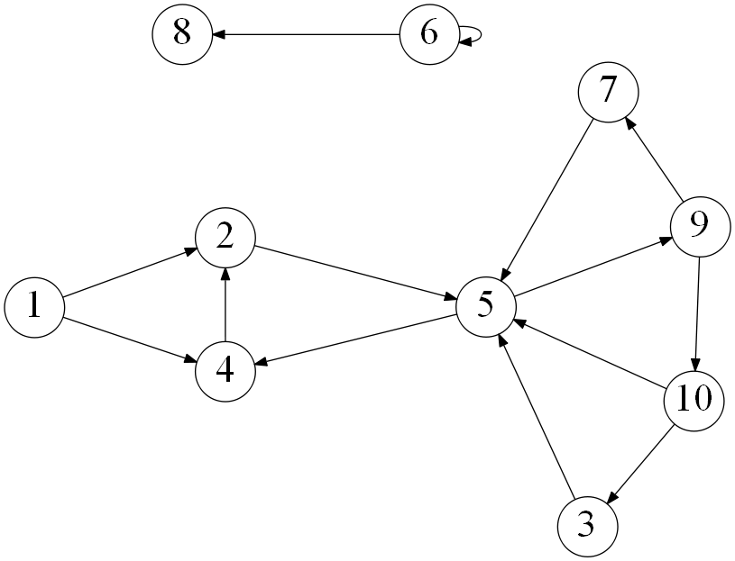

1. Draw how the graph would look if represented by an adjacency matrix. You may assume the indexes are from 1 through 10. Indicate 1 if there is an edge from vertex A -> vertex B, and 0 otherwise. (10 points)

|  |  |  |  |  |  |  |  |  |  |  |
| --- | --- | --- | --- | --- | --- | --- | --- | --- | --- | --- |
|  | 1 | 2 | 3 | 4 | 5 | 6 | 7 | 8 | 9 | 10 |
| 1 | 0 | 1 | 0 | 1 | 0 | 0 | 0 | 0 | 0 | 0 |
| 2 | 0 | 0 | 0 | 0 | 1 | 0 | 0 | 0 | 0 | 0 |
| 3 | 0 | 0 | 0 | 0 | 1 | 0 | 0 | 0 | 0 | 0 |
| 4 | 0 | 1 | 0 | 0 | 0 | 0 | 0 | 0 | 0 | 0 |
| 5 | 0 | 0 | 0 | 1 | 0 | 0 | 0 | 0 | 1 | 0 |
| 6 | 0 | 0 | 0 | 0 | 0 | 1 | 0 | 1 | 0 | 0 |
| 7 | 0 | 0 | 0 | 0 | 1 | 0 | 0 | 0 | 0 | 0 |
| 8 | 0 | 0 | 0 | 0 | 0 | 0 | 0 | 0 | 0 | 0 |
| 9 | 0 | 0 | 0 | 0 | 0 | 0 | 1 | 0 | 0 | 1 |
| 10 | 0 | 0 | 1 | 0 | 1 | 0 | 0 | 0 | 0 | 0 |

1. Draw how the graph would look if represented by an adjacency list. You may assume the indexes are from 1 through 10. (10 points)

|  |  |  |  |  |
| --- | --- | --- | --- | --- |
| 1 | 2 | 4 |  |  |
| 2 | 5 |  |  |  |
| 3 | 5 |  |  |  |
| 4 | 2 |  |  |  |
| 5 | 4 | 9 |  |  |
| 6 | 6 | 8 |  |  |
| 7 | 5 |  |  |  |
| 8 |  |  |  |  |
| 9 | 7 | 10 |  |  |
| 10 | 3 | 5 |  |  |

1. List the order in which the vertices are visited with a breadth-first search. If there are multiple vertices adjacent to a given vertex, visit the adjacent vertex with the lowest value first. (10 points)

**1, 2 , 4, 5, 9, 7, 10, 3, 6, 8**

1. List the order in which the vertices are visited with a depth-first search. If there are multiple vertices adjacent to a given vertex, visit the adjacent vertex with the lowest value first. (10 points)

**1, 2, 5, 9, 7, 10, 3, 4, 6, 8**

1. a) What is the running time of breadth-first search with an adjacency matrix? (5 points)

**O(V ^ 2)**

b) What is the running time of breadth-first search with an adjacency list? (5 points)

**O(V + E)**

1. a) What is the running time of depth-first search with an adjacency matrix? (5 points)

**O(V ^ 2)**

b) What is the running time of depth-first search with an adjacency list? (5 points)

**O(V + E)**

1. While an adjacency matrix is typically easier to code than an adjacency list, it is not always a better solution. Explain when an adjacency list is a clear winner in the efficiency of your algorithm? (5 points)

**For very small graphs an adjacency list is much better since it only accesses actual connections, instead of the adjacency matrix where it will access all relationships even with no connection.**

1. Explain how one can use a breadth-first to determine if an undirected graph contains a cycle. (10 points)

**If a vertex connects to an already visited vertex then there is a cycle**

1. On undirected graphs, does either of the two traversals, DFS or BFS, always find a cycle faster than the other? If yes, indicate which of them is better and explain why it is the case; if not, draw two graphs supporting your answer and explain the graphs. (10 points)

**DFS, since it goes all the way through, back to the beginning. A BFS must go to all other elements on the way first.**

1. Explain why a topological sort is not possible on the graph at the very top of this document. (5 points)

**6 points to itself**

Consider the following graph:

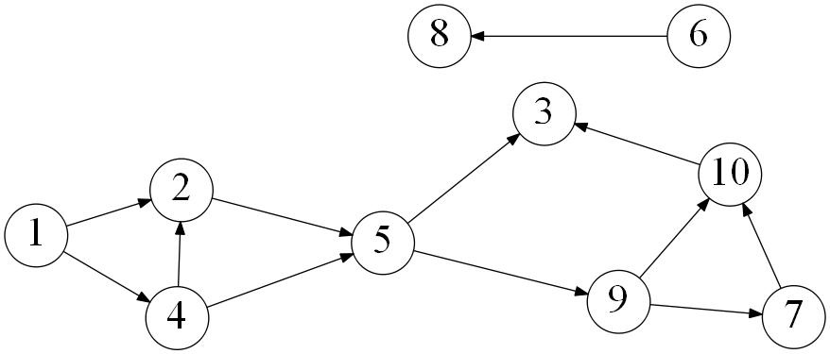

1. List the order in which the vertices are visited with a topological sort. Break ties by visiting the vertex with the lowest value first. (10 points)

**1, 4, 2, 5, 6, 8, 9, 7, 10, 3**