Name: **Zachary Talarick** Date: **3/4/2019**

Pledge: **I pledge my honor that I have abided by the Stevens Honor System.**

For each of the graphs below, list the order in which the vertices are visited in a **breadth-first search**, starting with vertex 1. If there are multiple vertices adjacent to a given vertex, visit the adjacent vertex with the lowest value first. Then repeat the process for **depth-first search**.

1. 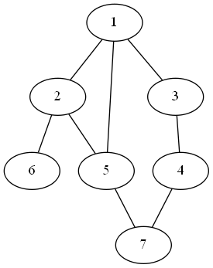

BFS: **1, 2, 3, 5, 6, 4, 7**

DFS: **1, 2, 5, 7, 6, 3, 4**

1. 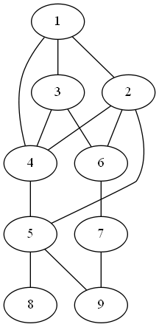

BFS: **1, 2, 3, 4, 5, 6, 8, 9, 7**

DFS: **1, 2, 4, 5, 8, 9, 4, 6, 7**

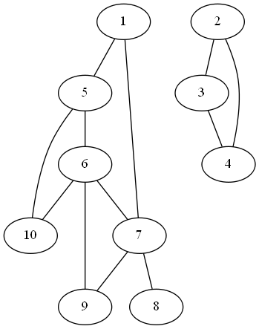

BFS: **1, 5, 7, 6, 10, 7, 9, 8, 2, 3, 4**

DFS: **1, 5, 6, 7, 8, 9, 10, 2, 3, 4**

For each of the graphs below, list the order in which the vertices are visited in a **topological sort**, starting with vertex 1. If there are multiple vertices adjacent to a given vertex, visit the adjacent vertex with the lowest value first.

1. 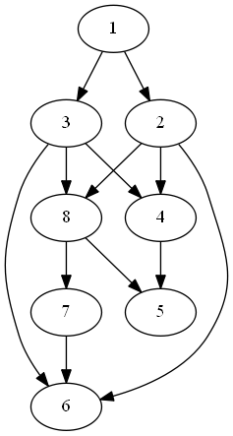

Topological sort: **1, 2, 3, 4, 6, 8, 5, 7**

1. 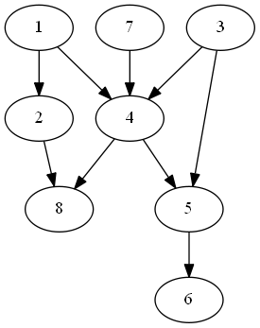

Topological sort: **1, 3, 7, 2, 4, 5, 8, 6**