**ENSF510 LAB04: Paper Type Analyzer Manual**

**Author: Ziyuan Tang**

**Introduction:**

This project is to use a photoresistor to analyze whether if a paper is print paper or sketch paper by measuring the resistance change between before and after cover the paper on top of the sensor. Data is collected by using Raspberry Pi. Data is sent to Azure iot hub and then sent to computer. The computer will pass the data to machine learning model and predict the type of paper.

**Set Up:**

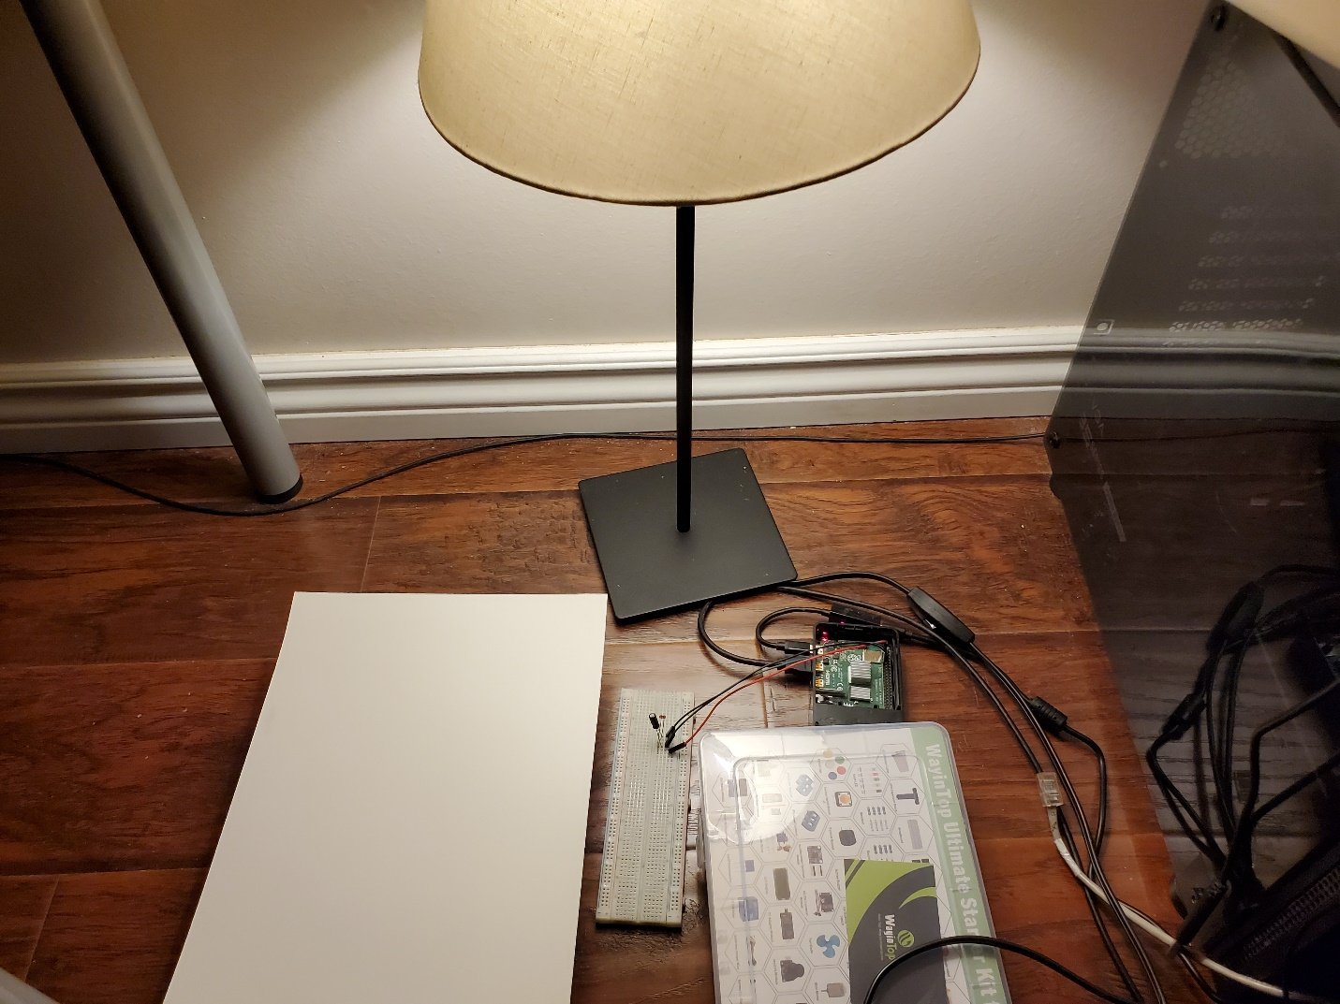

**How to Run**

To run this project, simply change connection string and device id in “receive_message.py” and “pushdata.py” to the one provided from the target iot hub.

Then run “receive_message.py” from computer and “pushdata.py” from Raspberry Pi(Note “pushdata.py” requires ”light_sensor.py” on the same directory to run )

Hit enter on Raspberry Pi terminal, once the “put your paper on” message pop up, put the tested paper on top of the photoresistor.

The prediction will be posted on the computer terminal