**Sphero BOLT Animation**

Author: Ziyuan Tang

**Task:**

The task of this lab is to control a Sphero BOLT robot to make it spin 720° and then play a short animation using its LED. This task is fulfilled through coding in Sphero Edu app and sending instructions to Sphero BOLT through Bluetooth.

**Result:**

Screenshot of the system and result:

The animation is sketched in Sphero Edu block program as showing:

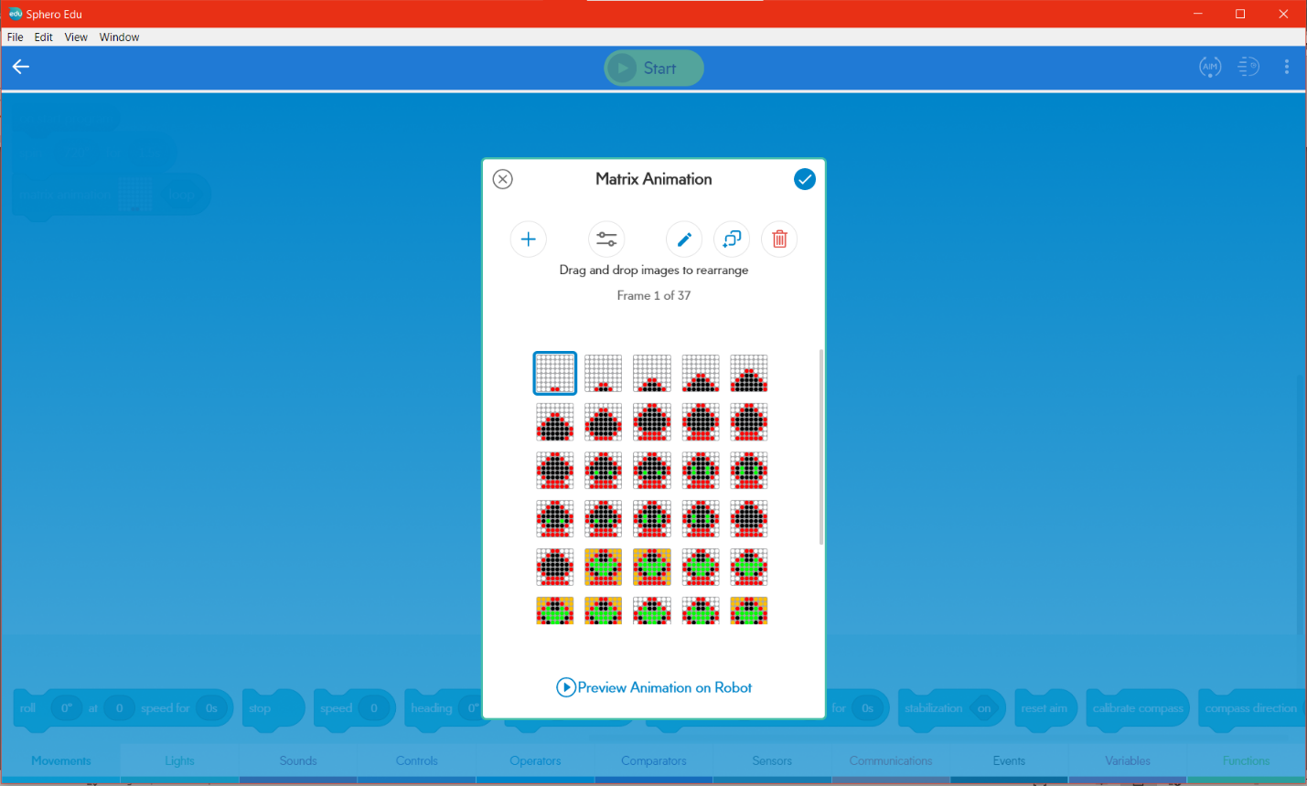

The whole program is exported to JavaScript Code attached in this folder and showed as following:

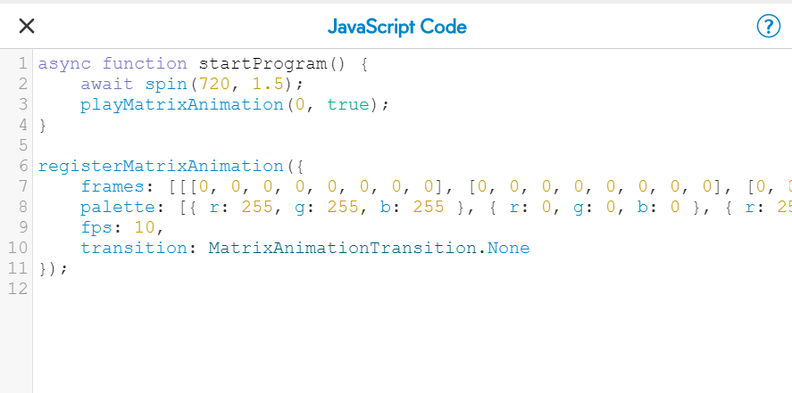

A demo video can be found in the folder of this file.