**Virtual Weather Forecaster Result**

Author: Ziyuan Tang

**Task:**

This project is to use Raspberry Pi to collect temperature, humidity and photoresistance data. Then send data to Azure ML and generate a weather forecast on desktop. The machine learning will predict the precipitation level based on humidity and temperature. The desktop has a virtual assistant to handle users’ requests and give the weather forecast speech.

**Inspiration:**

The inspiration of this project is from virtual assistance such as Siri, Bixby, Alexa. Code to build the virtual assistant is from “How To Build A Digital Virtual Assistant In Python”[1].

**Result:**

Since the result is speech, it can only be presented in demo video; however, the text of the speech is recorded in the terminal as shown in the picture. Video link: <https://www.youtube.com/watch?v=XWIJkW8doQM>

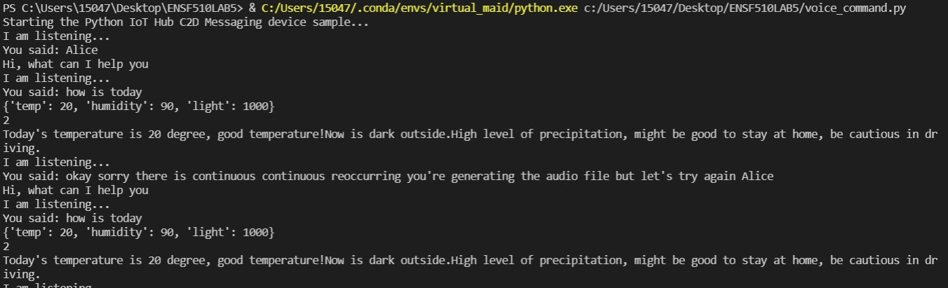

**Screenshot of Codes:**

**Main code on desktop**

**Code to push sensor data:**

**Reference:**

[1] Virtual assistance code: <https://www.activestate.com/blog/how-to-build-a-digital-virtual-assistant-in-python/>

[2] DTH 11 sensor code: <https://peppe8o.com/using-raspberry-pi-with-dht11-temperature-and-humidity-sensor-and-python/>

[3] Photo resistor sensor code: <https://github.com/chris-gong/forty-yard-dash-rpi/blob/master/photoResistorTest.py>