Works with 1 IP:
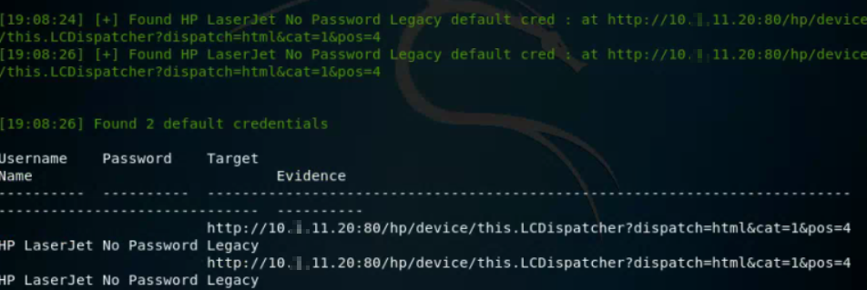

Works using a file with 2 IP’s:
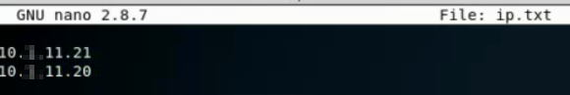
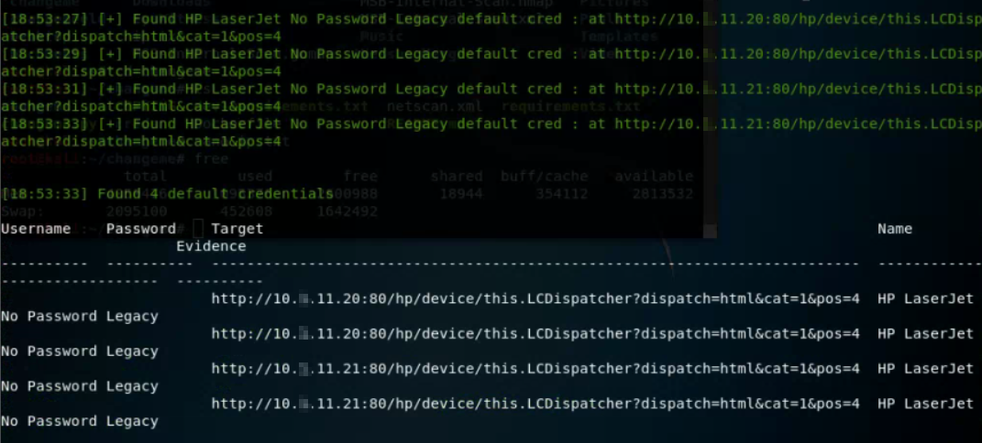

File with 100 IP’s: No default credentials found with several errors
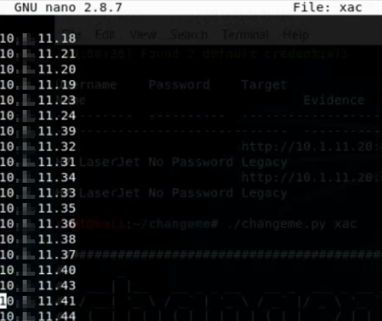

No default credentials found
Process Process-13:
Traceback (most recent call last):
File "/usr/lib/python2.7/multiprocessing/process.py", line 267, in _bootstrap
self.run()
File "/usr/lib/python2.7/multiprocessing/process.py", line 114, in run
self._target(*self._args, **self._kwargs)
File "/root/changeme/changeme/scan_engine.py", line 107, in fingerprint_targets
while self.fingerprints.qsize() != 0:
File "<string>", line 2, in qsize
File "/usr/lib/python2.7/multiprocessing/managers.py", line 758, in _callmethod
conn.send((self._id, methodname, args, kwds))
IOError: [Errno 32] Broken pipe
Process Process-12:
Traceback (most recent call last):
File "/usr/lib/python2.7/multiprocessing/process.py", line 267, in _bootstrap
self.run()
File "/usr/lib/python2.7/multiprocessing/process.py", line 114, in run
self._target(*self._args, **self._kwargs)
File "/root/changeme/changeme/scan_engine.py", line 107, in fingerprint_targets
while self.fingerprints.qsize() != 0:
File "<string>", line 2, in qsize
File "/usr/lib/python2.7/multiprocessing/managers.py", line 758, in _callmethod
conn.send((self._id, methodname, args, kwds))
IOError: [Errno 32] Broken pipe
Process Process-11:
Traceback (most recent call last):
File "/usr/lib/python2.7/multiprocessing/process.py", line 267, in _bootstrap
self.run()
File "/usr/lib/python2.7/multiprocessing/process.py", line 114, in run
self._target(*self._args, **self._kwargs)
File "/root/changeme/changeme/scan_engine.py", line 107, in fingerprint_targets
while self.fingerprints.qsize() != 0:
File "<string>", line 2, in qsize
File "/usr/lib/python2.7/multiprocessing/managers.py", line 758, in _callmethod
conn.send((self._id, methodname, args, kwds))
IOError: [Errno 32] Broken pipe
Process Process-10:
Traceback (most recent call last):
File "/usr/lib/python2.7/multiprocessing/process.py", line 267, in _bootstrap
self.run()
File "/usr/lib/python2.7/multiprocessing/process.py", line 114, in run
self._target(*self._args, **self._kwargs)
File "/root/changeme/changeme/scan_engine.py", line 107, in fingerprint_targets
while self.fingerprints.qsize() != 0:
File "<string>", line 2, in qsize
File "/usr/lib/python2.7/multiprocessing/managers.py", line 758, in _callmethod
conn.send((self._id, methodname, args, kwds))
IOError: [Errno 32] Broken pipe
Process Process-9:
Traceback (most recent call last):
File "/usr/lib/python2.7/multiprocessing/process.py", line 267, in _bootstrap
self.run()
File "/usr/lib/python2.7/multiprocessing/process.py", line 114, in run
self._target(*self._args, **self._kwargs)
File "/root/changeme/changeme/scan_engine.py", line 107, in fingerprint_targets
while self.fingerprints.qsize() != 0:
File "<string>", line 2, in qsize
File "/usr/lib/python2.7/multiprocessing/managers.py", line 758, in _callmethod
conn.send((self._id, methodname, args, kwds))
IOError: [Errno 32] Broken pipe
Process Process-8:
Traceback (most recent call last):
File "/usr/lib/python2.7/multiprocessing/process.py", line 267, in _bootstrap
self.run()
File "/usr/lib/python2.7/multiprocessing/process.py", line 114, in run
self._target(*self._args, **self._kwargs)
File "/root/changeme/changeme/scan_engine.py", line 107, in fingerprint_targets
while self.fingerprints.qsize() != 0:
File "<string>", line 2, in qsize
File "/usr/lib/python2.7/multiprocessing/managers.py", line 758, in _callmethod
conn.send((self._id, methodname, args, kwds))
IOError: [Errno 32] Broken pipe
Process Process-6:
Traceback (most recent call last):
File "/usr/lib/python2.7/multiprocessing/process.py", line 267, in _bootstrap
self.run()
File "/usr/lib/python2.7/multiprocessing/process.py", line 114, in run
self._target(*self._args, **self._kwargs)
File "/root/changeme/changeme/scan_engine.py", line 107, in fingerprint_targets
while self.fingerprints.qsize() != 0:
File "<string>", line 2, in qsize
File "/usr/lib/python2.7/multiprocessing/managers.py", line 758, in _callmethod
conn.send((self._id, methodname, args, kwds))
IOError: [Errno 32] Broken pipe
Process Process-5:
Traceback (most recent call last):
File "/usr/lib/python2.7/multiprocessing/process.py", line 267, in _bootstrap
self.run()
File "/usr/lib/python2.7/multiprocessing/process.py", line 114, in run
self._target(*self._args, **self._kwargs)
File "/root/changeme/changeme/scan_engine.py", line 107, in fingerprint_targets
while self.fingerprints.qsize() != 0:
File "<string>", line 2, in qsize
File "/usr/lib/python2.7/multiprocessing/managers.py", line 758, in _callmethod
conn.send((self._id, methodname, args, kwds))
IOError: [Errno 32] Broken pipe
Process Process-4:
Traceback (most recent call last):
File "/usr/lib/python2.7/multiprocessing/process.py", line 267, in _bootstrap
self.run()
File "/usr/lib/python2.7/multiprocessing/process.py", line 114, in run
self._target(*self._args, **self._kwargs)
File "/root/changeme/changeme/scan_engine.py", line 107, in fingerprint_targets
while self.fingerprints.qsize() != 0:
File "<string>", line 2, in qsize
File "/usr/lib/python2.7/multiprocessing/managers.py", line 758, in _callmethod
conn.send((self._id, methodname, args, kwds))
IOError: [Errno 32] Broken pipe
Process Process-7:
Traceback (most recent call last):
File "/usr/lib/python2.7/multiprocessing/process.py", line 267, in _bootstrap
self.run()
File "/usr/lib/python2.7/multiprocessing/process.py", line 114, in run
self._target(*self._args, **self._kwargs)
File "/root/changeme/changeme/scan_engine.py", line 107, in fingerprint_targets
while self.fingerprints.qsize() != 0:
File "<string>", line 2, in qsize
File "/usr/lib/python2.7/multiprocessing/managers.py", line 758, in _callmethod
conn.send((self._id, methodname, args, kwds))
IOError: [Errno 32] Broken pipe

Using subnet: No default credentials found with several errors
No default credentials found
Process Process-11:
Traceback (most recent call last):
File "/usr/lib/python2.7/multiprocessing/process.py", line 267, in _bootstrap
self.run()
File "/usr/lib/python2.7/multiprocessing/process.py", line 114, in run
self._target(*self._args, **self._kwargs)
File "/root/changeme/changeme/scan_engine.py", line 107, in fingerprint_targets
while self.fingerprints.qsize() != 0:
File "<string>", line 2, in qsize
File "/usr/lib/python2.7/multiprocessing/managers.py", line 759, in _callmethod
kind, result = conn.recv()
IOError: [Errno 104] Connection reset by peer
Process Process-12:
Traceback (most recent call last):
File "/usr/lib/python2.7/multiprocessing/process.py", line 267, in _bootstrap
self.run()
File "/usr/lib/python2.7/multiprocessing/process.py", line 114, in run
self._target(*self._args, **self._kwargs)
File "/root/changeme/changeme/scan_engine.py", line 107, in fingerprint_targets
while self.fingerprints.qsize() != 0:
File "<string>", line 2, in qsize
File "/usr/lib/python2.7/multiprocessing/managers.py", line 759, in _callmethod
kind, result = conn.recv()
IOError: [Errno 104] Connection reset by peer
Process Process-10:
Traceback (most recent call last):
File "/usr/lib/python2.7/multiprocessing/process.py", line 267, in _bootstrap
self.run()
File "/usr/lib/python2.7/multiprocessing/process.py", line 114, in run
self._target(*self._args, **self._kwargs)
File "/root/changeme/changeme/scan_engine.py", line 107, in fingerprint_targets
while self.fingerprints.qsize() != 0:
File "<string>", line 2, in qsize
File "/usr/lib/python2.7/multiprocessing/managers.py", line 758, in _callmethod
conn.send((self._id, methodname, args, kwds))
IOError: [Errno 32] Broken pipe
Process Process-9:
Traceback (most recent call last):
File "/usr/lib/python2.7/multiprocessing/process.py", line 267, in _bootstrap
self.run()
File "/usr/lib/python2.7/multiprocessing/process.py", line 114, in run
self._target(*self._args, **self._kwargs)
File "/root/changeme/changeme/scan_engine.py", line 107, in fingerprint_targets
while self.fingerprints.qsize() != 0:
File "<string>", line 2, in qsize
File "/usr/lib/python2.7/multiprocessing/managers.py", line 758, in _callmethod
conn.send((self._id, methodname, args, kwds))
IOError: [Errno 32] Broken pipe
Process Process-8:
Traceback (most recent call last):
File "/usr/lib/python2.7/multiprocessing/process.py", line 267, in _bootstrap
self.run()
File "/usr/lib/python2.7/multiprocessing/process.py", line 114, in run
self._target(*self._args, **self._kwargs)
File "/root/changeme/changeme/scan_engine.py", line 107, in fingerprint_targets
while self.fingerprints.qsize() != 0:
File "<string>", line 2, in qsize
File "/usr/lib/python2.7/multiprocessing/managers.py", line 758, in _callmethod
conn.send((self._id, methodname, args, kwds))
IOError: [Errno 32] Broken pipe
Process Process-7:
Traceback (most recent call last):
File "/usr/lib/python2.7/multiprocessing/process.py", line 267, in _bootstrap
self.run()
File "/usr/lib/python2.7/multiprocessing/process.py", line 114, in run
self._target(*self._args, **self._kwargs)
File "/root/changeme/changeme/scan_engine.py", line 107, in fingerprint_targets
while self.fingerprints.qsize() != 0:
File "<string>", line 2, in qsize
File "/usr/lib/python2.7/multiprocessing/managers.py", line 758, in _callmethod
conn.send((self._id, methodname, args, kwds))
IOError: [Errno 32] Broken pipe
Process Process-6:
Process Process-5:
Traceback (most recent call last):
File "/usr/lib/python2.7/multiprocessing/process.py", line 267, in _bootstrap
self.run()
Traceback (most recent call last):
File "/usr/lib/python2.7/multiprocessing/process.py", line 267, in _bootstrap
self.run()
File "/usr/lib/python2.7/multiprocessing/process.py", line 114, in run
self._target(*self._args, **self._kwargs)
File "/root/changeme/changeme/scan_engine.py", line 107, in fingerprint_targets
while self.fingerprints.qsize() != 0:
File "/usr/lib/python2.7/multiprocessing/process.py", line 114, in run
self._target(*self._args, **self._kwargs)
File "/root/changeme/changeme/scan_engine.py", line 107, in fingerprint_targets
File "<string>", line 2, in qsize
File "/usr/lib/python2.7/multiprocessing/managers.py", line 758, in _callmethod
conn.send((self._id, methodname, args, kwds))
while self.fingerprints.qsize() != 0:
File "<string>", line 2, in qsize
File "/usr/lib/python2.7/multiprocessing/managers.py", line 758, in _callmethod
conn.send((self._id, methodname, args, kwds))
IOError: [Errno 32] Broken pipe
IOError: [Errno 32] Broken pipe
Process Process-4:
Traceback (most recent call last):
File "/usr/lib/python2.7/multiprocessing/process.py", line 267, in _bootstrap
self.run()
File "/usr/lib/python2.7/multiprocessing/process.py", line 114, in run
self._target(*self._args, **self._kwargs)
File "/root/changeme/changeme/scan_engine.py", line 107, in fingerprint_targets
while self.fingerprints.qsize() != 0:
File "<string>", line 2, in qsize
File "/usr/lib/python2.7/multiprocessing/managers.py", line 758, in _callmethod
conn.send((self._id, methodname, args, kwds))
IOError: [Errno 32] Broken pipe
Process Process-13:
Traceback (most recent call last):
File "/usr/lib/python2.7/multiprocessing/process.py", line 267, in _bootstrap
self.run()
File "/usr/lib/python2.7/multiprocessing/process.py", line 114, in run
self._target(*self._args, **self._kwargs)
File "/root/changeme/changeme/scan_engine.py", line 107, in fingerprint_targets
while self.fingerprints.qsize() != 0:
File "<string>", line 2, in qsize
File "/usr/lib/python2.7/multiprocessing/managers.py", line 758, in _callmethod
conn.send((self._id, methodname, args, kwds))
IOError: [Errno 32] Broken pipe

