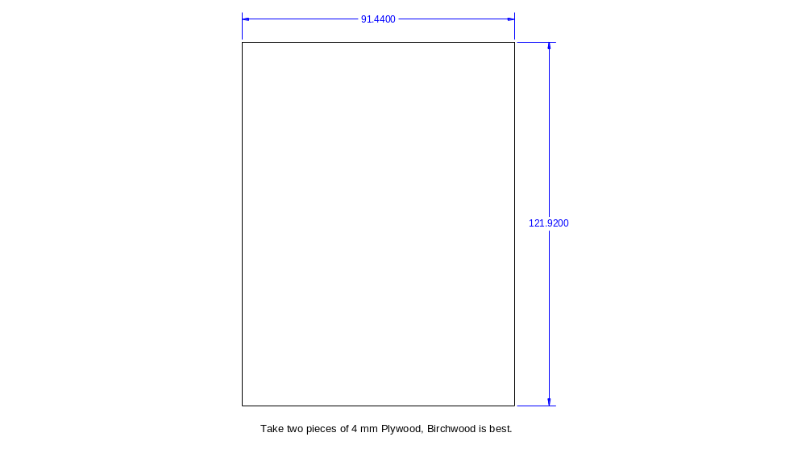
Take two pieces of (Birchwood) plywood
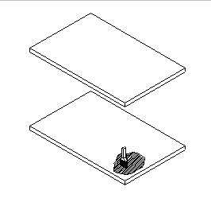
With a paint brush spread carpenter’s glue on one piece, then glue the pieces together. Allow to dry.
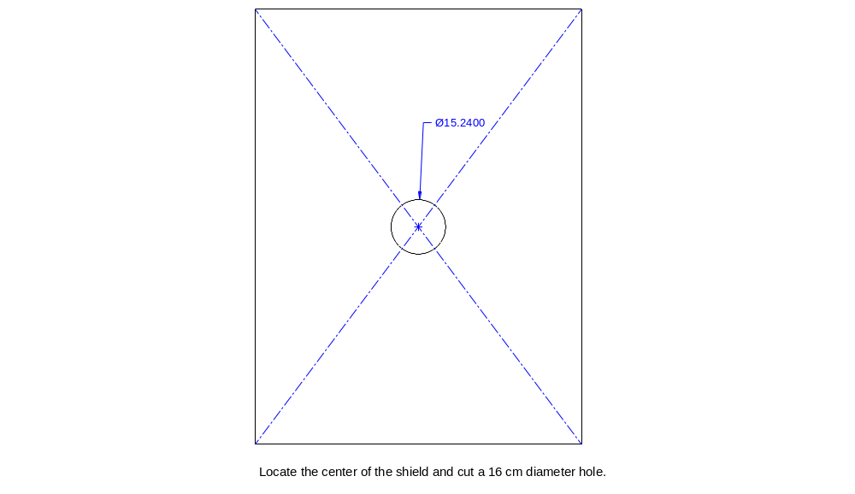
Once dry, locate the center and cut out a hole as shown.

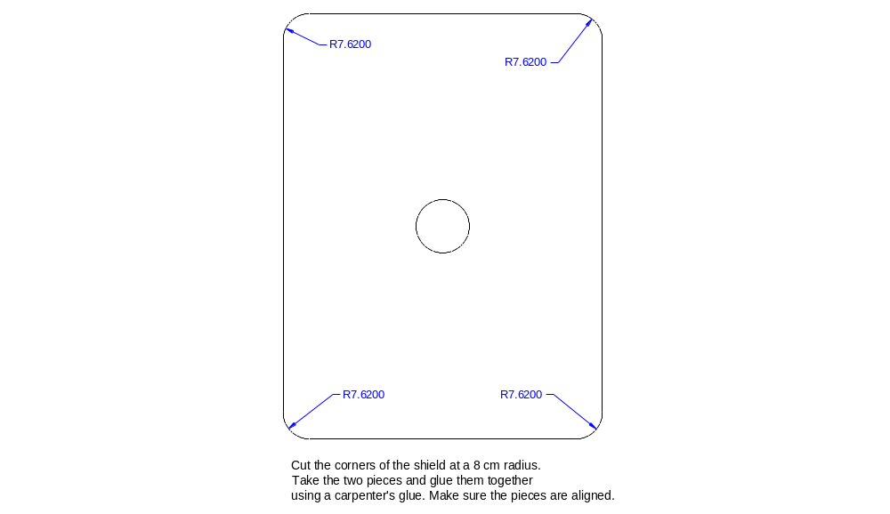
Round off the edges as shown.
Now soak the piece in water overnight then place it in the shield press.
See Press Manual on how to build your press if you do not have one.
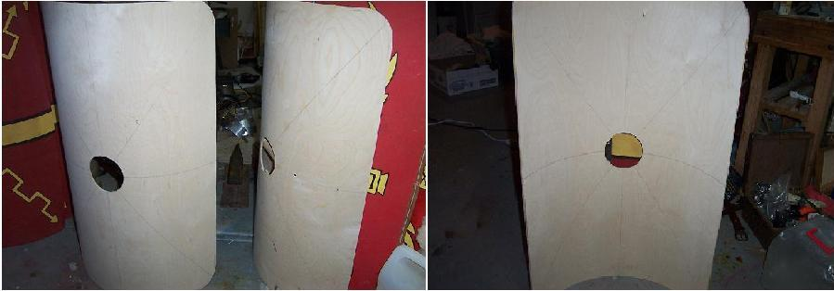
After waiting about 48 hours I remove the piece and I'm left with a nicely curved blank.

Next comes the back bracing. This should be something thin. I use pinewood strips. I locate the bracing 8 cm (approx.) from the shield edge.
Remember the bracing should match the curvature of the shield.
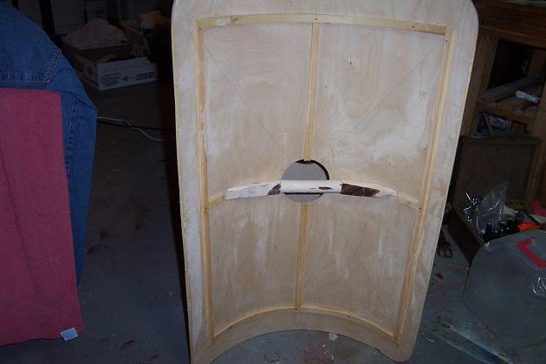
One method of making the curved bracing is to take a piece of 4 mm x 8 cm x 70 cm board soak it overnight and then place it in the press. After it has dried remove from press and cut it into 2 cm strips. The curvature should match the shields exactly.

Making the handle
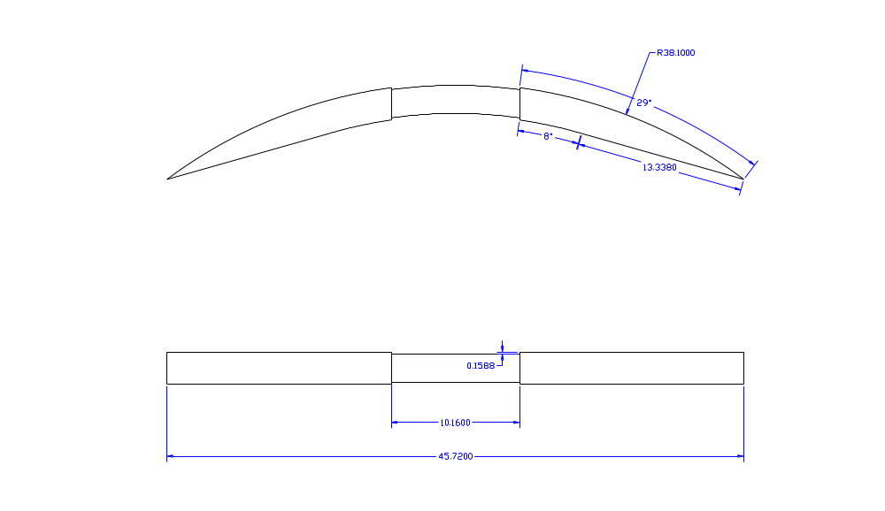

The handle extends back from the umbo hole. I cut a piece of white oak, 3 cm x 3 cm x 45 cm to become the center horizontal back bracing. Trim to fit your shield and install.

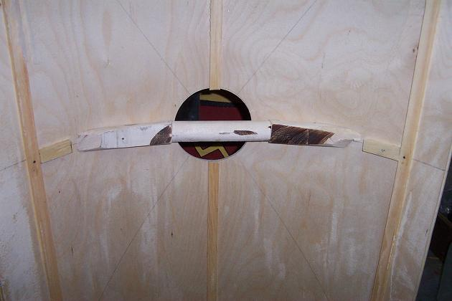

Hold the handle in place with two wood screws counter sunk from the front.
The next thing you will want to do is cover the front and back with linen
Cut out a piece of linen 100 cm x 130 cm, (or as needed).
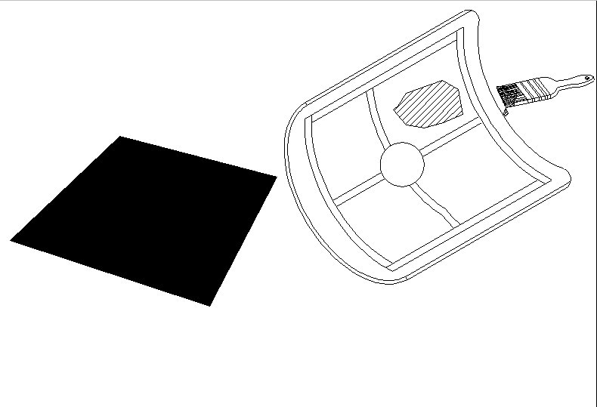
Again using a paint brush cover the back of the shield with a light glue coating and commence applying the linen press the linen into the wood until it is as smooth a fit as you can get. You will have to cut a slit to allow the handle to fit through. Again smooth out the fabric under the handle we will cut out access areas as required when the glue dries. If you have excess fabric left over fold it over the shield edges. All trimming will be done after the glue has dried.

When the glue has dried, trim away excess fabric from the umbo hole and any fabric that impedes the comfortable grip of the handle. Repeat this procedure for front of shield. It will be easier on the front as there is not handle to get in the way.

Painting the shield pattern:
It is important to have your pattern for the shield centered over the boss hole.
This will make the mounting of the boss easier, and also allow for a better looking finished product.
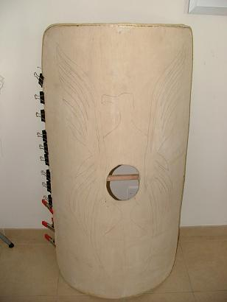
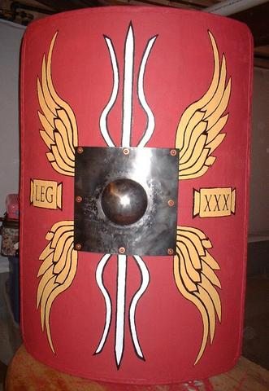

After painting the shield, the boss is affixed to the shield using ¼”x1.5” inch Brass rivets (Why Brass? This is a guess the Romans used copper/bronze/brass rivets a lot). You might want to attach a couple of rings for a carrying strap to the rivets that pass through the handle at this time.

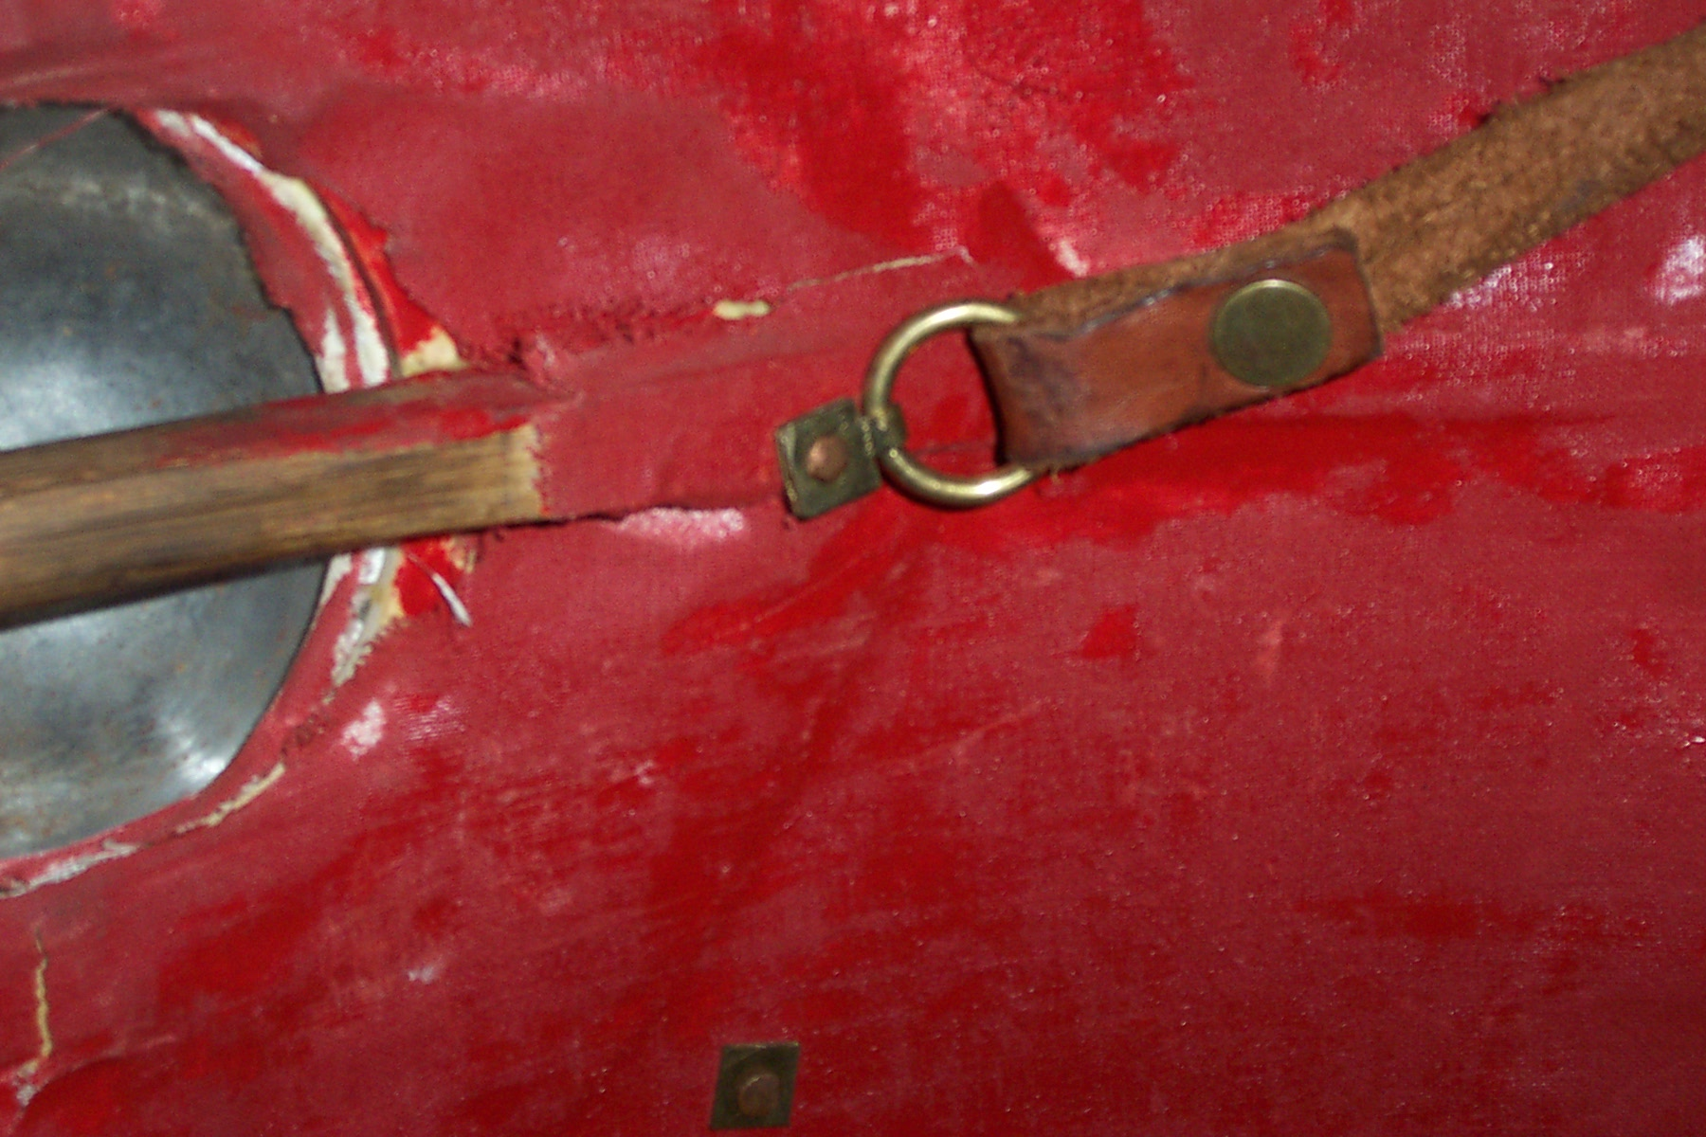

Lastly you do the rim. A rawhide rim is stitched on. Soak the rawhide and clamp the rawhide onto the shield edge overlap any pieces at least 3 cm to allow for shrinkage.

Leave overnight. The rawhide will have dried a bit, but not completely, drill holes every I.5 cm completely through the Rawhide and Shield using a 2 or 3 mm drill bit. Sew on the rim using waxed thread. Alternatively, you may make a brass rim which is more expensive and requires much more detail in manufacturing.
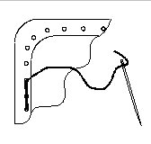
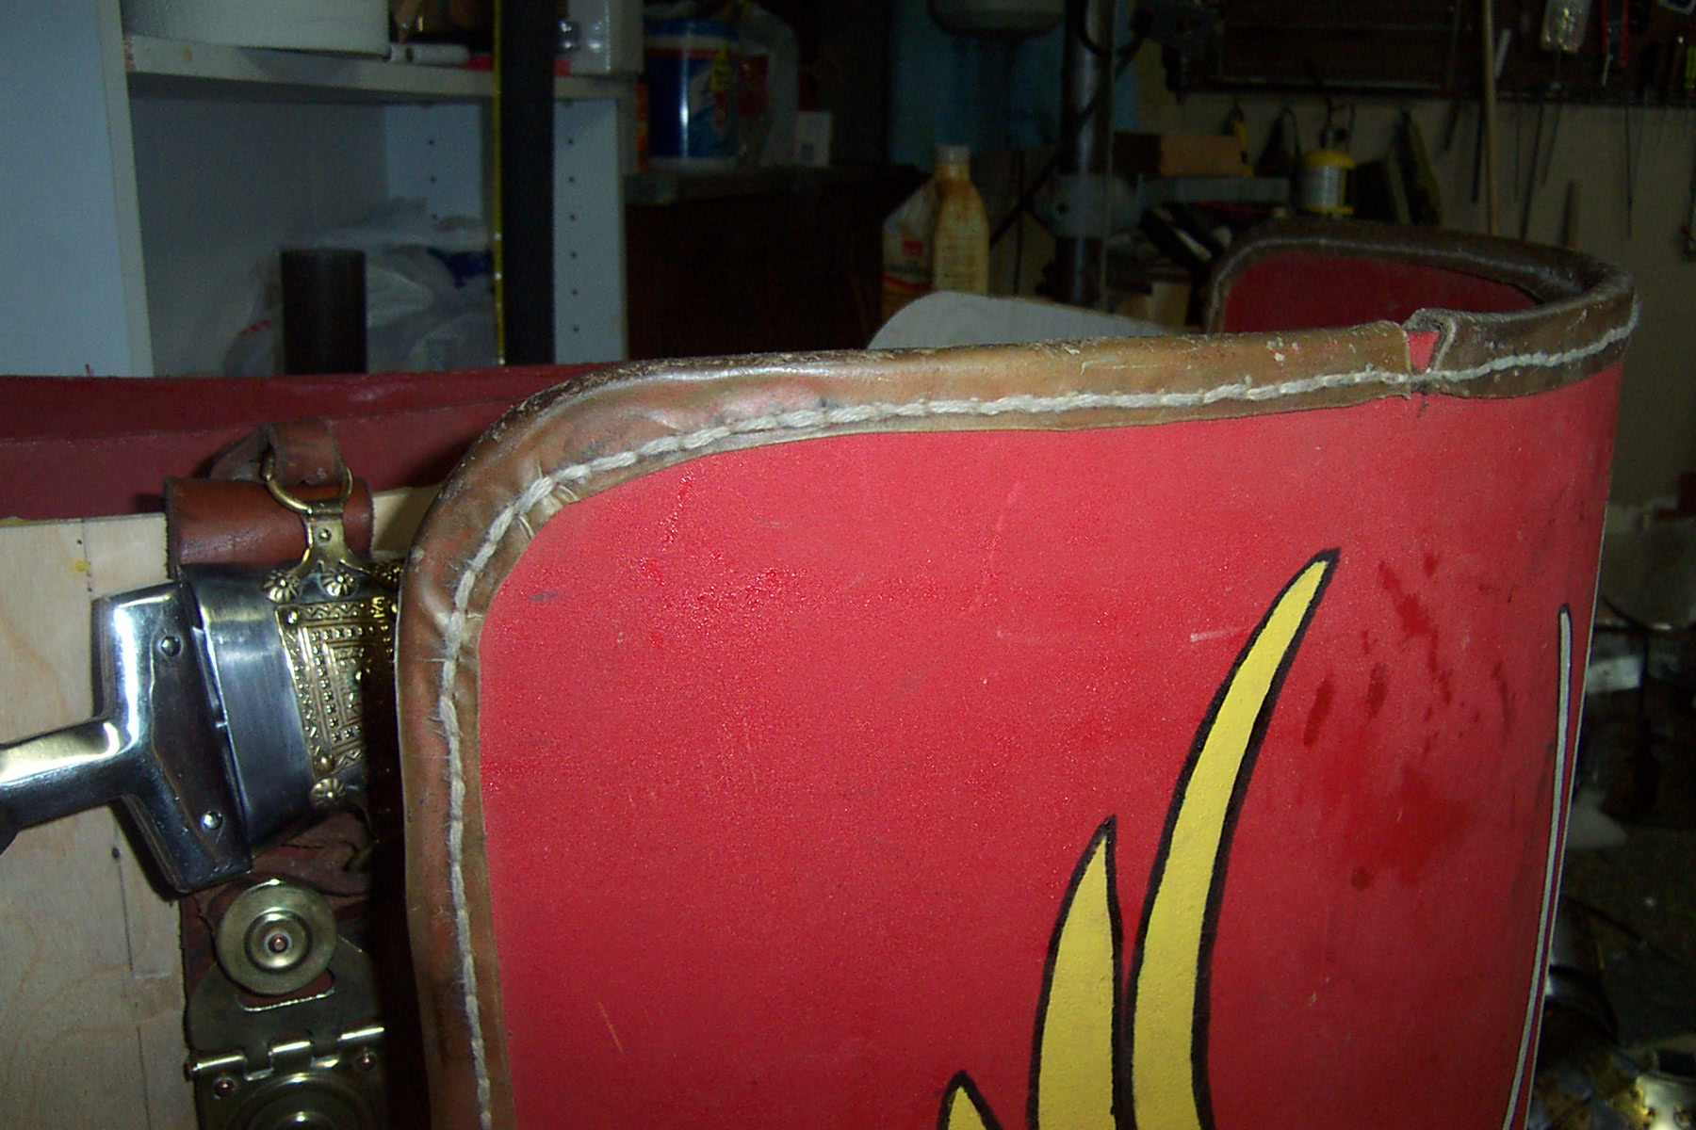

This manual is a beta version.

