看 https://tvm.ai/2017/11/08/android-rpc-introduction使用TVM RPC在移动电话上远程配置和测试深度学习交叉编译，想到的一个实验

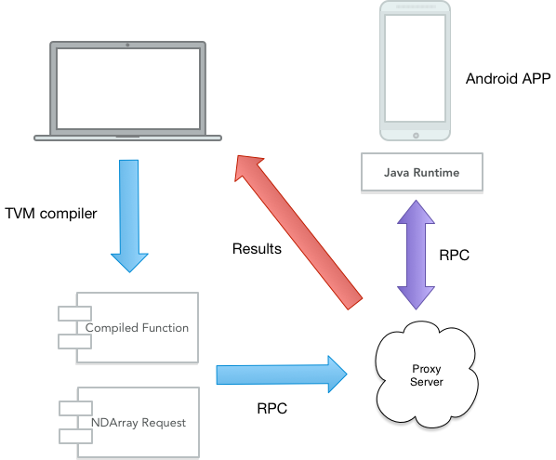

通过RPC和代理来更方便的来进行不同平台的测试。

Nvidia1070ti驱动

sudo add-apt-repository ppa:graphics-drivers/ppa

sudo apt-get update

sudo apt-get install nvidia-390 #此处要根据上面查询到的版本适当更改

sudo apt-get install mesa-common-dev

sudo apt-get install freeglut3-dev  
nvidia-smi #若出现电脑GPU列表，即安装成功

我是先给这个服务器备份了一下，这几天搞了不少小问题出来

备份命令：

sudo -i

cd /

tar cvpzf backup.tgz --exclude=/proc --exclude=/lost+found --exclude=/backup.tgz --exclude=/mnt --exclude=/sys --exclude=/media /

恢复指令：

$ sudo rm -rf /media/磁盘名称/分区名称*

将备份文件”backup.tgz”拷入该分区；

$ sudo cp -i backup.tgz /media/磁盘名/分区名sdaX

进入分区并将压缩文件解压缩，参数x是告诉tar程序解压缩备份文件。

$ sudo tar xvpfz backup.tgz

重新创建那些在备份时被排除在外的目录；

$ sudo mkdir proc lost+found mnt sys media

**Requirements：**

JDK、Android NDK、Android设备，LLVM已装

Gradle的安装

requires only a Java JDK or JRE version 8 or higher to be installed. To check, run java -version

java -version

要装个sdkman！

<https://sdkman.io/install>

curl -s "https://get.sdkman.io" | bash

source "$HOME/.sdkman/bin/sdkman-init.sh"

检查版本

sdk version

sdk install gradle 5.5.1

NDK我是通过Android Studio来装的

AS在Linux x64 上要先安装32位库

sudo apt-get install lib32z1 lib32ncurses5 lib32bz2-1.0 lib32stdc++6

有时会出现错误

但安装时出现错误：

E: Unable to locate package lib32bz2-1.0

E: Couldn't find any package by glob 'lib32bz2-1.0'

E: Couldn't find any package by regex 'lib32bz2-1.0'

sudo apt-get install lib32z1 lib32ncurses5 libbz2-1.0:i386 lib32stdc++6

装好AS后注意安装Android SDK路径 ，在sdk manager那里把NDK也要选中

AS连接不是很好要下好几次。

PATH 导入

sudo vim /etc/profile

export PATH=$PATH:/home/s5/android-stuudio/bin

export PATH=$PATH:/home/s5/Android/SDK/ndk-bundle/

export ANDROID_HOME=~/Android/Sdk/

刷新

source /etc/profile

TVM目前只支持openjdk8

换Ubuntu 下切换 JDK 版本

sudo update-alternatives --config java

java -version

Maven 3以上

sudo apt-get install maven

mvn --version

编译安装TVM4J

Tvm下 有时候会没权限加sudo

make jvmpkg

Reactor Summary for TVM4J Package - Parent 0.0.1-SNAPSHOT:

[INFO]

[INFO] TVM4J Package - Parent ............................. SUCCESS [ 1.510 s]

[INFO] TVM4J Package - Core ............................... SUCCESS [ 3.713 s]

[INFO] TVM4J Package - Native Parent ...................... SUCCESS [ 0.025 s]

[INFO] TVM4J Package - Native Linux-x86_64 ................ SUCCESS [ 58.494 s]

[INFO] TVM4J Package - Full Parent ........................ SUCCESS [ 0.028 s]

[INFO] TVM4J Package - Full Linux-x86_64 .................. SUCCESS [01:47 min]

[INFO] ------------------------------------------------------------------------

[INFO] BUILD SUCCESS

make jvminstall

我前面是用sudo make jvmpkg 导致后面的依赖装到/root/.m2

Copy过来

sudo cp /root/.m2 /home/s5 -R

再跑sudo make jvminstall

下一步安装RPC App到Android手机

换到tvm/app/android_rpc/

PATH设定

export ANDROID_HOME=~/Android/Sdk/

export PATH=$PATH:/home/s5/Android/Sdk/ndk-bundle/

编译RPC的apk

gradle clean build or gradle clean build --no-daemon

编译完成后

find . -name "*.apk" -exec ls -l {} \+

会看到

./app/build/outputs/apk/release/app-release-unsigned.apk

你要生成签名，不然不能通过adb安装

keytool -genkey -keystore /home/s5/tvm/apps/android_rpc/dev_tools/tvmrpc.keystore -alias tvmrpc -keyalg RSA -validity 10000

为apk生成签名

jarsigner -keystore /home/s5/tvm/apps/android_rpc/dev_tools/tvmrpc.keystore \

-signedjar

/home/s5/tvm/apps/android_rpc/dev_tools/../app/build/outputs/apk/release/tvmrpc-release.apk \

/home/s5/tvm/apps/android_rpc/dev_tools/../app/build/outputs/apk/release/app-release-unsigned.apk 'tvmrpc'

再通过adb装上去

adb install -r /home/s5/tvm/apps/android_rpc/dev_tools/../app/build/outputs/apk/release/tvmrpc-release.apk

Success

再Android机上调试RPC

python -m tvm.exec.rpc_tracker --port 7030 开放在7030端口

再机子上天上

Address：192.168.xxx.xxx

Port：7030

Key：android

宿主机上查看RPC连接

python -m tvm.exec.query_rpc_tracker --port 7030

Server List

----------------------------

server-address key

----------------------------

10.66.79.132:47700 server:android

----------------------------

Queue Status

-------------------------------

key total free pending

-------------------------------

android 1 1 0

tests/android_rpc_test.py

Run CPU test ...

5.18708e-05 secs/op

跑个教程示例

安装ninja：

sudo apt install ninja-build

cd tvm/apps/android_deploy

#setup env

export PATH=$PATH:/home/s5/Android/Sdk/ndk-bundle/

export ANDROID_HOME=~/Android/Sdk/

#build

gradle clean build --no-daemon

出现一下错误

### Execution failed for task ':app:packageDebug'.

开始以为是zip损坏了，后来发现

Just create a file called gradle.properties in your root project:

root

|--gradle.properties

|--build.gradle

|--settings.gradle

|--app

|----build.gradle

Then add inside the file:

org.gradle.jvmargs=-Xmx2048m

每次构建执行启动一个新JVM

接下来和上面构建RPC一样

find . -name "*.apk" -exec ls -l {} \+

再生成密钥和签名

jarsigner -keystore /home/s5/tvm/apps/android_deploy/dev_tools/tvmrpc.keystore \

-signedjar /home/s5/tvm/apps/android_deploy/dev_tools/../app/build/outputs/apk/release/tvmrpc-release.apk \

/home/s5/tvm/apps/android_deploy/dev_tools/../app/build/outputs/apk/release/app-release-unsigned.apk 'tvmrpc'

再通过adb安装

adb install -r /home/gemfield/projects/tvm/apps/android_deploy/dev_tools/../app/build/outputs/apk/release/tvmdemo-release.apk