I am trying to optimize a building layout in a game, and it seems like the problem could be solved by a computer much quicker than by my own trial and error. However, I only have a cursory understanding of programming (mostly JavaScript), so I'm hoping some software exists which can do most of the work for me, or some open-source code is available that does something similar enough to be adapted to my purpose without too much difficulty.

I tried searching for programs/code related to graph theory, as the node-and-link nature of the game's building layout seems connected to graph theory, but I wasn't able to find anything. Most results were about drawing graphs or analyzing the properties of known graphs, rather than finding a graph with the desired properties. I also tried more general searches with no luck.

**The Problem To Which I Want To Find An Optimal Solution**

We have a finite square lattice of 248 nodes, each of which can only be linked to its immediate neighbors (up to four Links total per node, fewer at the boundaries of the grid). Each node can contain a Workshop, contain a Module, or be empty. There is an additional special blocked node at the center of the grid which cannot contain a Workshop or Module, and to which all **non-empty** nodes **must** be connected by a path of Links through other nodes. A picture of the grid of nodes and possible Links is included below.

There are finite numbers of Workshops (12), Modules (48), and Links (120) available. There are five different types of Workshops (the total of 12 can consist of any combination of the 5 types) and six different types of Modules (the total of 48 can consist of any combination of the 6 types).

**The challenge is to get all Workshops up to maximum efficiency given the limited numbers of Modules, Links, and nodes. I want to be able to input any desired mix of Workshop types (for anywhere between 1 and 12 Workshops in total) and have the computer calculate the layout of Workshops, Modules, and Links that satisfies all requirements using the minimum possible number of Modules and Links, OR, if such a layout is impossible, calculate the layout that comes closest to satisfying all requirements.**

**Layout Requirements**

Each type of Workshop requires three types of Modules nearby for full productivity. The effect of a Module decreases linearly with distance: at a distance of one Link the strength is 5, at two Links it is 4, at three Links it is 3, at four Links it is 2, at five Links it is 1, and at six Links or farther it is 0. The required minimum strength of each Module varies with the type of Workshop; values are given below.

Workshops and Modules both produce heat (except the Radiator Module, which produces cooling or "negative heat"), and Workshops must be in a specific temperature range to function; values are given below. The magnitude of the temperature effect of a Workshop or Module decreases by 2° per Link from one to five Links, then drops to zero at six Links or farther. For example, the Solar Module increases a Workshop's temperature by 10° at a distance of one Link, 8° at a distance of two Links, 6° at a distance of three Links, 4° at a distance of five Links, and 0° for any greater distance.

The effects (including temperature) of Workshops and Modules only travel across empty nodes to which they are linked. A node with a Workshop or Module on it will block the effects of any Workshops or Modules beyond it. The central node also blocks effects, but has no effect or heat itself. A Workshop always spreads only its base heat level to other linked Workshops, even if nearby Modules/Workshops are raising or lowering its effective heat level. The requirement that all non-empty nodes be connected to the central node is not blocked by other Modules/Workshops.

Module effects and heat travel along the shortest available path of Links through empty nodes to each **separate** Workshop, so if a direct path is blocked but a less-direct path is available, the less-direct path will be used. If more than one free path to the same Workshop is available, the shortest one is used for calculations. One Module can affect many Workshops, so for maximum efficiency, Modules should be shared by multiple Workshops when possible. Effects/heat from multiple Modules/Workshops can travel down a single Link.

**How a Layout is Graded**

A Workshop on its own, with no Modules and within its required temperature range, has a productivity of 10. With all Module requirements fully satisfied, a Workshop has a productivity of 80, or the base 10 productivity-points plus 70 bonus productivity-points. Each Workshop requires a total of 21 Module-strength-points, receiving 10/3 ≈ 3.33 productivity-points for each Module-strength-point up to the maximum for that Module type. There is no penalty or bonus for having higher-than-required Module strength.

Workshops that are outside their required temperature range drop by levels to 75%, 50%, and finally 25% productivity as their temperature goes farther above or below the required range. I haven't figured out the exact calculation behind the penalty yet, but even 1° of deviation outside the desired range leads to a 25% loss in productivity, so maintaining the desired temperature is critical.

An optimum layout will have all temperature requirements met, and all Module requirements met (or exceeded), for all Workshops. If meeting all the Module requirements is impossible, the most-optimal layout will have the greatest total number of Module-strength-points (ignoring any that go over the requirement) per Workshop.

**The Construction Grid**

[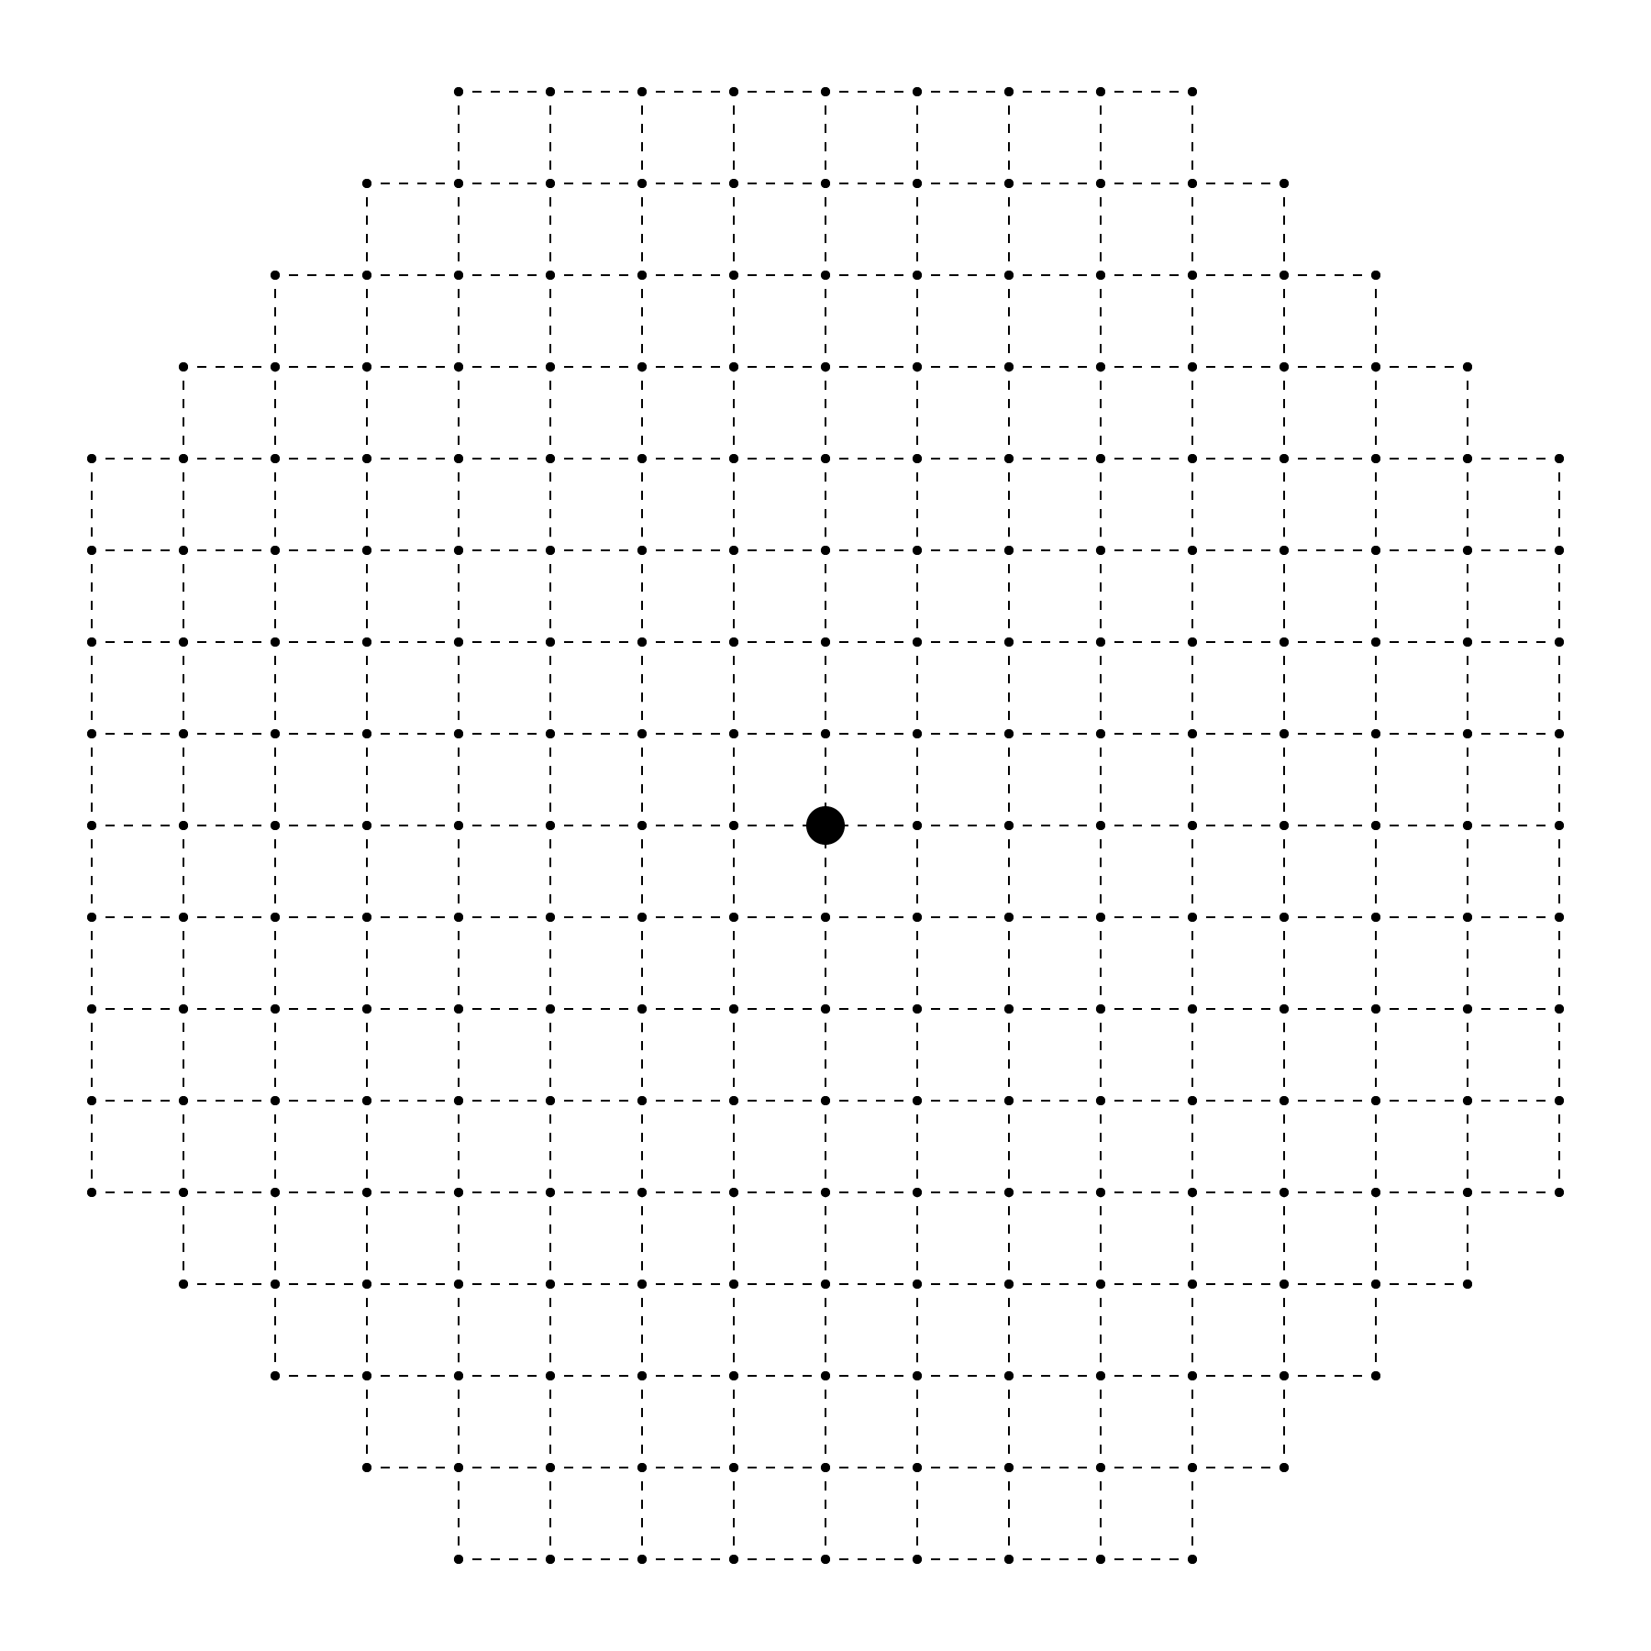](https://i.stack.imgur.com/OJy22.png)

**Workshop Stats**

* Workshop-Agriculture
  + Base Temp: 20°
  + Min Temp: 20°
  + Max Temp: 39°
  + Module Requirements
    - Module-Artificial-G: 6
    - Module-Solar: 3
    - Module-Greenhouse: 12
* Workshop-Biotech
  + Base Temp: 5°
  + Min Temp: 30°
  + Max Temp: 39°
  + Module Requirements
    - Module-Artificial-G: 9
    - Module-Solar: 6
    - Module-Greenhouse: 6
* Workshop-Electronics
  + Base Temp: 5°
  + Min Temp: 0°
  + Max Temp: 9°
  + Module Requirements
    - Module-Solar: 6
    - Module-Stowage: 6
    - Module-Recycling: 9
* Workshop-Energy
  + Base Temp: 30°
  + Min Temp: 20°
  + Max Temp: 29°
  + Module Requirements
    - Module-Artificial-G: 3
    - Module-Solar: 15
    - Module-Stowage: 3
* Workshop-Heavy-Industry
  + Base Temp: 30°
  + Min Temp: 20°
  + Max Temp: 29°
  + Module Requirements
    - Module-Solar: 6
    - Module-Stowage: 9
    - Module-Recycling: 6

**Module Heat**

* Module-Radiator: −20°
* Module-Solar: +10°
* Module-Greenhouse: +2°
* Module-Artificial-G: +6°
* Module-Stowage: +6°
* Module-Recycling: +8°