**Ex 6-1 #2:**

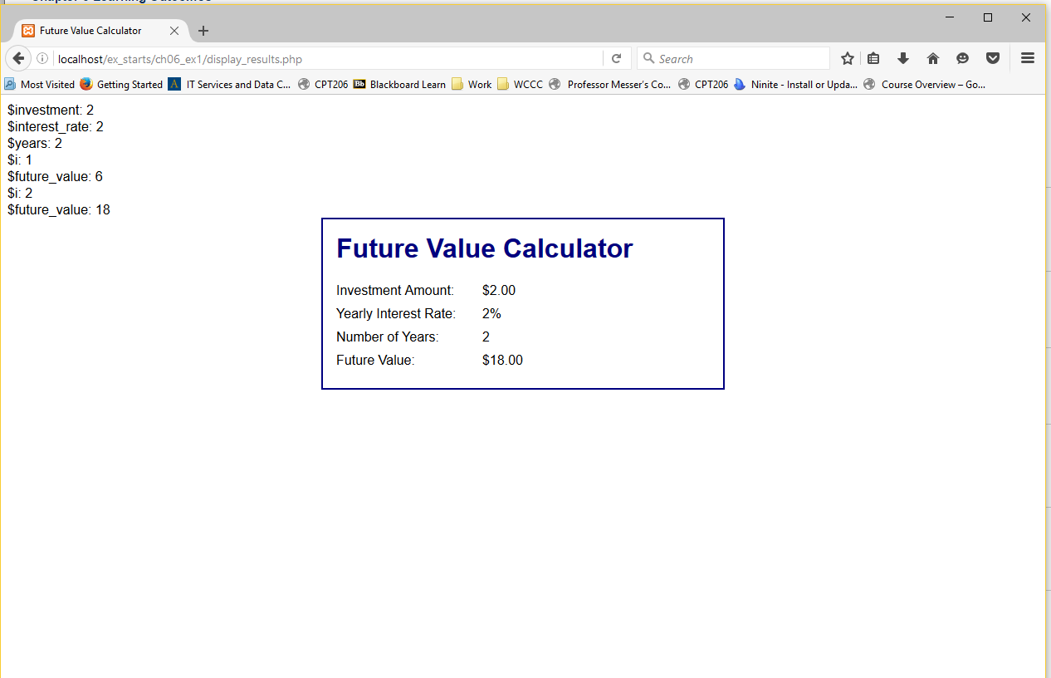

This is how the echo statements I made appear when running the application.

**Ex 6-2 # 1:**

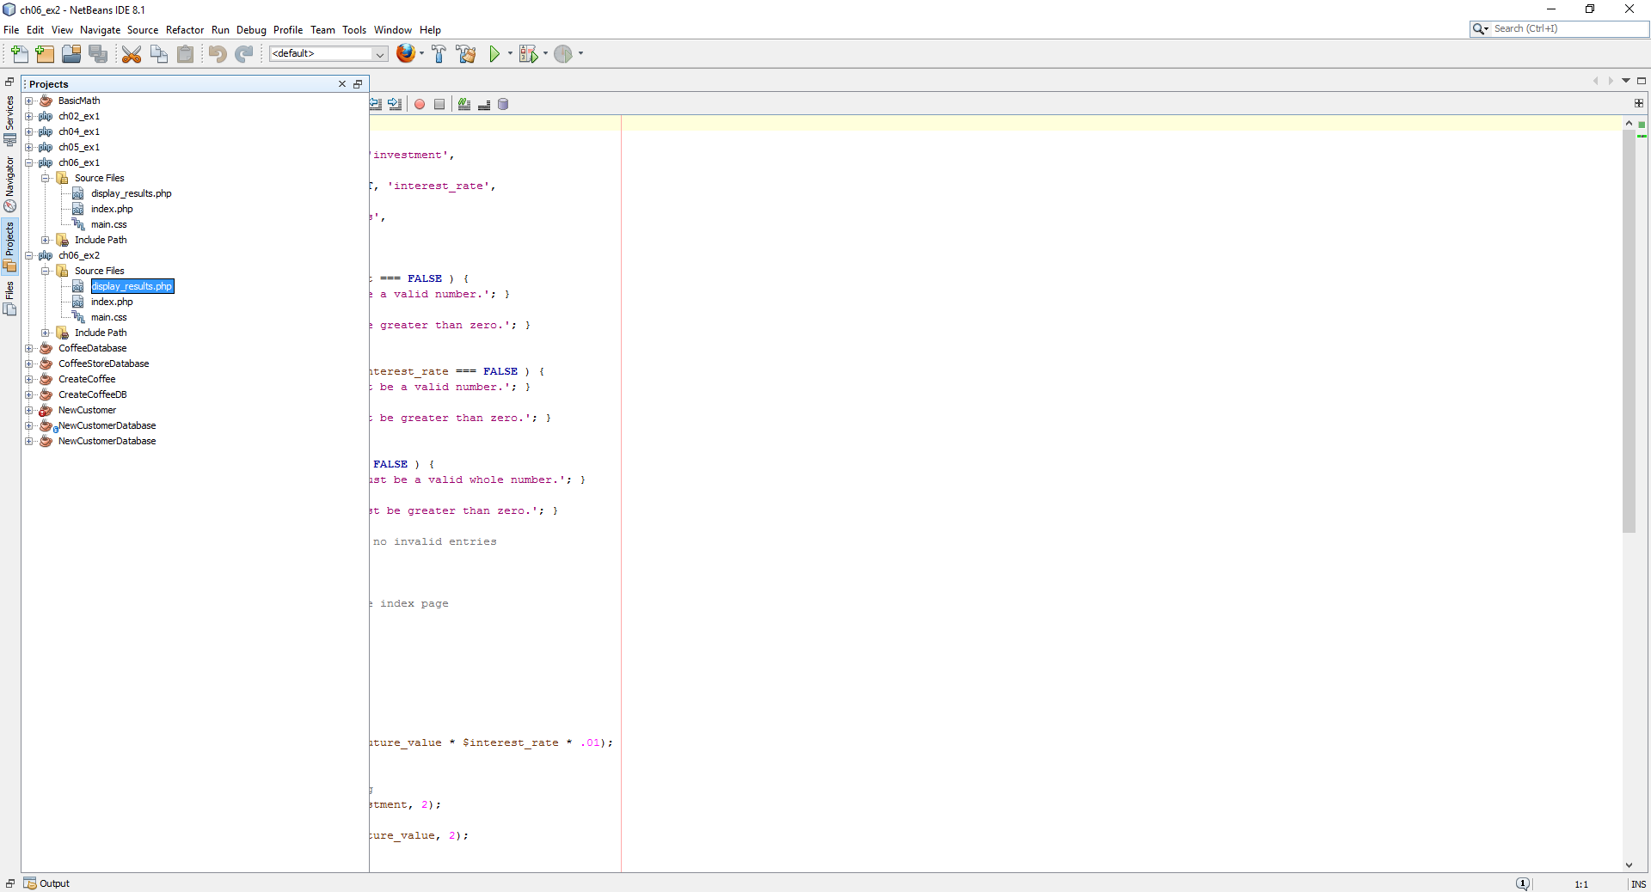

Opened up the display_results.php from the ex2 directory in NetBeans.

**Ex 6-2 #4:**

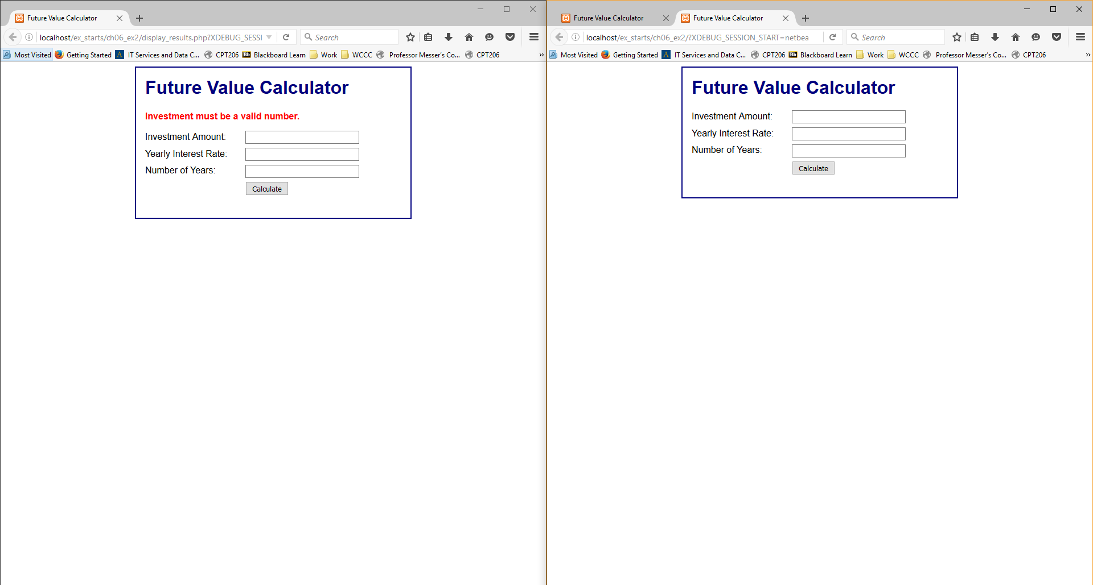Beginning vs. end result of debugging.

**Ex 6-2 #8:**

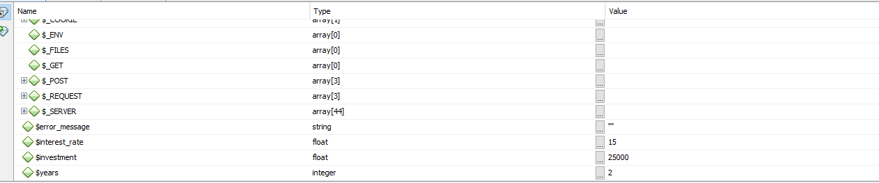

Able to view variables in NetBeans

**Ex 6-2 #9:**

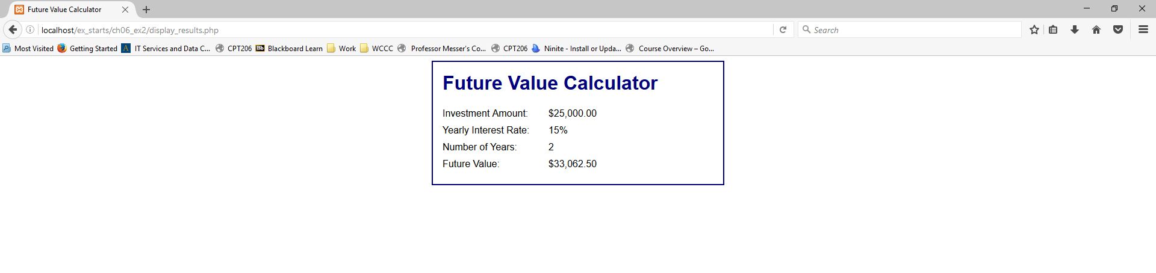

Displays information as it should in browser.

**Ex 6-3 #3:**

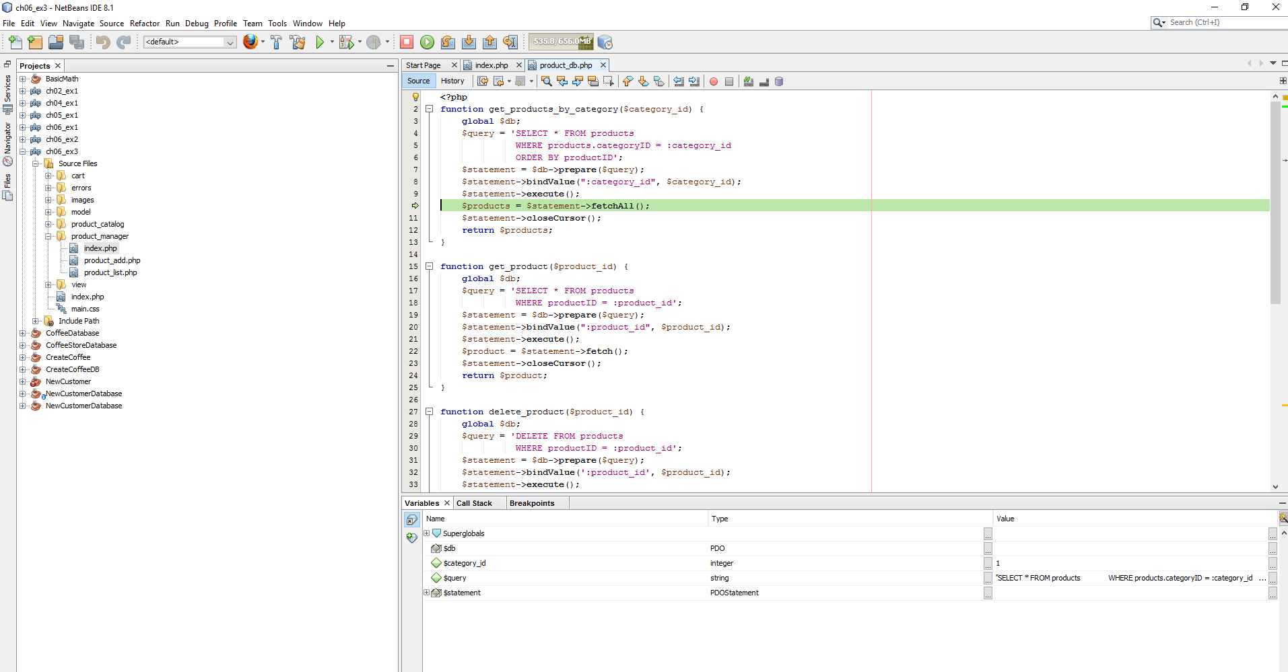

Stepping through the Debug, couple screenshots as moving through.

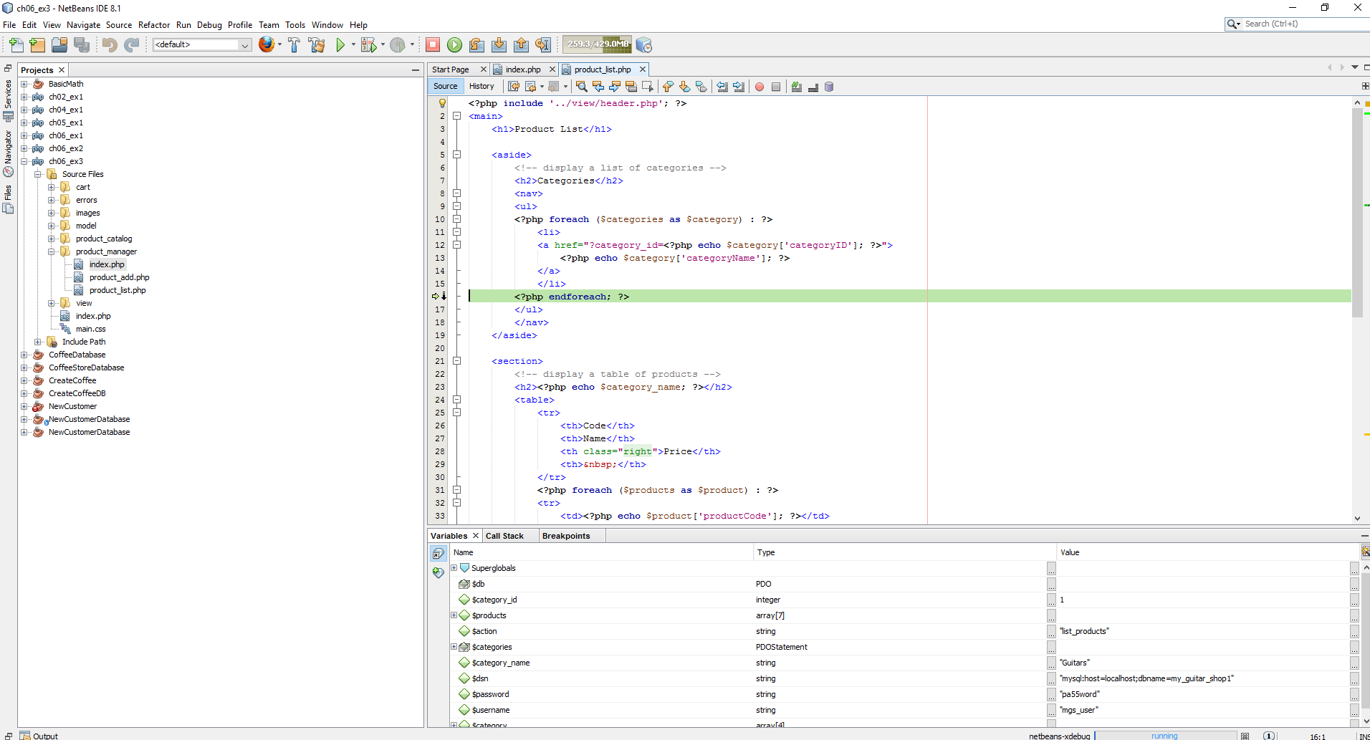

Stepping through the Debug, couple screenshots as moving through.