**Ex 10-1 # 2:**

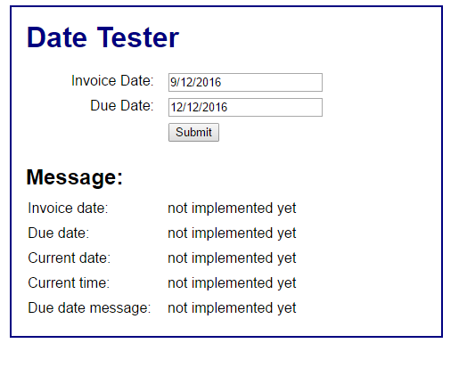

When you hit submit all areas in the message state ‘not implemented yet’.

**Ex 10-1 # 6:**

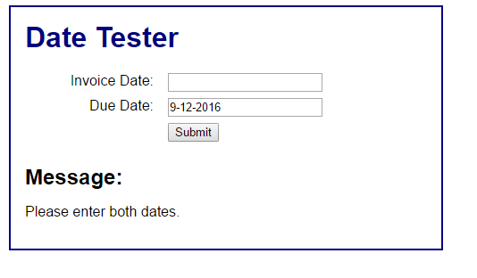

Ensures both dates are entered.

**Ex 10-1 #8:**

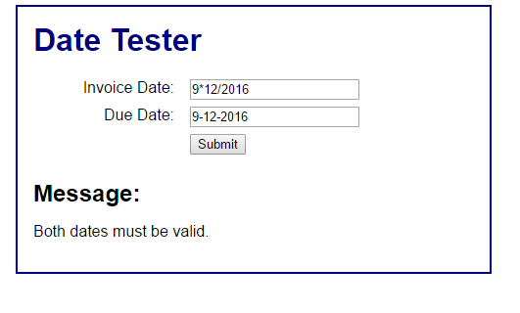

Ensures dates are entered in proper format.

**Ex 10-1 #9:**

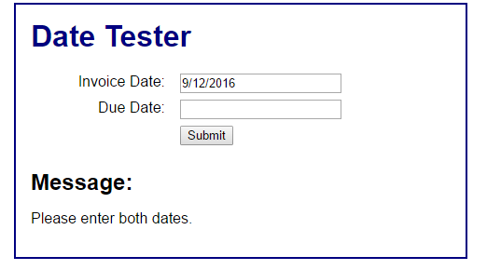

**Ex 10-1 # 10:**

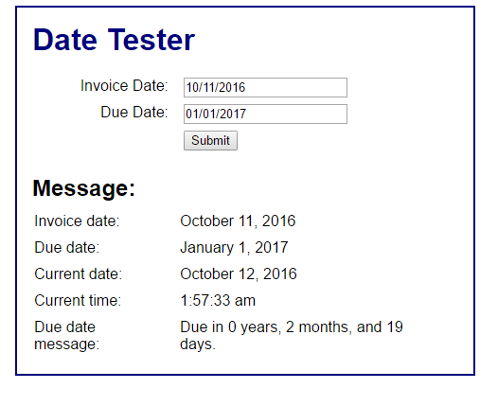

Application works properly.