**Ex 9-1 #2:**

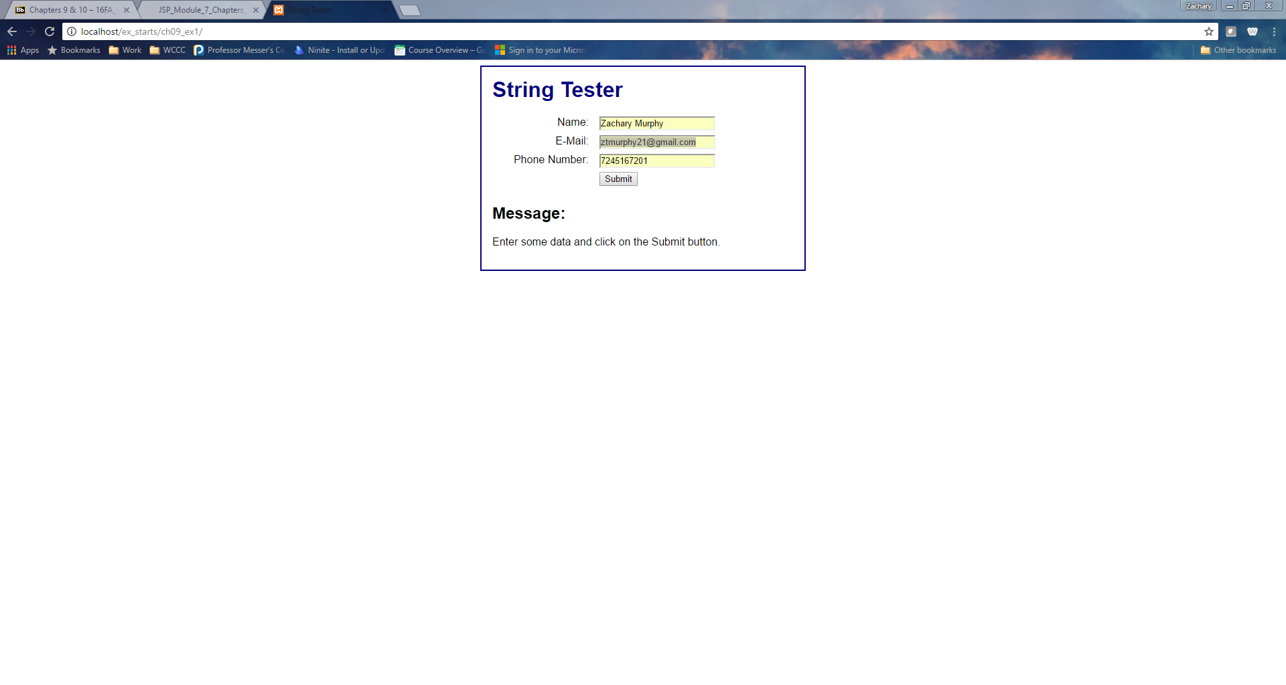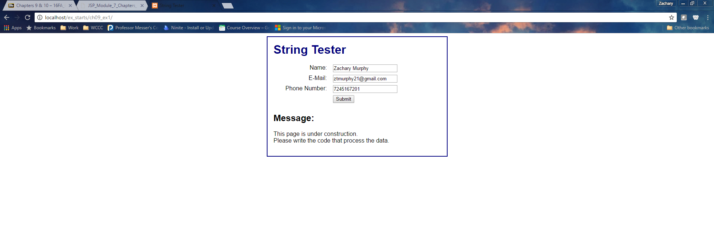

If you hit submit it says this site is under construction.

**Ex 9-1 #9:**

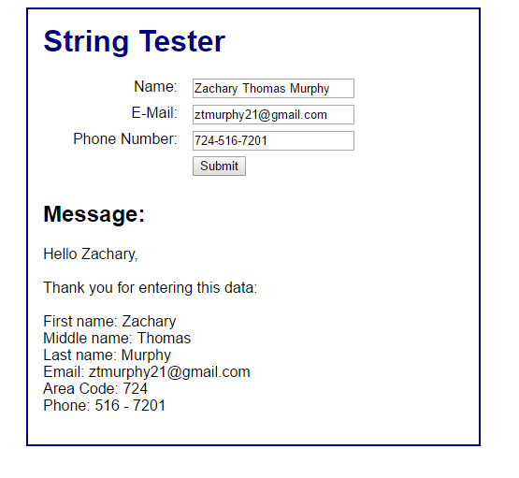

Input works if user enters full name.

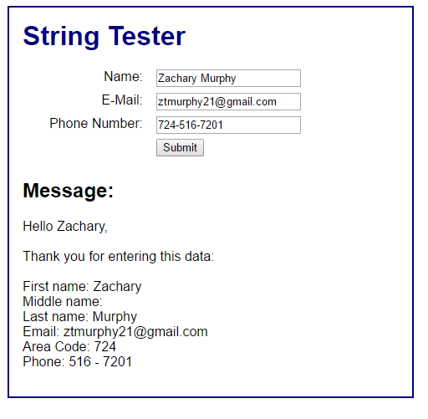

Input works if user does not enter middle name.

**Ex 9-2 #2:**

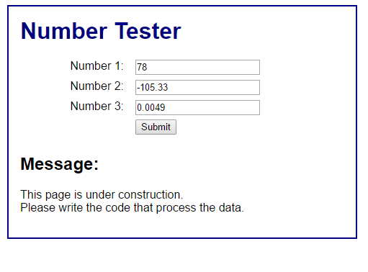

When you hit submit it says this page is under construction. Also values are automatically inputted.

**Ex 92- # 9:**

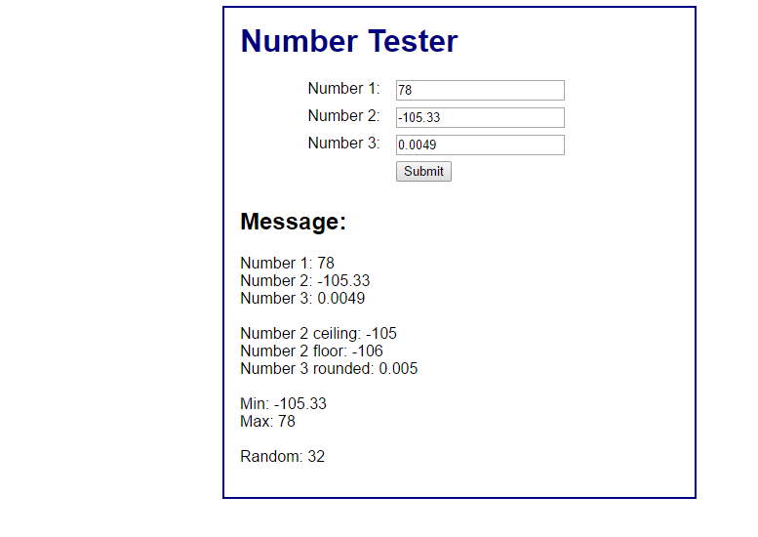

All information outputs properly.