**Ex1-1 #7:**

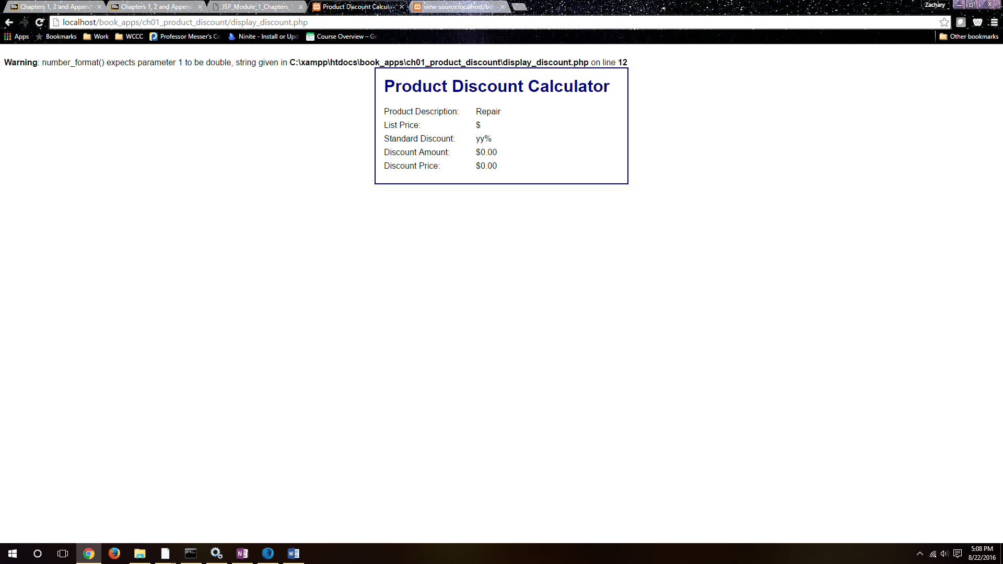

If you type in xx and yy for the second and third fields it will give you this error/warning at the top of the page. We will be learning about this layer in the book.

**Ex 1-2 #4:**

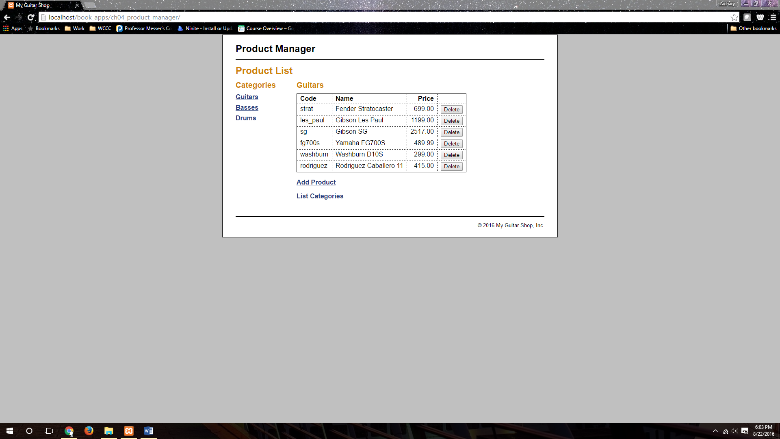

This shows I have installed the MySQL and downloadable MySQL databases properly.

**Ex 1-2 #8:**

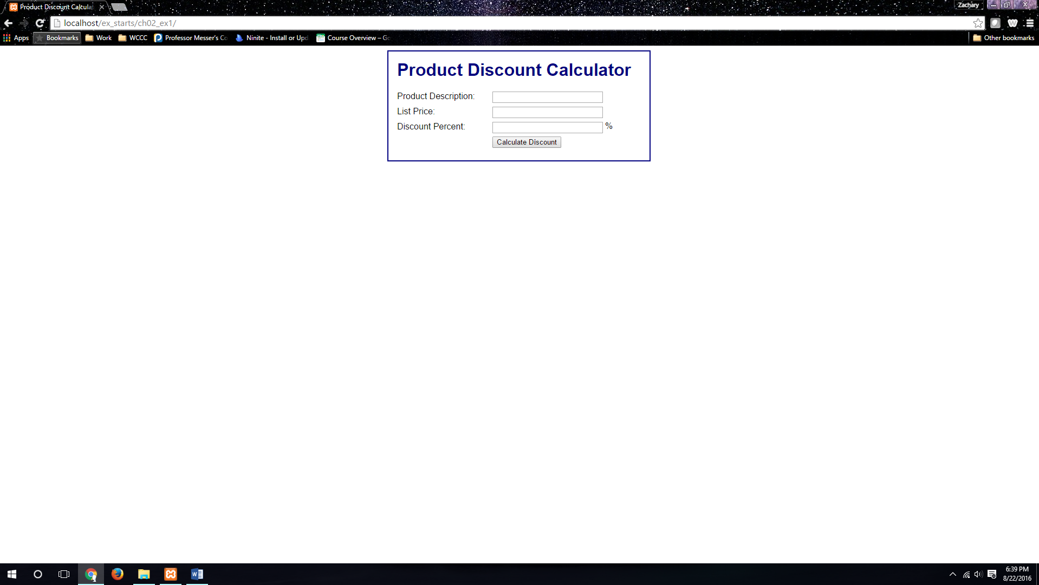

This is the Product Discount app from chapter one that will be worked on later in chapter two, this is accessible through the directory.

**Ex 1-3 #5:**

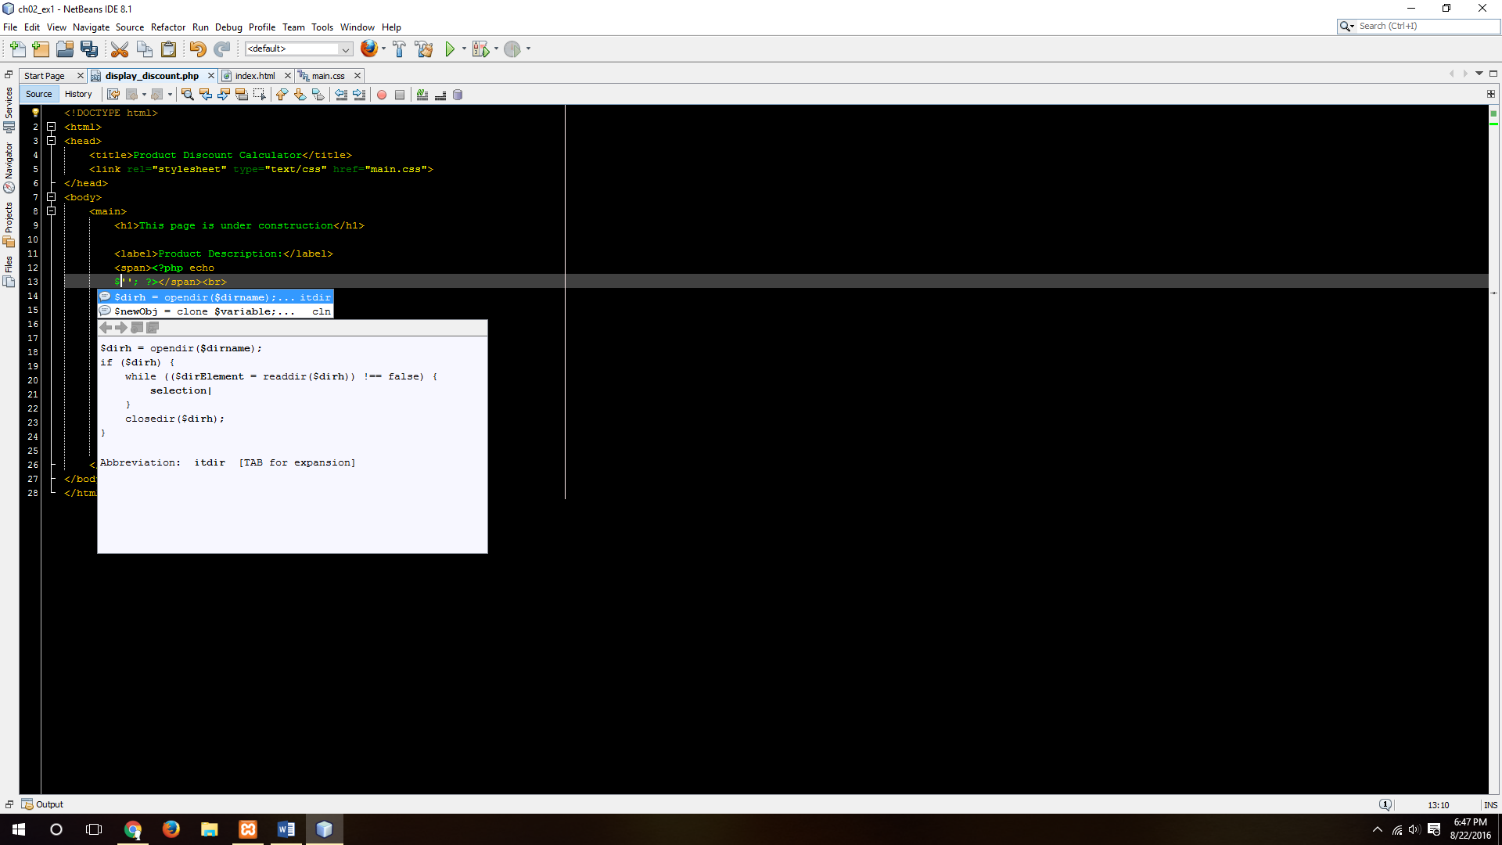

This shows the auto-completion function in NetBeans.

**Ex 1-4 # 6:**

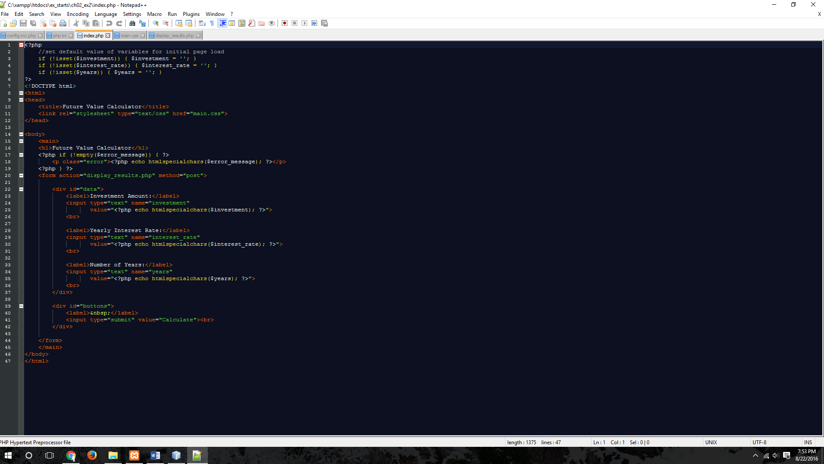

I am fine with the way the comments appear in NotePad++.