**Ex 7-1 #2:**



Only the email that was submitted is displayed, none of the other data entered is displayed.

**Ex 7-1 # 10:**

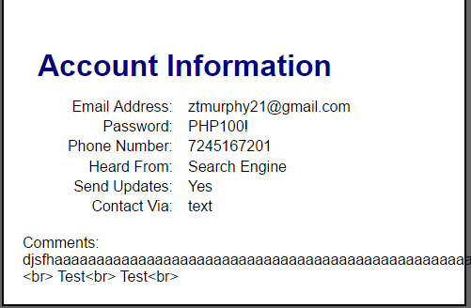

Displays all information and also does the <br> when you type enter.

**Ex 7-2 # 2:**

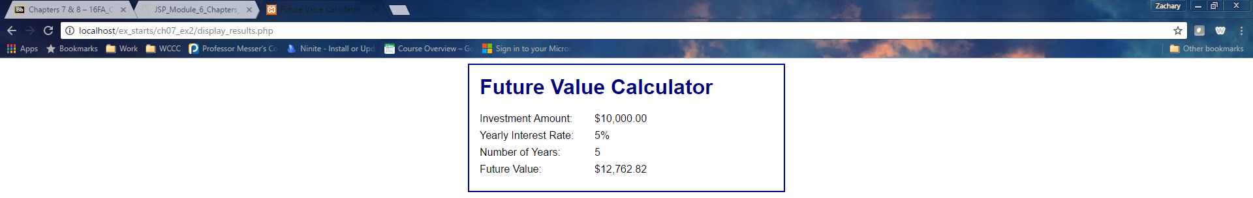

Correct future value calculation displayed.

**Ex: 7-2 #5:**

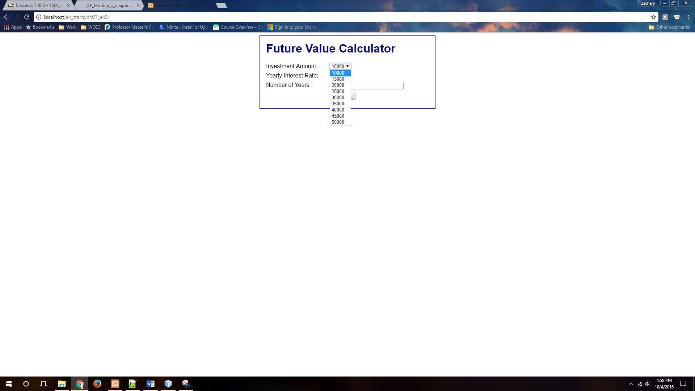

Values for investment amount increase by 5000.

**Ex: 7-2 #6:**

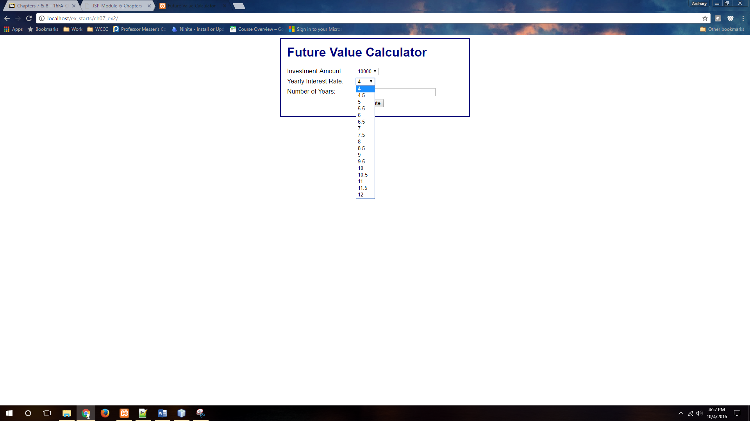

Values of yearly interest rate drop down increment by 0.5.

**Ex: 7-2 #7:**

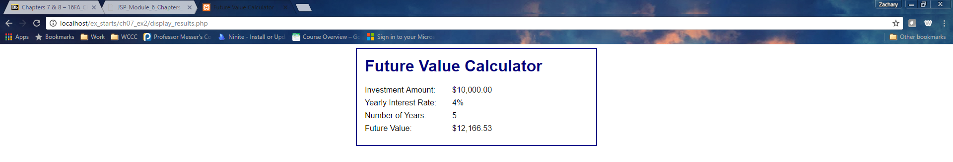

Application works properly.