**Ex 4-1 #1:**

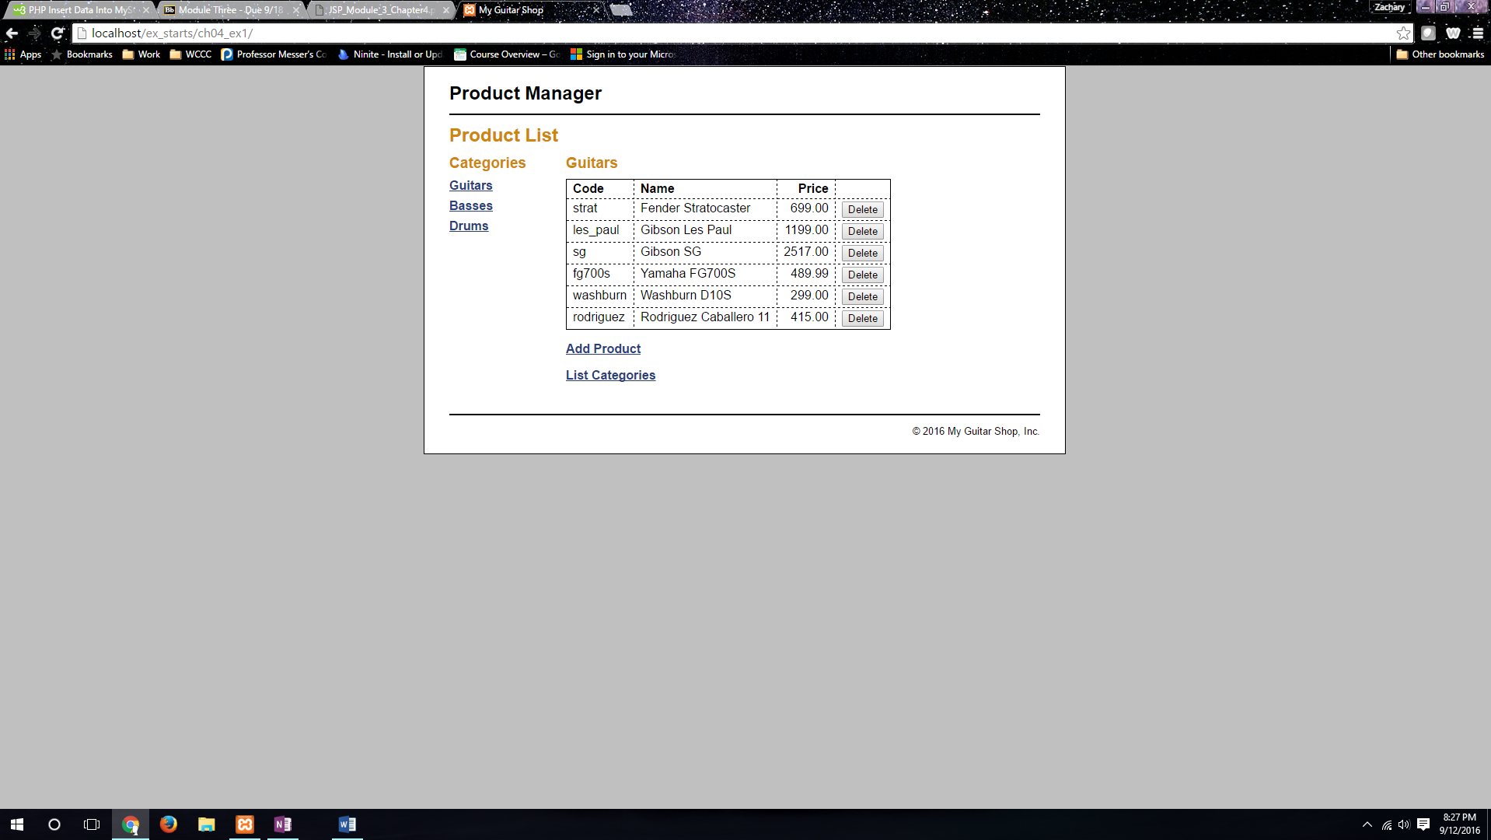

This shows products of database my_guitar_shop1

**Ex 4-1 #7:**

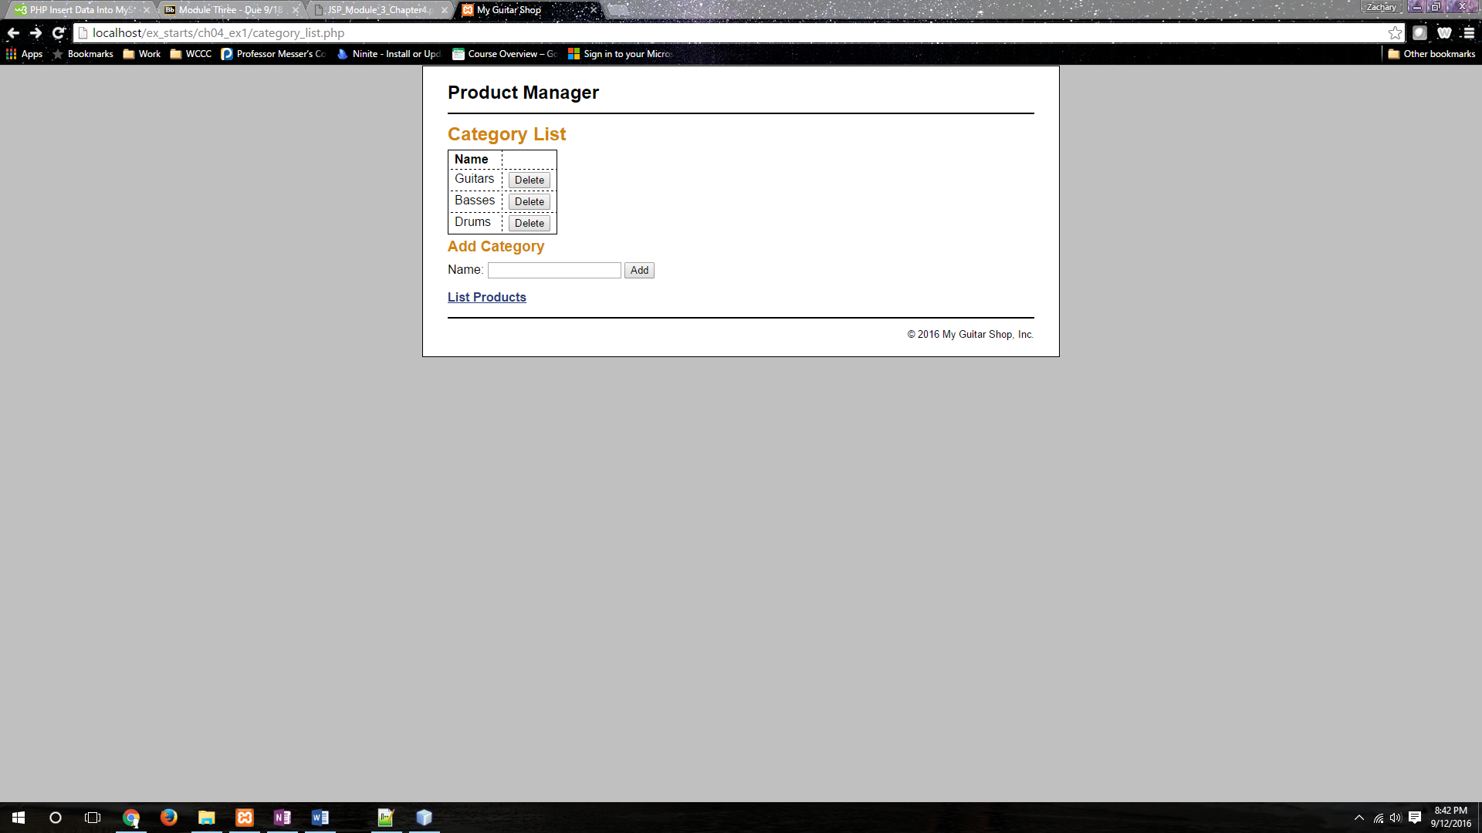

The category_list.php is displaying properly.

**Ex 4-1 #8:**

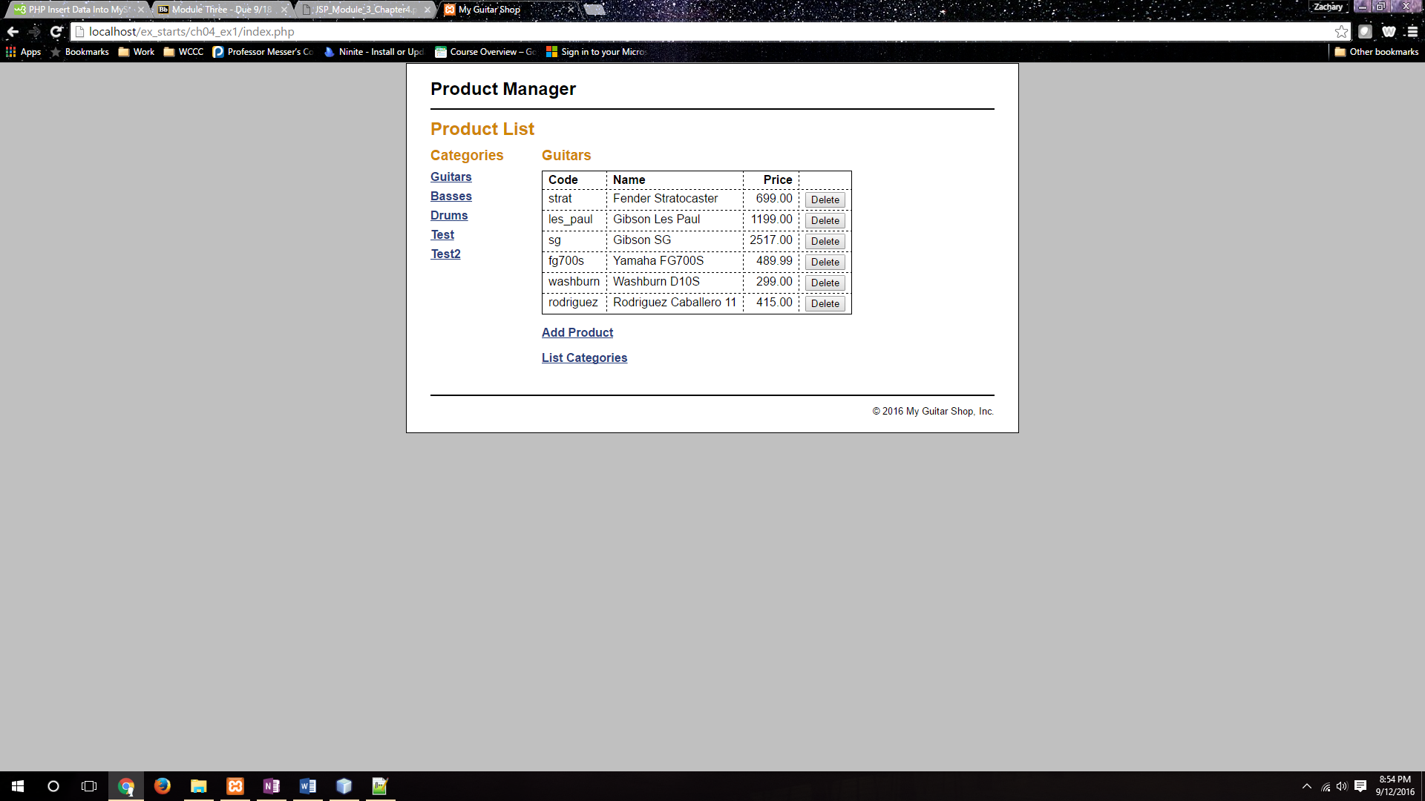

I am able to add two categories successfully.

**Ex 4-1 #9:**

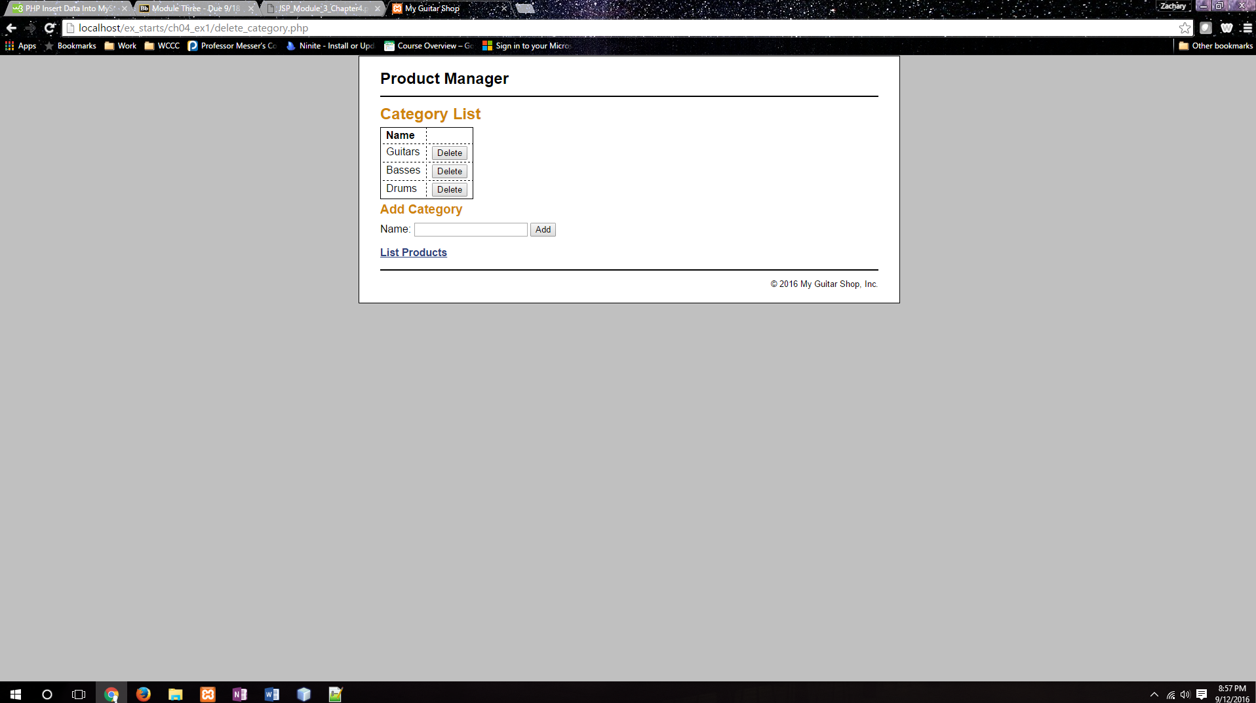

I am able to delete the two categories that I added successfully.