**Ex 8-1 #5:**

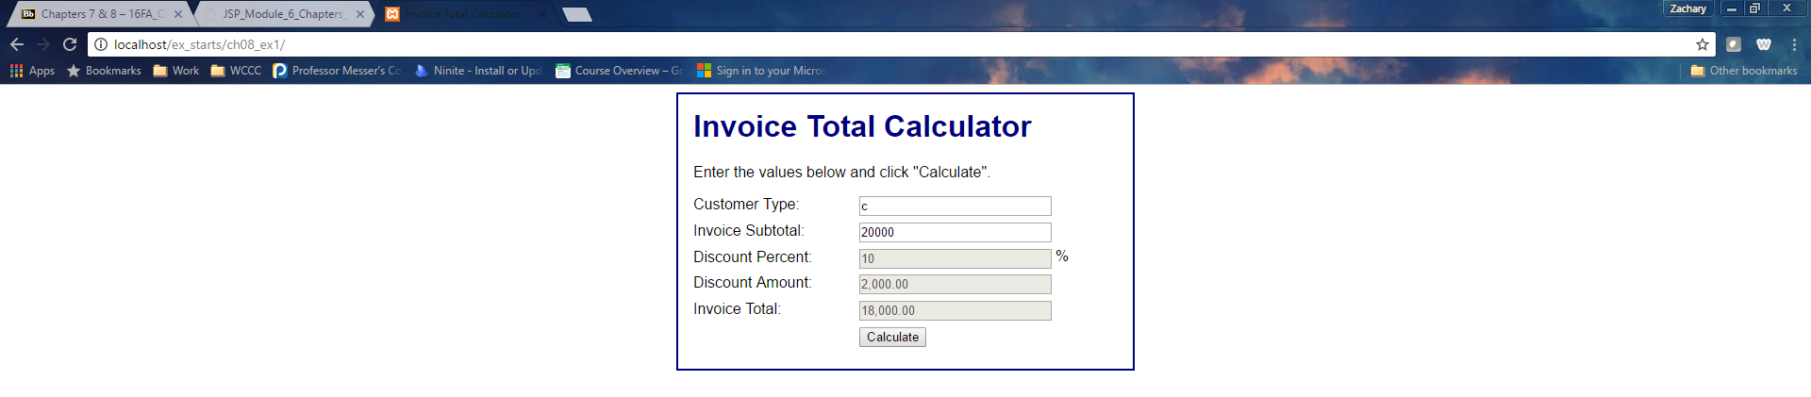

Lowercase letters input in customer type are not evaluated.

**Ex 8-1 # 6:**



Now lower case letters work!

**Ex 8-1 #8:**

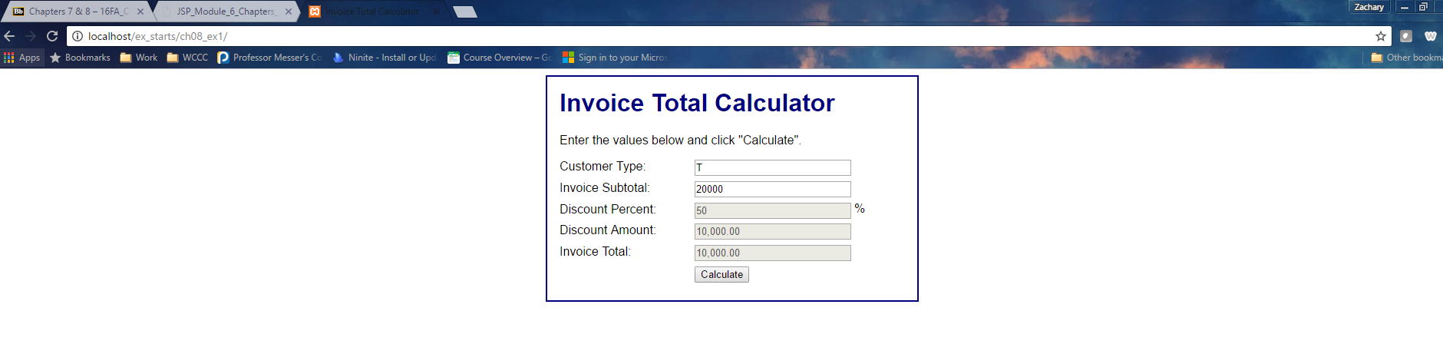

Using the switch statements everything works just as good as the if statements.

**Ex 8-2 #5:**



Process scores button displays the correct total and average.

**Ex 8-2 # 7:**



Changes made to validate user entities work.

**Ex 8-2 #10:**

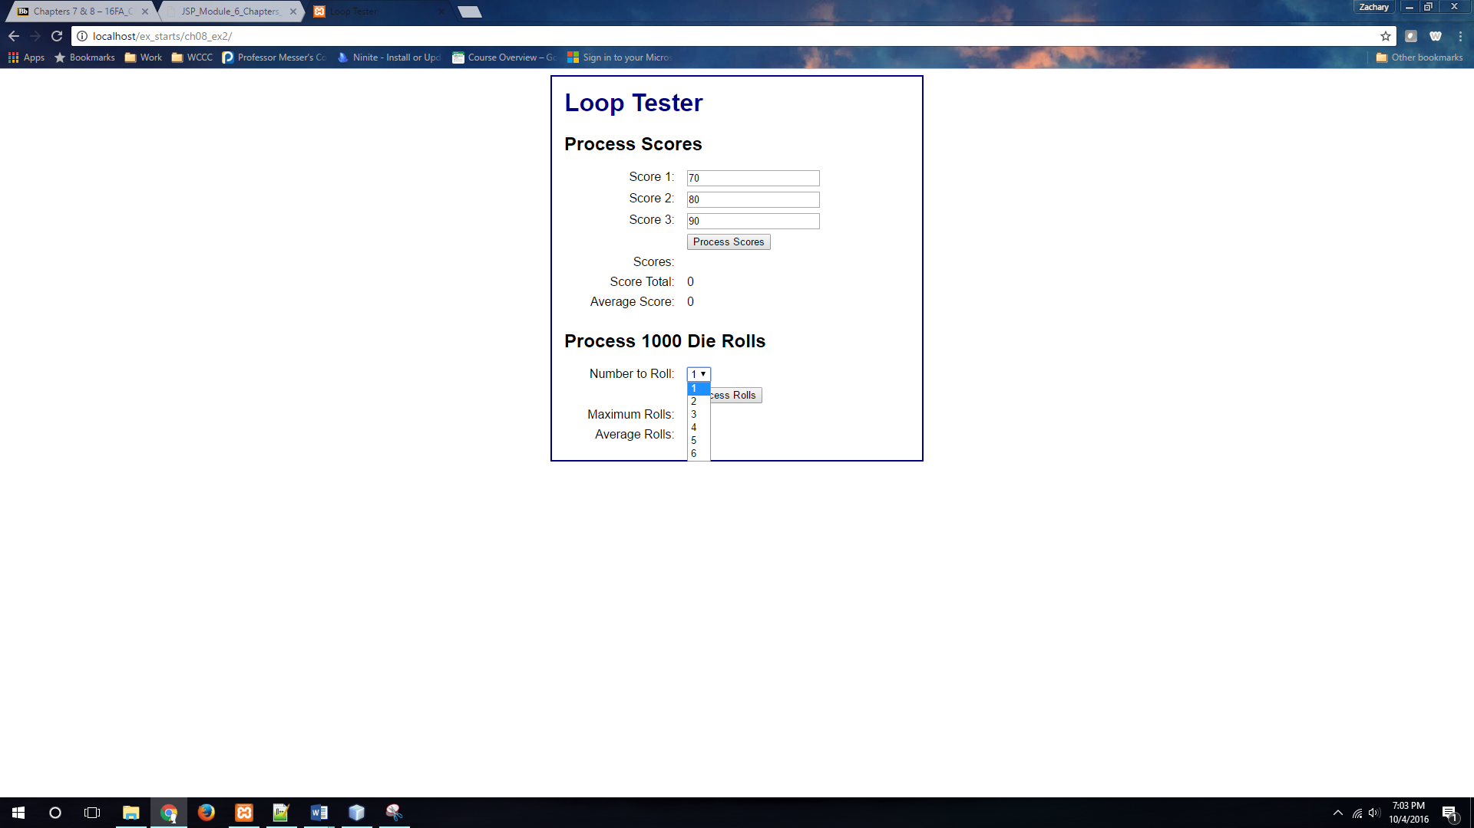



Change the loop and made a loop in the HTML rather than manually listing numbers.