**Ex 3-1 #5:**

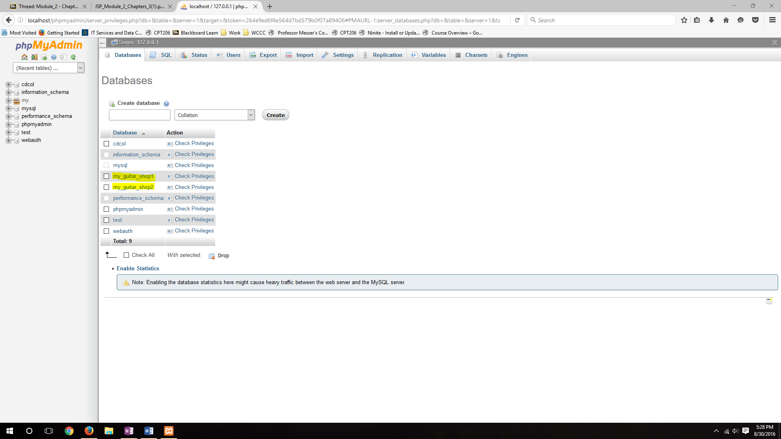

As you can see both the my_guitar_shop1 and my_guitar_shop2 databases are imported successfully.

**Ex 3-1 #7:**

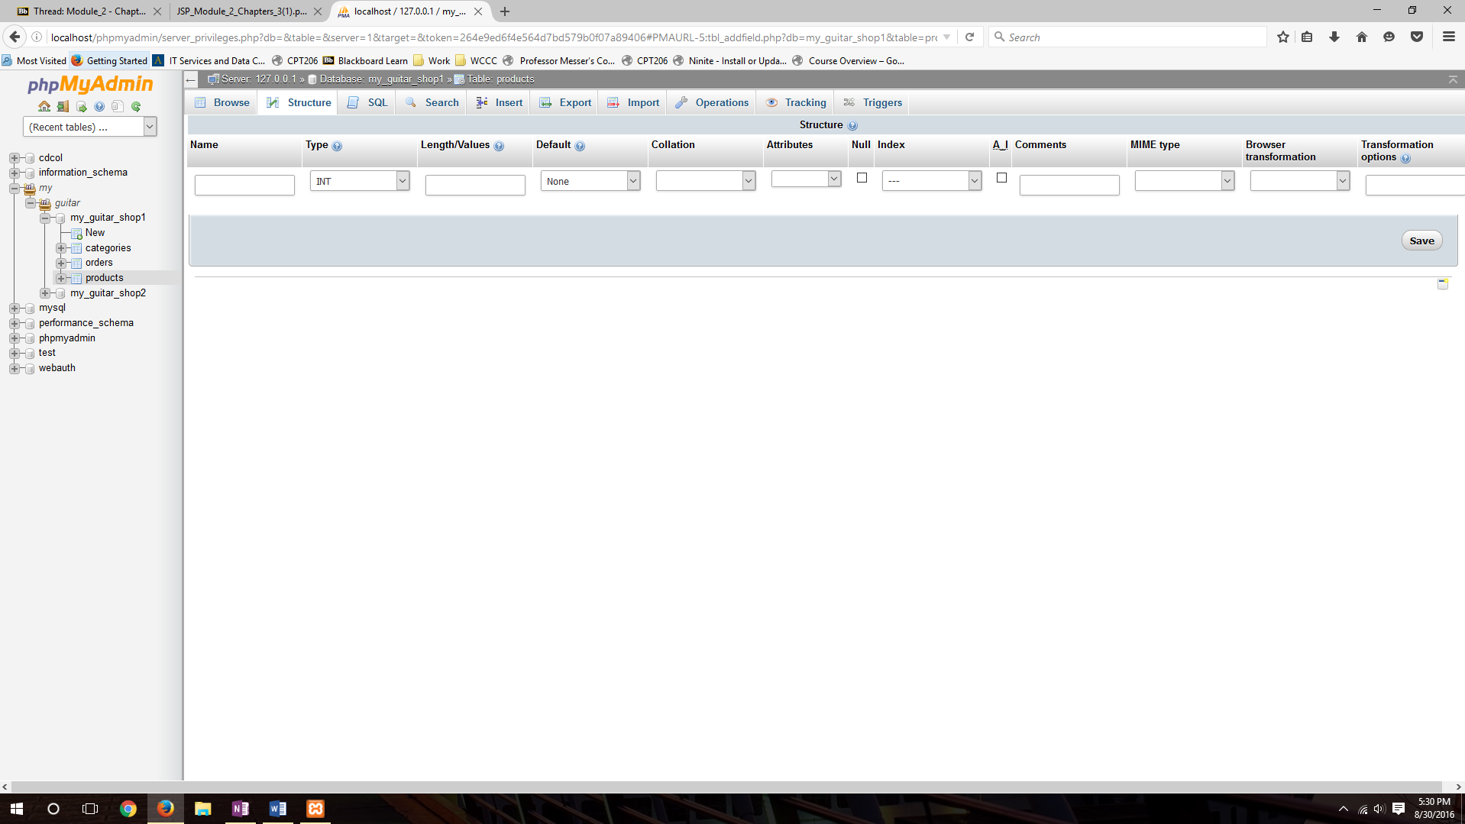

Showing the definitions of the products table.

**Ex 3-1 # 13:**

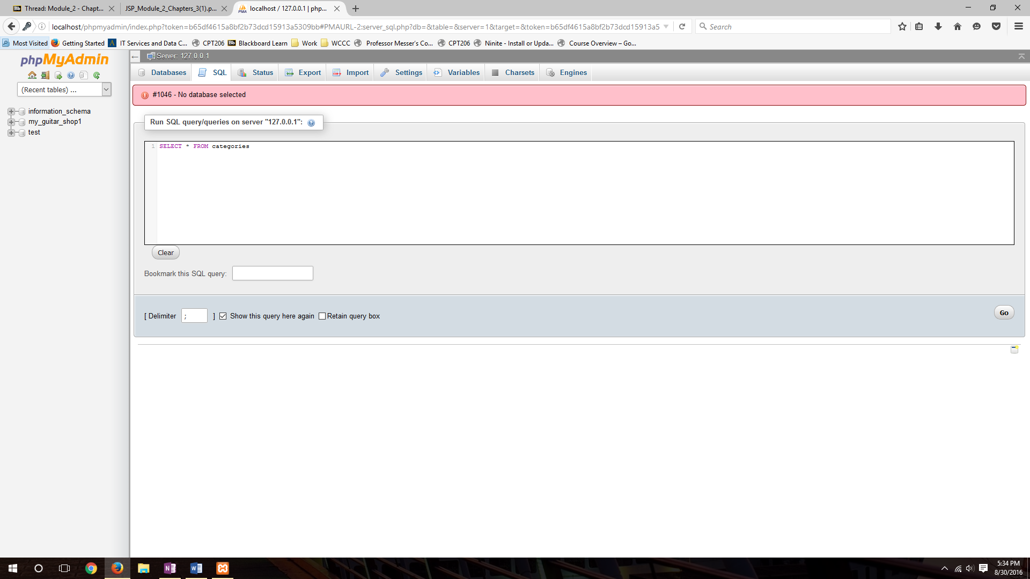

The mgs_tester account works properly with its restrictions.