**Ex 5-1 #2:**

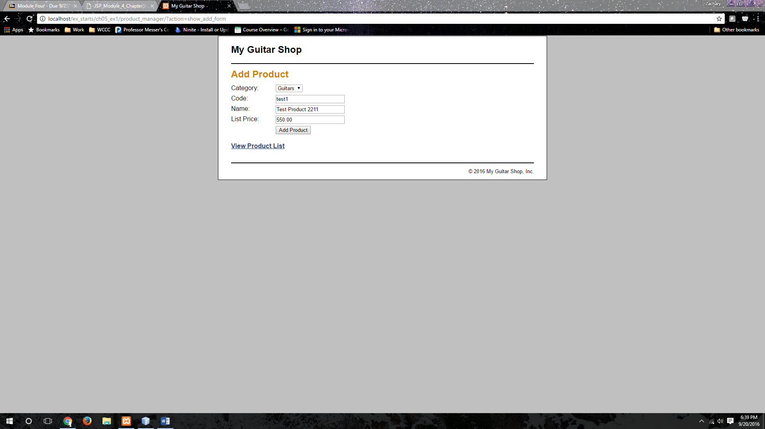

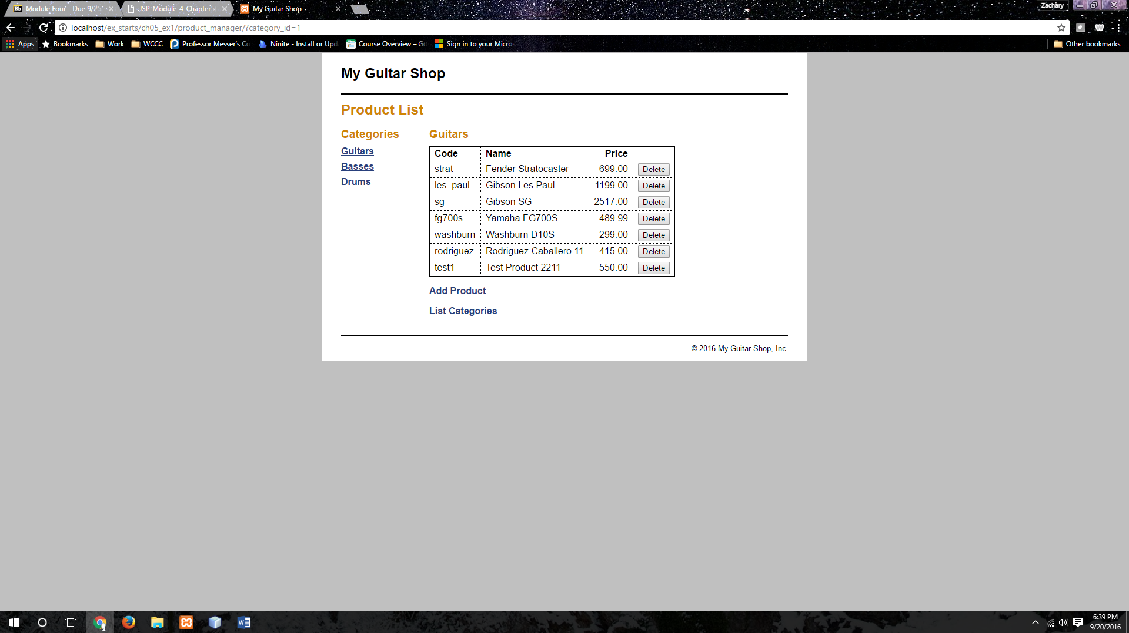Able to add the specified product.

**Ex 5-1 # 6:**

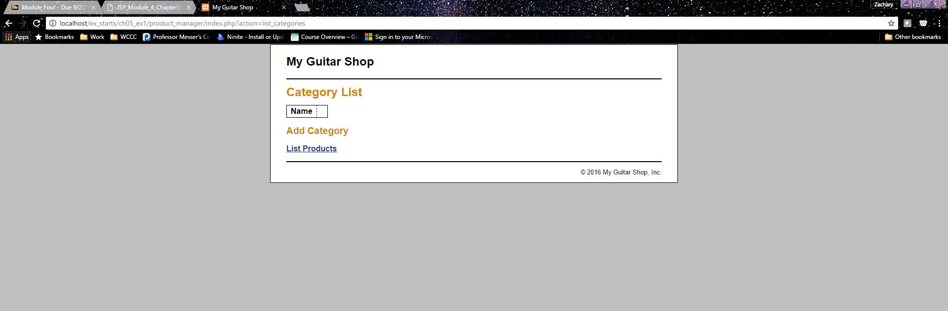

Displays the Category List Page Properly.

**Ex 5-1 #8:**

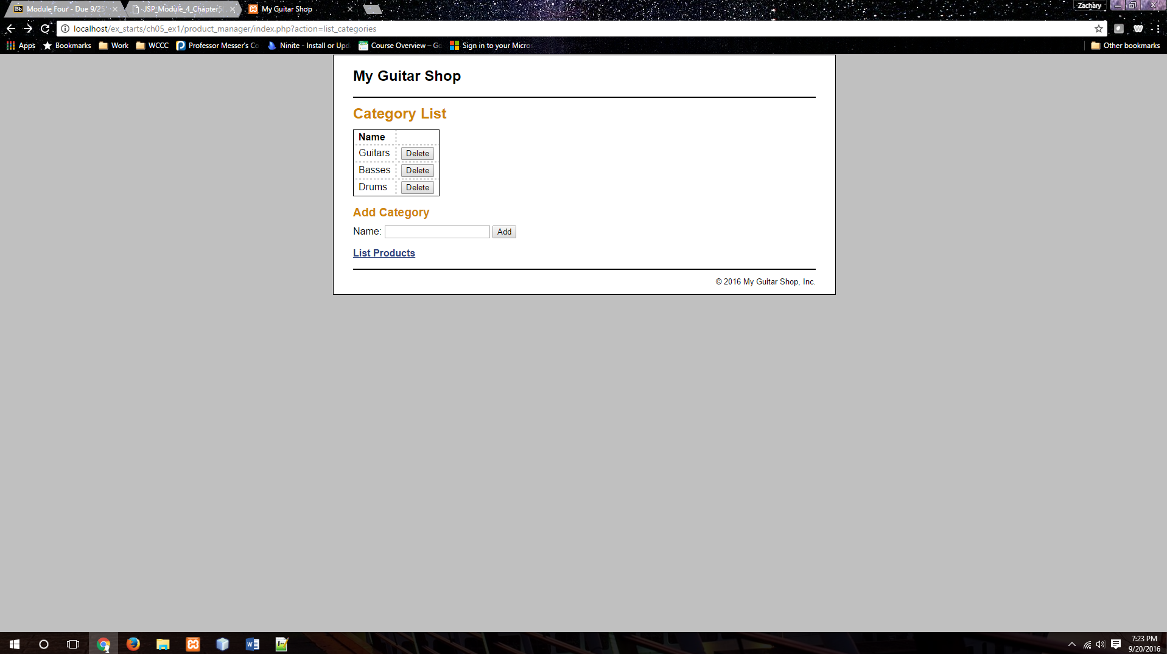

Lets the user add a category.

**Ex 5-1 #9:**

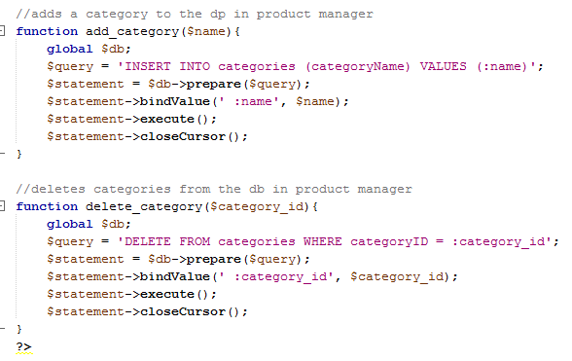

The functions needed to add and remove categories.

**Ex 5-1 #10:**



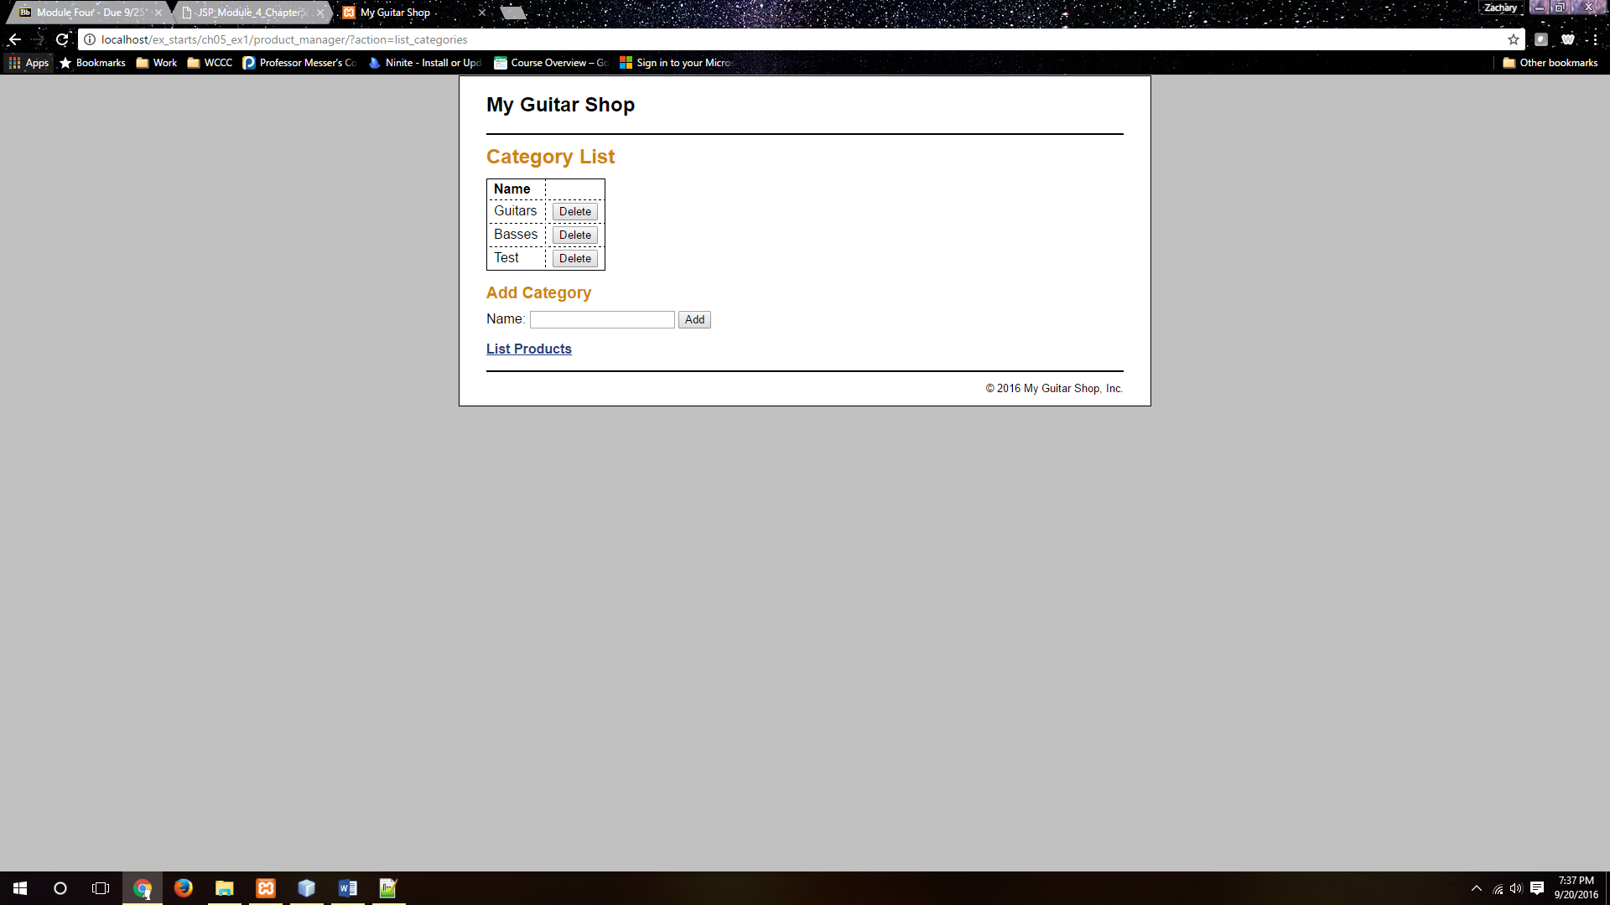

The add and remove buttons work successfully.

**Ex 51- #15:**

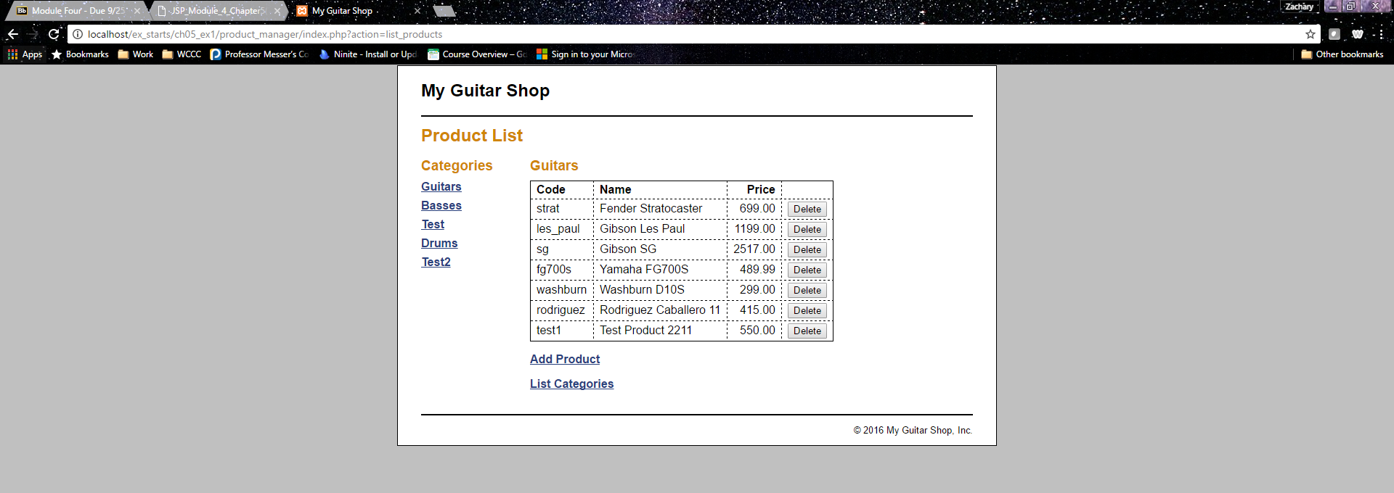

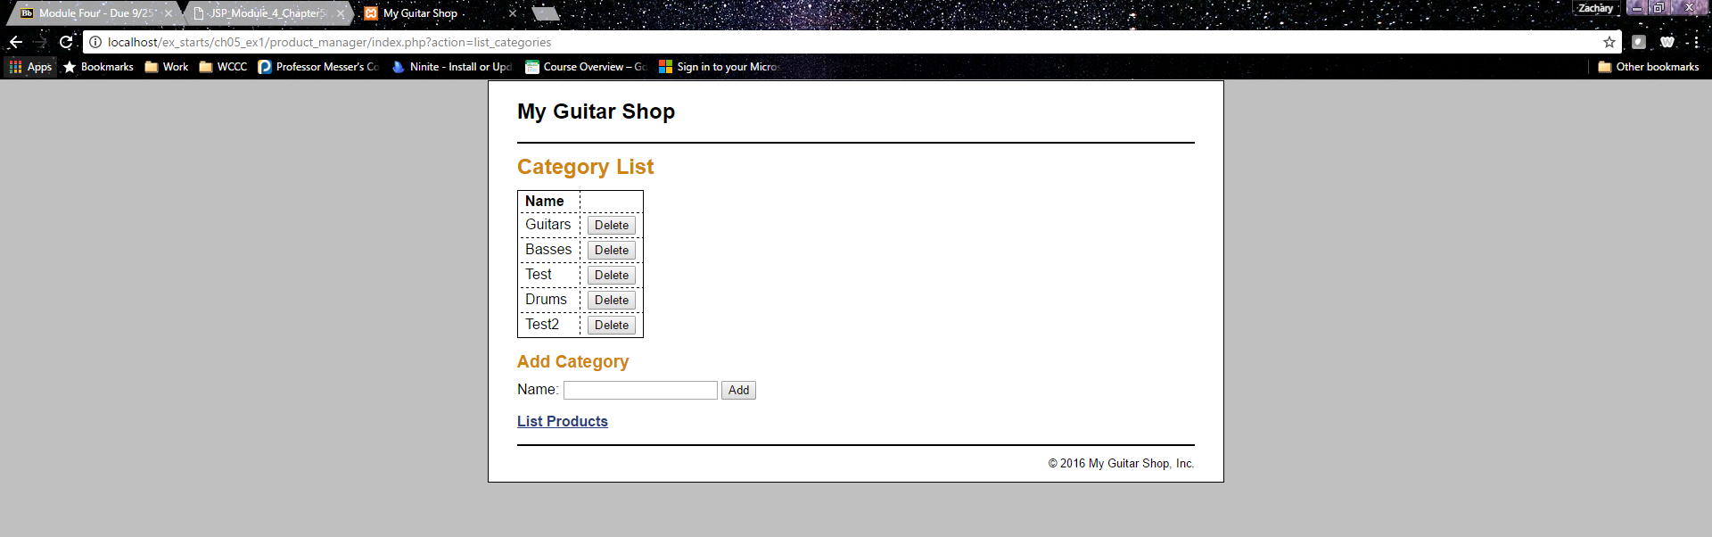

All items still view the same after some refactoring.