电 子 科 技 大 学
实 验 报 告

一、实验三：OpenGL光照与材质编程实验
二、实验室名称：主楼A2-412 实验时间：14：30~17：55
三、实验目的：

1、理解OpenGL光照模型的相关原理，掌握与光照参数和对象材质设置相关的OpenGL API函数的用法，熟悉光照与材质参数设置的基本技巧；

2、理解OpenGL混合（融合）的基本原理，掌握与混合相关的OpenGL API函数的用法。四、实验原理：OpenGl
五、实验内容：
（一）编程任务1——绘制一个具有光照的房间
（二）编程任务2——绘制一个具有地板反光效果的房间

利用OpenGL混合功能可以模拟地板反光效果，这需要将地板和场景中其它物体分开处理六、实验器材（设备、元器件）：电脑

七、实验步骤：
- 按次序完成要求的函数
- 绘制出地板镜像场景，利用混合在上述镜像场景之上绘制出半透明的地板，以正常的光源和场景位置来绘制场景。

八、实验数据及结果分析：
编程任务1：
程序功能：
程序实现了绘制一个具有光照的房间。
源代码：
#include <glut.h>
#include <stdio.h>
#include <math.h>
#define PI 3.14159265

void init();
void display();
void mykey(unsigned char, int, int);
void mymouse(int, int, int, int);
void CreateWall();
void CreateCeiling();
void CreateGround();
void CreateFurnishings(int);//0=球体
void CreateLightAndProxy(GLenum);
void DrawWorld(void);
void menu(int);
void move(int, int);
int bx;
float p1[] = { -2,3,-8,1 };
float p2[] = { 2,2,-8,1 };
GLint buff[100];
int by;
typedef struct obj {
GLfloat a[4];
GLfloat d[4];
GLfloat s[4];
GLfloat shin;
}obj;
obj ball = {
{1,0.6,0.07,1},
{1,0.6,0.07,1},
{1,0.6,0.07,1},
50
};
obj cone = {
{0.25,0.4,0.88,1},
{0.25,0.4,0.88,1},
{0.25,0.4,0.88,1},
50
};
obj wall = {
{0.85,0.625,0.86,1},
{0.85,0.625,0.86,1},
{0.85,0.625,0.86,1},
100
};
obj ceiling = {
{0.1875,0.5,0.08,1},
{0.1875,0.5,0.08,1},
{0.1875,0.5,0.08,1},
100
};
obj ground = {
{1,1,1,1},
{1,1,1,1},
{1,1,1,1},
100
};
obj light = {
{1,1,0,1},
{1,1,0,1},
{1,1,0,1},
50
};

void use(obj t) {
glMaterialfv(GL_FRONT_AND_BACK, GL_AMBIENT, t.a);
glMaterialfv(GL_FRONT_AND_BACK, GL_DIFFUSE, t.d);
glMaterialfv(GL_FRONT_AND_BACK, GL_SPECULAR, t.s);
glMaterialf(GL_FRONT_AND_BACK, GL_SHININESS, t.shin);
}

int main(int argc, char** argv) {
glutInit(&argc, argv);
glutInitWindowSize(800, 800);
glutInitWindowPosition(0, 0);
glutCreateWindow("第三次实验");
init();
glutDisplayFunc(display);
glutKeyboardFunc(mykey);
glutMouseFunc(mymouse);
glutMotionFunc(move);
glutMainLoop();
}

void display()
{
glClear(GL_COLOR_BUFFER_BIT | GL_DEPTH_BUFFER_BIT);
DrawWorld();
glFlush();
}

void init() {
glEnable(GL_DEPTH_TEST);
glEnable(GL_LIGHTING);
glEnable(GL_NORMALIZE);
glLightModeli(GL_LIGHT_MODEL_TWO_SIDE, GL_TRUE);
float a[] = { 0.5,0.5,0.5,1 };
glLightModelfv(GL_LIGHT_MODEL_AMBIENT, a);
glMatrixMode(GL_PROJECTION);
glLoadIdentity();
gluPerspective(80, 1, 1, 30);
glutCreateMenu(menu);
glutAddMenuEntry("开启点光源", 0);
glutAddMenuEntry("关闭点光源", 1);
glutAddMenuEntry("开启聚光灯", 2);
glutAddMenuEntry("关闭聚光灯", 3);
glutAttachMenu(GLUT_RIGHT_BUTTON);
}

void mykey(unsigned char key, int a, int b) {
switch (key)
{
case 'w':ball.shin += 10;
case 's':ball.shin -= 10;
}
glutPostRedisplay();
}

void mymouse(int button, int state, int x, int y)
{

GLint viewport[4];
int hit;

if (button == GLUT_LEFT_BUTTON && state == GLUT_DOWN) {
bx = x;
by = y;
glGetIntegerv(GL_VIEWPORT, viewport);
glSelectBuffer(100, buff);
glRenderMode(GL_SELECT);
glInitNames();
glPushName(0);
glMatrixMode(GL_PROJECTION);
glPushMatrix();
glLoadIdentity();
gluPickMatrix(x, viewport[3] - y, 3, 3, viewport);
gluPerspective(80, 1, 1, 30);
glMatrixMode(GL_MODELVIEW);
glLoadIdentity();
gluLookAt(0, 5, 10, 0, 5, 0, 0, 1, 0);
CreateLightAndProxy(GL_SELECT);
glMatrixMode(GL_PROJECTION);
glPopMatrix();
glFlush();
hit = glRenderMode(GL_RENDER);
glMatrixMode(GL_MODELVIEW);
glutPostRedisplay();
}
}

void CreateWall()
{
use(wall);

glNormal3f(0, 0, 1);
glBegin(GL_POLYGON);
glVertex3f(10, 0, -10);
glVertex3f(-10, 0, -10);
glVertex3f(-10, 10, -10);
glVertex3f(10, 10, -10);
glEnd();

glNormal3f(-1, 0, 0);
glBegin(GL_POLYGON);
glVertex3f(10, 0, -10);
glVertex3f(10, 0, 10);
glVertex3f(10, 10, 10);
glVertex3f(10, 10, -10);
glEnd();

glNormal3f(0, 0, -1);
glBegin(GL_POLYGON);
glVertex3f(10, 10, 10);
glVertex3f(10, 0, 10);
glVertex3f(-10, 0, 10);
glVertex3f(-10, 10, 10);
glEnd();

glNormal3f(1, 0, 0);
glBegin(GL_POLYGON);
glVertex3f(-10, 10, 10);
glVertex3f(-10, 0, 10);
glVertex3f(-10, 0, -10);
glVertex3f(-10, 10, -10);
glEnd();
}

void CreateCeiling()
{
glNormal3f(0, 1, 0);
use(ceiling);
glBegin(GL_POLYGON);
glVertex3f(10, 10, -10);
glVertex3f(-10, 10, -10);
glVertex3f(-10, 10, 10);
glVertex3f(10, 10, 10);
glEnd();
}

void CreateGround()
{
GLubyte image[4][4][3];
int t;
for (int i = 0; i < 4; i++) {
for (int j = 0; j < 4; j++) {
if ((i < 2 && j < 2) || (i >= 2 && j >= 2))
t = 255;
else
t = 0;

image[i][j][0] = (GLubyte)t;
image[i][j][1] = (GLubyte)t;
image[i][j][2] = (GLubyte)t;

}
}
glEnable(GL_TEXTURE_2D);
glTexImage2D(GL_TEXTURE_2D, 0, GL_RGB, 4, 4, 0, GL_RGB, GL_UNSIGNED_BYTE, image);
glTexParameteri(GL_TEXTURE_2D, GL_TEXTURE_WRAP_S, GL_REPEAT);
glTexParameteri(GL_TEXTURE_2D, GL_TEXTURE_WRAP_T, GL_REPEAT);
glTexParameterf(GL_TEXTURE_2D, GL_TEXTURE_MAG_FILTER, GL_NEAREST);//需要增加对于超出部分像素的处理，否则无法显示
glTexParameterf(GL_TEXTURE_2D, GL_TEXTURE_MIN_FILTER, GL_NEAREST);
glNormal3f(0, 1, 0);
use(ground);
glBegin(GL_POLYGON);
glTexCoord2f(0, 0);
glVertex3f(-10, 0, 10);
glTexCoord2f(16, 0);
glVertex3f(10, 0, 10);
glTexCoord2f(16, 16);
glVertex3f(10, 0, -10);
glTexCoord2f(0, 16);
glVertex3f(-10, 0, -10);
glEnd();
glDisable(GL_TEXTURE_2D);//纹理用完必须关闭，不然影响其他物体
}

void CreateFurnishings(int choice)
{
glPushMatrix();
if (choice == 0) {
use(ball);
glutSolidSphere(1, 60, 60);
}
else {
use(cone);
glRotatef(-90, 1, 0, 0);
glutSolidCone(1, 3, 50, 50);
}
glPopMatrix();
}

void CreateLightAndProxy(GLenum c)
{
float a1[] = { 0.1,0.1,0.1,1 };
float d1[] = { 1,1,0.8,1 };
float s1[] = { 1,1,1,1 };
glLightfv(GL_LIGHT0, GL_POSITION, p1);
glLightfv(GL_LIGHT0, GL_AMBIENT, a1);
glLightfv(GL_LIGHT0, GL_DIFFUSE, d1);
glLightfv(GL_LIGHT0, GL_SPECULAR, s1);
float a2[] = { 0.1,0.1,0.1,1 };
float d2[] = { 1,1,1,1 };
float s2[] = { 1,1,1,1 };
float dir[] = { -1,-1,1 };
glLightfv(GL_LIGHT1, GL_POSITION, p2);
glLightfv(GL_LIGHT1, GL_SPOT_DIRECTION, dir);
glLightf(GL_LIGHT1, GL_SPOT_CUTOFF, 30);
glLightfv(GL_LIGHT1, GL_AMBIENT, a2);
glLightfv(GL_LIGHT1, GL_DIFFUSE, d2);
glLightfv(GL_LIGHT1, GL_SPECULAR, s2);
if (c == GL_SELECT)
glLoadName(1);
use(light);
glPushMatrix();
glTranslatef(p1[0], p1[1], p1[2]);
glutSolidCube(1);
glPopMatrix();
if (c == GL_SELECT)
glLoadName(2);
use(light);
glPushMatrix();
glTranslatef(p2[0], p2[1], p2[2]);
glutSolidSphere(0.5, 50, 50);
glPopMatrix();
}

void DrawWorld(void)
{
glMatrixMode(GL_PROJECTION);
glLoadIdentity();
gluPerspective(80, 1, 1, 30);
glMatrixMode(GL_MODELVIEW);
glLoadIdentity();
gluLookAt(0, 5, 10, 0, 5, 0, 0, 1, 0);
glPushMatrix();
CreateWall();
CreateCeiling();
CreateGround();
glTranslatef(0, 1, -5);
CreateFurnishings(0);
glTranslatef(-5, -1, 5);
CreateFurnishings(1);
glPopMatrix();
CreateLightAndProxy(GL_RENDER);
}

void menu(int t)
{
switch (t)
{
case 0:glEnable(GL_LIGHT0); break;
case 1:glDisable(GL_LIGHT0); break;
case 2:glEnable(GL_LIGHT1); break;
case 3:glDisable(GL_LIGHT1); break;
}
glutPostRedisplay();
}

void move(int x, int y)
{
if (buff[3] == 1) {
p1[0] += (x - bx) / 35.0;
p1[1] += (by - y) / 35.0;
}
else {
p2[0] += (x - bx) / 35.0;
p2[1] += (by - y) / 35.0;
}
bx = x; by = y;
glutPostRedisplay();
}运行结果：
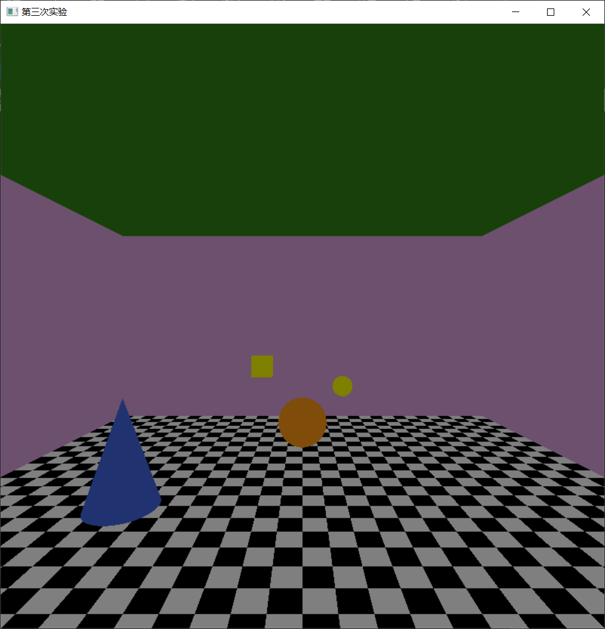刚开始没有光照。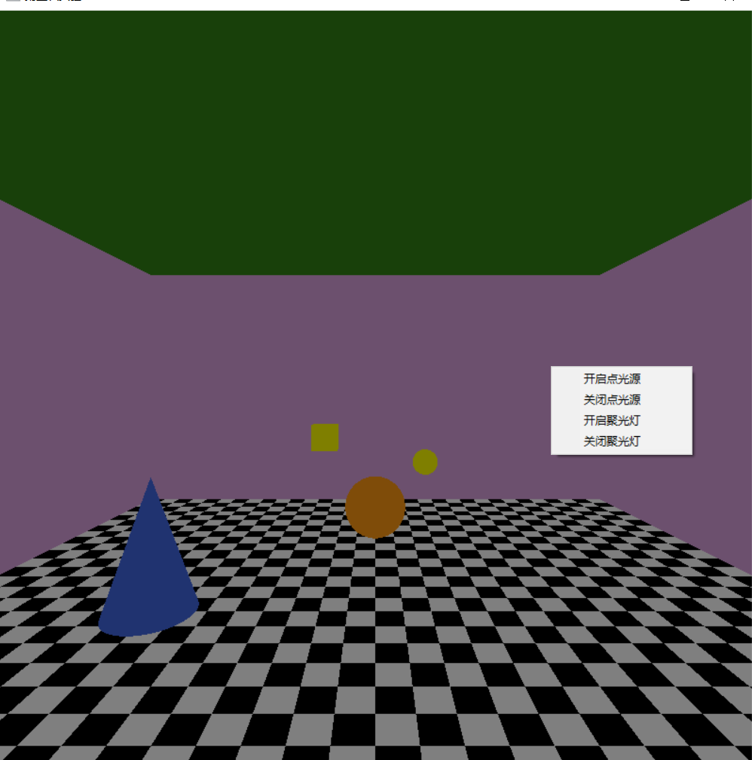通过菜单界面修改光照。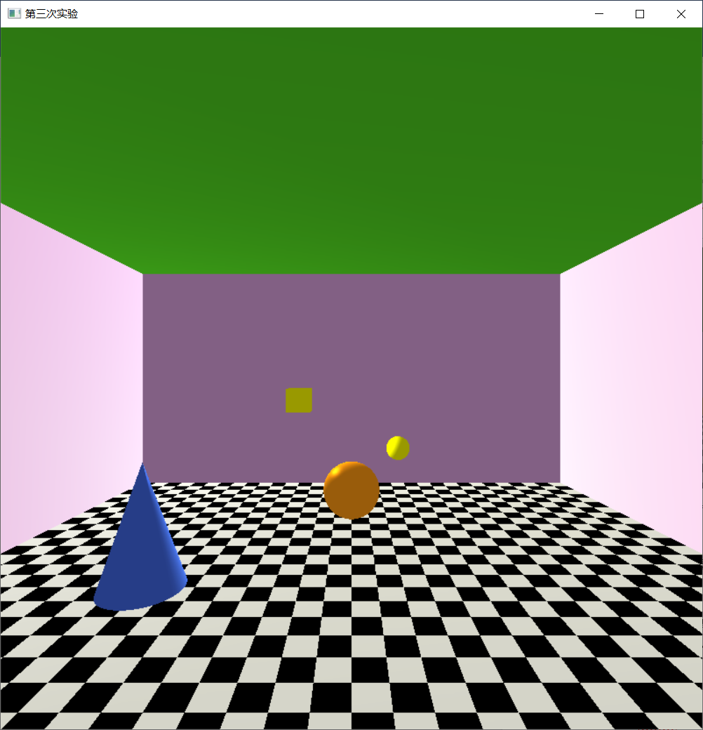开启点光源后。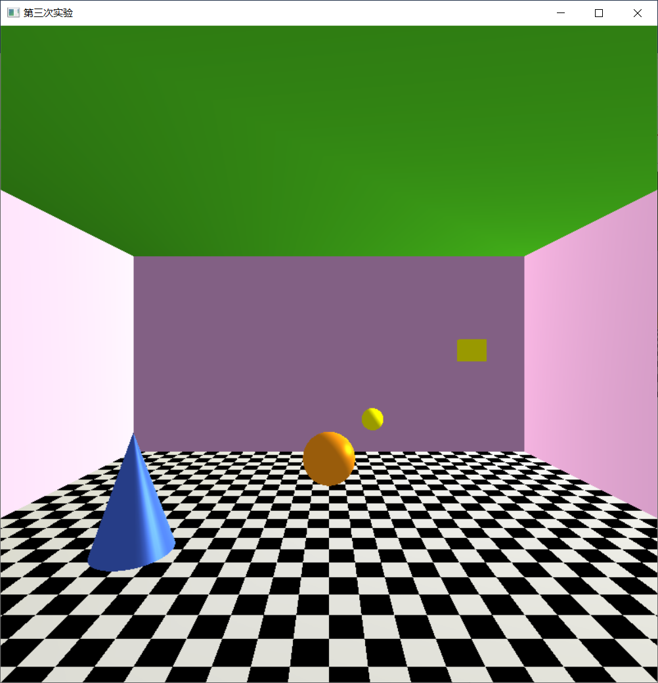通过鼠标选择更改点光源位置。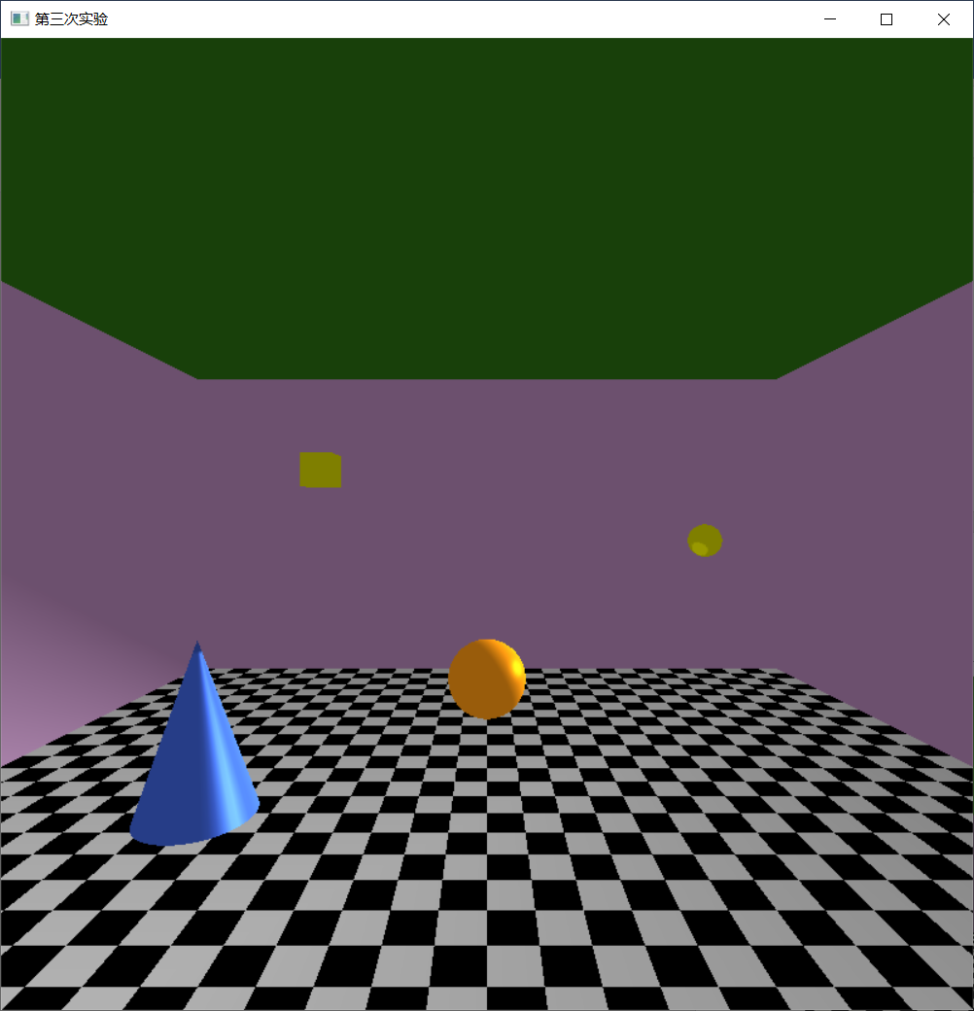关闭点光源，开启聚光灯后。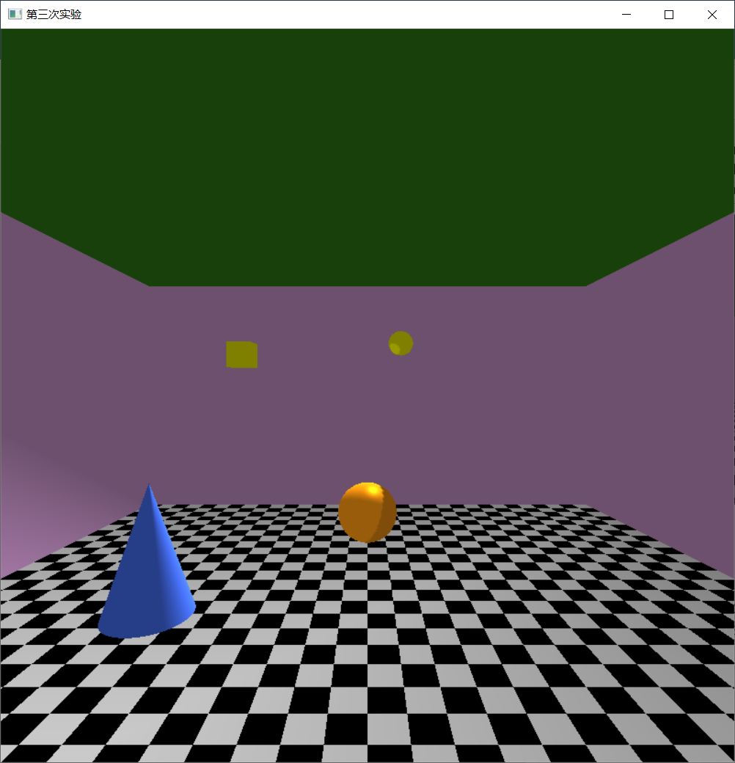更改聚光灯位置。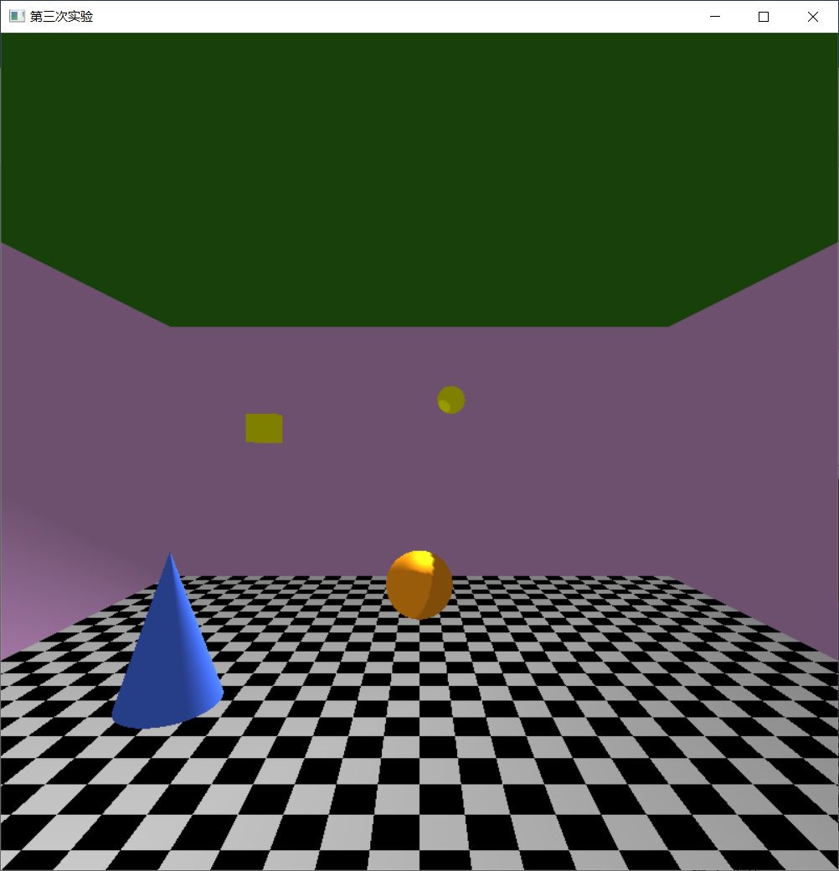通过键盘修改球的辉度系数。
编程任务2：
程序功能：
程序实现了绘制一个具有地板反光效果的房间。
源代码：
#include <glut.h>
#include <stdio.h>
#include <math.h>

void init();
void display();
void CreateWall();
void CreateCeiling();
void CreateGround();
void CreateFurnishings(int);//0=球体
void DrawWorld(void);
void CreatWorld();

float p1[] = { -2,3,-8,1 };
float p2[] = { -2,-3,-8,1 };

typedef struct obj {
GLfloat a[4];
GLfloat d[4];
GLfloat s[4];
GLfloat shin;
}obj;
obj ball = {
{1,0.6,0.07,1},
{1,0.6,0.07,1},
{1,0.6,0.07,1},
50
};
obj cone = {
{0.25,0.4,0.88,1},
{0.25,0.4,0.88,1},
{0.25,0.4,0.88,1},
50
};
obj wall = {
{0.85,0.625,0.86,1},
{0.85,0.625,0.86,1},
{0.85,0.625,0.86,1},
100
};
obj ceiling = {
{0.1875,0.5,0.08,1},
{0.1875,0.5,0.08,1},
{0.1875,0.5,0.08,1},
100
};
obj ground = {
{1,1,1,0.5},
{1,1,1,0.5},
{1,1,1,0.5},
50
};

void use(obj t) {
glMaterialfv(GL_FRONT_AND_BACK, GL_AMBIENT, t.a);
glMaterialfv(GL_FRONT_AND_BACK, GL_DIFFUSE, t.d);
glMaterialfv(GL_FRONT_AND_BACK, GL_SPECULAR, t.s);
glMaterialf(GL_FRONT_AND_BACK, GL_SHININESS, t.shin);
}

int main(int argc, char** argv) {
glutInit(&argc, argv);
glutInitWindowSize(800, 800);
glutInitWindowPosition(0, 0);
glutCreateWindow("第三次实验");
init();
glutDisplayFunc(display);
glutMainLoop();
}

void display()
{
glClear(GL_COLOR_BUFFER_BIT | GL_DEPTH_BUFFER_BIT);
DrawWorld();
glFlush();
}

void init() {
glEnable(GL_DEPTH_TEST);
glEnable(GL_LIGHTING);
glEnable(GL_LIGHT0);
glEnable(GL_NORMALIZE);
float a[] = { 0.5,0.5,0.5,1 };
glLightModelfv(GL_LIGHT_MODEL_AMBIENT, a);
glMatrixMode(GL_PROJECTION);
glLoadIdentity();
gluPerspective(80, 1, 1, 30);
}

void CreateWall()
{
use(wall);

glNormal3f(0, 0, 1);
glBegin(GL_POLYGON);
glVertex3f(10, 0, -10);
glVertex3f(-10, 0, -10);
glVertex3f(-10, 10, -10);
glVertex3f(10, 10, -10);
glEnd();

glNormal3f(-1, 0, 0);
glBegin(GL_POLYGON);
glVertex3f(10, 0, -10);
glVertex3f(10, 0, 10);
glVertex3f(10, 10, 10);
glVertex3f(10, 10, -10);
glEnd();

glNormal3f(0, 0, -1);
glBegin(GL_POLYGON);
glVertex3f(10, 10, 10);
glVertex3f(10, 0, 10);
glVertex3f(-10, 0, 10);
glVertex3f(-10, 10, 10);
glEnd();

glNormal3f(1, 0, 0);
glBegin(GL_POLYGON);
glVertex3f(-10, 10, 10);
glVertex3f(-10, 0, 10);
glVertex3f(-10, 0, -10);
glVertex3f(-10, 10, -10);
glEnd();
}

void CreateCeiling()
{
glNormal3f(0, 1, 0);
use(ceiling);
glBegin(GL_POLYGON);
glVertex3f(10, 10, -10);
glVertex3f(-10, 10, -10);
glVertex3f(-10, 10, 10);
glVertex3f(10, 10, 10);
glEnd();
}

void CreateGround()
{
glNormal3f(0, 1, 0);
use(ground);
glBegin(GL_POLYGON);
glVertex3f(-10, 0, 10);
glVertex3f(10, 0, 10);
glVertex3f(10, 0, -10);
glVertex3f(-10, 0, -10);
glEnd();
}

void CreateFurnishings(int choice)
{
glPushMatrix();
if (choice == 0) {
use(ball);
glutSolidSphere(1, 60, 60);
}
else {
use(cone);
glRotatef(-90, 1, 0, 0);
glutSolidCone(1, 3, 50, 50);
}
glPopMatrix();
}

void CreatWorld() {
glPushMatrix();
CreateWall();
CreateCeiling();
glTranslatef(0, 1, -5);
CreateFurnishings(0);
glTranslatef(-5, -1, 5);
CreateFurnishings(1);
glPopMatrix();
}
void DrawWorld(void)
{
glMatrixMode(GL_MODELVIEW);
glLoadIdentity();
gluLookAt(0, 5, 10, 0, 5, 0, 0, 1, 0);
glPushMatrix();
float a1[] = { 0.1,0.1,0.1,1 };
float d1[] = { 1,1,1,1 };
float s1[] = { 1,1,1,1 };
glLightfv(GL_LIGHT0, GL_POSITION, p2);
glLightfv(GL_LIGHT0, GL_AMBIENT, a1);
glLightfv(GL_LIGHT0, GL_DIFFUSE, d1);
glLightfv(GL_LIGHT0, GL_SPECULAR, s1);

glPushMatrix();
glScalef(1, -1, 1);
CreatWorld();
glPopMatrix();

glLightfv(GL_LIGHT0, GL_POSITION, p1);
//glDisable(GL_LIGHTING);不能关闭光照，不然无法正常显示
glEnable(GL_BLEND);
glBlendFunc(GL_SRC_ALPHA, GL_ONE_MINUS_SRC_ALPHA);
glDepthMask(GL_FALSE);
CreateGround();
glDepthMask(GL_TRUE);
glDisable(GL_BLEND);
//glEnable(GL_LIGHTING);

CreatWorld();
glPopMatrix();

}
运行结果：
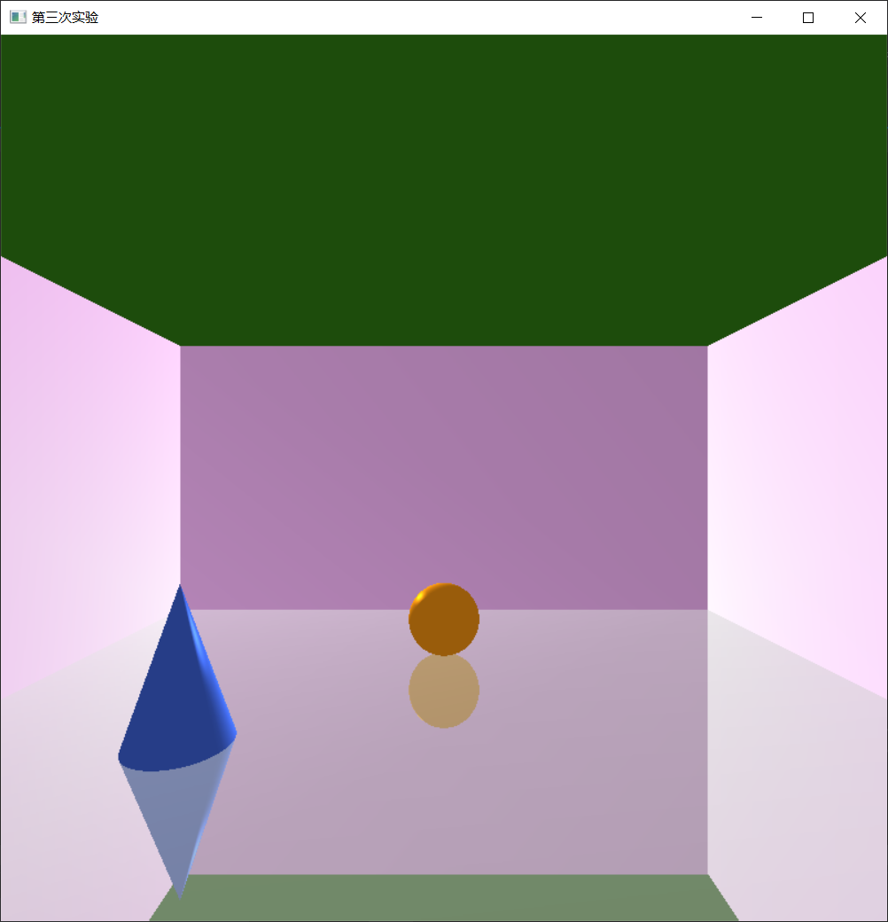成功显示出有反光的地板。
总结、改进建议及心得体会：
对于实验一，在通过鼠标移动光源是要注意除以一个数值，因为一个是窗口的坐标系，一个是世界坐标系，其中的转换比较麻烦。在绘制纹理的时候，必须对于GL_TEXTURE_MAG_FILTER进行设定，不然纹理无法正常显示，而且在使用纹理后要立马关闭纹理，不然会对之后绘制的物体产生影响。
对于实验二，在绘制地板的时候，不能按照实验指导书上的代码写，不能关闭光照，不然地板接受不到底下的颜色信息。

