环境
2020年11月16日
13:20
Anaconda安装：
下载对应版本的Anaconda

命令：bash A********.sh
Yes 到底
最后 [source ~/.bashrc]

输入python查看结果：
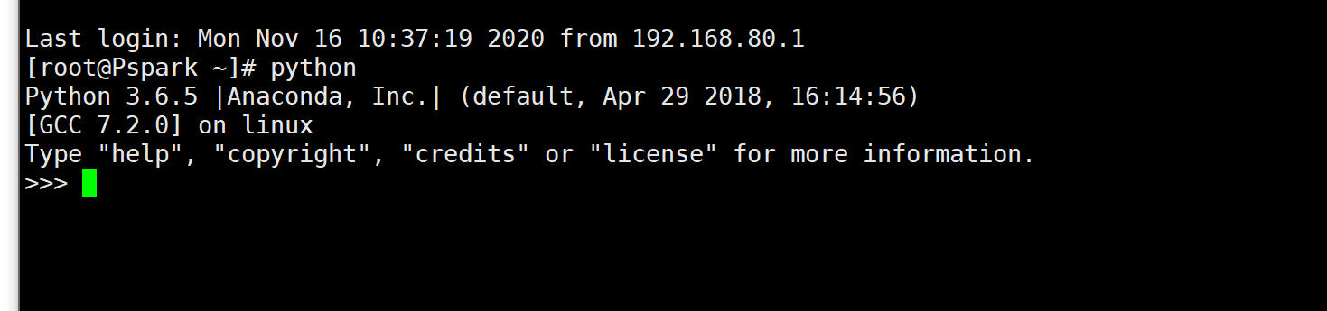

Scala
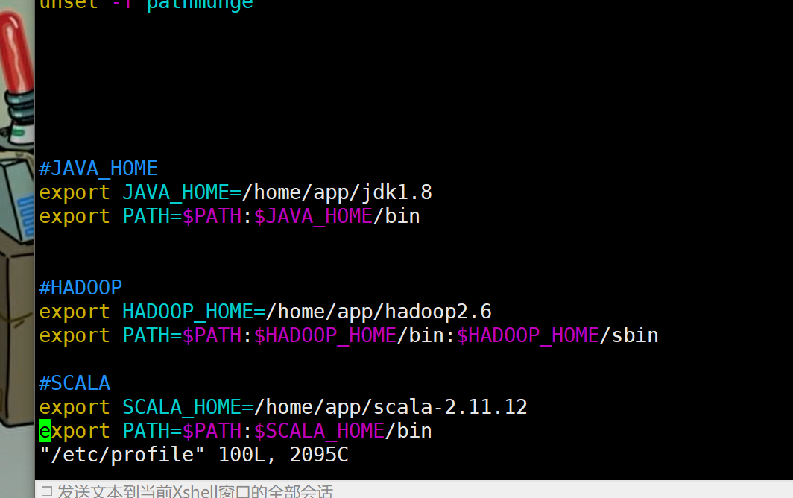

maven安装：
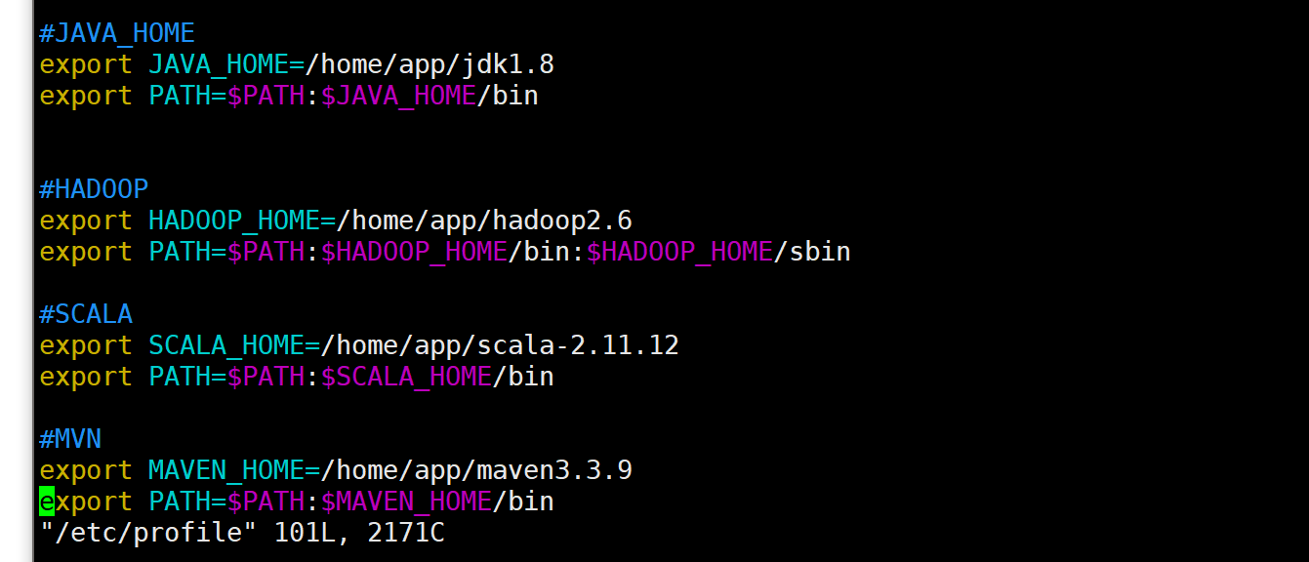

修改一下缓存路径：

Hadoop：2.6.1
Spark：2.4.6-hadoop2.6

Python 3.6.5 ==anaconda3.5
Java： 1.8
Scala： 2.11.12
Maven 3.3.9

ElasticSearch 6.3.0
Kibana：6.3.0

Cen7info： root root

网络连接以及Hadoop安装：
分布式
换源：

mv /etc/yum.repos.d/CentOS-Base.repo /etc/yum.repos.d/CentOS-Base.repo.backupcache

wget -O /etc/yum.repos.d/CentOS-Base.repo http://mirrors.aliyun.com/repo/Centos-7.repo
wget -O /etc/yum.repos.d/epel.repo http://mirrors.aliyun.com/repo/epel-7.repo

yum clean all

yum makecache

yum -y install autoconf automake libtool cmake ncurses-devel openss-devel lzo-devel zlib-devel gcc gcc-c++

yum -y install zlib-devel bzip2-devel openssl-devel ncurses-devel sqlite-devel readline-devel tk-devel gdbm-devel db4-devel libpcap-devel xz-devel
1、关闭防火墙：
$ systemctl stop firewalld.service
$ systemctl disable firewalld.service

2、禁用selinux
$ vim /etc/sysconfig/selinux

3、网络相关配置，改成自己相对应的

$ vi /etc/sysconfig/network-scripts/ifcfg-ens33
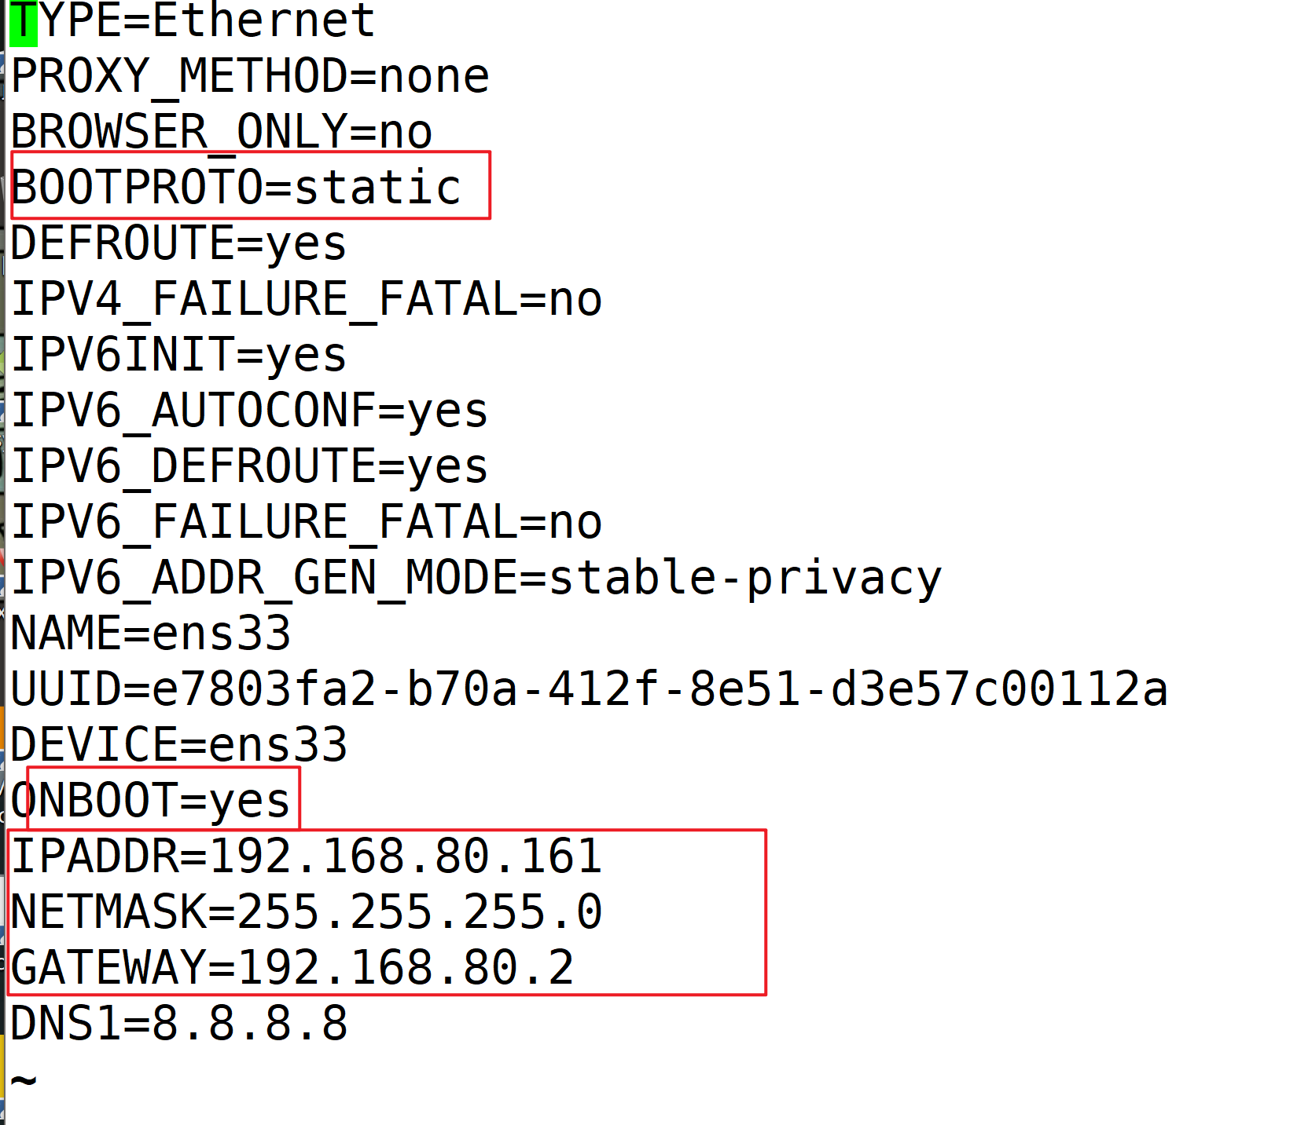

$ vim /etc/sysconfig/network

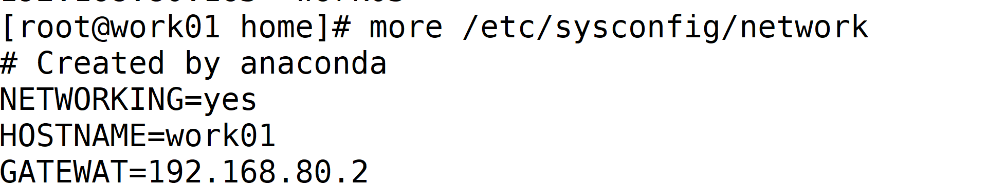

$ vim /etc/hostname
重启生效

$ vim /etc/hosts
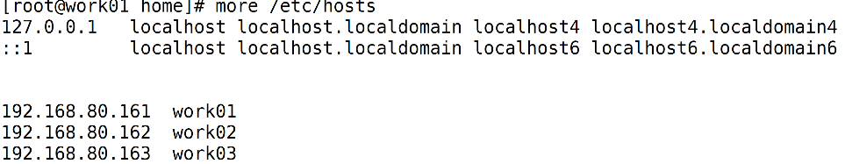

4、SSH免密登录
$ ssh-keygen -t rsa //四下回车
$ ssh-copy-id 主节点ip
$ spc -r /root/.ssh 其余节点ip:/root

5、添加用户组
$adduser hadoop
$vim /etc/sudoers


修改用户所属用户组：
$chown -R hadoop:hadoop /home/local/hadoop-2.9.2

6、Jdk8安装
$ tar -zxvf /home/tools/jdk-8u231-linux-x64.tar.gz -C /home/local
$ vim /etc/profile



7、 Hadoop需修改文件
文件路径：【安装路径/etc/hadoop】
core-site.xml
<configuration>
<property>
<name>fs.defaultFS</name>
<value>hdfs://主机名:9000</value>
</property>
<property>
<name>io.file.buffer.size</name>
<value>131072</value>
</property>
<property>
<name>hadoop.tmp.dir</name>
<value>file:/home/local/hadoop-2.9.2/tmp</value>
</property>
<property>
<name>hadoop.proxyuser.root.hosts</name>
<value>*</value>
</property>
<property>
<name>hadoop.proxyuser.root.groups</name>
<value>*</value>
</property>
</configuration>

Hadoop-env.sh【env文件都改为自己的路径】
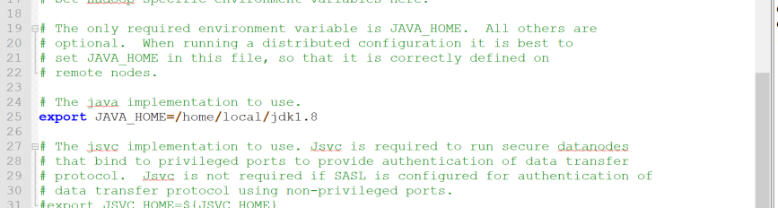

hdfs-site.xml 主机名、文件存储位置
/dfs/name, /dfs/data 需自行创建

<configuration>
<property>
<name>dfs.namenode.secondary.http-address</name>
<value>work01:9001</value>
</property>
<property>
<name>dfs.namenode.name.dir</name>
<value>file:/home/app/hadoop2.6/dfs/name</value>
</property>
<property>
<name>dfs.datanode.data.dir</name>
<value>file:/home/app/hadoop2.6/dfs/data</value>
</property>
<property>
<name>dfs.replication</name>
<value>3</value>
</property>
<property>
<name>dfs.webhdfs.enabled</name>
<value>true</value>
</property>
<property>
<name>dfs.permissions</name>
<value>false</value>
</property>
<property>
<name>dfs.web.ugi</name>
<value>supergroup</value>
</property>
</configuration>

mapred-site.xml

<configuration>
<property>
<name>mapreduce.framework.name</name>
<value>yarn</value>
</property>
<property>
<name>mapreduce.jobhistory.address</name>
<value>work01:10020</value>
</property>
<property>
<name>mapreduce.jobhistory.webapp.address</name>
<value>work01:19888</value>
</property>
</configuration>

Slaves 自己主机名

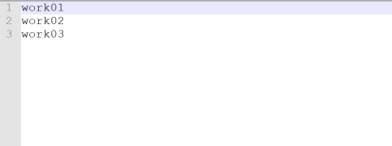

Yarn-site.xml
<configuration>
<property>
<name>yarn.nodemanager.aux-services</name>
<value>mapreduce_shuffle</value>
</property>
<property>
<name>yarn.nodemanager.aux-services.mapreduce.shuffle.class</name>
<value>org.apache.hadoop.mapred.ShuffleHandler</value>
</property>
<property>
<name>yarn.resourcemanager.hostname</name>
<value>work01</value>
</property>
<property>
<name>yarn.resourcemanager.address</name>
<value>work01:8032</value>
</property>
<property>
<name>yarn.resourcemanager.scheduler.address</name>
<value>work01:8030</value>
</property>
<property>
<name>yarn.resourcemanager.resource-tracker.address</name>
<value>work01:8031</value>
</property>
<property>
<name>yarn.resourcemanager.admin.address</name>
<value>work01:8033</value>
</property>
<property>
<name>yarn.resourcemanager.webapp.address</name>
<value>work01:8088</value>
</property>
<property>
<name>yarn.scheduler.maximum-allocation-mb</name>
<value>2048</value>
</property>
<property>
<name>yarn.scheduler.minimum-allocation-mb</name>
<value>2048</value>
</property>
<property>
<name>yarn.nodemanager.vmem-pmem-ratio</name>
<value>2.1</value>
</property>
<property>
<name>mapred.child.java.opts</name>
<value>-Xmx2048m</value>
</property>
</configuration>
格式化集群
$ bin/hdfs namenode -format

启动与关闭：
安装目录下：
$ sbin/start-all.sh
$ sbin/stop-all.sh
WEB管理界面
Namenodeip_:50070 //HDFS管理界面
resourmanger_ip:8088 //yarn 管理界面

分布式：
一个namenode
2-3个datanode

伪分布式：

