

实验报告
课程名称：数据库应用基础（创新学分）
学 院：计算机科学与工程学院
专 业：数据科学与大数据技术
学生姓名指导教师：符朝旭
评 分：
日 期： 2022 年 4月 1 日

实验一：创建数据库
实验学时：4学时
一、实验内容和目的：
本实验要求学生掌握创建数据库的方法及相关操作
二、实验原理：
使用数据库管理系统DB、DDL创建数据库及数据库对象。
三、实验器材（设备、元器件）
PC机
操作系统：Windows
数据库 ： Microsoft SQL server
四、实验步骤：
Create database DB2019081307027;
create table dep(depid varchar(8) not null,depname varchar(20) not null,primary key (depid));
create table teacher(tid varchar(8) not null,tname varchar(8) not null,title varchar(10),depid varchar(8),primary key (tid));
create table stud(studid varchar(11) not null,sname varchar(8) not
null,sex char(2) not null,depid varchar(8),birthd date,semail varchar(20),homeaddr varchar(40),primary key (studid));
create table course(cid varchar(8) not null,cname varchar(30) not null,credits numeric(3,1) not null,primary key (cid));
create table sc(studid varchar(11) not null,cid varchar(8) not null,tid varchar(8) not
null,score integer,primary key (studid,cid));
五、实验数据及结果分析：
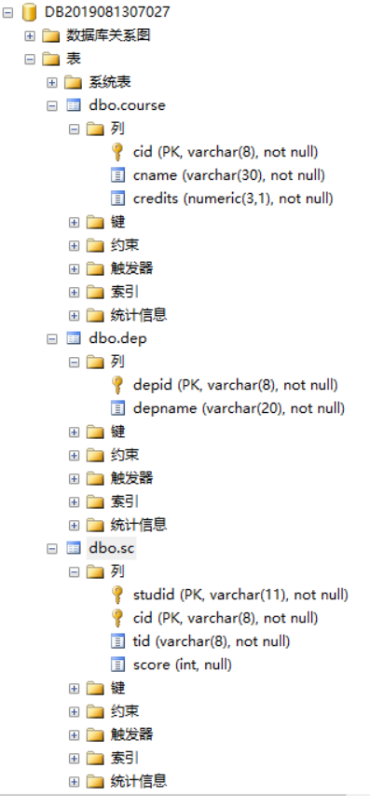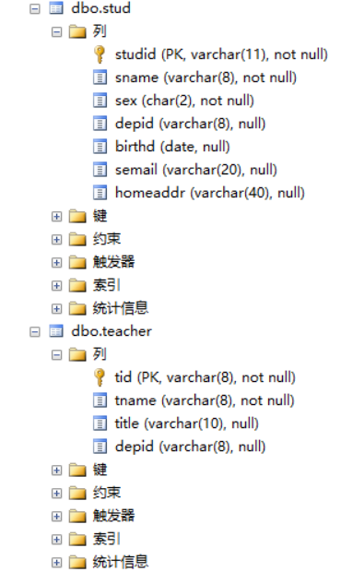
六、实验结论、心得体会和改进建议：
学习了如何创建数据库

实验二：数据库的完整性
实验学时：4学时
一、实验内容和目的：
通过设置表的检查约束、外键约束体会数据库完整性的含义，约束条件下数据修改操作的限制，以及实现修改操作的技巧。
二、实验原理：
数据库库的完整性、约束条件、结构化查询语言。
三、实验器材（设备、元器件）
PC机
操作系统：Windows
数据库 ： Microsoft SQL server
四、实验步骤：
alter table stud add constraint fk1 foreign key (depid) references
dep (depid);
alter table teacher add constraint fk2 foreign key (depid) references
dep (depid);
alter table sc add constraint fk3 foreign key (studid) references stud
(studid);
alter table sc add constraint fk4 foreign key (cid) references course
(cid);
alter table sc add constraint fk5 foreign key (tid) references teacher
(tid);
alter table stud alter column sname varchar(8) not null;
alter table sc add constraint chk1 check (score>=0 and score<=100);
alter table stud add constraint chk2 check (sex in ('男','女'));
alter table stud add constraint chk3 check (semail like '_%@_%');
五、实验数据及结果分析：
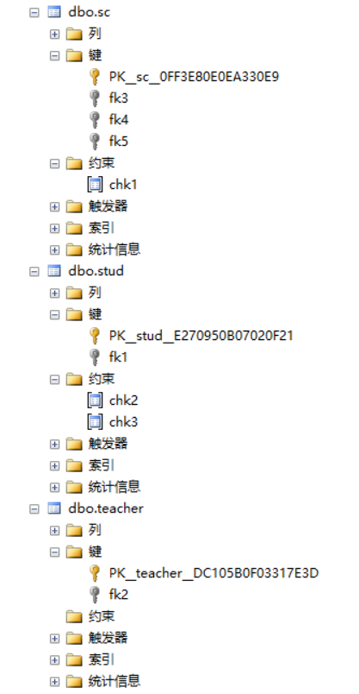
插入数据后查询得到如下所示，结果正常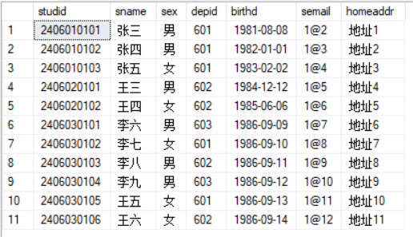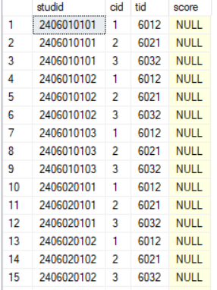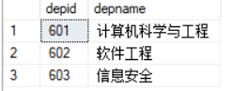
六、实验结论、心得体会和改进建议：
学习了如何插入数据，增加约束

实验三：数据的修改
实验学时：4学时
一、实验内容和目的：
练习UPDATE、DELETE命令的使用，实现对数据的修改和删除，同时体会主键、外键及约束条件对修改操作的限制。
二、实验原理：
使用结构化查询语言，在满足约束条件的情况下完成数据修改
三、实验器材（设备、元器件）
PC机
操作系统：Windows
数据库 ： Microsoft SQL server
四、实验步骤：
update dep set depname='information' where depname ='is';
delete sc where cid='2' and studid in (select studid from stud join dep on
stud.depid=dep.depid where depname = '计算机科学与工程');
delete sc where cid='1' and studid in (select studid from stud join dep on
stud.depid=dep.depid where depname = '软件工程');
update sc set studid='888' where studid='2406030103';
update stud set studid='888' where studid='2406030103';
五、实验数据及结果分析：
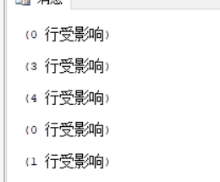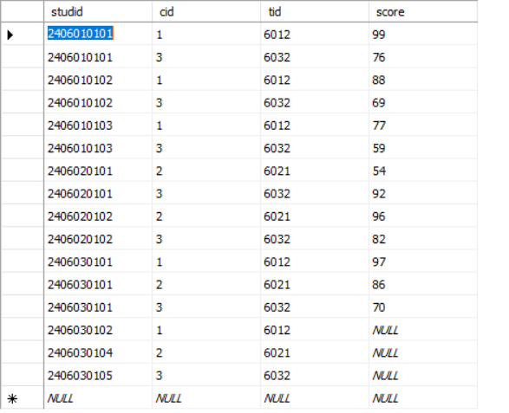
六、实验结论、心得体会和改进建议：
学习了如何修改数据

实验四：简单查询、多表查询
实验学时：4学时
一、实验内容和目的：
练习用SELECT查询语句，设置查询条件，实现单表查询。练习使用SELECT语句从多个表中查询数据，表的连接的使用以及设置连接条件，区分连接条件和查询条件的在目的和功能上的区别。
二、实验原理：
结构化查询语言、表的连接、关系运算
三、实验器材（设备、元器件）
PC机
操作系统：Windows
数据库 ： Microsoft SQL server
四、实验步骤：
select sname from stud where year(getdate())-year(birthd) between 20 and 22
select * from teacher where title ='副教授'
select studid,sname,semail from stud where sname like '张%'
select studid,cid from sc where score is not null
select stud.studid,sname,cname,sc.score
from stud join sc on stud.studid=sc.studid join course on sc.cid=course.cid where sc.score <60 and sc.cid=2
select stud.studid,stud.sname,teacher.tname from sc join stud on sc.studid=stud.studid join course on sc.cid=course.cid join teacher on sc.tid=teacher.tid where course.cname like '数据库'
五、实验数据及结果分析：
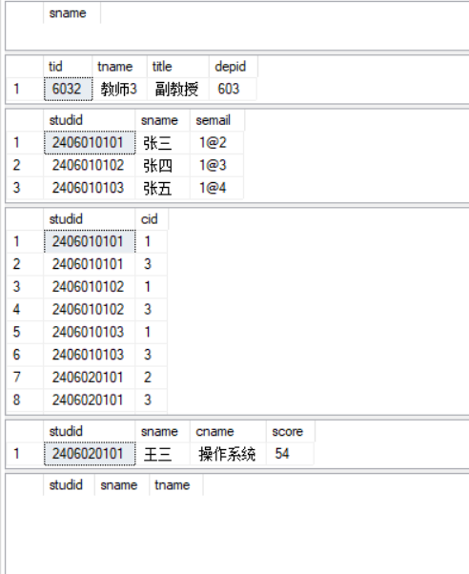
第一个没有结果因为年龄都大于22岁，最后一个没结果因为没有人选择这门课
六、实验结论、心得体会和改进建议：
学习了如何进行数据库的查询

实验五：分组统计查询
实验学时：4学时
一、实验内容和目的：
练习使用聚集函数count(),max(),min(),avg()等在SQL命令中实现统计功能。使用GROUP BY子句实现分组查询，以及聚集函数在分组查询中的应用。体会分组查询的功能特点。
二、实验原理：
结构化查询语言、分组查询、集函数
三、实验器材（设备、元器件）
PC机
操作系统：Windows
数据库 ： Microsoft SQL server
四、实验步骤：
select count(*) from sc join course on sc.cid=course.cid where cname like '操作系统' group by course.cid
select studid,count(cid) from sc group by studid
select studid,sum(credits) from sc join course on sc.cid=course.cid group by studid
select count(*) from sc join course on sc.cid=course.cid where cname like '操作系统' and score >60 group by sc.cid
select cname,max(score) as 最高分,min(score) as 最低分,avg(score) as 平均分 from course join sc on sc.cid=course.cid group by sc.cid,course.cname
select sname,semail from stud join sc on stud.studid=sc.studid group by sc.studid,stud.sname,stud.semail having count(*)>=5
改成操作系统因为我没加数据库这门课
五、实验数据及结果分析：
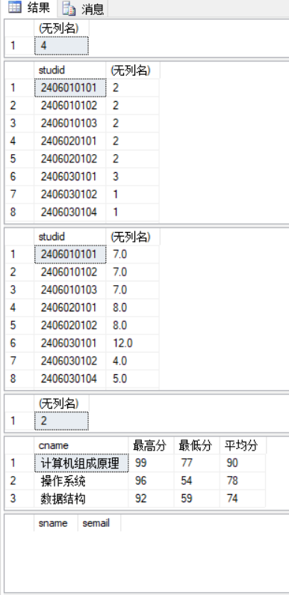
六、实验结论、心得体会和改进建议：
学习了如何分组查询

实验六：集合操作、子查询
实验学时：4学时
一、实验内容和目的：
练习IN、EXISTS、NOT EXISTS 运算在WHERE子句中的应用；静态集合和由SELECT命令产生的动态结果集运算
二、实验原理：
结构化查询语言、集合运算、子查询
三、实验器材（设备、元器件）
PC机
操作系统：Windows
数据库 ： Microsoft SQL server
四、实验步骤：
select sname,year(getdate())-year(birthd) from stud where birthd < (select min(birthd) from stud where depid='601' and sname='张五')
select sname,depname,semail from stud join dep on stud.depid=dep.depid where studid not in (select distinct studid from sc)
select sname from stud where not exists (select * from course where not exists (select * from sc where sc.studid=stud.studid and sc.cid=course.cid))
select studid from sc where cid='1' and studid in (select studid from sc where cid='2')
select sname from stud where studid in (select studid from sc where cid='1' and studid in (select studid from sc where cid='2'))
五、实验数据及结果分析：
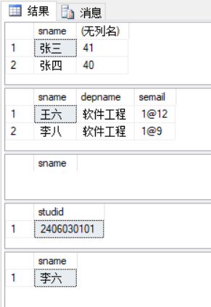
六、实验结论、心得体会和改进建议：
学习了如何使用集合操作、子操作进行查询

实验七：数据库建模
实验学时：8学时
一、实验内容和目的：
学习数据库建模工具PowerDesigner最基本的使用方法，使用PDM（物理模型），以图形化界面方式创建表及确定各表之间的关系；通过物理模型生成创建数据库的脚本；
- 使用PDM物理模型设计数据库
- 生成数据库脚本
- 在SQL SERVER系统上运行脚本创建表
二、实验原理：
学习数据库建模工具PowerDesigner设计数据库
三、实验器材（设备、元器件）
PC机
操作系统：Windows
数据库 ： Power Designer
四、实验步骤：
- 生成的数据库脚本
/*==============================================================*/
/* DBMS name: Microsoft SQL Server 2005 */
/* Created on: 2022/4/12 20:56:46 */
/*==============================================================*/

if exists (select 1
from sysobjects
where id = object_id('"CLR Trigger_classes"')
and type = 'TR')
drop trigger "CLR Trigger_classes"
go

if exists (select 1
from sys.sysreferences r join sys.sysobjects o on (o.id = r.constid and o.type = 'F')
where r.fkeyid = object_id('ClassTeacher') and o.name = 'FK_CLASSTEA_FK_CLASS__CLASSES')
alter table ClassTeacher
drop constraint FK_CLASSTEA_FK_CLASS__CLASSES
go

if exists (select 1
from sys.sysreferences r join sys.sysobjects o on (o.id = r.constid and o.type = 'F')
where r.fkeyid = object_id('ClassTeacher') and o.name = 'FK_CLASSTEA_FK_CLASS__TEACHER')
alter table ClassTeacher
drop constraint FK_CLASSTEA_FK_CLASS__TEACHER
go

if exists (select 1
from sys.sysreferences r join sys.sysobjects o on (o.id = r.constid and o.type = 'F')
where r.fkeyid = object_id('ClassTime') and o.name = 'FK_CLASSTIM_FK_CLASST_CLASSES')
alter table ClassTime
drop constraint FK_CLASSTIM_FK_CLASST_CLASSES
go

if exists (select 1
from sys.sysreferences r join sys.sysobjects o on (o.id = r.constid and o.type = 'F')
where r.fkeyid = object_id('Classes') and o.name = 'FK_CLASSES_FK_CLASS__COURSE')
alter table Classes
drop constraint FK_CLASSES_FK_CLASS__COURSE
go

if exists (select 1
from sys.sysreferences r join sys.sysobjects o on (o.id = r.constid and o.type = 'F')
where r.fkeyid = object_id('Classes') and o.name = 'FK_CLASSES_FK_CLASSE_TEACHER')
alter table Classes
drop constraint FK_CLASSES_FK_CLASSE_TEACHER
go

if exists (select 1
from sys.sysreferences r join sys.sysobjects o on (o.id = r.constid and o.type = 'F')
where r.fkeyid = object_id('SC') and o.name = 'FK_SC_FK_SC_CLA_CLASSES')
alter table SC
drop constraint FK_SC_FK_SC_CLA_CLASSES
go

if exists (select 1
from sys.sysreferences r join sys.sysobjects o on (o.id = r.constid and o.type = 'F')
where r.fkeyid = object_id('SC') and o.name = 'FK_SC_FK_SC_STU_STUDENT')
alter table SC
drop constraint FK_SC_FK_SC_STU_STUDENT
go

if exists (select 1
from sys.sysreferences r join sys.sysobjects o on (o.id = r.constid and o.type = 'F')
where r.fkeyid = object_id('Student') and o.name = 'FK_STUDENT_PK_STUD_D_DEP')
alter table Student
drop constraint FK_STUDENT_PK_STUD_D_DEP
go

if exists (select 1
from sys.sysreferences r join sys.sysobjects o on (o.id = r.constid and o.type = 'F')
where r.fkeyid = object_id('Teacher') and o.name = 'FK_TEACHER_PK_TEACHE_DEP')
alter table Teacher
drop constraint FK_TEACHER_PK_TEACHE_DEP
go

if exists (select 1
from sysindexes
where id = object_id('ClassTeacher')
and name = 'FK_class_teacher_tid_FK'
and indid > 0
and indid < 255)
drop index ClassTeacher.FK_class_teacher_tid_FK
go

if exists (select 1
from sysindexes
where id = object_id('ClassTeacher')
and name = 'FK_class_class_classid_FK'
and indid > 0
and indid < 255)
drop index ClassTeacher.FK_class_class_classid_FK
go

if exists (select 1
from sysobjects
where id = object_id('ClassTeacher')
and type = 'U')
drop table ClassTeacher
go

if exists (select 1
from sysindexes
where id = object_id('ClassTime')
and name = 'FK_classtime_class_FK'
and indid > 0
and indid < 255)
drop index ClassTime.FK_classtime_class_FK
go

if exists (select 1
from sysobjects
where id = object_id('ClassTime')
and type = 'U')
drop table ClassTime
go

if exists (select 1
from sysindexes
where id = object_id('Classes')
and name = 'FK_class_course_cid_FK'
and indid > 0
and indid < 255)
drop index Classes.FK_class_course_cid_FK
go

if exists (select 1
from sysindexes
where id = object_id('Classes')
and name = 'FK_classes_teacher_tid_FK'
and indid > 0
and indid < 255)
drop index Classes.FK_classes_teacher_tid_FK
go

if exists (select 1
from sysobjects
where id = object_id('Classes')
and type = 'U')
drop table Classes
go

if exists (select 1
from sysobjects
where id = object_id('Course')
and type = 'U')
drop table Course
go

if exists (select 1
from sysobjects
where id = object_id('DEP')
and type = 'U')
drop table DEP
go

if exists (select 1
from sysindexes
where id = object_id('SC')
and name = 'FK_SC_class_classid_FK'
and indid > 0
and indid < 255)
drop index SC.FK_SC_class_classid_FK
go

if exists (select 1
from sysindexes
where id = object_id('SC')
and name = 'FK_sc_stud_FK'
and indid > 0
and indid < 255)
drop index SC.FK_sc_stud_FK
go

if exists (select 1
from sysobjects
where id = object_id('SC')
and type = 'U')
drop table SC
go

if exists (select 1
from sysindexes
where id = object_id('Student')
and name = 'PK_STUD_dep_FK'
and indid > 0
and indid < 255)
drop index Student.PK_STUD_dep_FK
go

if exists (select 1
from sysobjects
where id = object_id('Student')
and type = 'U')
drop table Student
go

if exists (select 1
from sysindexes
where id = object_id('Teacher')
and name = 'PK_teacher_dep_FK'
and indid > 0
and indid < 255)
drop index Teacher.PK_teacher_dep_FK
go

if exists (select 1
from sysobjects
where id = object_id('Teacher')
and type = 'U')
drop table Teacher
go

/*==============================================================*/
/* Table: ClassTeacher */
/*==============================================================*/
create table ClassTeacher (
TeacherID int null,
ClassID int null,
descripe varbinary(500) null
)
go

/*==============================================================*/
/* Index: FK_class_class_classid_FK */
/*==============================================================*/
create index FK_class_class_classid_FK on ClassTeacher (
ClassID ASC
)
go

/*==============================================================*/
/* Index: FK_class_teacher_tid_FK */
/*==============================================================*/
create index FK_class_teacher_tid_FK on ClassTeacher (
TeacherID ASC
)
go

/*==============================================================*/
/* Table: ClassTime */
/*==============================================================*/
create table ClassTime (
WeekID smallint not null,
DayID smallint not null,
TimeUnit varchar(8) not null,
ClassID int null,
RoomID int null,
constraint PK_CLASSTIME primary key nonclustered (WeekID, DayID, TimeUnit)
)
go

/*==============================================================*/
/* Index: FK_classtime_class_FK */
/*==============================================================*/
create index FK_classtime_class_FK on ClassTime (
ClassID ASC
)
go

/*==============================================================*/
/* Table: Classes */
/*==============================================================*/
create table Classes (
ClassID int identity,
TeacherID int null,
CourseID int null,
TermID char(11) not null,
constraint PK_CLASSES primary key nonclustered (ClassID)
)
go

/*==============================================================*/
/* Index: FK_classes_teacher_tid_FK */
/*==============================================================*/
create index FK_classes_teacher_tid_FK on Classes (
TeacherID ASC
)
go

/*==============================================================*/
/* Index: FK_class_course_cid_FK */
/*==============================================================*/
create index FK_class_course_cid_FK on Classes (
CourseID ASC
)
go

/*==============================================================*/
/* Table: Course */
/*==============================================================*/
create table Course (
CourseID int not null,
CourseName varchar(50) not null,
Credits numeric(3,1) not null,
ClassHours int null,
constraint PK_COURSE primary key nonclustered (CourseID)
)
go

/*==============================================================*/
/* Table: DEP */
/*==============================================================*/
create table DEP (
DEPID int not null,
DEPNAME char(20) not null,
constraint PK_DEP primary key nonclustered (DEPID)
)
go

/*==============================================================*/
/* Table: SC */
/*==============================================================*/
create table SC (
StudID varchar(13) null,
ClassID int null,
SCORE int null
)
go

/*==============================================================*/
/* Index: FK_sc_stud_FK */
/*==============================================================*/
create index FK_sc_stud_FK on SC (
StudID ASC
)
go

/*==============================================================*/
/* Index: FK_SC_class_classid_FK */
/*==============================================================*/
create index FK_SC_class_classid_FK on SC (
ClassID ASC
)
go

/*==============================================================*/
/* Table: Student */
/*==============================================================*/
create table Student (
StudID varchar(13) not null,
DEPID int null,
SNAME varchar(8) not null,
sex char(2) not null,
BIRTH timestamp not null,
EMAIL varchar(40) null,
HOMEADDR varchar(40) null,
constraint PK_STUDENT primary key nonclustered (StudID)
)
go

/*==============================================================*/
/* Index: PK_STUD_dep_FK */
/*==============================================================*/
create index PK_STUD_dep_FK on Student (
DEPID ASC
)
go

/*==============================================================*/
/* Table: Teacher */
/*==============================================================*/
create table Teacher (
TeacherID int not null,
DEPID int null,
TNAME varchar(20) not null,
TITLE varchar(8) not null,
constraint PK_TEACHER primary key nonclustered (TeacherID)
)
go

/*==============================================================*/
/* Index: PK_teacher_dep_FK */
/*==============================================================*/
create index PK_teacher_dep_FK on Teacher (
DEPID ASC
)
go

alter table ClassTeacher
add constraint FK_CLASSTEA_FK_CLASS__CLASSES foreign key (ClassID)
references Classes (ClassID)
go

alter table ClassTeacher
add constraint FK_CLASSTEA_FK_CLASS__TEACHER foreign key (TeacherID)
references Teacher (TeacherID)
go

alter table ClassTime
add constraint FK_CLASSTIM_FK_CLASST_CLASSES foreign key (ClassID)
references Classes (ClassID)
go

alter table Classes
add constraint FK_CLASSES_FK_CLASS__COURSE foreign key (CourseID)
references Course (CourseID)
go

alter table Classes
add constraint FK_CLASSES_FK_CLASSE_TEACHER foreign key (TeacherID)
references Teacher (TeacherID)
go

alter table SC
add constraint FK_SC_FK_SC_CLA_CLASSES foreign key (ClassID)
references Classes (ClassID)
go

alter table SC
add constraint FK_SC_FK_SC_STU_STUDENT foreign key (StudID)
references Student (StudID)
go

alter table Student
add constraint FK_STUDENT_PK_STUD_D_DEP foreign key (DEPID)
references DEP (DEPID)
go

alter table Teacher
add constraint FK_TEACHER_PK_TEACHE_DEP foreign key (DEPID)
references DEP (DEPID)
go

五、实验数据及结果分析：
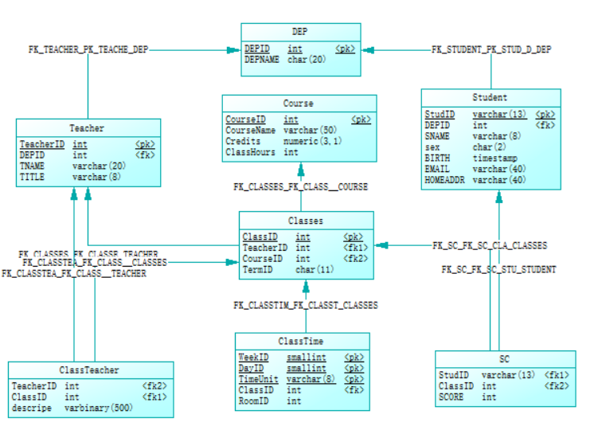
生成后的数据库
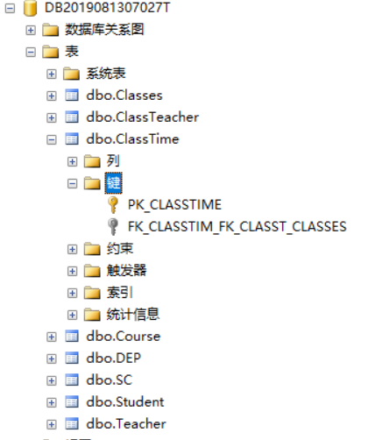
六、实验结论、心得体会和改进建议：
学习了数据库建模工具PowerDesigner最基本的使用方法，以图形化界面方式创建表及确定各表之间的关系。并且通过物理模型生成创建数据库的脚本

