
计算机专业类课程
实验报告
课程名称：大数据存储与管理综合课程实验
学 院：计算机科学与工程学院
专 业：数据科学与大数据技术
学生姓指导教师：高辉
日 期： 2022 年 10月 27 日

电 子 科 技 大 学
实 验 报 告
学生姓名

一、实验室名称： A2-412

二、实验项目名称：熟悉常用的HBase操作

三、实验目的：
1. 理解HBase在Hadoop体系结构中的角色；
2. 熟练使用HBase操作常用的Shell命令；
3. 熟悉HBase操作常用的Java API。

四、实验平台：
操作系统：Linux
Hadoop版本：2.6.0或以上版本
HBase版本：1.1.2或以上版本
JDK版本：1.6或以上版本
Java IDE：Eclipse

五、实验内容：
- 编程实现以下指定功能，并用Hadoop提供的HBase Shell命令完成相同任务：
- 列出HBase所有的表的相关信息，例如表名；
- 在终端打印出指定的表的所有记录数据；
- 向已经创建好的表添加和删除指定的列族或列；
- 清空指定的表的所有记录数据；
- 统计表的行数。
- 现有以下关系型数据库中的表和数据，要求将其转换为适合于HBase存储的表并插入数据：
学生表（Student）
学号（S_No） | 姓名（S_Name） | 性别（S_Sex） | 年龄（S_Age）
2015001 | Zhangsan | male | 23
2015003 | Mary | female | 22
2015003 | Lisi | male | 24

课程表（Course）
课程号（C_No） | 课程名（C_Name） | 学分（C_Credit）
123001 | Math | 2.0
123002 | Computer Science | 5.0
123003 | English | 3.0

选课表（SC）
学号（SC_Sno） | 课程号（SC_Cno） | 成绩（SC_Score）
2015001 | 123001 | 86
2015001 | 123003 | 69
2015002 | 123002 | 77
2015002 | 123003 | 99
2015003 | 123001 | 98
2015003 | 123002 | 95

同时，请编程完成以下指定功能：
（1）createTable(String tableName, String[] fields)
创建表，参数tableName为表的名称，字符串数组fields为存储记录各个域名称的数组。要求当HBase已经存在名为tableName的表的时候，先删除原有的表，然后再创建新的表。
（2）addRecord(String tableName, String row, String[] fields, String[] values)
向表tableName、行row（用S_Name表示）和字符串数组files指定的单元格中添加对应的数据values。其中fields中每个元素如果对应的列族下还有相应的列限定符的话，用“columnFamily:column”表示。例如，同时向“Math”、“Computer Science”、“English”三列添加成绩时，字符串数组fields为{“Score:Math”,”Score；Computer Science”,”Score:English”}，数组values存储这三门课的成绩。
（3）scanColumn(String tableName, String column)
浏览表tableName某一列的数据，如果某一行记录中该列数据不存在，则返回null。要求当参数column为某一列族名称时，如果底下有若干个列限定符，则要列出每个列限定符代表的列的数据；当参数column为某一列具体名称（例如“Score:Math”）时，只需要列出该列的数据。
（4）modifyData(String tableName, String row, String column)
修改表tableName，行row（可以用学生姓名S_Name表示），列column指定的单元格的数据。
（5）deleteRow(String tableName, String row)
删除表tableName中row指定的行的记录。
- 利用HBase和MapReduce完成如下任务：
假设HBase有2张表，表的逻辑视图及部分数据如下所示：
表 逻辑视图及部分数据
书名（bookName） | 价格（price）
Database System Concept | 30$
Thinking in Java | 60$
Data Mining | 25$
要求：从HBase读出上述两张表的数据，对“price”的排序，并将结果存储到HBase中。

六、实验步骤（针对实验内容，具体描述实验步骤，包括操作指令、程序源代码，并给出实验结果的截图）：
1.Java代码：package org.example;

import org.apache.hadoop.conf.Configuration;
import org.apache.hadoop.hbase.*;
import org.apache.hadoop.hbase.client.*;
import org.apache.hadoop.hbase.util.Bytes;

import java.io.IOException;

public class Main {
Configuration configuration;
Connection connection;
Admin admin;

public void setUp() throws Exception {
configuration = HBaseConfiguration.create();
configuration.set("hbase.zookeeper.quorum", "192.168.71.150");
connection = ConnectionFactory.createConnection(configuration);
admin = connection.getAdmin();
}

public void close() {
try {
if (admin != null) {
admin.close();
}
if (null != connection) {
connection.close();
}
} catch (IOException e) {
e.printStackTrace();
}
}

public void listTables() throws IOException {
HTableDescriptor[] hTableDescriptors = admin.listTables();
for (HTableDescriptor hTableDescriptor : hTableDescriptors) {
System.out.println("表名:" + hTableDescriptor.getNameAsString());
}
}

public void createTable(String tableName, String[] fields) throws IOException {
TableName tablename = TableName.valueOf(tableName);
if (admin.tableExists(tablename)) {
System.out.println("表已存在");
admin.disableTable(tablename);
admin.deleteTable(tablename);//删除原来的表
}
HTableDescriptor tableDescriptor = new HTableDescriptor(tablename);
for (String str : fields) {
HColumnDescriptor hColumnDescriptor = new HColumnDescriptor(str);
tableDescriptor.addFamily(hColumnDescriptor);
}
admin.createTable(tableDescriptor);
}

public void getData(String tableName) throws IOException {
Table table = connection.getTable(TableName.valueOf(tableName));
Scan scan = new Scan();
ResultScanner scanner = table.getScanner(scan);
for (Result result : scanner) {
printRecoder(result);
}
}

//打印一条记录的详情
public void printRecoder(Result result) {
for (Cell cell : result.rawCells()) {
System.out.print("行健: " + new String(CellUtil.cloneRow(cell)));
System.out.print("列簇: " + new String(CellUtil.cloneFamily(cell)));
System.out.print(" 列: " + new String(CellUtil.cloneQualifier(cell)));
System.out.print(" 值: " + new String(CellUtil.cloneValue(cell)));
System.out.println("时间戳: " + cell.getTimestamp());
}
}

public void scanColumn(String tableName, String column) throws IOException {
Table table = connection.getTable(TableName.valueOf(tableName));
Scan scan = new Scan();
scan.addFamily(Bytes.toBytes(column));
ResultScanner scanner = table.getScanner(scan);
for (Result result = scanner.next(); result != null; result = scanner.next()) {
printRecoder(result);
}
table.close();
}

public void insertRow(String tableName, String rowKey, String colFamily, String col, String val) throws IOException {
Table table = connection.getTable(TableName.valueOf(tableName));
Put put = new Put(rowKey.getBytes());
put.addColumn(colFamily.getBytes(), col.getBytes(), val.getBytes());
table.put(put);
table.close();
}

public void addRecord(String tableName, String row, String[] fields, String[] values) throws IOException {
Table table = connection.getTable(TableName.valueOf(tableName));
Put put = new Put(Bytes.toBytes(row));
for (int i = 0; i < fields.length; i++) {
String field = fields[i];
String columnFamily = field.split(":")[0];
String column = field.split(":")[1];
put.addColumn(Bytes.toBytes(columnFamily), Bytes.toBytes(column), Bytes.toBytes(values[i]));
}
table.put(put);
table.close();
}

public void modifyData(String tableName, String row, String column, String val) throws IOException {
Table table = connection.getTable(TableName.valueOf(tableName));
Put put = new Put(row.getBytes());
Scan scan = new Scan();
ResultScanner resultScanner = table.getScanner(scan);
long ts = 0;
for (Result r : resultScanner) {
for (Cell cell : r.getColumnCells(row.getBytes(), column.getBytes())) {
ts = cell.getTimestamp();
}
}
put.addColumn(row.getBytes(), column.getBytes(), ts, val.getBytes());
table.put(put);
table.close();
}

public void deleteRow(String tableName, String rowKey, String colFamily, String col) throws IOException {
Table table = connection.getTable(TableName.valueOf(tableName));
Delete delete = new Delete(rowKey.getBytes());
//删除指定列族
delete.addFamily(Bytes.toBytes(colFamily));
//删除指定列
delete.addColumn(Bytes.toBytes(colFamily), Bytes.toBytes(col));
table.delete(delete);
table.close();
}

public void deleteRow(String tableName, String row) throws IOException {
Table table = connection.getTable(TableName.valueOf(tableName));
Delete delete = new Delete(row.getBytes());
table.delete(delete);
table.close();
}

public void clearRows(String tableName, String[] fields) throws IOException {
TableName tablename = TableName.valueOf(tableName);
admin.disableTable(tablename);
admin.deleteTable(tablename);
createTable(tableName, fields);
}

public void countRows(String tableName) throws IOException {
Table table = connection.getTable(TableName.valueOf(tableName));
Scan scan = new Scan();
ResultScanner scanner = table.getScanner(scan);
int num = 0;
for (Result result = scanner.next(); result != null; result = scanner.next()) {
num++;
}
System.out.println("行数:" + num);
scanner.close();
}

public static void main(String[] args) {
Main main = new Main();
try {
main.setUp();
System.out.println("创建表");
main.createTable("abc", new String[]{"cf1", "cf2", "cf3"});
System.out.println("列出表");
main.listTables();
System.out.println("插入数据");
main.insertRow("abc", "row1", "cf1", "col1", "val1");
main.insertRow("abc", "row1", "cf2", "col2", "val2");
main.insertRow("abc", "row1", "cf3", "col3", "val3");
main.insertRow("abc", "row2", "cf1", "col1_2", "val1_2");
System.out.println("打印表");
main.getData("abc");
System.out.println("删除数据");
main.deleteRow("abc", "row1", "cf1", "col1");
System.out.println("打印表");
main.getData("abc");
System.out.println("统计行数");
main.countRows("abc");
System.out.println("清空表");
main.clearRows("abc", new String[]{"cf1", "cf2", "cf3"});
System.out.println("打印表");
main.getData("abc");
main.close();
} catch (Exception e) {
e.printStackTrace();
}
}
}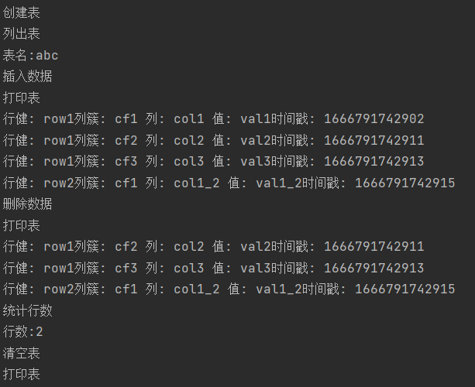
Shell命令结果：
create 'abc','cf1','cf2','cf3'
list
scan 'abc'
put 'abc','row1','cf1:col1','val1'
put 'abc','row1','cf2:col2','val2'
delete 'abc','row1','cf1:col1'
scan 'abc'
count 'abc'
truncate 'abc'
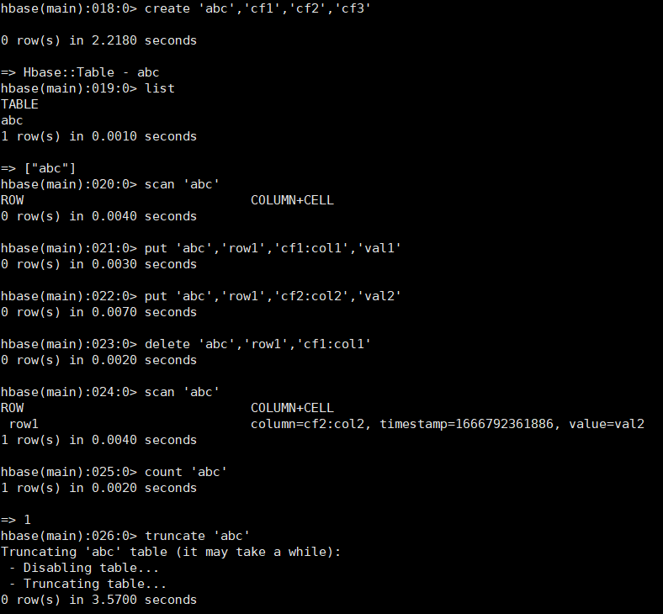
2. public void createTable(String tableName, String[] fields) throws IOException {
TableName tablename = TableName.valueOf(tableName);
if (admin.tableExists(tablename)) {
System.out.println("表已存在");
admin.disableTable(tablename);
admin.deleteTable(tablename);
}
HTableDescriptor tableDescriptor = new HTableDescriptor(tablename);
for (String str : fields) {
HColumnDescriptor hColumnDescriptor = new HColumnDescriptor(str);
tableDescriptor.addFamily(hColumnDescriptor);
}
admin.createTable(tableDescriptor);
}
public void addRecord(String tableName, String row, String[] fields, String[] values) throws IOException {
Table table = connection.getTable(TableName.valueOf(tableName));
Put put = new Put(Bytes.toBytes(row));
for (int i = 0; i < fields.length; i++) {
String field = fields[i];
String columnFamily = field.split(":")[0];
String column = field.split(":")[1];
put.addColumn(Bytes.toBytes(columnFamily), Bytes.toBytes(column), Bytes.toBytes(values[i]));
}
table.put(put);
table.close();
}
public void scanColumn(String tableName, String column) throws IOException {
Table table = connection.getTable(TableName.valueOf(tableName));
Scan scan = new Scan();
scan.addFamily(Bytes.toBytes(column));
ResultScanner scanner = table.getScanner(scan);
for (Result result = scanner.next(); result != null; result = scanner.next()) {
printRecoder(result);
}
table.close();
}
public void modifyData(String tableName, String row, String column, String val) throws IOException {
Table table = connection.getTable(TableName.valueOf(tableName));
Put put = new Put(row.getBytes());
Scan scan = new Scan();
ResultScanner resultScanner = table.getScanner(scan);
long ts = 0;
for (Result r : resultScanner) {
for (Cell cell : r.getColumnCells(row.getBytes(), column.getBytes())) {
ts = cell.getTimestamp();
}
}
put.addColumn(row.getBytes(), column.getBytes(), ts, val.getBytes());
table.put(put);
table.close();
}
public void deleteRow(String tableName, String row) throws IOException {
Table table = connection.getTable(TableName.valueOf(tableName));
Delete delete = new Delete(row.getBytes());
table.delete(delete);
table.close();
}
create 'Student','S_No','S_Name','S_Sex','S_Age'
put 'Student','row1','S_No','2015001'
put 'Student','row1','S_Name','Zhangsan'
put 'Student','row1','S_Sex','male'
put 'Student','row1','S_Age','23'
put 'Student','row2','S_No','2015003'
put 'Student','row2','S_Name','Mary'
put 'Student','row2','S_Sex','female'
put 'Student','row2','S_Age','22'
put 'Student','row3','S_No','2015003'
put 'Student','row3','S_Name','Lisi'
put 'Student','row3','S_Sex','male'
put 'Student','row3','S_Age','24'
create 'Course','C_No','C_Name','C_Credit'
put 'Course','row1','C_No','123001'
put 'Course','row1','C_Name','Math'
put 'Course','row1','C_Credit','2.0'
put 'Course','row2','C_No','123002'
put 'Course','row2','C_Name','Computer'
put 'Course','row2','C_Credit','5.0'
put 'Course','row3','C_No','123003'
put 'Course','row3','C_Name','English'
put 'Course','row3','C_Credit','3.0'
create 'SC','SC_Sno','SC_Cno','SC_Score'
put 'SC','row1','SC_Sno','2015001'
put 'SC','row1','SC_Cno','123001'
put 'SC','row1','SC_Score','86'
put 'SC','row2','SC_Sno','2015001'
put 'SC','row2','SC_Cno','123003'
put 'SC','row2','SC_Score','69'
put 'SC','row3','SC_Sno','2015002'
put 'SC','row3','SC_Cno','123002'
put 'SC','row3','SC_Score','77'
put 'SC','row4','SC_Sno','2015002'
put 'SC','row4','SC_Cno','123003'
put 'SC','row4','SC_Score','99'
put 'SC','row5','SC_Sno','2015003'
put 'SC','row5','SC_Cno','123001'
put 'SC','row5','SC_Score','98'
put 'SC','row6','SC_Sno','2015003'
put 'SC','row6','SC_Cno','123002'
put 'SC','row6','SC_Score','95'
scan 'Student'
scan 'Course'
scan 'SC'
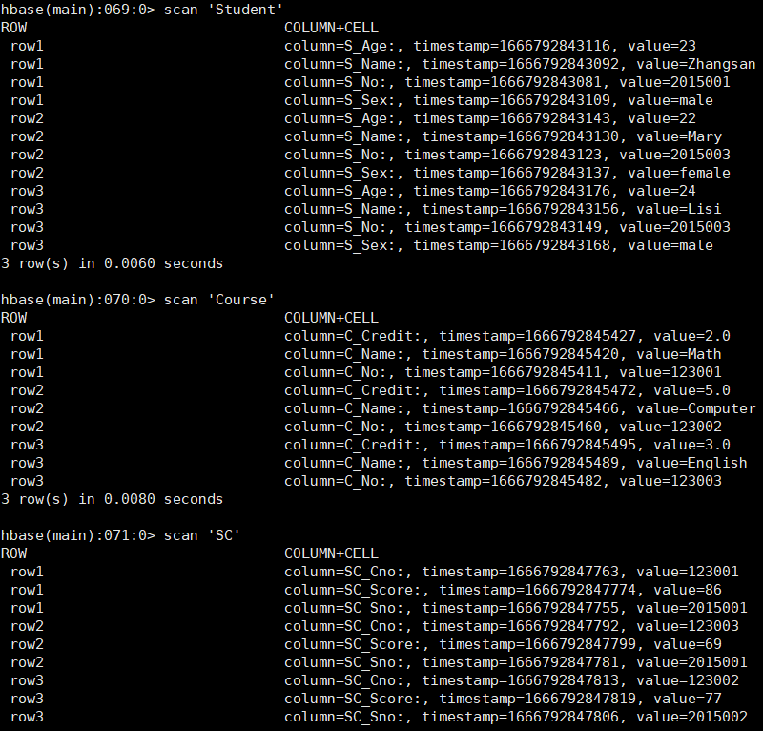
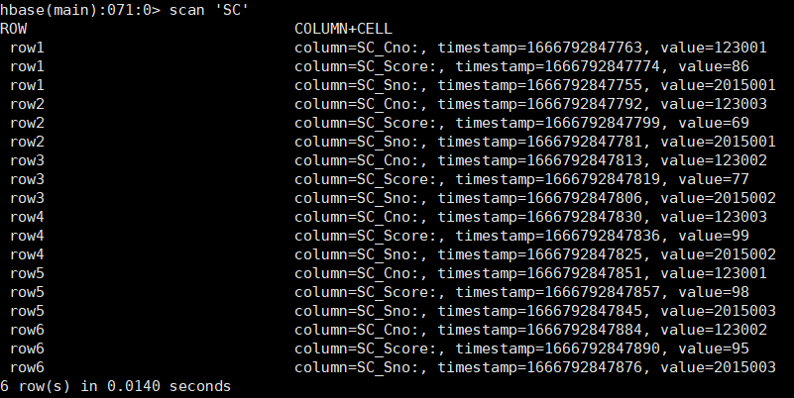
3. create 'book','price','bookname'
put 'book','30$','bookname','Datavase System Concept'
put 'book','60$','bookname','Thinking in Java'
put 'book','25$','bookname','Data Mining'
scan 'book'
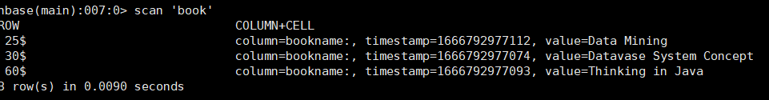

七、问题及解决方案（列出遇到的问题和解决办法，列出没有解决的问题）：

无

八、实验总结（给出实验结论，描述心得体会，并对本实验过程及方法、手段提出改进建议）：
无

报告评分：
指导教师签字：

