**Instruction of DETsrc (0.1v)**

**Demo running instructions:**

1. Input file:

case1.txt: The expression data of miRNA and its target mRNAs

PlnTFDB_rice.txt: The collected TF of Rice mRNA

2. Run Case1_step1:

To get the prepared miRNA data (R1-miRNA-expr.txt), and mRNA data (R1-mRNA-expr.txt), and miNna-mRNA data (R1-miRNA-mRNA.txt)

3. Run Case1_step2:

To get the network of each sample and also their population network, and the output in R2-nodes.txt and R2-edges.txt

**Data format instructions:**

1. Raw data (e.g. case1.txt): The 1~N columns are the expressions of miRNA in (N-1) samples, and the (N+1)~2N columns are the expressions of corresponding target mRNA in the same (N-1) samples.

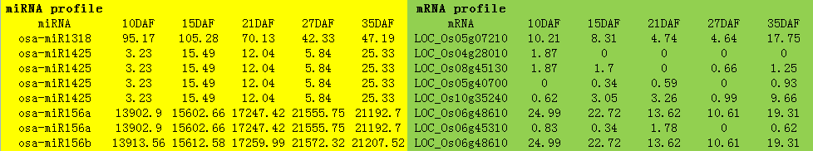

2. Node data (e.g. R2-nodes.txt): The first column lists the name of miRNA or mRNA; the second column indicates the type of molecule (i.e. miRNA or mRNA); the third column indicates if a mRNA is a TF; the latter (N-2) columns are the fold change of expression of each molecule in (N-2) samples conpared to the first sample (e.g. given as the control sample); the last column lists the largest fold-change.

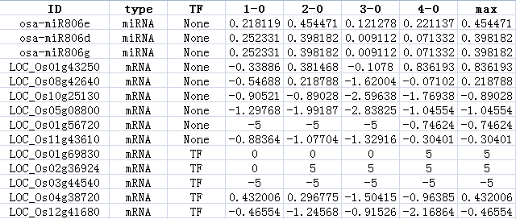

3. Edge data (e.g. R2-edges.txt): The first 2 columns give a miRNA and its a target mRNA; the 3-4 columns give the PCC value and its P-value for this pair of miRNA-mRNA in all samples; the latter (N-2) columns give the network change of (N-2) samples compared to the first sample (e.g. given as a control sample), where the value 'gain' means a appearance of a network edge in the one-sample network, and the value 'loss' points a disappearance of a network edge in the one-sample network; the last 2 columns tell if this edge or miRNA-mRNA pair is a local (one-sample) edge or a global (population) edge.

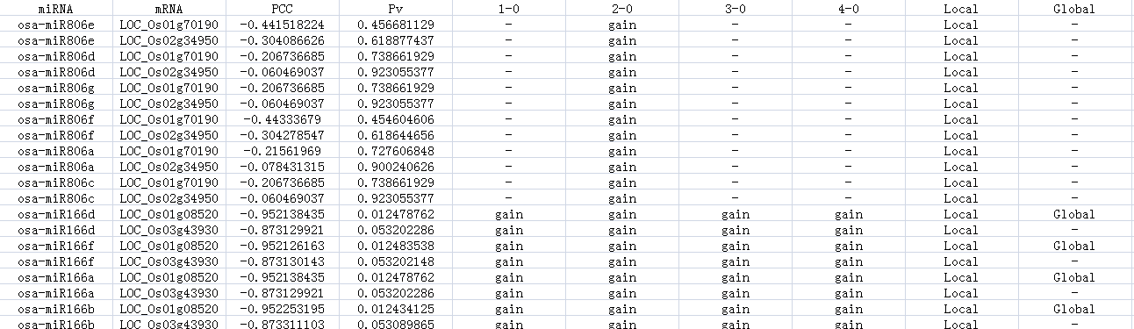

4. The above node and edge data can be directly used to draw the network in Cytoscape.

5. The current in-house rice data in Taoyuan-rice-data.zip, whose password can be required from authors.