March 21st to April 2nd

<1>Working on Gesher Trade experience.

1. Understanding the structure of the Gesher Trade experience.
2. Inserted and integrated data into database
3. Adapt showcase and product page from database
4. Create search tag, about tag, did not find it
5. Implement “search by tag” function

<2>Working on map and camera for users

1. Search solution for map in website (openlayer and googlemap)
2. Find solution for targeting user by map using openlayer
3. Showing latitude and longitude of the user
4. Getting permission for GPS and Camera from users

March 23rd: 5 hours (Gesher Trade experience)

March 24th: 8 hours (Gesher Trade experience)

March 25th:8 hours (Gesher Trade experience)

March 26th: 8 hours (Gesher Trade experience)

March 27th: 5hours (Gesher Trade experience)

March 30th:8 hours (Gesher Trade experience)

March 31st:5 hours (Gesher Trade experience)

April 1st :8 hours (Gesher Trade experience)

April 2nd :5 hours (Working on map and camera for users)

Totally: 60 hours.

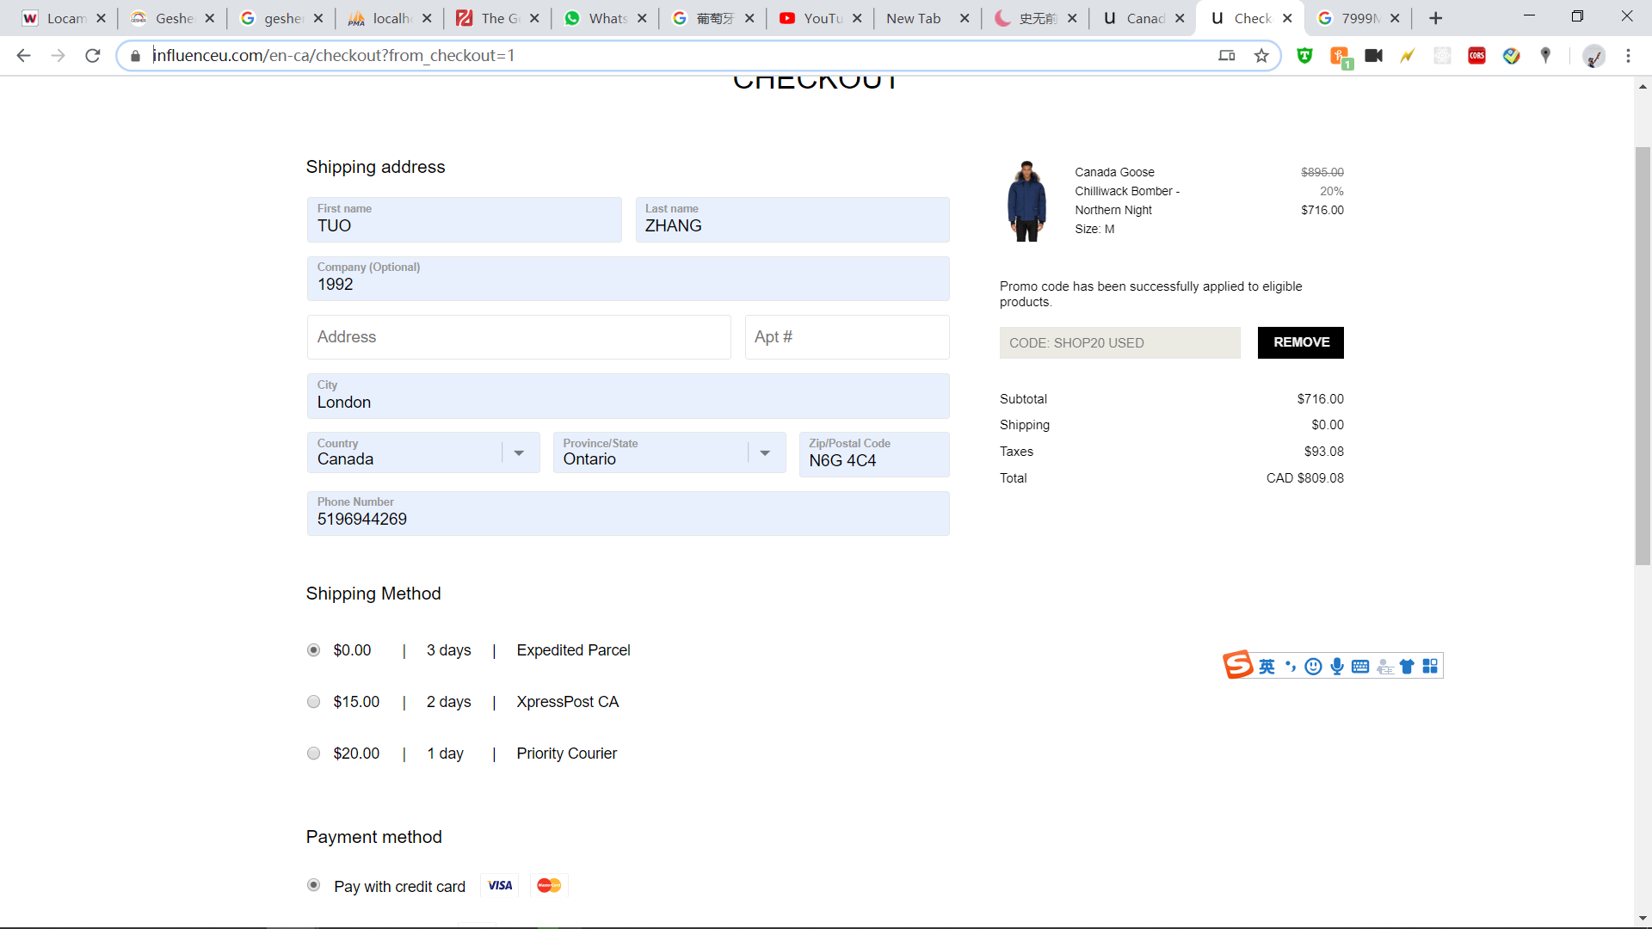

TUO ZHANG has joined the chat

price match

Coco has joined the chat

Hi there!

How can I help you today?

Hello, I wonder whether I can make the price match of my order

Please expand on where you saw a lower price and for which order

734691111394

OK and which lower price are you referring to

<https://www.influenceu.com/>

they are doing 20 percent off

I need the exact link.

[https://www.influenceu.com/en-ca/men/product/canada-goose/chilliwack-b...](https://www.influenceu.com/en-ca/men/product/canada-goose/chilliwack-bomber-northern-night/7198480)

you can use SHOP20 to check out

it is the size M and same coloe

color

No worries

yes

So this is approved

I can offer another 5% discount to your order as an exception!

That said, your order is currently locked and I am unable to make any adjustments

So, once the order ships, I will go back in your order and add the other 5%

Is that ok?

OK, so you will make the price match refund?

Yes

When the order ships

Can you sent some evidence to my email.

When next time I talk to you agent

This is the conversation: 5888371

Because I am worrying they do not believe me.

No worries, I kept a note to myself

I will be the one applying it

So I just need to keep the conversation number and your name.right?

Yes :)

OK, thank you. The money will go back to my credit card, right?

Yes

In 0-7 business days

The difference money

Yes

Thank you .Have a good day

If you found this helpful, please rate the chat good at the top of this window, I would really appreciate it :)