Homework 6 Report

Team Members: Zachary Tschirhart (zst75) and Thomas Lo (tl7543)

First, increased reward for finding the flag and placed a flag pretty close to the agents spawn point. When most of the agents were able to find the flag easily, I moved the flag and spawn points around. I then started moving the spawn and flag points on opposite ends of the wall so they had to navigate around it. Repeating this several times showed that the agents were able to quickly adapt to new locations.

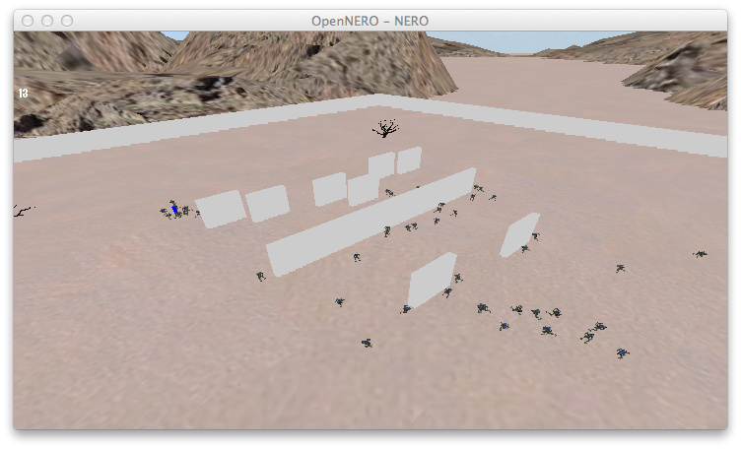

Then more walls were added to obstruct their normal path, so they would take an alternative route.

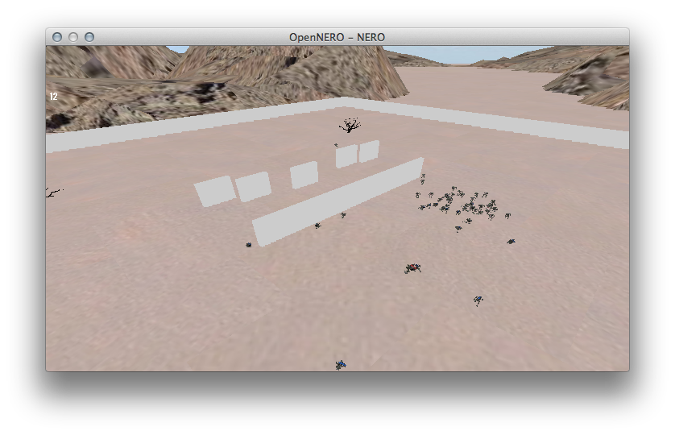

After we felt confortable with how the agents were able to adapt to new obstructions, we added a stationary turret and increased the reward to approach the enemy.

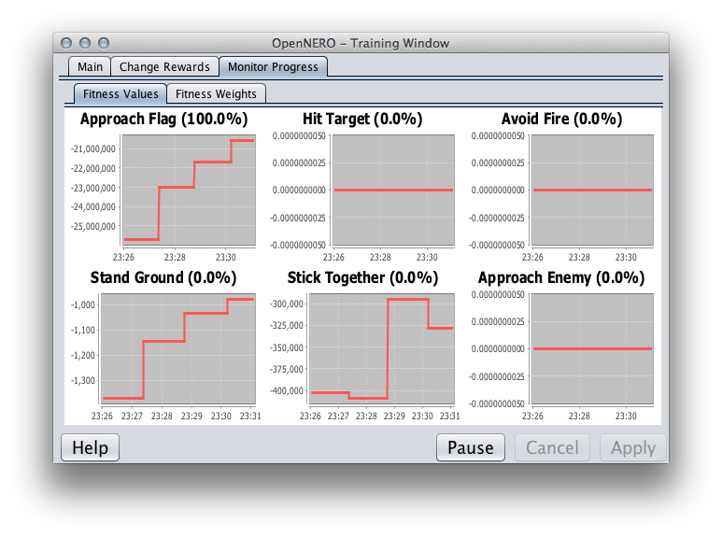

When this was done, the Hit Target, Stick Together, Stand Ground, Avoid fire, and Approach enemy fitness values were changed, mostly a negative value change. When the agents finally converged on the target, the target was moved to new locations and the spawn point was moved as well as adding new walls to the field.

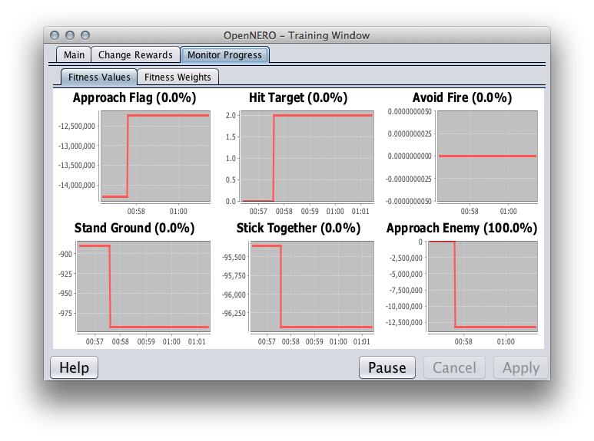

After several permeations of that, we added several targets to verify that the agents would engage more than one target. Then we started tweaking the settings to Hit Target 50%, Avoid Fire 10%, Stick Together 30%, and Approach Enemy 100%, this seemed to have the best seek and destroy capabilities after several generations. 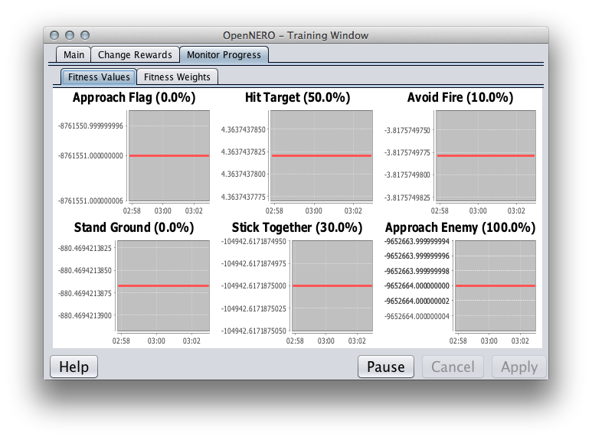

After pitting this team against the example team from last year, the results were devastating and the team lost large casualties. This defeat only resulted in more training and tweaking the rewards. After many tweaks, the team that beat the example teams with the least casualties had the following rewards set: Hit Target 80%, Avoid Fire 30%, Stand Ground -50%, Stick together 30%, and Approach Enemy 100%. 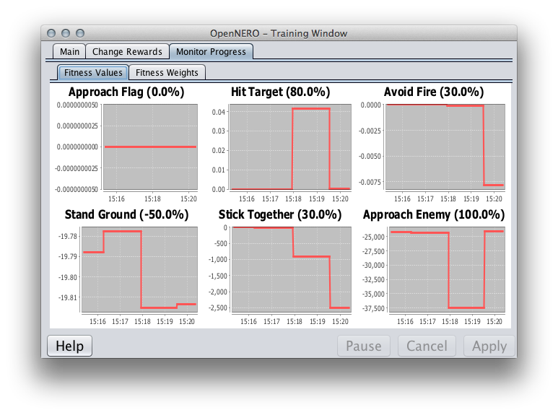

After training for a few hours with these reward levels, the team was undefeated for more than 15 rounds.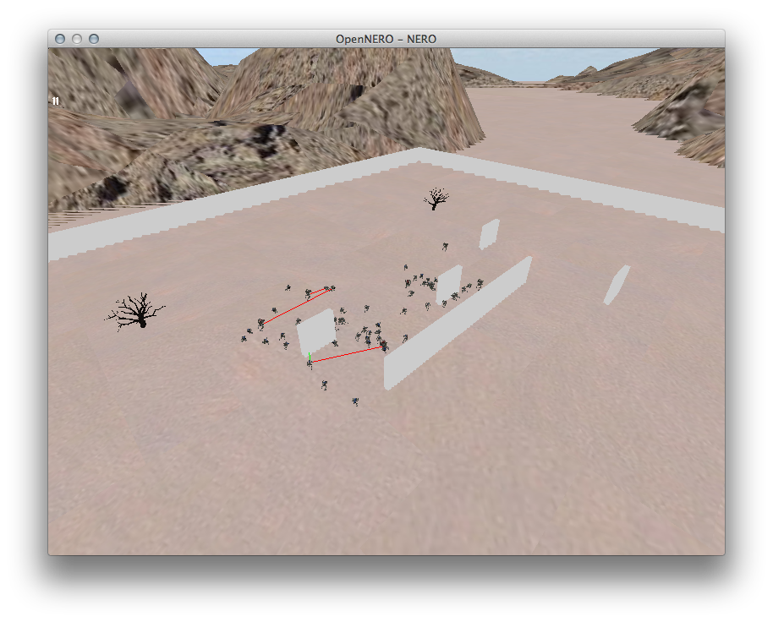

For reference, the following files are saved along with this report:

CaptureTheFlagCowards.txt – The saved team for the first two steps of the Homework, just training to capture the flag

ApproachTheEnemyCowards.txt – The saved team continuing from the first two steps and including the third which approaches the enemy instead of a flag.

KillTheEnemyIneffectively.txt – Our first attempt at making a successful team, this isn’t too effective at killing enemies.

TournamentTeam-ZachT-ThomasL.txt – This is our final attempt at killing the enemy more effectively.