Homework 2

1)

1. Y = -5x4 + 11x2 – 2

Roots:

-1.4142

1.4142

-0.4472

0.4472

Graph: 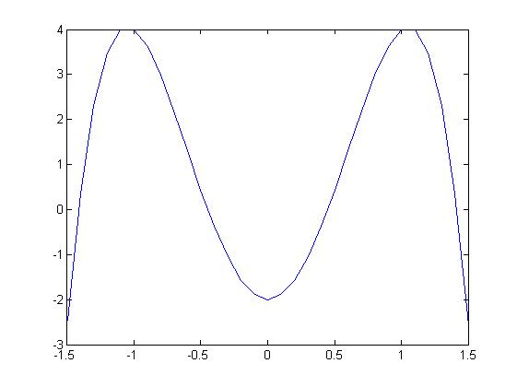

1. W = x3 -4x + 1

Roots:

-2.1149 (this is out of bounds of what we want)

1.8608 (this is out of bounds of what we want)

0.2541

Graph:

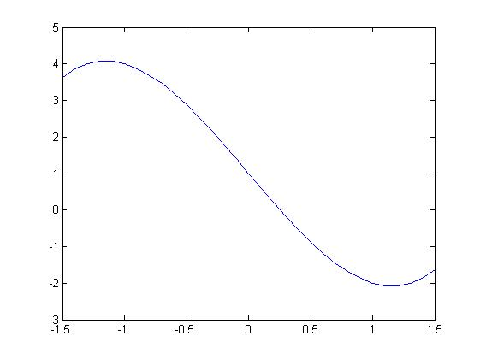

1. Z = x5 – 0.5

Roots:

-0.7043 + 0.5117i

-0.7043 - 0.5117i

0.2690 + 0.8279i

0.2690 - 0.8279i

0.8706

Graph:

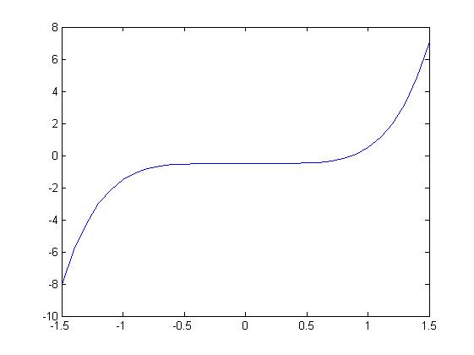

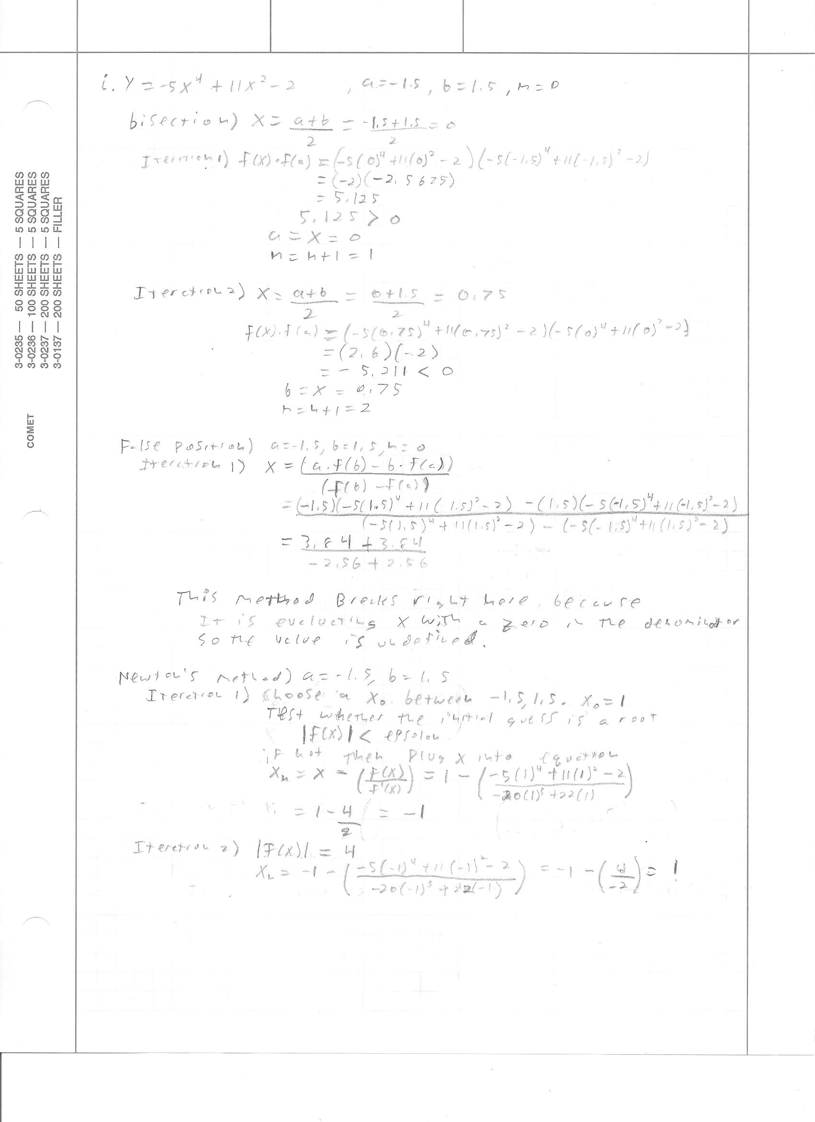

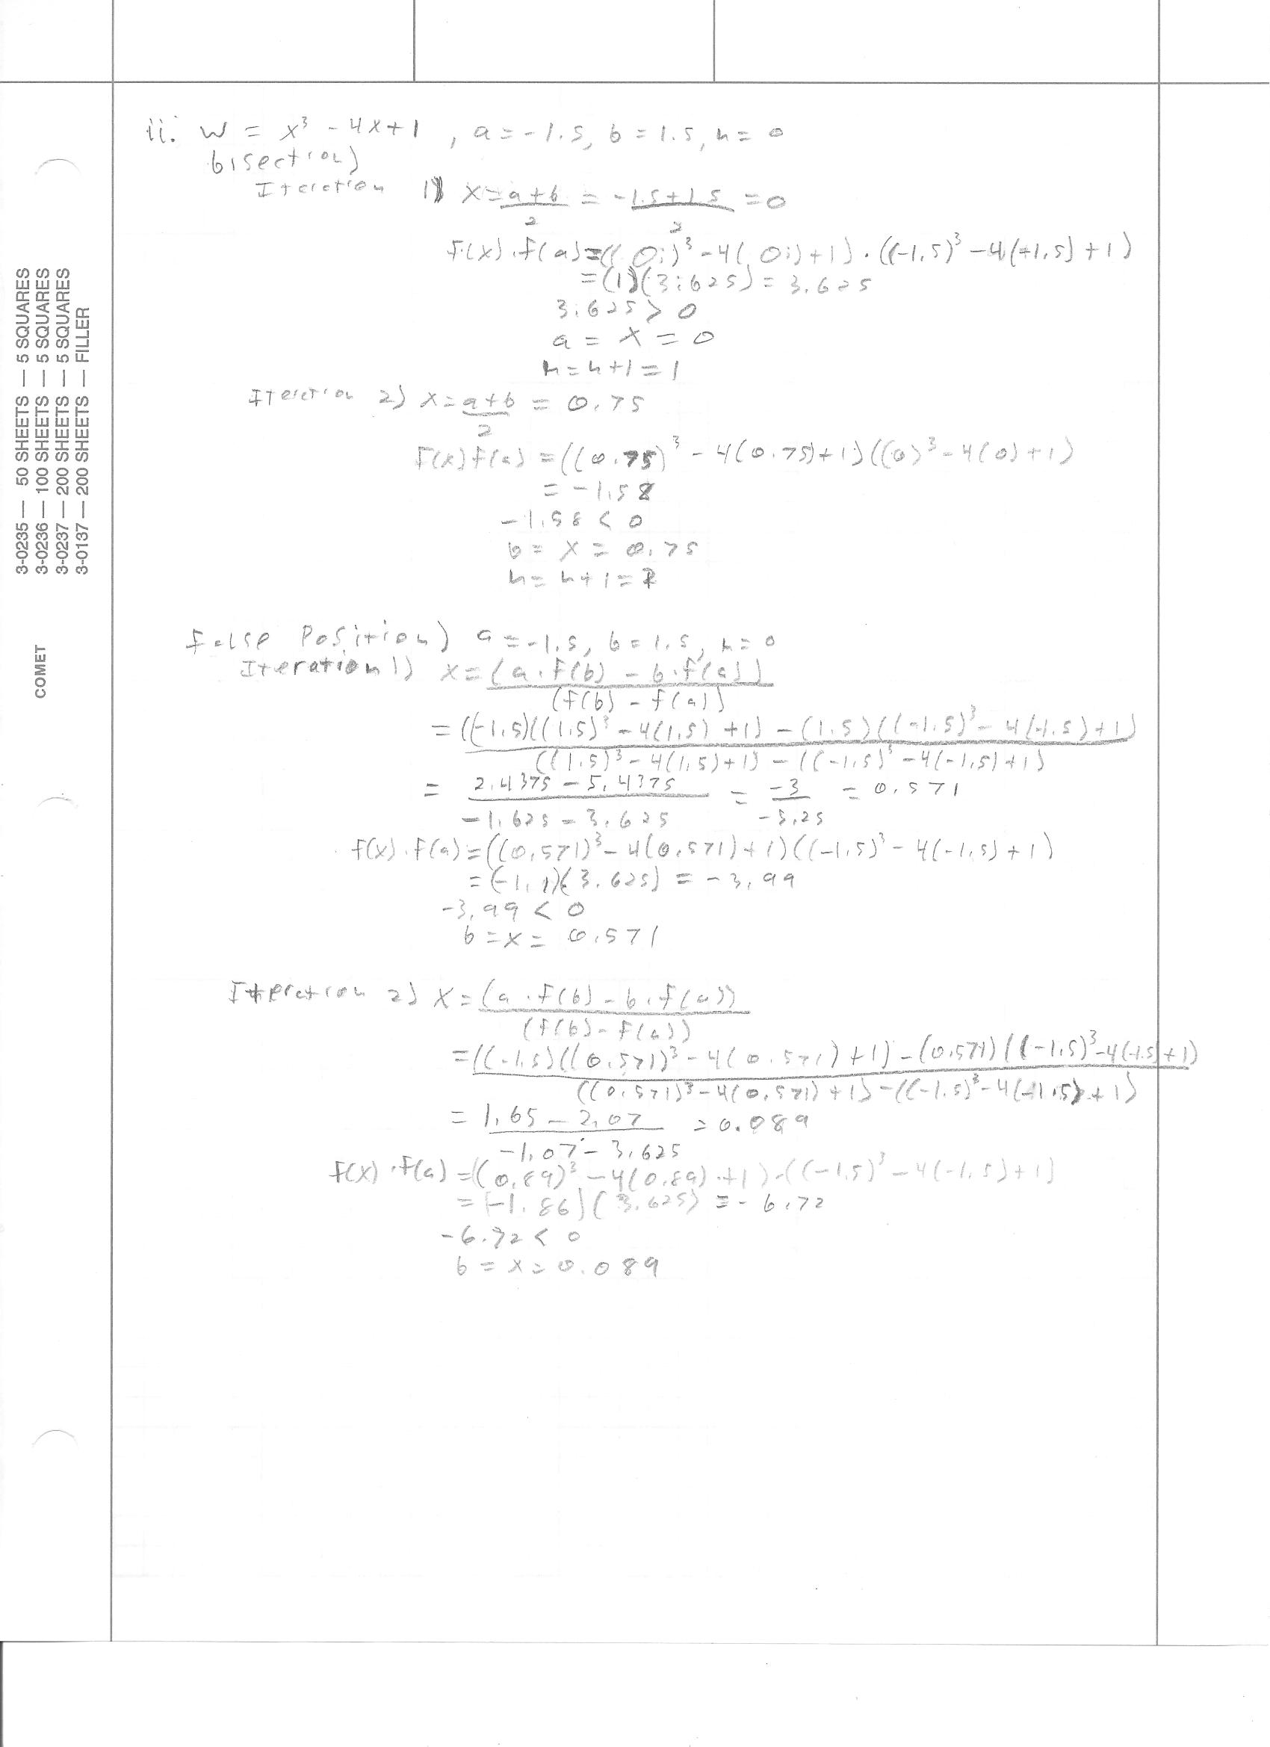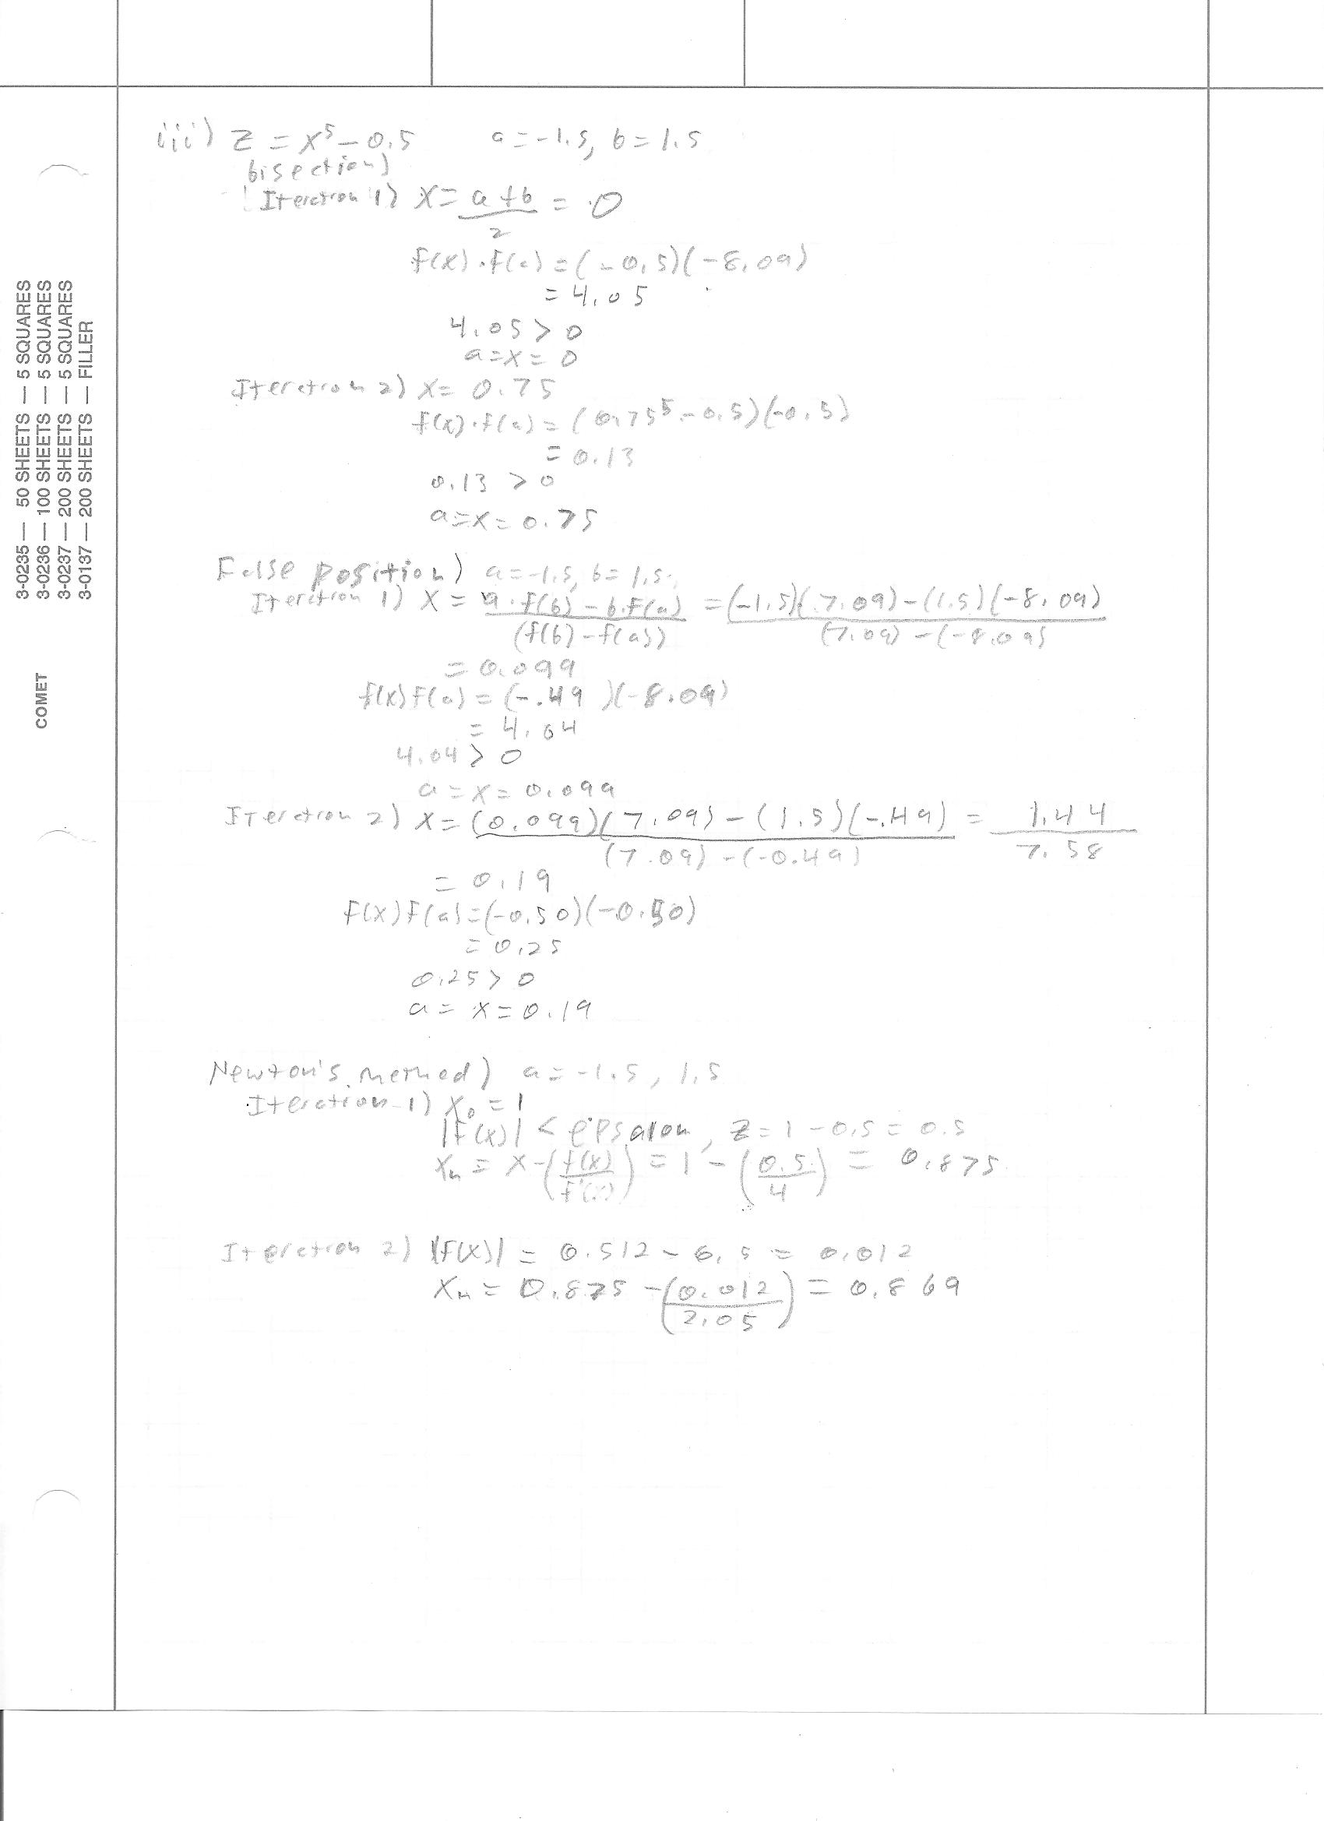

b.

1. Bisection:

n a f(a) b f(b) x f(x)

1 -1.50 -2.56 1.50 -2.56 0.00 -2.00

2 0.00 -2.00 1.50 -2.56 0.75 2.61

3 0.00 -2.00 0.75 2.61 0.38 -0.55

4 0.38 -0.55 0.75 2.61 0.56 0.98

5 0.38 -0.55 0.56 0.98 0.47 0.18

6 0.38 -0.55 0.47 0.18 0.42 -0.20

7 0.42 -0.20 0.47 0.18 0.45 -0.02

8 0.45 -0.02 0.47 0.18 0.46 0.08

9 0.45 -0.02 0.46 0.08 0.45 0.03

10 0.45 -0.02 0.45 0.03 0.45 0.01

Compared to my handwritten iterations, this matches up.

False Position:

n a f(a) b f(b) x f(x)

This didn’t output anything, so this matches up as well.

Newton’s Method:

n x f(x)

1 1.00 4.00

2 -1.00 4.00

3 1.00 4.00

4 -1.00 4.00

5 1.00 4.00

6 -1.00 4.00

7 1.00 4.00

8 -1.00 4.00

9 1.00 4.00

10 -1.00 4.00

11 1.00 4.00

12 -1.00 4.00

Continue…

This matches with my handwritten calculations.

1. Bisection:

n a f(a) b f(b) x f(x)

1 -1.50 3.63 1.50 -1.63 0.00 1.00

2 0.00 1.00 1.50 -1.63 0.75 -1.58

3 0.00 1.00 0.75 -1.58 0.38 -0.45

4 0.00 1.00 0.38 -0.45 0.19 0.26

5 0.19 0.26 0.38 -0.45 0.28 -0.10

6 0.19 0.26 0.28 -0.10 0.23 0.08

7 0.23 0.08 0.28 -0.10 0.26 -0.01

8 0.23 0.08 0.26 -0.01 0.25 0.03

9 0.25 0.03 0.26 -0.01 0.25 0.01

This matches my calculations

False position:

n a f(a) b f(b) x f(x)

1 -1.50 3.63 1.50 -1.63 0.57 -1.10

2 -1.50 3.63 0.57 -1.10 0.09 0.64

3 0.09 0.64 0.57 -1.10 0.27 -0.05

4 0.09 0.64 0.27 -0.05 0.25 -0.00

This matches my calculations

Newton’s method:

n x f(x)

1 1.00 -2.00

2 -1.00 4.00

3 3.00 16.00

4 2.30 4.02

5 1.97 0.75

6 1.87 0.06

These match my calculations, if you count the original guess as an iteration.

1. Bisection:

n a f(a) b f(b) x f(x)

1 -1.50 -8.09 1.50 7.09 0.00 -0.50

2 0.00 -0.50 1.50 7.09 0.75 -0.26

3 0.75 -0.26 1.50 7.09 1.13 1.30

4 0.75 -0.26 1.13 1.30 0.94 0.22

5 0.75 -0.26 0.94 0.22 0.84 -0.07

6 0.84 -0.07 0.94 0.22 0.89 0.06

7 0.84 -0.07 0.89 0.06 0.87 -0.01

Matches my calculations.

False position:

n a f(a) b f(b) x f(x)

1 -1.50 -8.09 1.50 7.09 0.10 -0.50

2 0.10 -0.50 1.50 7.09 0.19 -0.50

3 0.19 -0.50 1.50 7.09 0.28 -0.50

4 0.28 -0.50 1.50 7.09 0.36 -0.49

5 0.36 -0.49 1.50 7.09 0.43 -0.48

6 0.43 -0.48 1.50 7.09 0.50 -0.47

7 0.50 -0.47 1.50 7.09 0.56 -0.44

8 0.56 -0.44 1.50 7.09 0.62 -0.41

9 0.62 -0.41 1.50 7.09 0.67 -0.37

10 0.67 -0.37 1.50 7.09 0.71 -0.32

11 0.71 -0.32 1.50 7.09 0.74 -0.28

12 0.74 -0.28 1.50 7.09 0.77 -0.23

13 0.77 -0.23 1.50 7.09 0.79 -0.19

14 0.79 -0.19 1.50 7.09 0.81 -0.15

15 0.81 -0.15 1.50 7.09 0.83 -0.12

16 0.83 -0.12 1.50 7.09 0.84 -0.09

17 0.84 -0.09 1.50 7.09 0.84 -0.07

18 0.84 -0.07 1.50 7.09 0.85 -0.05

19 0.85 -0.05 1.50 7.09 0.86 -0.04

20 0.86 -0.04 1.50 7.09 0.86 -0.03

21 0.86 -0.03 1.50 7.09 0.86 -0.02

22 0.86 -0.02 1.50 7.09 0.86 -0.02

Matches my calculations.

Newton’s method:

n x f(x)

1 1.00 0.50

2 0.90 0.09

Matches my calculations.

Bisection.m:

function [root, numIter] = bisection(f, a, b, ep)

%fprintf('n a f(a) b f(b) x f(x)\n');

n = 1;

x = (a + b)/2;

while (abs(f(x)) > ep)

x = (a + b)/2;

%fprintf('%d %4.2f %4.2f %4.2f %4.2f %4.2f %4.2f\n', n,a, f(a), b, f(b), x, f(x));

if(f(x)\*f(a) > 0)

a = x;

else

b = x;

end

n = n + 1;

end

root = x;

numIter = n;

falsePosition.m:

function [root, numIter] = falsePosition(f, a, b, ep)

%fprintf('n a f(a) b f(b) x f(x)\n');

n = 1;

x = (a\*f(b)-b\*f(a))/(f(b)-f(a));

while (abs(f(x)) > ep)

x = (a\*f(b)-b\*f(a))/(f(b)-f(a));

%fprintf('%d %4.2f %4.2f %4.2f %4.2f %4.2f %4.2f\n', n,a, f(a), b, f(b), x, f(x));

if(f(x)\*f(a) > 0)

a = x;

else

b = x;

end

n = n + 1;

end

root = x;

numIter = n;

newtonsMethod.m:

function [root, numIter] = newtonsMethod(f, x0, ep)

%fprintf('n x f(x)\n');

syms x;

fprime = matlabFunction(diff(f,x));

n = 1;

while(abs(f(x0)) > ep)

%fprintf('%d %4.2f %4.2f\n', n, x0, f(x0));

x = x0 - (f(x0)/fprime(x0));

x0 = x;

n = n + 1;

end

root = x0;

numIter = n;

1. I observed that for the first equation, bisection was the only one that actually converged. False position had an issue when plugging in a zero in the denominator for the first function evaluation and gave NaN. Newton’s method seemed to be stuck in a never ending loop moving back and forth between two points.

For the second equation, false positioning seemed to have the best performance while the other two lagged behind just slightly. The overall efficiency of these was roughly about the same.

For the third equation, Newton’s method was by far the fastest with only two iterations, while false positioning had the worst performance with over 20.

Over all, it seems that the Newton’s method is the quickest overall, but the bisection is the most reliable.

2) a. Equation: f = @(x) 1 - ((20.^2) / (9.81 \* (3\*x + (x.^2)/2).^3))\*(3 + x)

Bisection: [root numiter] = bisection(f,0.5,2.5,0.01);

False Position: [root numiter] = falsePosition(f,0.5,2.5,0.01)

b. Bisection Root: 1.5156

Number of Iterations: 8

False Position: Root: 1.5185

Number of Iterations: 84

It looks like the Bisection method works much better than the False Position on this equation. The solution to this problem describes the critical depth x for a channel that allows for the flow with those parameters. So the Channel must be a depth of around 1.51 meters.

c. I actually did run this through Newton’s method and it decreased the amount of iterations. I do think using Newton’s method is a better idea with this problem. This is because it should run slightly faster than the alternatives, according to my previous tests.

3) It seems that the code that I wrote for Newton’s method is not robust enough to take into account the boundaries that were set in this problem. With this starting x, my function seems to converge only on the root 0.4685 instead of 18.89 that is within the bounds given. If I change my starting condition to something like 16.8 it will converge directly to the wanted 18.89 number. This is because Newton’s method works by finding the derivative of the function at the initially given point and depending on that initial guess, is whether the function converges towards the number you want. When I ran the code, it only took 6 iterations.

4) a. f = @(x) (4\*acos((2-x)/2) - (2 - x)\*sqrt(4\*x - x.^2))\*5 - 8.5

[root numIter] = newtonsMethod(f,1,0.01)

Root: 0.7720 meters

Iterations: 3

b. I chose to use Newton’s method because it seems to be the fastest method so far with the most accurate results. I chose an initial condition at random, but I figured there would only be positive height so I kept my bounds positive. My stopping criteria was within 1% precision because the given numbers only had a precision of 1 decimal place. If I had any more precision it wouldn’t really mean anything. The performance seemed to be good with only 3 iterations.

5) a. OMITED

b. f = @(theta) 20\*tand(theta)\*35 - ((9.81/(800\*cosd(theta).^2))\*35.^2) + 2 – 1

[root numIter] = bisection(f,0,90,0.1)

Root: 1.15 or 88.77 degrees

c. I chose the bisection method this time because the other methods failed to work. These methods failed because of the equation and how there was a tangent and a cosine in the denominator. I also gave the boundaries of 0 and 90 because those are the maximum angles at which the initial velocity could have been in the direction of. The stopping criteria I picked was again based on the values given. The performance of this method was probably not the best possible, but it was the only method that worked out of the three.