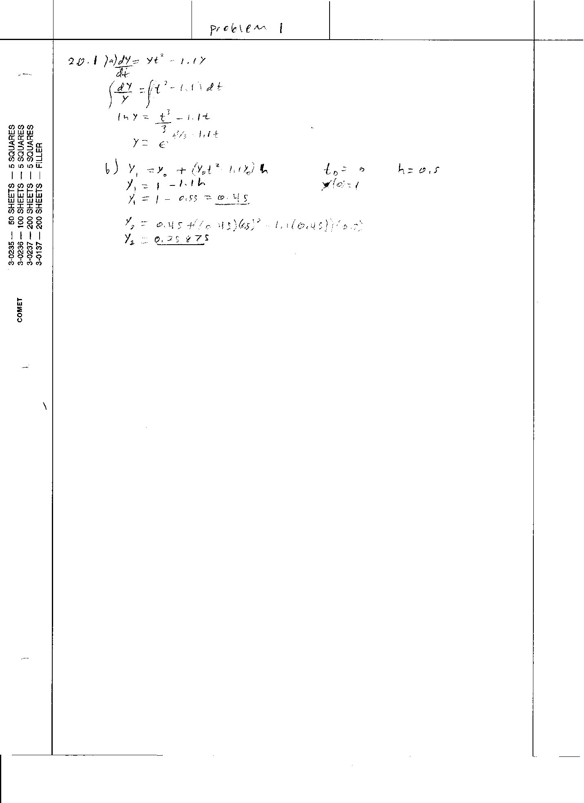

c.

function [y t] = Euler(deFunction, y0, t0, tF, dt)

t=t0:dt:tF;

y(1)=y0;

for n=1:length(t)-1

y(n+1)=y(n)+dt\*deFunction(y(n), t(n));

end

d.

yhalf = 1.0000 0.4500 0.2587 0.2458 0.3872

thalf = 0 0.5000 1.0000 1.5000 2.0000

yquar = 1.0000 0.7250 0.5370 0.4229 0.3660 0.3569 0.3981 0.5126 0.7641

tquar = 0 0.2500 0.5000 0.7500 1.0000 1.2500 1.5000 1.7500 2.0000

e.

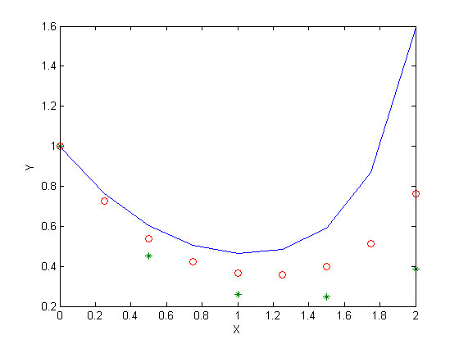

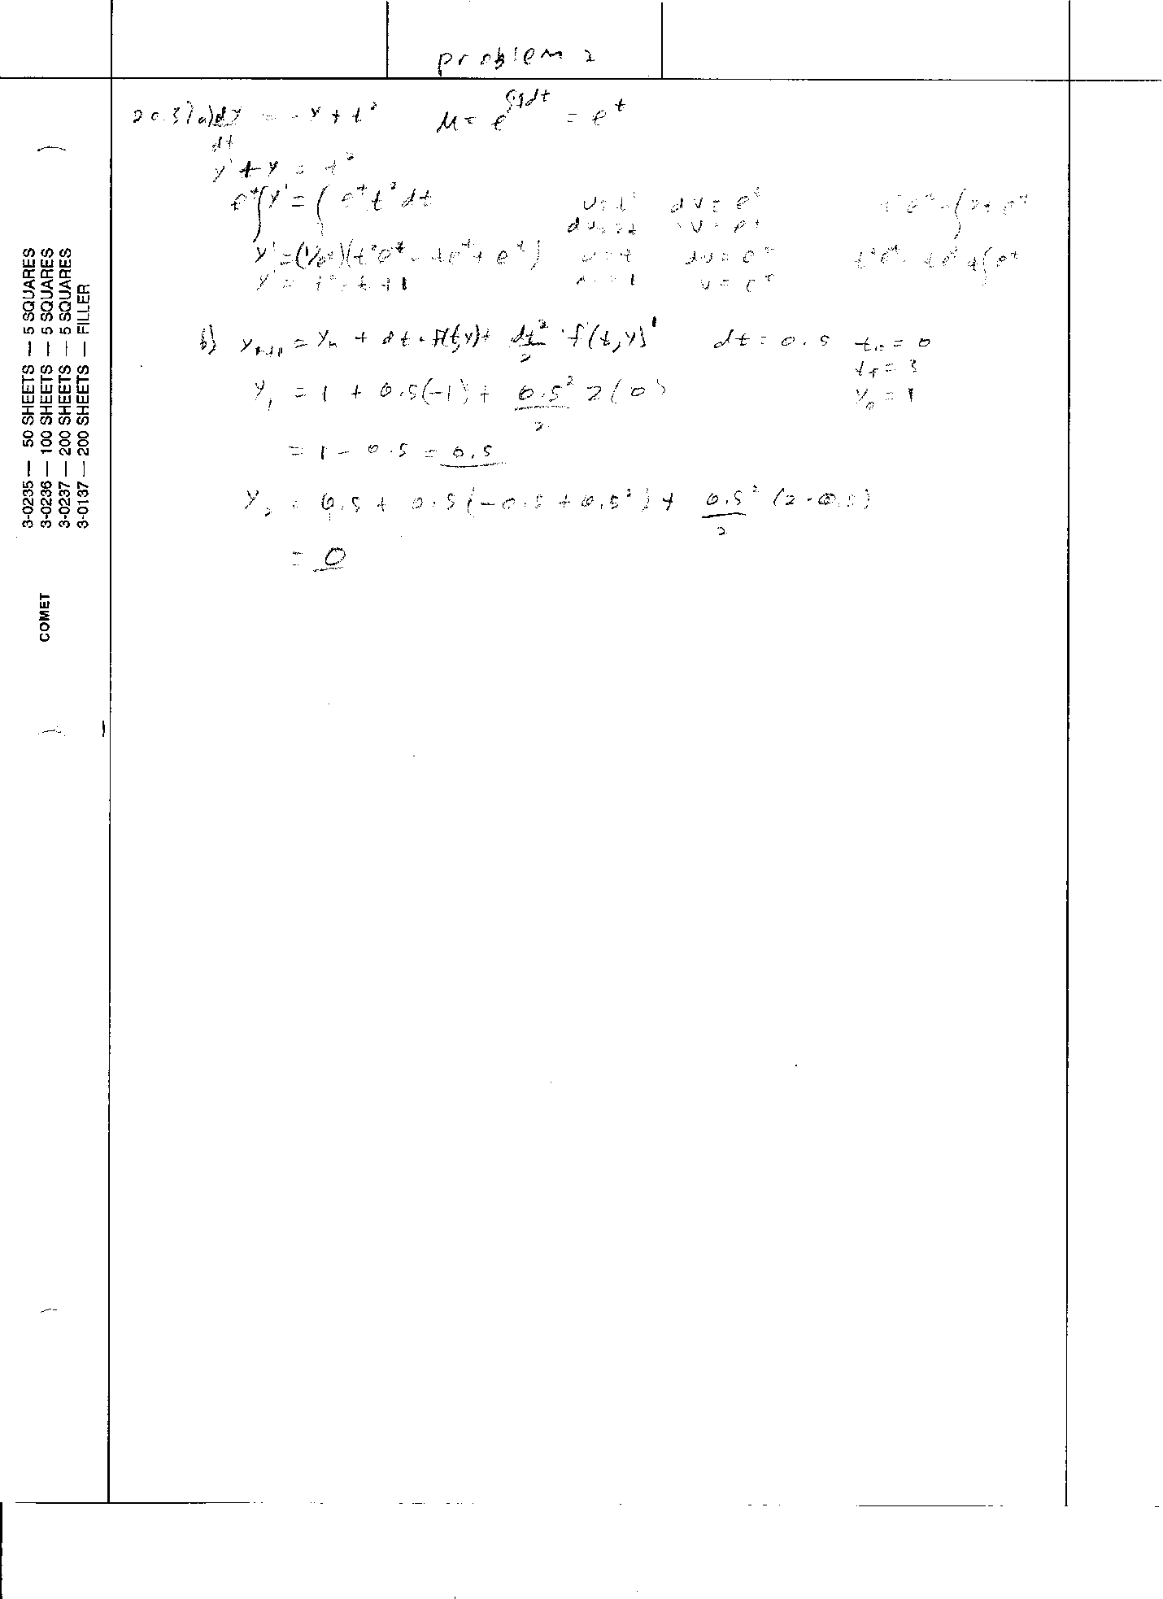

c.

function [y t] = Taylor(deFunction, y0, t0, tF, dt)

syms y; syms t;

deFunctionPrime = matlabFunction(diff(deFunction, t));

t=t0:dt:tF;

y(1)=y0;

for n=1:length(t)-1

y(n+1) = y(n) + dt\*deFunction(y(n), t(n)) + (dt^2)/2 \* deFunctionPrime(t(n));

end

d.

yhalf = 1 1/2 1/2 1 2 7/2 11/2

thalf = 0 0.5000 1.0000 1.5000 2.0000 2.5000 3.0000

e.

yquar = 1.0000 0.7500 0.5781 0.4961 0.5127 0.6345 0.8665

1.2124 1.6749 2.2562 2.9578 3.7808 4.7262

tquar = 0 0.2500 0.5000 0.7500 1.0000 1.2500 1.5000

1.7500 2.0000 2.2500 2.5000 2.7500 3.0000

f.

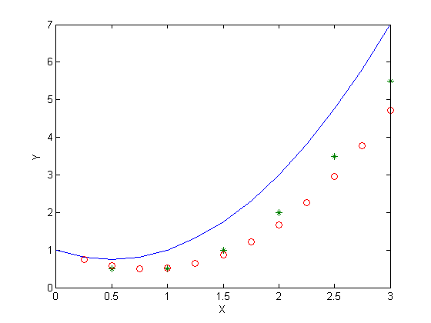

e. The total error using Taylor’s method was about 5 and the total error using Euler’s method was about 11 . The fact that Taylor’s method took half as many iterations/calculations as Euler’s method and had less of an error, shows that Taylor’s method is an overall better function for these cases.

Problem 3

1. Terminal velocity is reached when dv/dt = 0. In other words, they will not have the same terminal velocities. The terminal velocity can be expressed as v = sqrt(g\*m/Cd). So, mass would affect the velocity as a factor or a sqrt. This would mean that the velocity of the heavier jumper would be bigger than the lighter jumper, which is exactly what I got when I ran this through my code. I ended up using Euler’s equation since there was no time variable in the equation. The terminal velocity of the lighter jumper was around 32 m/s, while the heavier jumper was around 59 m/s or so. Although, the heavier jumper did not reach terminal velocity faster, by about 2 seconds. I ended up using a step size of .5, because the values should be accurate enough to represent the true velocity of the jumpers.
2. At any time t, the heavier jumper was falling faster. I reached this conclusion by looking at the data/plot and comparing the velocities.
3. 45kg – 29.97 m/s

145kg - 38.90 m/s

1. No, because the rate at which the velocity increases is linear with the mass of the person that jumps. So, unless there is some sweet spot that someone is trying to avoid, then there shouldn’t be any need because the minimum and maximum velocities are represented.
2. First I would use the person with lower mass, because the equation should reach terminal velocity faster and thus using less calculations. I could still use Euler’s method to find the values as long as it’s dt is less than .3 or so. This is probably not as good as using the Taylor’s method with a dt of below .6, but the differences are small and since this is a small problem with a very little amount of steps, doing more steps don’t require a lot of time or processing power.