**HW 7**

1.

a)

x =

-15.1812

-7.2464

-0.1449

inv(A) =

-0.1775 -0.1232 0.2500

-0.1014 0.0725 0

0.0580 0.1014 0

b)x =

-3.7935

0.2609

1.5652

2.

a) Since the Truss problem is derived for us in the problem itself, the matrix form is listed below:

A =

-0.8660 0 0.5000 0 0 0

-0.5000 0 -0.8660 0 0 0

0.8660 1.0000 0 1.0000 0 0

0.5000 0 0 0 1.0000 0

0 -1.0000 -0.5000 0 0 0

0 0 0.8660 0 0 1.0000

f =

0

1000

0

0

0

0

b)EDU>> x = A\f

x =

-500.0000

433.0127

-866.0254

0

250.0000

750.0000

c)EDU>> inv(A)

ans =

-0.8660 -0.5000 0 0 0 0

-0.2500 0.4330 0 0 -1.0000 0

0.5000 -0.8660 0 0 0 0

1.0000 0 1.0000 0 1.0000 0

0.4330 0.2500 0 1.0000 0 0

-0.4330 0.7500 0 0 0 1.0000

EDU>> x = inv(A)*f

x =

-500.0000

433.0127

-866.0254

0

250.0000

750.0000

3.

a)From my linear algebra class notes:

1. The matrix A is invertible.

2. There is a square matrix B such that BA = I, where I is the Identity matrix.

3. The linear system Ax = b has only the trivial solution.

4. rank A = n, where n is the number of rows.

5. The matrix A is a product of elementary matrices.

b) No, because the determinate is nonzero means that the matrix is invertible, which means it has a unique solution. The only solution to this problem is zero.

4.

a)Let A be a square NxN matrix. A non-zero vector K is called an eigenvector of A if and only if there exists a number$\lambda$ such AC = $\lambda$K. If a number$\lambda$exists, then it’s called an eigenvalue of A. K is the associated eigenvector to the eigenvalue$\lambda$.

b)It could be said that x = 0.1*v1 + 2.2*v2 – 4*v3 + 5.5*v4, it can also be said that the eigenvectors are linearly independent. Also, there are only 4 eigenvectors.

c) The eigenvectors of a symmetric matrix are orthogonal, or in other words has an orthonormal basis of eigenvectors. The matrix A has exactly 5 eigenvalue, also there exists 5 eigenvectors, one for each eigenvalue.

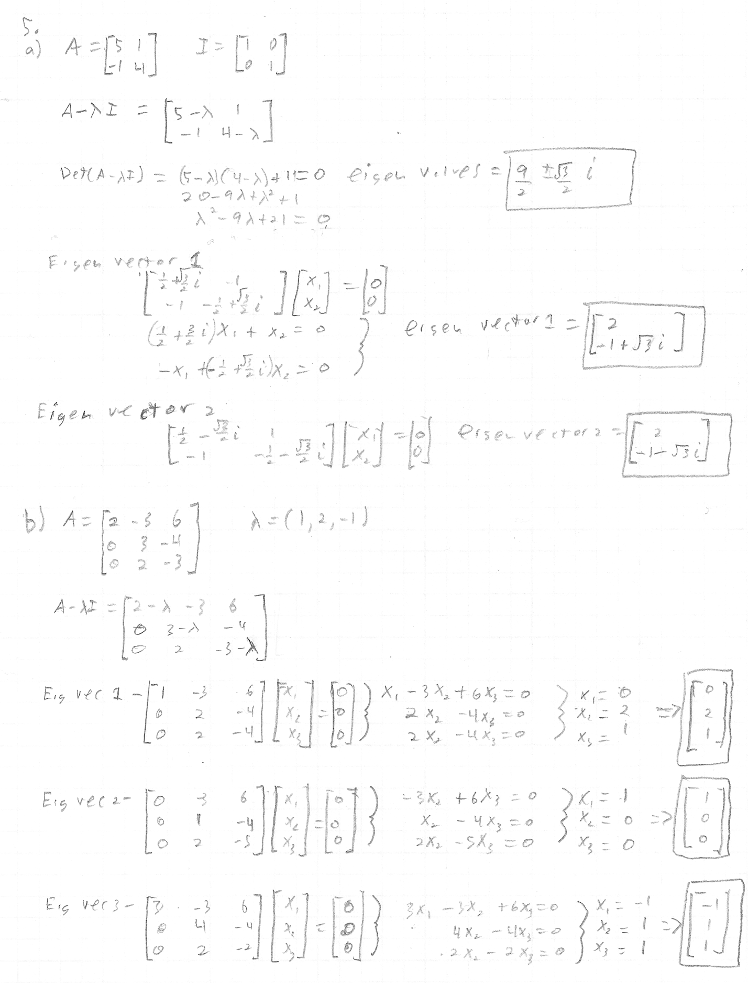

c. Yes, I get the same answers as the hand calculated except in numerical form, which is understandable since I didn’t specify the answer to be in symbolic form. The reason I got the same answers is because the above didn’t have to be approximated or anything that would differentiate the two.

d)eigenvalues =

1.0000

0.1921 + 1.1729i

0.1921 - 1.1729i

0.7358

-0.8383

-1.1478

Eigenvectors=

(0.822, 0.009, -0.463, -0.188, -0.194, 0.186)

(-0.469, -0.306, -0.026, 0.734, -0.381, 0.012)

(-0.072, 0.321, -0.231, -0.429, -0.279, 0.758)

(0, 0, 0, 0, 0, 1)

(0.180, -0.360 + 0.299i, 0.381 + 0.422i, -0.217 + 0.229i, -0.400 - 0.210i, 0.080 - 0.336i)

(0.180, -0.360 - 0.299i, 0.381 - 0.422i, -0.217 - 0.229i, -0.400 + 0.210i, 0.080 + 0.336i)

6.

a)None of the vectors can be written in as a linear combination of any multiple of the others.

b) Yes, because the matrix A formed by the vectors listed, is invertible. This is only possible when the columns of A are linearly independent.

c) c =

1.8234

7.0809

2.4759

-2.4285

Y =

2

-1

3

4

A =

2.7000 1.0000 -1.0000 3.1000

-3.1000 1.0000 0 1.0000

0 1.0000 1.0000 2.7000

1.0000 1.0000 -1.0000 1.0000