4.

a) Natural Frequencies = 0.8358, 0.5826, 0.2386 Hz

Modes in order from 1 to 3:

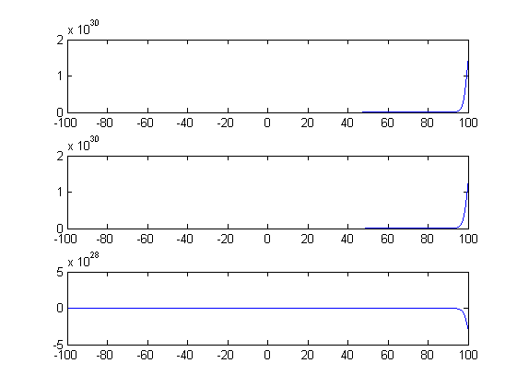

5.

a) 0 0 40 0

.5 0 0 0

0 .6 0 0

0 0 .3 0

b) We separated this into 4 different age groups: chicks, Juveniles, sexual mature adults, and the elderly. Since the first 2 and last groups don’t produce any eggs, they are set to zero on the top. Since the sexual mature adults have the ability of reproducing for 20 years (30 year lifespan, can’t reproduce until 5 years of age, and last 5 years they don’t produce), and they on average produce 2 eggs per year, while one of them will have a chance of being female. This adds up to be about 40 eggs they will produce over a 20 year period. Since two or three chicks will survive but one will more than likely kill the other, we set this to an average of about 50 percent survival from a chick. Then since 40 percent don’t make it as a sexual mature adult, we set the juveniles rate to 60 percent survival rate. When looking on the internet, the rate at which eagles reach an elderly age (past 25 years of age) is roughly 30 percent. When we put this through 30 years of time, or 4 iterations, we got roughly 5000 total females. This corresponds very well to the 4500 females 30 years later stated in the text.