Homework 8

1)

a) The matrix is 4x4 so I was able to use the formulas used on the previous homework to get the eigenvalues and vectors. I plugged matrix A1 into matlab and computed the determinatnt of the matrix. The determinate is non zero letting me know that the eignenvalue is linearly independent.

Initial Condition = [1 1 1 1]

matrix A = [25 -41 10 -6; -41 68 -17 10; 10 -17 5 -3; -6 10 -3 2]

# of iterations = 10

RQuotient =

1.5000 98.5208 98.5217 98.5217 98.5217 98.5217 98.5217 98.5217 98.5217 98.5217

b) After looking at the arrays, It took the power method about 5 iterations to get the largest eigenvalue. In terms of the iteration vectors, they all started out at 0 for the first 7 iterations, and then started converging, however they did not converge within the first 10 iterations that were given as the input.

c) Initial Condition = [1 1 1 1]

matrix A = [25 -41 10 -6; -41 68 -17 10; 10 -17 5 -3; -6 10 -3 2]

# of iterations = 10

RQuotient =

1.5000 98.5208 98.5217 98.5217 98.5217 98.5217 98.5217 98.5217 98.5217 98.5217

The scaled power method took the same number of iterations to converge as the power method. This time they all converge to a specific value quickly.

d) When using the Raleigh Quotient to estimate the largest eigenvalue, it surpasses both the power method and the scaled power method in terms of speed.

2)

a) Initial Condition = [1 1 1 1]

matrix A = inv([1 2 -2 4; 2 12 3 5; 3 13 0 7; 2 11 2 2])

# of iterations = 10

RQuotient =

28.2500 81.6889 81.9313 81.9298 81.9299 81.9299 81.9299 81.9299 81.9299 81.9299

inv(81.9299) =

0.0122

Therefore, the smallest eigenvalue is 0.0122.

b)In this problem, if lambda is an eigenvalue of A, then inv(lambda) is an eigenvalue of inv(A). Because of this, take the inverse of A2 as my initial condition, and use the power method to find the highest eigenvalue within the inverse(A2) matrix. I applied this specific equation and when I knew that the highest eigenvalue of the inverse matrix must in fact be the inverse of the eigenvalue with the smallest absolute value of the original A2 matrix. Therefore, I took the inverse of the highest eigenvalue of the inverse matrix and got the smallest eigenvalue of the original matrix.

c) Initial Condition = [1 1 1 1]

matrix A = [1 2 -2 4; 2 12 3 5; 3 13 0 7; 2 11 2 2]

# of iterations = 10

R_Quotient =

16.7500 18.8960 19.2085 19.1791 19.1824 19.1820 19.1820 19.1820 19.1820 19.1820

After running the code for the original matrix, I did in fact see that although this A2 matrix is not symmetric, the Raleigh Quotient Method did converge, although not as quickly as in problem one, after 6 iterations, to the highest eigenvalue of the A2 matrix.

3)

If we assume that there are 3 distinct eigenvalues, A, B, and C, where A is the largest eigenvalue we can assume that B<A and C<A. Therefore, B-A<0, and C-A is also less than 0. That means that both of those values must be negative. Suppose that B<C. That would make B-A < C-A, and A-A=0. So, the eigenvalues of the matrix A are 0, B-A, and C-A, where B-A and C-A are negative. So if |B-A|<|C-A| then B-A< C-A, and so B<C. Now, after using the AaI identity, we can use the new matrix created and then once again use the power method to find the smaller eigenvalue. Once that value has been added to A, we will finally obtain the smallest eigenvalue of the initial matrix.

Initial Condition = [1 1 1]

matrix A = [9 10 8; 10 5 -1; 8 -1 3]

# of iterations = 15

RQuotient =

17.0000 18.9668 19.2436 19.2804 19.2853 19.2860 19.2861 19.2861 19.2861 19.2861 19.2861 19.2861 19.2861 19.2861 19.2861

I =

1 0 0

0 1 0

0 0 1

B =

9 10 8

10 5 -1

8 -1 3

B-(z*I) =

-10.2861 10.0000 8.0000

10.0000 -14.2861 -1.0000

8.0000 -1.0000 -16.2861

Initial Condition = [1 1 1]

matrix A = ans

# of iterations = 15

RQuotient =

-2.2861 -25.7686 -26.1772 -26.3066 -26.3463 -26.3583 -26.3620 -26.3631 -26.3634 -26.3635 -26.3635 -26.3635 -26.3635 -26.3635 -26.3635

-26.3635+19.2861 = -7.0774

Firstly, by using the power method on the original matrix, we are given 19.2861 as the highest eigenvalue of the matrix. After running through everything else (as explained earlier) we are given -7.0774 as the smallest eigenvalue of the matrix without having to use the inverse of the original matrix.

4.

a) Natural Frequencies = 0.8358, 0.5826, 0.2386 Hz

Modes in order from 1 to 3:

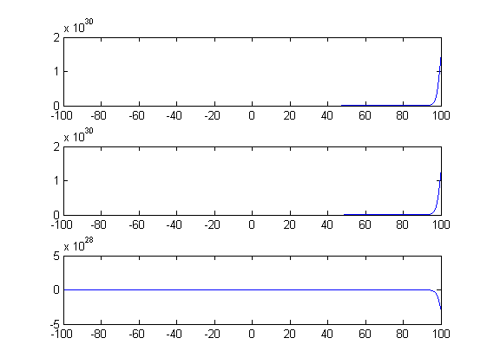

5.

a) 0 0 40 0

.5 0 0 0

0 .6 0 0

0 0 .3 0

b) We separated this into 4 different age groups: chicks, Juveniles, sexual mature adults, and the elderly. Since the first 2 and last groups don’t produce any eggs, they are set to zero on the top. Since the sexual mature adults have the ability of reproducing for 20 years (30 year lifespan, can’t reproduce until 5 years of age, and last 5 years they don’t produce), and they on average produce 2 eggs per year, while one of them will have a chance of being female. This adds up to be about 40 eggs they will produce over a 20 year period. Since two or three chicks will survive but one will more than likely kill the other, we set this to an average of about 50 percent survival from a chick. Then since 40 percent don’t make it as a sexual mature adult, we set the juveniles rate to 60 percent survival rate. When looking on the internet, the rate at which eagles reach an elderly age (past 25 years of age) is roughly 30 percent. When we put this through 30 years of time, or 4 iterations, we got roughly 5000 total females. This corresponds very well to the 4500 females 30 years later stated in the text.