HW 9

Problem 1)

1. T(x) = -12.5x2 + 141x + 40
2. Ti-1 - 2Ti + Ti+1 / (.252 ) = -25

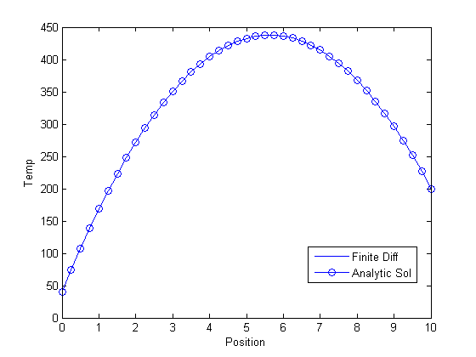

Problem 2)

1. N/A
2. I used .1 dx for all of the plots, because all of these have the same length and this should be a small enough number to represent all of the detail that these graphs are showing.

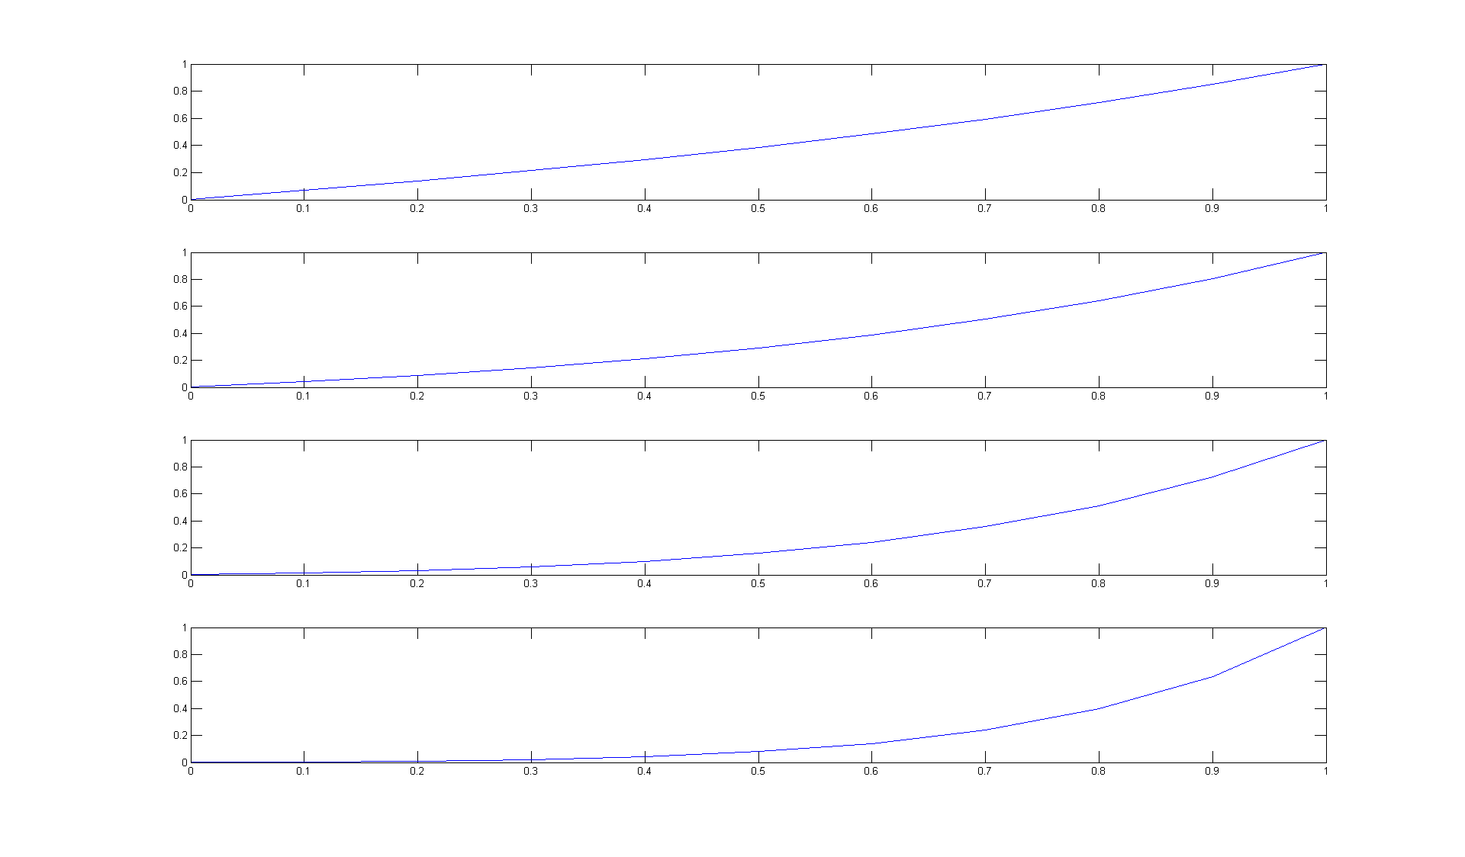

Problem 3)

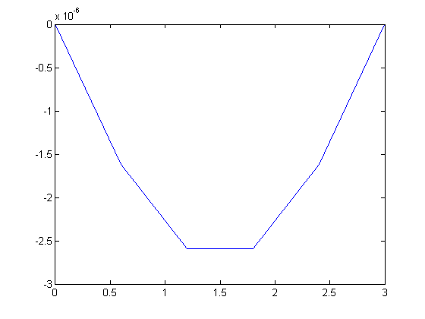

Problem 4)

1. Plot 1 used dt = .25

Plot 2 used dt = .15

Plot 3 used dt = .05

Plot 4 used dt = .005

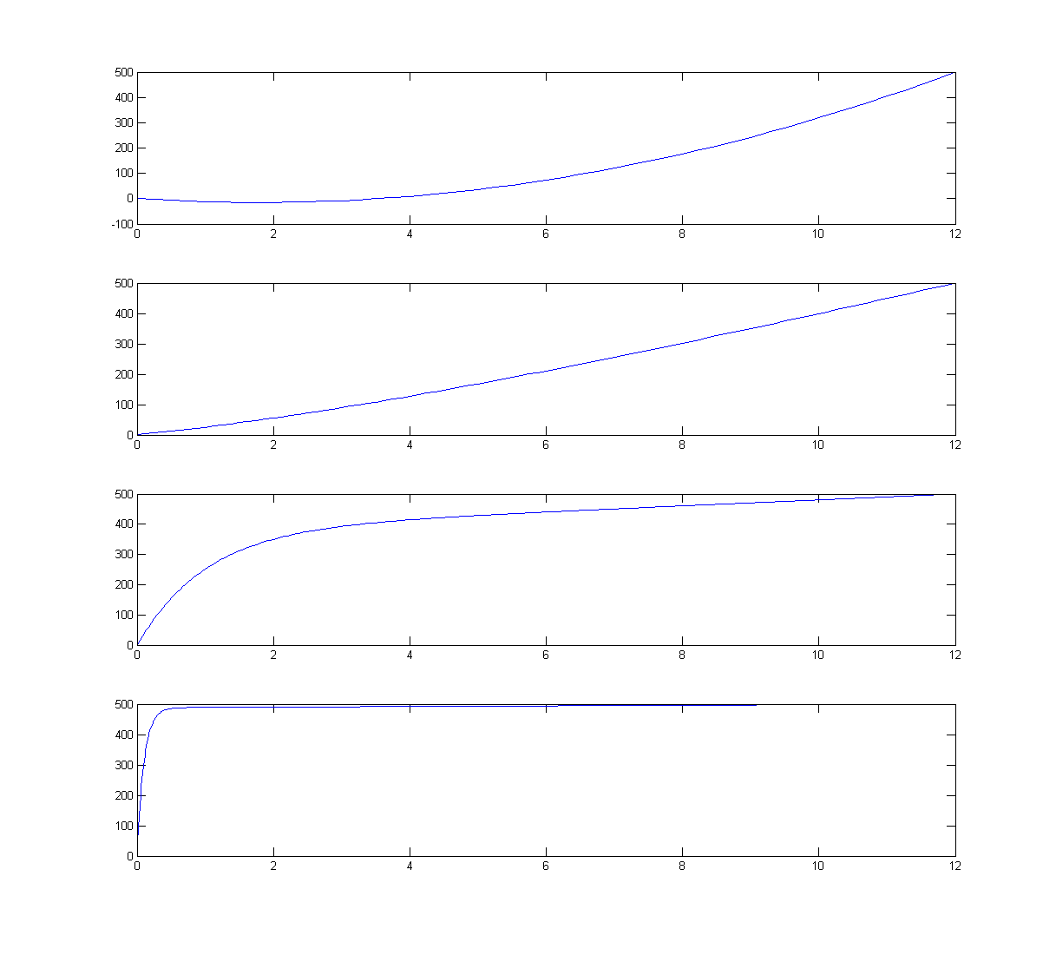

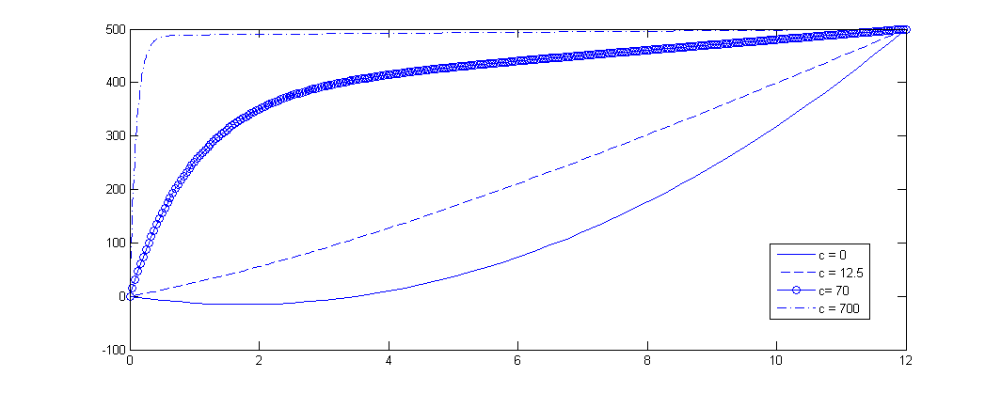

Convection seems to push the graph toward the top left, and make it look like a step function.

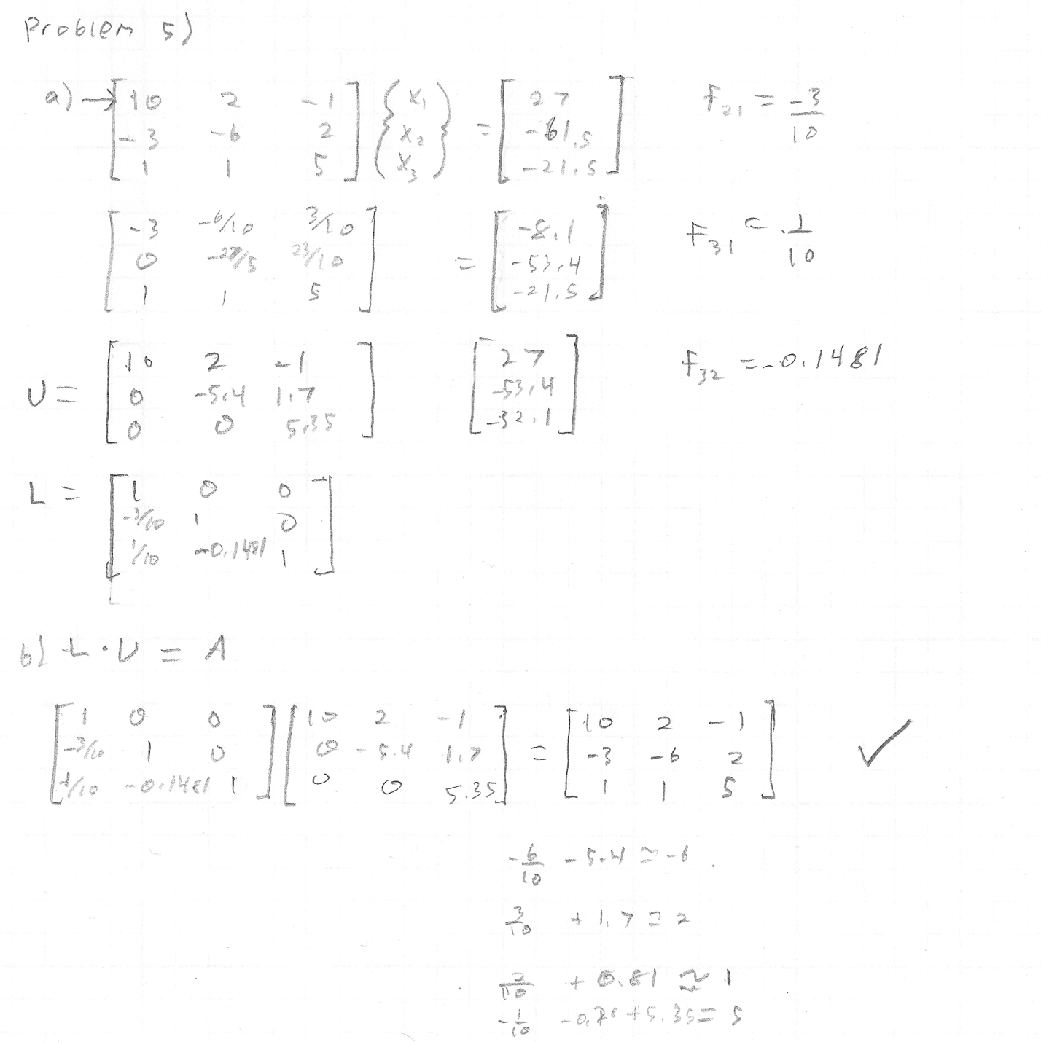

Problem 6)

L =

1 0 0

0 1 0

0 0 1

U =

10.0000 2.0000 -1.0000 27.0000

0 -5.4000 1.7000 -53.4000

0 0 5.3519 -32.1111