**Lab #1:**

**Orientation Flight**

Zachary Tschirhart

Department of Aerospace Engineering and Engineering Mechanics

**ASE 167M**

**(Wed 3:00-4:00)**

Lab Partners: Zachary May, Joshua Eboh, and Brian Huber

TA: Noble Hatten

February 6, 2013

# Abstract

In this lab, the simulator replicated a flight while the students collected data testing for certain conditions in order to empirically find specifications about the type of aircraft depicted in the simulation. The lab, in conjunction, was used to familiarize the students with the controls of the simulator and to gain an intuitive understanding of pitch, flight path angle, power, airspeed, and trim. Specifically the data that was recorded, eventually was used to find the maximum rate of climb, maximum flight path angle, minimum glide angle, and minimum rate of descent of the simulated aircraft. The most important result came in the form of the four values previously stated, which can give critical information on how the aircraft will perform during a flight, and what the pilot expects during the flight.

Contents

Abstract 2

Objectives 4

Procedure 4

Discussion 5

Results 8

Conclusion 12

Recommendations 13

Bibliography 13

Appendix 13

# Objectives

The objective of this laboratory was for the students to familiarize themselves with the airplane controls. This includes controls like flaps, throttle, propeller RPM control, control yoke, rudder pedals, and other switches. The student must progress to a point where the instructor will no longer need aid in operating the controls. The other main objective was to have the students qualitatively explain the relationships between pitch, flight path angle, power, flaps, airspeed, and trim. Along with explaining these relationships, the student must gain an intuitive understanding on how each of these play into effect on the aircraft control.

# Procedure

1. Preflight checklist.
2. Takeoff, then raise landing gear and fully raise flaps.
3. Climb and hold at 120 knots, then record the Rate of Climb after dial is steady.
4. Climb and hold at 110 knots, then record the Rate of Climb after dial is steady.
5. Climb and hold at 100 knots, then record the Rate of Climb after dial is steady.
6. Climb and hold at 90 knots, then record the Rate of Climb after dial is steady.
7. Climb and hold at 80 knots, then record the Rate of Climb after dial is steady.
8. Level off at 6000 ft. and stabilize for roughly 3 minutes, record the airspeed after stabilizing.
9. Reduce the Manifold Pressure to 28 inches of Hg, and then record the airspeed after stabilizing.
10. Reduce the Manifold Pressure to 24 inches of Hg, and then record the airspeed after stabilizing.
11. Reduce the Manifold Pressure to 22 inches of Hg, and then record the airspeed after stabilizing.
12. Lower flaps to half, then record the airspeed after stabilizing. After recording value, raise flaps.
13. Reduce Manifold pressure to 17 inches of Hg, and then adjust pitch of the aircraft to maintain a speed of 120 knots. Record the Rate of Climb after plane is stabilized.
14. Reduce the Manifold Pressure to 15 inches of Hg, and then adjust pitch of the aircraft to maintain a speed of 100 knots. Record the Rate of Climb after the plane is stabilized.
15. Reduce the Manifold Pressure to the minimum value available, and then adjust the pitch to maintain 90 Knots. Record the Rate of Climb after the aircraft has stabilized. Hold this pitch until altitude reaches 2000 ft.
16. Lower to half flaps
17. Adjust pitch for 80 Knots, and then record Rate of climb after stabilized. Keep descending until an altitude of 1000 ft., when the flaps should be lowered in full.
18. Adjust pitch for 80 Knots, and then record Rate of Climb after aircraft is stabilized.
19. Lower landing gear; continue decent; land the aircraft on the runway.
20. Perform Shutdown Checklist.

# Discussion

The derived equations of motion for an aircraft can describe many aspects of the craft in flight with a few assumptions. These equations portray everything from rate of climb, ground speed, rate of weight change from fuel loss, flight path angle rate, and airspeed rate. One basic assumption for all of these equations is that the aircraft is in non-steady flight over a vertical plane over a flat earth. In this lab, the use of only one of these equations was needed, namely, the one describing the rate of climb:

$$\dot{h}=\frac{dh}{dt}=v\sin{γ}$$

(Equation 1)

Where $\dot{h}$, is the rate of climb of the aircraft, which describes the change in height over time. The value $\dot{h}$ is also commonly referred to as R/C, as the gage in the simulator displays. The height of the aircraft with respect to the mean sea level of the earth is referred to as h. The flight path angle, $γ$, is the angle between the lines formed by the aircraft body axis and the axis parallel to the ground also known as the horizon axis system. Finally, v is the airspeed of the aircraft relative to the wind axis system. The data that was recorded fits a parabolic equation and can be approximated by using a second order form equation:

$$R/C= \dot{h}=a_{0}+{a_{1}v+a}_{2}v^{2}$$

(Equation 2)

Where $a_{0}$, $a_{1}$, and $a_{2}$ are the parabola coefficients needed in order to describe the curve. While $\dot{h}$ and v are consistent with the previous definitions listed above. In order to find the maximum rate of ascent and, conversely, the minimum rate of descent, the $\dot{h}$ parabola equation first needs to be differentiated with respect to the airspeed. We can then find when $\dot{h}$ is a local maximum by setting this differentiated equation to zero and solving for the velocity. This local maximum can easily be seen as the global maximum since the equation is only second order in nature.

$$\frac{d\dot{h}}{dv}=0=\frac{d}{dv}\left[a_{0}+{a_{1}v+a}_{2}v^{2}\right]=a_{1}+2a_{2}v$$

(Equation 3)

Manipulating the above equation to solve for airspeed results in:

$$v=\frac{{-a}_{1}}{2a_{2}}$$

(Equation 4)

Plugging Equation 4 into Equation 2 will give the final result for finding ${\dot{h}}_{max}$ and ${\dot{h}}_{min}$ for the ascend and descend during the flight, respectively.

$${\dot{h}}_{max}={\dot{h}}_{min}=a_{0}+ a_{1}\frac{a_{1}}{{2a}_{2}}+a_{2}{\left(\frac{a_{1}}{{2a}_{2}}\right)}^{2}=a_{0}+ \frac{3a_{1}^{2}}{{4a}_{2}}$$

(Equation 5)

Now, Equation 1 can be used to find the flight path angle for both the ascent and descent for the flight. We can also substitute Equation 2 into the parabolic equation to represent the parabolic data that was recorded, represented by:

$$\sin{γ}=\frac{\dot{h}}{v}=\frac{a_{0}}{v}+ a_{1}+ a_{2}v$$

(Equation 6)

The $\sin{γ}$ can be represented as $γ$ using a small angle approximation. This approximation holds over +/- 30 degrees from the horizon axis, so assuming quasi-steady flight this assumption can be made. Differentiating Equation 6 and setting to zero will give us the velocity at which the flight angle will be a maximum or minimum.

$$\frac{d}{dv}γ=\frac{d}{dv}\left[\frac{\dot{h}}{v}\right]=0=-\frac{{ a}_{0}}{v^{2}}+a_{2}$$

(Equation 7)

Solving for the airspeed yields:

$$v=\sqrt{\frac{a_{0}}{a_{2}}}$$

(Equation 8)

Now substituting Equation 8 into Equation 6 will give us the $γ_{max}$ and $γ_{min}$, otherwise known as the maximum and minimum flight path angles.

$$γ_{max}=\sin^{-1}\left[a_{2}\sqrt{\frac{a_{0}}{a_{2}}}+a_{1}+\frac{a_{0}}{\sqrt{\frac{a_{0}}{a_{2}}}}\right]$$

(Equation 9)

# Results

The results of this lab can be easily understood by observing the plots presenting the data collected over the course of the flight. These plots and calculations show maximum ascending rate, minimum descending rate, curve fit airspeed vs. rate of climb/descent, minimum and maximum flight path angles, and the altitude of the aircraft.

Figure 1 shows the altitude of the aircraft over the events that occurred throughout the flight. The instructor artificially maintained the altitudes, which is why the altitudes may not accurately depict the actual flight path taken. The independent axis is not to scale, since the ground path was not recorded during the flight.

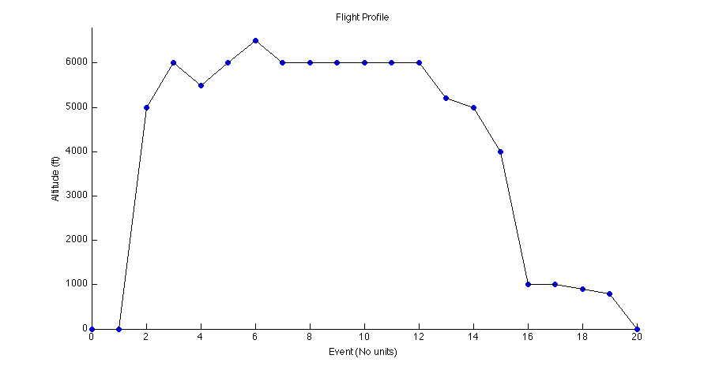

**Figure 1**: Altitude of the aircraft over the particular event listed in the procedure

Figure 2 represents the rate of climb vs. the airspeed of the aircraft, which also displays the maximum climb rate that can be achieved by this aircraft. In the plot, it is understood that the airspeed increases while the climb rate increases until it reaches a maximum rate. After this rate has been reached, the rate then begins to decrease as the airspeed increases. It can also be seen that the maximum flight path angle reached by the aircraft is plotted as a tangent line attached to the parabolic curve fitted to the collected data.

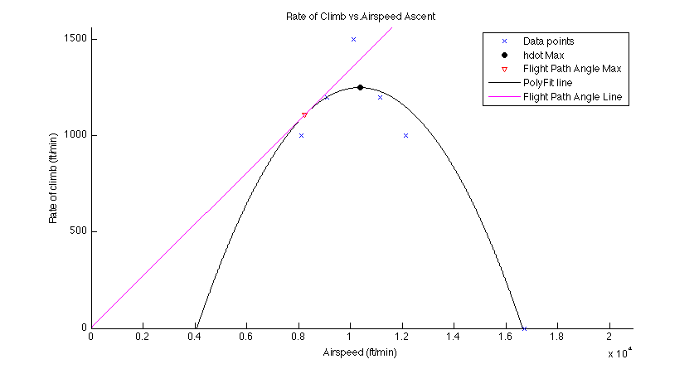

**Figure 2**: Rate of Climb vs. Airspeed, depicting the max climb rate and flight path angle

The calculated results for maximum climb rate and maximum flight path angle for the instructor given values can be found below in Table 1. The students recorded different data values found in Table 2. These recorded values had induced pilot errors introduced, so a reference was needed to identify the maximum climb rate and flight path angle in an ideal situation.

|  |  |  |
| --- | --- | --- |
|  | Calculated Value | At Airspeed (Feet/Min) |
| $\dot{h}$ (Feet/Min) | 1251.45 | 10364.80 |
| $γ$ (Degrees) | 7.73 | 8241.25 |

**Table 1**: Ideal Data Max Rate of Climb and Flight Path Angle

|  |  |  |
| --- | --- | --- |
|  | Calculated Value | At Airspeed (Feet/Min) |
| $\dot{h}$ (Feet/Min) | 1131.39 | 10170.50 |
| $γ$ (Degrees) | 7.25 | 7760.86 |

**Table 2**: Recorded Data Max Rate of Climb and Flight Path Angle

Figure 3 represents the negative rate of climb vs. the airspeed of the aircraft while it was descending, which also displays the minimum descending rate that can be achieved by this aircraft. The plot confirms that as the airspeed increases the descent rate decreases until it reaches a minimum rate. After this rate has been reached, the descent rate begins to increase again as the airspeed further increases. It is expressed that the minimum flight path angle reached by the aircraft is plotted as a tangent line with respect to the horizontal rate of climb set to zero.

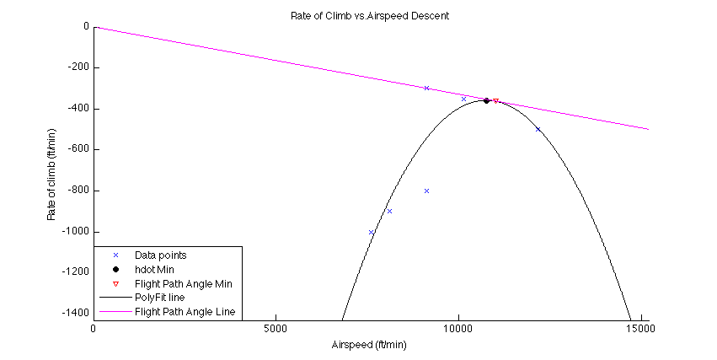

**Figure 3**: Rate of Climb vs. Airspeed, depicting the min descend rate and flight path angle

The calculated results for minimum descend rate and minimum flight path angle for the instructor given values can be found below in Table 3. Again, our group recorded different data values found in Table 4.

|  |  |  |
| --- | --- | --- |
|  | Calculated Value | At Airspeed (Feet/Min) |
| $\dot{h}$ (Feet/Min) | -357.82 | 10757.70 |
| $γ$ (Degrees) | -1.89 | 10997.20 |

**Table 3**: Ideal Data Min Rate of Descent and Glide Angle

|  |  |  |
| --- | --- | --- |
|  | Calculated Value | At Airspeed (Feet/Min) |
| $\dot{h}$ (Feet/Min) | -336.49 | 12088.60 |
| $γ$ (Degrees) | -1.60 | 12487.00 |

**Table 4**: Recorded Data Min Rate of Descent and Glide Angle

# Conclusion

In conclusion, the results for this lab clearly describes a way to empirically deduce a maximum flight path angle, maximum rate of climb, minimum glide angle, and minimum rate of descent. These calculations can help verify an aircrafts manufacture specs, or for the purposes of the lab, help the students draw a relationship to airspeed and the rate of climb. This lab also helped explain the relationships between pitch, flight path angle, power, flaps, airspeed, and trim. In order to maximize the aircrafts potential, these factors must be taken into account when flying. Another conclusion that can be drawn from this lab, are the effects of the flaps of the lift and drag on the aircraft, it is obvious now that flaps greatly increase both lift and drag on the aircraft. Thus, flaps should only be used during takeoff and landing.

# Recommendations

No recommendations.

# Bibliography

1. **Eduardo Gilden, Greg Holt, Kyle DeMars, George Jacobellis.** ASE 167M Flight Dynamics Laboratory Flight Simulator Experiments and Computer Projects. s.l. : The University of Texas at Austin Department of Aerospace Engineering, 2012.

# Appendix

**Flight Profile Plot**

clear; clc;

% Script to plot the Flight Profile

% Altitude data

Altitude = [0, 0, 5000, 6000, 5500, 6000, 6500, 6000, 6000, 6000, 6000, ...

6000, 6000, 5200, 5000, 4000, 1000, 1000, 900, 800, 0];

% Ground Distance data (Not to scale)

GroundDist = 0:1:length(Altitude) - 1;

figure;hold on;

axis([0, max(GroundDist), 0, (max(Altitude) + 300)]);

scatter(GroundDist, Altitude, 'b', 'filled');

plot(GroundDist, Altitude,'k');

title('Flight Profile');

xlabel('Event (No units)');

ylabel('Altitude (ft)');

hold off;

**RC vs Airspeed for the Ascent**

clear; clc;

% Script to plot the Rate of Climb vs. Airspeed

% ------------------------Input Data------------------------

% Rate of Climb data, these values were given to us by the TA,

% since ours were off. Given in Ft/min

RC = [1000, 1200, 1500, 1200, 1000, 0];

%RealRC = [1200, 900, 1100, 1200, 1000, 0];

% Airspeed data, Convert to Ft/min

KnotsToFtPerMinute = 101.268591;

Airspeed = [120, 110, 100, 90, 80, 165]*KnotsToFtPerMinute;

% ----------------------------------------------------------

% Setup

A = fliplr(polyfit(Airspeed,RC,2));% Polyfit data to parabola

vmin = min(Airspeed);

vmax = max(Airspeed);

V = 0:1:vmax; % Break data into fine segments

hdot = A(1) + A(2).*V + A(3).*V.^2; % hdot for every speed

vStar = -A(2) / (2*A(3));

hdotmax = A(1) + A(2).*vStar + A(3).*vStar.^2;

vStar2 = sqrt(A(1) / A(3));

hdotFAmax = A(1) + A(2)*vStar2 + A(3)*vStar2^2;

hdotDivV = A(1)/vStar2 + A(2) + A(3)*vStar2;

flightAngleMax = asind(hdotDivV);

x = 0:1:vmax + vmax/4;

y = hdotDivV.*x + hdotFAmax/(hdotDivV*vStar2);

fprintf('hdot Max = %g (ft/min) at airspeed = %g (ft/min)\n',hdotmax, vStar);

fprintf('Flight Angle Max = %g degrees at airspeed = %g (ft/min)\n',flightAngleMax, vStar2);

figure;hold on;

title('Rate of Climb vs.Airspeed Ascent');

xlabel('Airspeed (ft/min)');

ylabel('Rate of climb (ft/min)');

axis([0,vmax + vmax/4,0,hdotmax + hdotmax/4]); % Set Axis

scatter(Airspeed,RC,'x'); % Plot Vel and RC points

scatter(vStar,hdotmax,'k', 'filled'); % Plot Max RC point

scatter(vStar2,hdotFAmax,'v'); % Plot Max Flight Angle

plot(V,hdot,'k'); % Plot V and hdot

plot(x,y,'m'); % Plot Flight Angle line

hold off;

**RC vs Airpspeed for the Decent**

clear; clc;

% Script to plot the Rate of Climb vs. Airspeed for landing

% Rate of Climb data, these values were given to us by the TA, since ours

% were off.

RC = [-500, -350, -300, -800, -900, -1000];

%RealRC = [-350, -400, -600, -750, -900, -1000];

% Airspeed data, Taking out step out record since it doesn't fit the plot

% well and isn't really showing anything needed.

KnotsToFtPerMinute = 101.268591;

Airspeed = [120, 100, 90, 90, 80, 75]*KnotsToFtPerMinute;

% Setup

A = fliplr(polyfit(Airspeed,RC,2));% Polyfit data to parabola

vmin = min(Airspeed);

vmax = max(Airspeed);

V = 0:1:vmax + 10000; % Break data into fine segments

hdot = A(1) + A(2).*V + A(3).*V.^2; % hdot for every speed

vStar = -A(2) / (2*A(3));

hdotmin = A(1) + A(2).*vStar + A(3).*vStar.^2;

vStar2 = sqrt(A(1) / A(3));

hdotFAmin = A(1) + A(2)*vStar2 + A(3)*vStar2^2;

hdotDivV = A(1)/vStar2 + A(2) + A(3)*vStar2;

flightAngleMin = asind(hdotDivV);

x = 0:1:vmax + vmax/4;

y = hdotDivV.*x + hdotFAmin/(hdotDivV*vStar2);

fprintf('hdot Min = %g (ft/min) at airspeed = %g (ft/min)\n',hdotmin, vStar);

fprintf('Flight Angle Min = %g degrees at airspeed = %g (ft/min)\n',flightAngleMin, vStar2);

figure;hold on;

title('Rate of Climb vs.Airspeed Descent');

xlabel('Airspeed (ft/min)');

ylabel('Rate of climb (ft/min)');

axis([0,vmax + vmax/4, 4*hdotmin, 0]); % Set Axis

scatter(Airspeed,RC,'x'); % Plot Vel and RC points

scatter(vStar,hdotmin,'k', 'filled'); % Plot Min RC point

scatter(vStar2,hdotFAmin,'v'); % Plot Min Flight Angle

plot(V,hdot,'k'); % Plot V and hdot

plot(x,y,'m'); % Plot Flight Angle line

hold off;