**To:** Noble Hatten

**From:** Zachary Tschirhart

**Section:** Wed 3:00-4:00

**Subject:** Lab #2 Memo

**Date:** February 13, 2013

The operation of the elevator on an aircraft is used to adjust the pitch and thus change the angle of attack of the wing. It is located on the horizontal tail of most aircrafts and, in the case of the lab, all of the other controls were set constant while only pitch was varied. In steady flight with the elevator at an angle of zero, the tail will only provide a lift force and almost no moment about the wing or center of mass of the aircraft as seen in Figure 1.

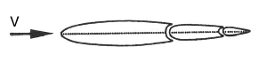

Figure 1: Horizontal tail with a zero elevator angle and no angle of attack.[1]

Where V is the velocity of the airstream. In order to create a moment about the center of mass of the plane and change the pitch, the elevators need to deflect the airflow to produce a force on the tip. This tip force is caused from pressure differences above and below the elevator much like lift is generated. Assuming a negative moment about the center (Nose up configuration), there is a higher pressure on the top of the elevator than on the bottom, causing a force on the top of the elevator as seen in Figure 2.

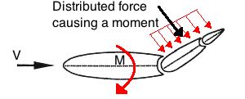

Figure 2: Horizontal tail with an elevator deflection.[1]

Where M is the moment caused by the tip force on the elevator. This Moment’s lever arm is with respect to the center of mass of the whole aircraft. While the operator can use the yoke to change the pitch of the aircraft with the elevator, the trim tab can also be used to “hold” the position of the elevators to a set angle. This helps by correcting any constant pitch adjustments needed throughout a steady flight. The trim tabs work by moving a smaller tab attached to the elevator that causes a force in the direction that is needed for the elevator adjustment as seen in Figure 3. This causes a moment about the elevator pivot point, moving the elevator into a corrective position that in whole causes a moment on the aircraft as seen in Figure 4.

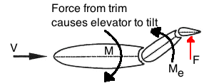

Figure 3: Horizontal tail with a trim tab causing the elevator to change position.[1]

Where F, located in figure 3, is the force caused by the trim tab, and Me is the moment about the elevator caused by the trim tab tip force. These trim tabs are useful to the pilot in order to reduce the constant force exerted on the yoke control that is needed to keep the pitch of the aircraft constant. If the pilot needed to exert this force over a long period of time while flying, he or she may become fatigued. Trim tabs can also be used to correct for inconsistent behavior of the aircraft.

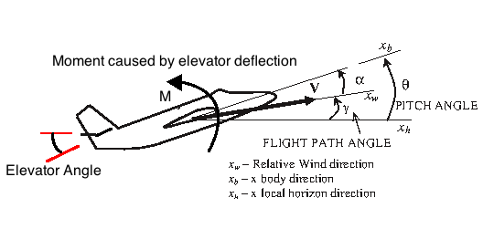

Figure 4: Aircraft changing pitch that is caused by the elevator deflection.[1]

While **α,** is the angle of attack of the aircraft and **γ** is the flight path angle. Also, **θ** is the total pitch angle relative to the local horizon axis. In the lab conducted, it is understood that the aircraft needs to change the pitch in order to change the angle of attack, which changes the lift coefficient of the aircraft. This can be seen in Figure 5, and the relationship can be seen in Equation 1.

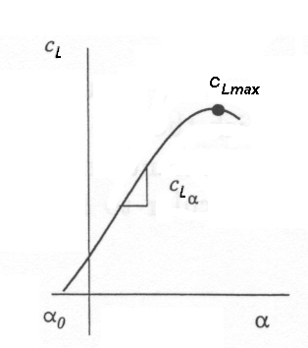

Figure 5: Coefficient of lift vs. angle of attack in general.[2]

$$C_{L}= \frac{L}{\frac{1}{2}ρv^{2}S}$$

(Equation 1)

Where $C_{L}$ is the coefficient of lift, L is the lift force, $ρ$ is the density of the atmosphere, and S is the surface area of the wing. It is clear from Figure 5 that if you change the angle of attack while in a reasonable region, that the Coefficient of lift will also change proportionally. During the flight in the lab, a few maneuvers were performed, such as climbing and descending, power increases and decreases, and maintaining level flight. Most of these maneuvers required the use of the trim tab to stabilize without the need to manually hold the yoke. Each of these operations required changing the elevator to change the angle of attack of the aircraft. In the case of power reduction or increase, that affects the velocity term in equation 1. In order to compensate for the change in velocity, a change in the Coefficient of Lift will need to be made to keep a constant lift force. Changing the angle of attack would change the Coefficient of Lift, shown to Figure 5, which in turn is caused by a pitch change from the elevator. The elevator angle change can be made by using the trim tab, holding it constant and stabilizing the plane. Other situations can also be corrected using the same approach.

References

[1] Eduardo Gilden, G. H. (2012). ASE 167M Flight Dynamics Laboratory Flight Simulator Experiments and Computer Projects. The University of Texas at Austin Department of Aerospace Engineering.

[2] Hull, David G. *Introduction to Airplane Flight Mechanics*, University of Texas at Austin, Austin, 2002.

**Flight card:**

Flight Plan 2

1. Normal start and take-off. Raise landing gear.
2. Climb at 100 knots with full power to 4000 ft, using MP = MAX; FUEL = FULL RICH; Trim (after stabilized in the climb, try taking hands off the control). Note R/C when stabilized.
3. Level off at 4500 ft. Trim (Take hands off the controls). Reduce power to maintain 120 knots and trim. Note trim changes required to stabilize in level flight. MP as needed. Note R/C and V when stabilized.
4. Increase airspeed to 150 knots maintaining level flight at 4500 ft. Note the pitch changes required to maintain level flight, and trim off control pressures as they become apparent. Trim (Hands off). MP as needed. Note R/C and V when stabilized.
5. Slow to 100 knots while maintaining level flight. Trim. MP as needed. Note R/C and V when stabilized.
6. Climb at 100 knots at full throttle (MP = MAX). Trim for “hands-off” climb. Note R/C, V and instantaneous altitude when stabilized.
7. Descend at 100 knots (do not change trim but try to control descent with throttle). MP = as needed. Note R/C, V and instantaneous altitude when stabilized.
8. Climb at 120 knots with full throttle (RPM = MAX, MP = MAX). Trim for hands-off. Note R/C, V and instantaneous altitude when stabilized.
9. Descend at 120 knots (do not change trim, use throttle). MP = as needed; Note R/C, V and instantaneous altitude when stable.
10. Climb at 90 knots with MP = 25” Hg. Trim for hands-off. Note R/C, V and instantaneous altitude when stable.
11. Descend to 1000 ft. at 95 knots, MP = MIN, hands-off. Land using hands on controls. MP as needed (Be sure to lower landing gear and flaps. Note R/C and V both prior to and after lowering landing gear and flaps.
12. Brake to a stop, shut down procedures, etc

|  |  |  |  |
| --- | --- | --- | --- |
| Step | R/C [ft./min] | V [knots] | Note |
| 1 | 0 | 0 |  |
| 2 | 1100 | 100 | Pitch up |
| 3 | 0 | 120 | Trim down |
| 4 | 0 | 150 | Trim down |
| 5 | 0 | 100 | Pitch up |
| 6 | 1300 | 110 | Pitch up |
| 7 | -700 | 110 |  |
| 8 | 1600 | 120 | Trim up |
| 9 | -1400 | 120 |  |
| 10 | 900 | 90 | Trim up |
| 11 | 750 | 95 |  |