



***Lab #2: Introduction to Electronic Instrumentation (continued)***

|  |  |
| --- | --- |
| **Course Number and Name:**  **ASE 269K Measurements and Instrumentation** | |
| **Semester and Year:**  **Fall 2013** | |
| **Name of Reporter:**  Zachary Tschirhart | **EID of Reporter:**  zst75 |
| **Unique Number and Meeting Time:**  13580 Monday 1-3pm | **Name of Lab Instructor**  **Zheng Wang** |
| **Title of Experiment:**  Introduction to Electronic Instrumentation (continued) | |
| **Date of Experiment Performed:**  September 16, 2013 | **Instructor Comments:** |
| **Date of Report Submitted:**  September 23, 2013 |
| **Names of Group Members:**  David Chang |
| **Grade:** |

**ABSTRACT**

This lab was intended to allow the students to become more comfortable and proficient with using the lab equipment that was introduced in the previous lab. The tools used in this lab were a DC Power Supply, Digital Multimeter, Function Generator, Oscilloscope, Electronic Prototyping Breadboard, Resistors at various resistances, a Potentiometer, LEDs, a Jumper wire kit, and a Silicon Photodiode. These tools familiarized students with collecting measurements and the intuitive knowledge of using the correct tool for the job. Again, in this lab, the Digital Multimeter and Oscilloscope were the tools used to measure the voltage in each of the experiments. To be more specific, when creating the voltage divider circuit, students found that measurements could be skewed and the results would be inconsistent if the internal resistance of the measurement device is similar in value with the resistance in the circuit. The LED and photodiode circuit proved that some methods of measurements are ineffective.

**OBJECTIVE AND INTRODUCTION**

The purpose of this lab is to further familiarize students with instruments that will be used in many of the labs preceding this one.

This lab enables the student to gain knowledge on how to use the tools, so that in future labs there will not be much need to use the product manual or ask the instructor for assistance. The student must also be aware of the tools’ limitations regarding ranges and accuracy when using certain instruments to measure current or voltage.

**THEORY AND EXPERIMENTAL METHODS**

Ohms law:

$V=I*R$ (1)

Where V is voltage, I is the current, and R is the resistance in a circuit.

Uncertainty calculation:

$Uncertainty= \left(\frac{P}{100}\right)*\left(U\right)+X*Y$ (2)

Where P is the accuracy range of the device, as a percentage, U is the value read from the device, and X is the number of digits of accuracy, and Y is the resolution of the measurement.

Responsivity:

$R= \frac{I_{PD}}{P}$ (3)

Where R is the Responsivity value, $I_{PD}$ is the generated photocurrent, and P is the light power.

**RESULTS AND DISCUSSION**

**Section 1: Voltage Divider / Potentiometer**

This section showed the students the importance of knowing what output

**1.1**

Question – “What is the voltage at VA

The voltage at VA was 2.5072 ± 0.0106 Volts according to the Digital Multimeter and using equation 2 for the uncertainty.

Homework Question – “How much current is flowing through the circuit?”

Using equation 1 and simplifying the circuit, a total of 2.5 mA of current should be flowing through the circuit.

Question – “What is the voltage with the DMM?”

The voltage according to the Digital Multimeter was 2.3920 ± 0.0102 Volts.

Question – “What is the voltage with the oscilloscope?”

According to the Oscilloscope, the voltage was 1.80 ± 0.072 Volts.

Homework Question – “Why are they different?”

These measurements are vastly different because of the variance of impedance in each of the devices. In the Digital Multimeter, the impedance is 10 MΩ versus the Oscilloscope, which only has 1 MΩ of impedance. With circuits that have low resistance values, the difference is unnoticeable, but, since the current was being split up between the device taking the measurement and the circuit itself, the measurements are skewed.

**1.2**

Please note that the potentiometer’s max resistance was not 20 kΩ, but instead 10 kΩ. This might have affected some of the results.

**1.3**

Question – “Estimate your voltage resolution, i.e. the smallest voltage increment that you can reliably discern.”

This was roughly around 0.0005 volts.

Homework Question – “If you needed higher resolution, what characteristics of the potentiometer would be required?”

This would require a less sensitive dial with a larger range of motion, so that the operator can reliably move the dial with more resolution consistently.

**1.4**

Question – “What happens as you turn the pot? Make a sample sketch of the input and attenuated signals”

The amplitude is attenuated, like the example below:

**Attenuated signal example**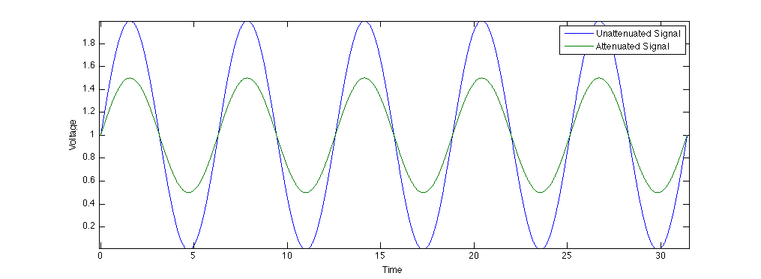

Figure 1: Attenuated signal versus non-attenuated signal

**Section 2: LED**

**2.1**

Question – “How much current is flowing through the LED?”

Using equation 1, 2, and the measurement of voltage drop across the resistor; the current flowing through the LED is 0.01 ± 0.01 Amps.

**2.2**

Question – “At what frequency can you no longer discern individual pulses?”

From what we could see, this was around 49.9 Hz

Question – “At what amplitude is the light from the LED no longer visible?

Since we were still using the function generator to provide power, the voltage/amplitude where we no longer saw a visible light coming from the LED was around 1.76 Volts.

**Section 3: Photodiode**

**3.2**

Question – “For the room lights, do you measure 60 Hz? If not, what frequency do you see?”

No, we see about 120 Hz.

Homework Question – “Why is the frequency different from 60 Hz?”

This is because the light sources are emitting light at a 120 Hz frequency. The power is being provided at 60 Hz, but the light sources will double that frequency by using a rectifier of some sort. The graph below demonstrates the process.

**Rectified Signal Example**

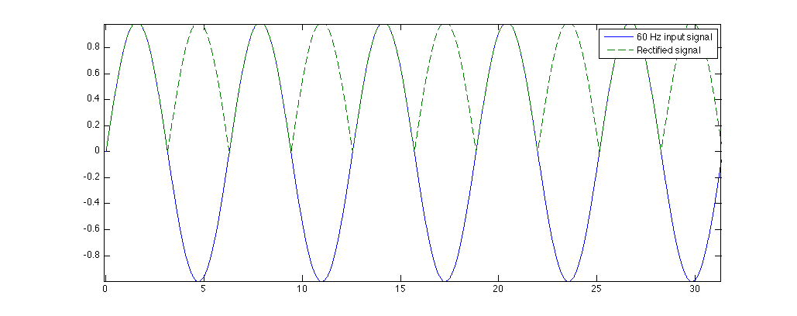

Figure 2: Example of what a Rectifier will do to a signal.

**3.3**

Question – “Is the photodiode reproducing the waveform of the LED?”

Yes, but it’s very noisy and hard to discern. The peak-to-peak voltage we recorded was 5.36 volts, but we think there was a problem with our circuit, or the noise was interfering too much. This seems very high for the photodiode. Here is a cleaned up example of what we saw:

**Noisy photodiode signal Example**

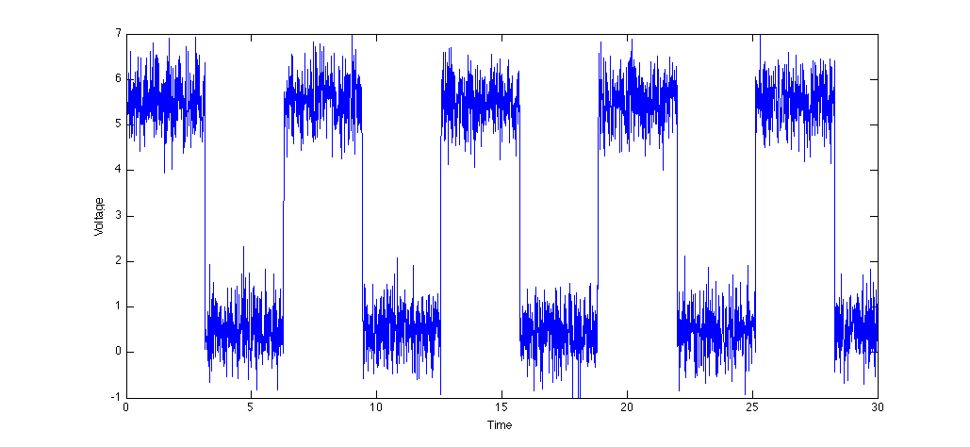

Figure 3: Simulated square wave

Homework Question – “Use the attached sensitivity curve to determine the radiated power incident on the photodiode. For a green LED, the wavelength is about 500 nm.”

Using equation 3, the radiated power came out to be 0.0019 Watts

Question – “What can detect a lower light level, the photodiode or your eye?”

This is very clearly your eye, since the amount of noise from the other lights and sources in the room make it very hard to measure any differences coming from the LED. Also, humans are very good at seeing green, since this is the greatest amount of the color spectrum we can see.

Question – “At how high of a frequency can you drive the photodiode before it is not able to respond as a square wave?”

We think we found this around 120 Hz, but with all of the light noise in the room, it was hard to tell the limit. We know the signal we should have seen would have looked like a saw tooth wave, but the noise level was too high and we couldn’t discern the signal from the noise. The signal just looked like a bunch of noise, so there an example sketch would not be beneficial.

**CONCLUSIONS**

In conclusion, this experiment was used to further understand the tools needed to accurately measure the required signals, and learn what implicit data is being displayed to the user, as well as what errors are present while using certain instrument. This lab also uncovered ways to calculate various values given other properties of the system, which will help students understand what measurements are needed to get the information they desire if the measurement can not be taken directly. When creating the voltage divider circuit, students found that if the tool used to measure the voltage had the same internal impedance as another part of the circuit, it would distort the measurement. The LED and photodiode circuit also proved to the students that some methods of measurements are ineffective and unreliable.

**BIBLIOGRAPHY**

RAVI-CHANDAR, Krishnaswamy. *Lab #1: Introduction to Electronic Instrumentation*. Rep. no. 1. N.p.: n.p., n.d. Print.

"Photodiode Tutorial." *Thorlabs*. N.p., n.d. Web. 22 Sept. 2013. <http://www.thorlabs.com/newgrouppage9.cfm?objectgroup_id=2822>.