



***Lab #4: Introduction Digital Data Acquisition***

|  |  |
| --- | --- |
| **Course Number and Name:**  **ASE 269K Measurements and Instrumentation** | |
| **Semester and Year:**  **Fall 2013** | |
| **Name of Reporter:**  Zachary Tschirhart | **EID of Reporter:**  zst75 |
| **Unique Number and Meeting Time:**  13580 Monday 1-3pm | **Name of Lab Instructor**  **Sungpil Yang** |
| **Title of Experiment:**  Introduction Digital Data Acquisition | |
| **Date of Experiment Performed:**  September 30, 2013 | **Instructor Comments:** |
| **Date of Report Submitted:**  October 7, 2013 |
| **Names of Group Members:**  Dayle Chang |
| **Grade:** |

**ABSTRACT**

This lab was intended to familiarize students with converting analog signals to digital signals using an Analog-to-Digital (A/D) converter, digital signals to analog ones with a Digital-to-Analog (D/A) converter, and using a microphone and speakers to help build intuition on signal processing. The lab helped visualize the effects of using a boosted signal, or Gain, to visualize small voltage input signals and the disadvantage of clipping when measuring a large voltage in the same configuration. The lab also discussed trying to measure a small signal with no Gain and how resolution affects the recorded signal. All of this was then made audible with the microphone and speakers to help build an understanding.

**OBJECTIVE AND INTRODUCTION**

The objective of this lab is to introduce students to computer-based digital data acquisition with A/D converters and back to analog with D/A converters. Students should learn the advantages and disadvantages to using a signal with Gain and without. The individual experiments consist of using converting an analog signal to a digital one, converting a digital signal to an analog one, and using a microphone to hear the differences. Equipment used in the experiment are a Function Generator, Oscilloscope, PC Computer with National Instruments Data Acquisition Board, National Instruments LabVIEW software package, a Dynamic Microphone, and a speakers.

**THEORY AND EXPERIMENTAL METHODS**

Minimum voltage resolution:

$∆V_{min}= \frac{∆V_{total}}{2^{bits}*Gain}$ (1)

Where $∆V_{total}$ is the total peak-to-peak voltage of the signal, “bits” is the number of bits of resolution the A/D converter has, and “Gain” is the gain currently applied to the input signal WRT the A/D converter.

**RESULTS AND DISCUSSION**

**Section 1: A/D Converter**

**1.1** – **No Gain**

Question 1 – “What happens to the saw-tooth wave when we approach 10 mV?”

The recorded waveform looks very choppy and lacks the necessary resolution to properly represent the waveform. It looked a little bit like this:

Figure 1: Example waveform with no gain.

Question 2 – “What is the minimum resolvable voltage that can be measured with the A/D at these settings?”

The minimum resolvable voltage is 0.004 volts.

Homework Question 1 – “Is it consistent with the expected value?”

This is mostly consistent, since using equation 1 the expected value is 0.0048.

Question 3 – “At what voltage does the signal clip (if it does)?”

The signal does not clip under these conditions.

Homework Question 2 – “Is it consistent with the expected value?”

This is expected, since the input signal is ∓ 10 Volts and the A/D can record up to ∓ 10 Volts with no gain.

**1.1** – **10x Gain**

Question 1 – “What happens to the saw-tooth wave when we approach 10 mV?”

The signal has no artifacts and looks like a saw-tooth wave.

Question 2 – “What is the minimum resolvable voltage that can be measured with the A/D at these settings?”

From the readings, it was about 0.0005 volts.

Homework Question 1 – “Is it consistent with the expected value?”

This is consistent with the expected value, since using equation 1 gives the estimated value of 0.00048 Volts.

Question 3 – “At what voltage does the signal clip (if it does)?”

The signal clips at around 2.6 Volts peak-to-peak voltage

Homework Question 2 – “Is it consistent with the expected value?”

This is a little bit higher than expected, since the expected value is around 2 Volts peak-to-peak or ∓ 1 Volt.

Homework Question for both No Gain and 10x Gain – “What is the purpose of the gain, when is it necessary to use it and when we can’t?”

This is useful if there is a need to measure a small input voltage with high resolution, but it can’t be used for higher voltage input signals. It also can’t be used on a signal with both low and high voltage signals. The resulting waveform with high gain and high voltage will result in clipping, while a low gain and low input voltage will result in a low-resolution output signal.

**Section 2: D/A Converter**

**2.4**

Question 1 – “Describe what you see, and hear, as you decrease the resolution.”

When the resolution is at 12 and 10 bits, the waveforms look about the same as the input signal. They also sound like a high-pitched noise. Although, when the resolution was decreased to 8 bits, the waveform looked more like this:

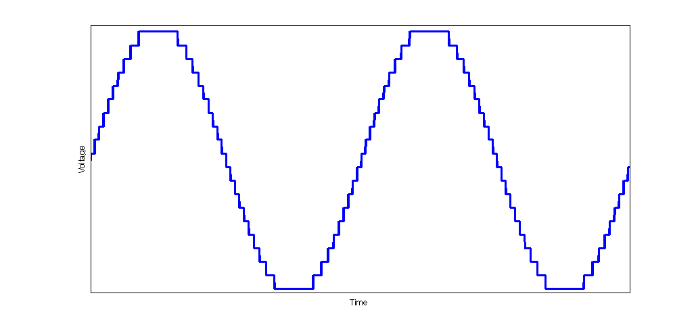 Figure 2: Example of choppy replay output signal.

The output signal also sounded choppy and distorted. Then when replayed at 4 and 2 bits, the waveform looked like a straight line and no sound played.

Question 2 – “What is the lowest resolution setting that doesn’t seem to compromise the quality of the signal?”

This seemed to be around 10 bits, at least with the quality speakers that the output signal was played on.

**Section 3: Microphone**

**3.4**

Question – “Describe what you hear as you lower the resolution.”

As the resolution was lowered, the sound became more distorted and harder to hear the original input sound.

**CONCLUSIONS**

In conclusion, this lab familiarized students with converting analog signals to digital signals, digital signals to analog ones, and the advantages and shortcomings of using gain and differing the resolution. The lab helped to visualize the effects of using a boosted signal, or Gain, to visualize small voltage input signals and the disadvantage of clipping when measuring a large voltage in the same configuration. The lab also discussed trying to measure a small signal with no Gain and how resolution affects the recorded signal. The final goal was to show that varying the number of bits of resolution available when recording or outputting would change the waveform quite a bit.

**BIBLIOGRAPHY**

RAVI-CHANDAR, Krishnaswamy. *Lab #4: Introduction Digital Data Acquisition*. Rep. no. 1. N.p.: n.p., n.d. Print.