



***Lab #5: Digital Signal Processing***

|  |  |
| --- | --- |
| **Course Number and Name:**  **ASE 269K Measurements and Instrumentation** | |
| **Semester and Year:**  **Fall 2013** | |
| **Name of Reporter:**  Zachary Tschirhart | **EID of Reporter:**  zst75 |
| **Unique Number and Meeting Time:**  13580 Monday 1-3pm | **Name of Lab Instructor**  **Shixuan Yang** |
| **Title of Experiment:**  Digital Signal Processing | |
| **Date of Experiment Performed:**  October 7, 2013 | **Instructor Comments:** |
| **Date of Report Submitted:**  October 14, 2013 |
| **Names of Group Members:**  Dayle Chang |
| **Grade:** |

**ABSTRACT**

This lab was intended to introduce several concepts about digital signal processing by using the dynamic signal analyzer VI and knowledge of how the signals are processed. The lab required students to find several properties of the A/D converter and sampler that is used, then use these properties to find when a signal leaks with too low of a frequency resolution. The students also saw the effects of using a Square and Sawtooth waveform and the effects it had on the Fast Fourier Transform algorithm through comparison to ideal waveforms. Lastly the lab went over the effects of aliasing and what signs to look for when an input frequency is too high to sample.

**OBJECTIVE AND INTRODUCTION**

The objective of this lab is to introduce students to digital signal processing with A/D converters and the dynamic signal analyzer VI. Students should learn the effects of periodic and transient signals. This was done using the dynamic signal analyzer and a Fast Fourier Transform algorithm. The students also found properties related to sampling including number of samples, rate of sampling, and aliasing. Equipment used in the experiment was a PC with NI PCI-MIO-16E-4 data-acquisition board, NI BNC 2120 Accessory Box, VirtualBench Instrument Library version 2.6, and a Function Generator.

**THEORY AND EXPERIMENTAL METHODS**

Sampling time interval:

$∆t= \frac{1}{f_{s}}$ (1)

Where $f_{s}$ is the sampling frequency.

Sampling time period:

$T= N∆t$ (2)

Where $∆t$ is the sampling time interval and N is the number of samples or “Block Size”.

Frequency resolution:

$∆f= \frac{f_{s}}{N}=2.5* \frac{f_{bs}}{N}$ (3)

Where $f_{s}$ is the sampling frequency, N is the number of samples or “Block Size”, and $f_{bs}$ is the baseband span.

Nyquist frequency:

$f_{nyq}= \frac{f_{s}}{2}$ (4)

Where $f_{s}$ is the sampling frequency.

**RESULTS AND DISCUSSION**

**Section 1: Pure Sine-Wave Input: Leakage**

**1.1**

Question 1 – “What is the sampling time interval?”

Using equation 1, the sampling time interval was 9.765 microseconds.

Question 2 – “What is the sampling time period?”

Using equation 2, the sampling time period is 0.01 seconds.

Question 3 – “What is the frequency resolution?”

Using equation 3, the frequency resolution was 97.65 Hz.

Homework Question – “Plot the amplitude spectra for input sine waves of frequency 100, 150, 200 Hz over a frequency range of 0-400 Hz. Explain the appearance of the spectra.”

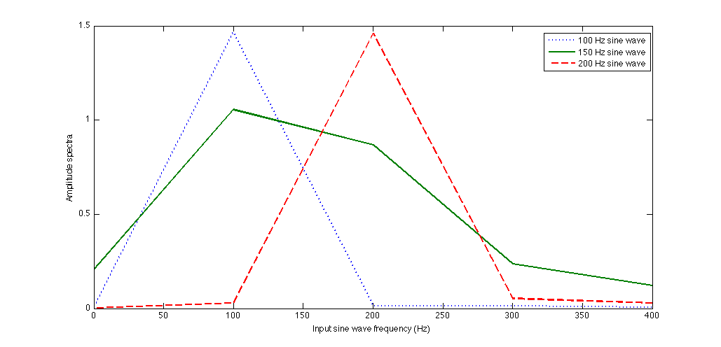

Figure 1: Amplitude spectra for input sine waves over frequency range 0-400Hz

The appearance of this graph is not unexpected for the 100 and 200 Hz input signals, but the input signal of 150 does not have a very apparent peak like the other two. This is because the frequency resolution of the graph is nearly 100 Hz, which will not capture the peak of the 150 Hz signal. If the frequency resolution were reduced to 50 Hz, all three of these peaks would be rather clear.

**Section 2: Square and Sawtooth Waves**

**2.1**

Question 1 – “What is your frequency resolution now?”

Using equation 3, the frequency resolution was 4.88 Hz.

Homework Question – Plot the spectrum for the 100 Hz Square Wave. Compare the peak amplitudes and frequencies with a Fourier series calculation.”

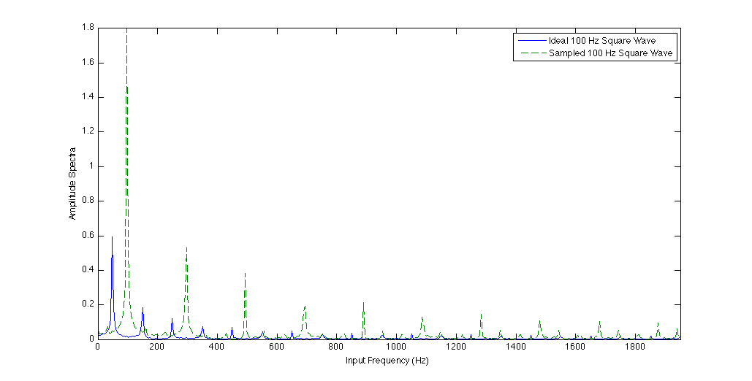

Figure 2: Ideal and Real 100 Hz Square Amplitude spectra

In order to clearly see both waveforms in a single graph, the ideal square waveform Fourier transform amplitude was divided by 1000, so the amplitude overall was much greater with the Ideal Fourier transform. It also seems that the ideal waveform had an offset from the sampled amplitude spectra peaks.

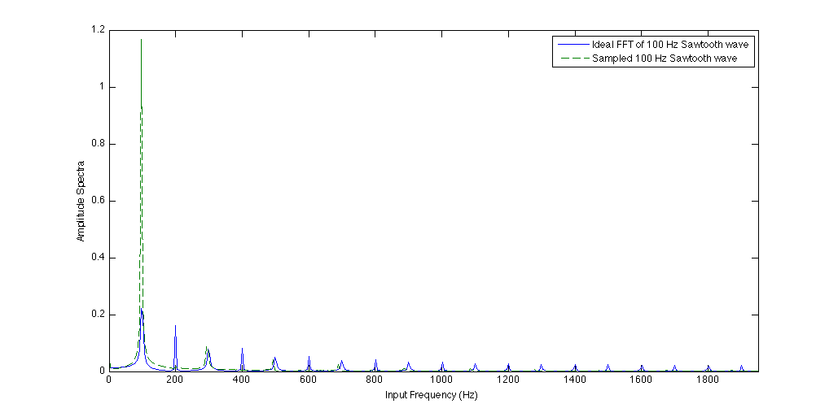

Figure 3: Ideal and Real 100 Hz Sawtooth Amplitude spectra

Again, in order to clearly see both waveforms in a single graph, the ideal Sawtooth waveform Fourier transform amplitude was divided by 1000. Instead of an offset like the last dataset, the ideal Fourier transform had peaks in between each of the sampled peaks.

**Section 3: Sampling; Aliasing; Nyquist Sampling Theorem**

**3.1**

Homework Question – “What is the Nyquist frequency for the data acquisition system? Explain how you determined this frequency by experimenting with the signal frequency.”

The theoretical Nyquist frequency is 52.1 kHz and this is almost exactly where we determined the frequency by experimenting. This was determined was by watching the amplitude spectra as we increased the frequency from 20 kHz to 100 kHz. The resulting plots showed the main peak increasing and following the frequency until it went outside of the baseband span, but when the frequency was increased even more to about 60 kHz, the signal came back into the amplitude spectra and the peak was moving to lower frequencies toward the left and had a few false peaks. This effect is called aliasing, when the input frequency is too high for the A/D converter to properly discretize the input waveform. The plot below demonstrates the effect.

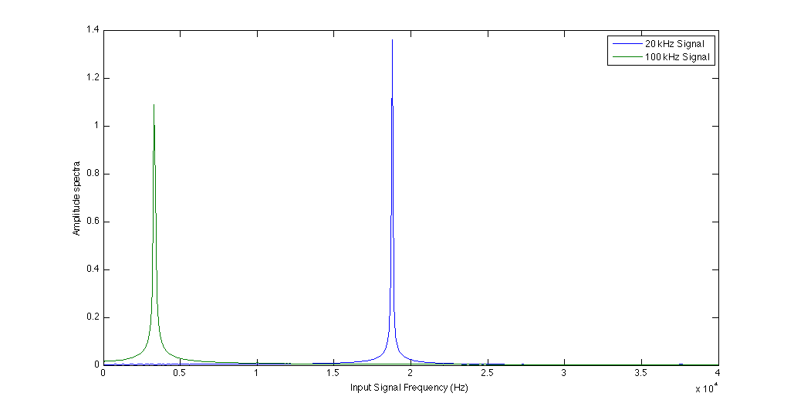

Figure 3: 20 and 100 kHz amplitude spectra showing aliasing effect

**Section 4: Audible Frequency Test**

**4.3**

Question – “What’s the audible range?”

The audible range for me was 40 Hz to 18.8 kHz.

**CONCLUSIONS**

In conclusion, this lab introduced several concepts about digital signal processing by using the dynamic signal analyzer VI. The students found the effects of fast Fourier transforms treating signals as periodic once. This effect was found by finding the peak of the half step frequency signals in the amplitude spectra graph. Additionally it was found that the Square and Sawtooth waveforms had many peaks and were different from what an ideal waveform should look like. The students also found the effects of aliasing by increasing an input signal to a frequency past the Nyquist frequency.

**BIBLIOGRAPHY**

RAVI-CHANDAR, Krishnaswamy. *Lab #5: Digital Signal Processing*. Rep. no. 1. N.p.: n.p., n.d. Print.