



***Lab #7: Impulse-Force Hammer; Vibration of Beams***

|  |  |
| --- | --- |
| **Course Number and Name:**  **ASE 269K Measurements and Instrumentation** | |
| **Semester and Year:**  **Fall 2013** | |
| **Name of Reporter:**  Zachary Tschirhart | **EID of Reporter:**  zst75 |
| **Unique Number and Meeting Time:**  13580 Monday 1-3pm | **Name of Lab Instructor**  **Shixuan Yang** |
| **Title of Experiment:**  Impulse-Force Hammer; Vibration of Beams | |
| **Date of Experiment Performed:**  October 21, 2013 | **Instructor Comments:** |
| **Date of Report Submitted:**  November 4, 2013 |
| **Names of Group Members:**  Dayle Chang |
| **Grade:** |

**ABSTRACT**

This lab was indented to show several concepts about using an accelerometer to gather frequency response data on a cantilever beam under the influence of an impulse forcing function. By connecting this device to the end of a cantilever beam, the students were also able to calculate the natural frequencies and determine the modes of the system, which turned out to be similar to the theoretical values.

**OBJECTIVE AND INTRODUCTION**

The objective of this lab is to introduce students to high frequency data gathering and calculating the properties of a beam under a forcing function. Equipment used in the experiment was a Dell Optiplex computer, PCI-MIO-16E-4 data-acquisition board, virtual bench Dynamic Signal Analyzer, Impulse-Force Hammer, Piezoelectric Accelerometer, Four-channel amplifier, and an aluminum beam.

**THEORY AND EXPERIMENTAL METHODS**

The resonant frequencies for a simple cantilever beam is given by

 (1)

 is the natural frequency, *E* is the modulus of elasticity of the material, *I* is the moment of inertia, *L is* length of the beam, *ρ* is the mass per unit length, and *Cn* is the coefficient for the different resonant modes.



**RESULTS AND DISCUSSION**

**Section 2: Assess the effect of hammer tip on the spectrum of an impulse force.**

**2.1.4**

Question 1 – Display the signal produced by the red hammer tip

Figure 1: Time waveforms for different hammer tips

Figure 2: Amplitude for different hammer tips

**Section 3: Beam, Accelerometer, and Impulse Hammer Set-up**

**3.1.2**

Question 1 – What are the beam dimensions.

Beam Length: 12.875 in.

Beam Width: 1.00 in.

Beam Thickness: 0.250 in.

Modulus of elasticity: 10x106 psi

Load weight: 0.1 lb/in3

Homework Question 1 – “Plot time history for hammer acceleration and tip acceleration explaining the results with respect of dumping trends and frequencies.”

Figure 3: 2 in. Time waveform

Figure 4: 5 in. time waveform

Figure 5: 8 in. time waveform

These results show that the waveforms decrease in amplitude as the forcing function gets closer to the clamped point. This is probably due to a reduced moment arm on the system. In the 2-inch example, the frequency seems to be changed partly because there seems to be a second impact from the hammer. This probably caused this lower frequency and amplitude in the system.

Homework Question 2 – “Plot frequency response for the tip of the beam and compare results with theoretical frequencies of vibration explaining amplitudes, differences, etc.”

Figure 6: Frequency response of 2-inch hammer impact

Figure 7: Frequency response of 5-inch hammer impact

Figure 8: Frequency response of 8-inch hammer impact

Using equation 1, the theoretical frequencies for this beam in the first two non-zero modes are:

Mode 1: 194.77 Hz

Mode 2: 1212.65 Hz

When measuring the 2 in. impulse, the following two frequencies had the highest amplitude:

Mode 1: 35.09 Hz

Mode 2: 1142.86 Hz

Difference Mode 1: 81.98 %

Difference Mode 2: 5.75 %

When measuring the 5 in. impulse, the following two frequencies had the highest amplitude:

Mode 1: 165.41 Hz

Mode 2: 1107.75 Hz

Difference Mode 1: 15.07 %

Difference Mode 2: 8.86 %

When measuring the 8 in. impulse, the following two frequencies had the highest amplitude:

Mode 1: 165.41 Hz

Mode 2: 1473.68 Hz

Difference Mode 1: 15.07 %

Difference Mode 2: 21.53 %

There seems to be a large difference in mode 1 for the 2-inch impact, which may have been caused by the second impulse that was mentioned before. It can also be noted that when moving closer to the clamped point, less of an error occurs in mode one, but more error is measured in the second mode. This is due to the moment arm that is created when the impulse forcing function is placed at different points across the beam.

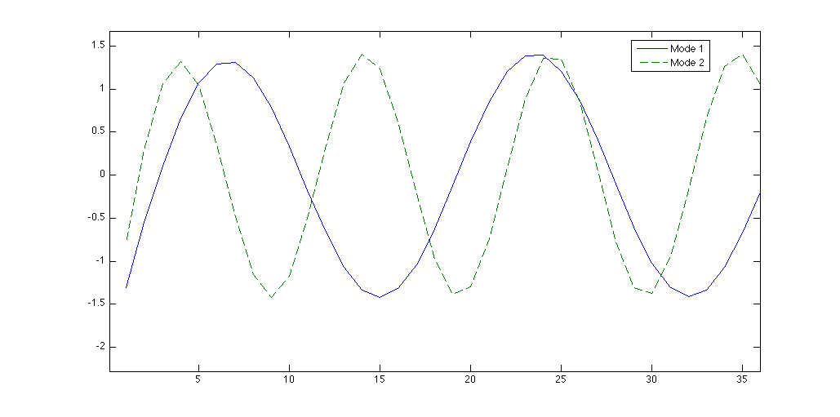

Figure 9: Theoretical vibration modes

Figure 9 shows the theoretical modes for the cantilever beam used in this experiment, which correspond to the natural frequencies of the system. It can be seen that the second mode is a higher frequency than the first mode, which correspond to all three amplitude plots. This could also be seen in Figures 3, 4, and 5, if we were to differentiate the acceleration results.

**CONCLUSIONS**

In conclusion, this lab showed several concepts about using accelerometers to gather frequency response data on a cantilever beam under the influence of an impulse forcing function. The students were also able to calculate the natural frequencies and determine the modes of the system, which turned out to be similar to the theoretical values.

**BIBLIOGRAPHY**

RAVI-CHANDAR, Krishnaswamy. *Lab #7:Impulse-Force Hammer; Vibration of Beams*. Rep. no. 1. N.p.: n.p., n.d. Print.