



***Lab #9: Buckling of Beams***

|  |  |
| --- | --- |
| **Course Number and Name:**  **ASE 269K Measurements and Instrumentation** | |
| **Semester and Year:**  **Fall 2013** | |
| **Name of Reporter:**  Zachary Tschirhart | **EID of Reporter:**  zst75 |
| **Unique Number and Meeting Time:**  13580 Monday 1-3pm | **Name of Lab Instructor**  **Shixuan Yang** |
| **Title of Experiment:**  Buckling of Beams | |
| **Date of Experiment Performed:**  November 4, 2013 | **Instructor Comments:** |
| **Date of Report Submitted:**  November 11, 2013 |
| **Names of Group Members:**  Dayle Chang |
| **Grade:** |

**ABSTRACT**

This lab was indented to show several concepts about using a loading frame to show concepts about finding properties of a beam in bending. In the lab, the students found that the beam has a unique moment diagram, which explains the forces in the beam while it’s bending. The beam also did not show the any signs of being perfectly straight, since the buckling force was much lower than the theoretical load.

**OBJECTIVE AND INTRODUCTION**

The objective of this lab is to familiarize students with the behavior of beams loaded in the axial direction and the instability of buckling. Equipment used in the experiment was a Dell Optiplex computer, Multimeter and DC power supply, LVDT with magnetic head, INSTRON loading frame w/Bluehill control software, and a steel beam.

**THEORY AND EXPERIMENTAL METHODS**

The deflected shape of the beam can be written as:

$y\left(x\right)=A\left[\cos\left(\frac{2πx}{L}\right)-1\right]$ (1)

Where x is the distance from the beam edge, A is the amplitude of deflection, and L is the length of the beam.



The buckling critical load is:

$P_{cr}=\frac{4π^{2}EI}{L^{2}}$ (2)

Where *E* is the modulus of elasticity of the material, *I* is the moment of inertia and *L is* length of the beam.

The relationship between the end shortening of the beam and the amplitude of deflection is:

$Δ=L- \int_{0}^{L}{\sqrt{1+{\left\{\frac{2πA}{L}sin\left(\frac{2πx}{L}\right)\right\}}^{2}}ds}$ (3)

Where L is the length of the beam, A is the amplitude of the deflection, and x is the current position from the edge of the beam.

The relationship between the moment and position in the pinned beam can be solve by this (previously solved differential equation) equation:

$ν\left(x\right)= C_{1}\sin\left(kx\right)+ C_{2}\cos\left(kx\right)+ \frac{R}{P}(L-x)$ (4)

Where L is the length of the beam, x is the current position in the beam, $C_{1} and C_{2}$ are the constants that are solved by using the boundary equations defined by the pinned beam, R is the unknown reaction force caused by the bending moment, P is the force applied to the beam on the edge of the beam, k is a constant relating the edge force, modulus of elasticity, and moment of inertia of the beam.

**RESULTS AND DISCUSSION**

**Section 1: Specimen dimensions**

Question 1 – What are the measurements of the beam?

Length – 20.8 inches

Width – 1.0 inch

Thickness – 0.063 inches

Material – Steel

**Homework Questions**

Question 1 – “Plot the stress curve for the tension test…”

This question was voided because of technical difficulties, per Shixuan’s email.

Question 2 – “Plot the buckling mode (shape) at the maximum deflection you measured.”

Using equation 1 to first find the amplitude (-0.1845), then plotting. The following plot shows the shape of the deflected beam:

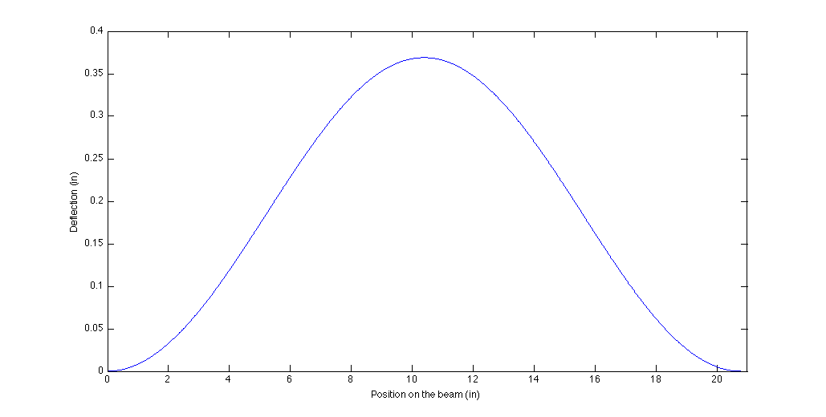

Figure 1: Deflection diagram of bending beam.

Question 3 – “Plot the bending moment diagram and find the location of maximum bending moment.”

Using equation 4 and solving for the unknowns, the following plot describes the moment across a beam with one end clamped and the other end on a pin. Unfortunately, the professor was unable to go over the case where both ends are clamped, so this may not be a good approximation of what the true moment diagram would look like. I have tried to solve the other case, but I am not confident enough in my answer. I would imagine it would look more like a 2nd order polynomial with a hump in the middle where the moment is minimum.

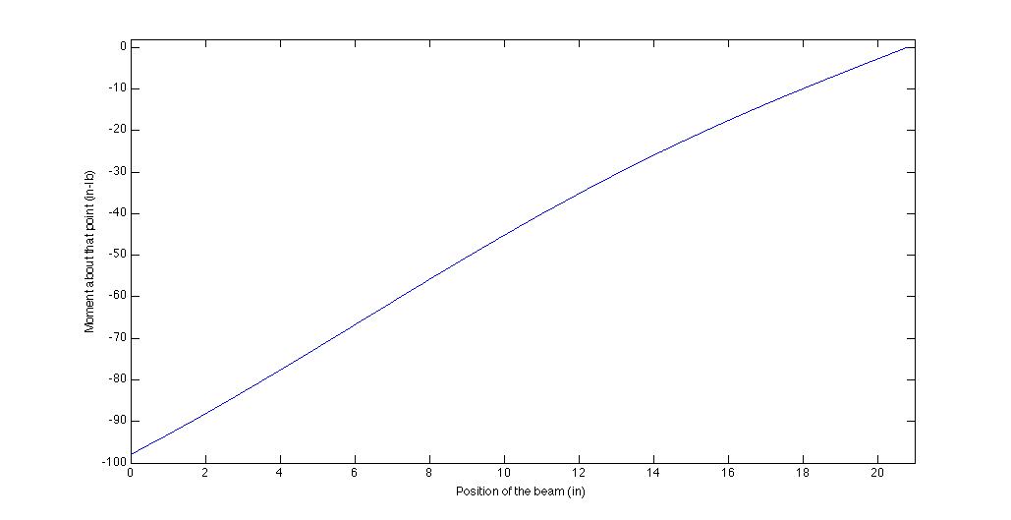

Figure 2: Moment diagram of bending beam.

Question 4 – “Plot the load vs. cross head displacement and load vs. mid span displacement on two separate plots and comment on the results”

These results seem within reason of what we would expect from a buckling beam.

Figure 3: Load vs. Cross head displacement

Figure 4: Load vs. mid span displacement

Question 4.1 – “Is the buckling load predicted correctly?”

No, the load critical was theoretically supposed to be 342.25 lb. according to equation 2, but according to the collected data it was less than half of that, around 115 lb.

Question 4.2 – “Is the behavior of the beam as predicted by a perfectly straight beam theory (explain)?”

No, the best indicator for this is the difference in the critical loading values. The value should have been more than twice of what was achieved. If the beam was perfectly straight, it would have been much closer to the theoretical value.

Question 4.3 – “What is the magnitude of the initial imperfection of the beam [for this point you need to plot the Δ vs. Δ/P as explained in class]?”

Again, this was not explained in class before this lab was due, but this seems fairly easy to plot.

The magnitude of the initial imperfection of the beam is 0.0002 in/lb.

Figure 5: End shortening length vs. end shortening length per load at given unit.

**CONCLUSIONS**

In conclusion, this lab showed several concepts about finding properties of a beam in bending, including finding the Young’s modulus of the beam, finding the mode and beam displacement, comparing theoretical buckling loads to the actual results. In the lab, the students found that the beam has a unique moment diagram, which explains the forces in the beam while it’s bending. The beam also did not show the any signs of being perfectly straight, since the buckling force was much lower than the theoretical load.

**BIBLIOGRAPHY**

RAVI-CHANDAR, Krishnaswamy. *Lab #9:Beam in bending*. Rep. no. 1. N.p.: n.p., n.d. Print.